Job:

# Hi Delta® - Type H

## Space Heating/Hot Water Boilers Models 992C-2342C

Engineer:

Contractor:

Prepared By:       Date:

Model:       Indoor/Outdoor:       MBTUH Input:

FrontPhase%202

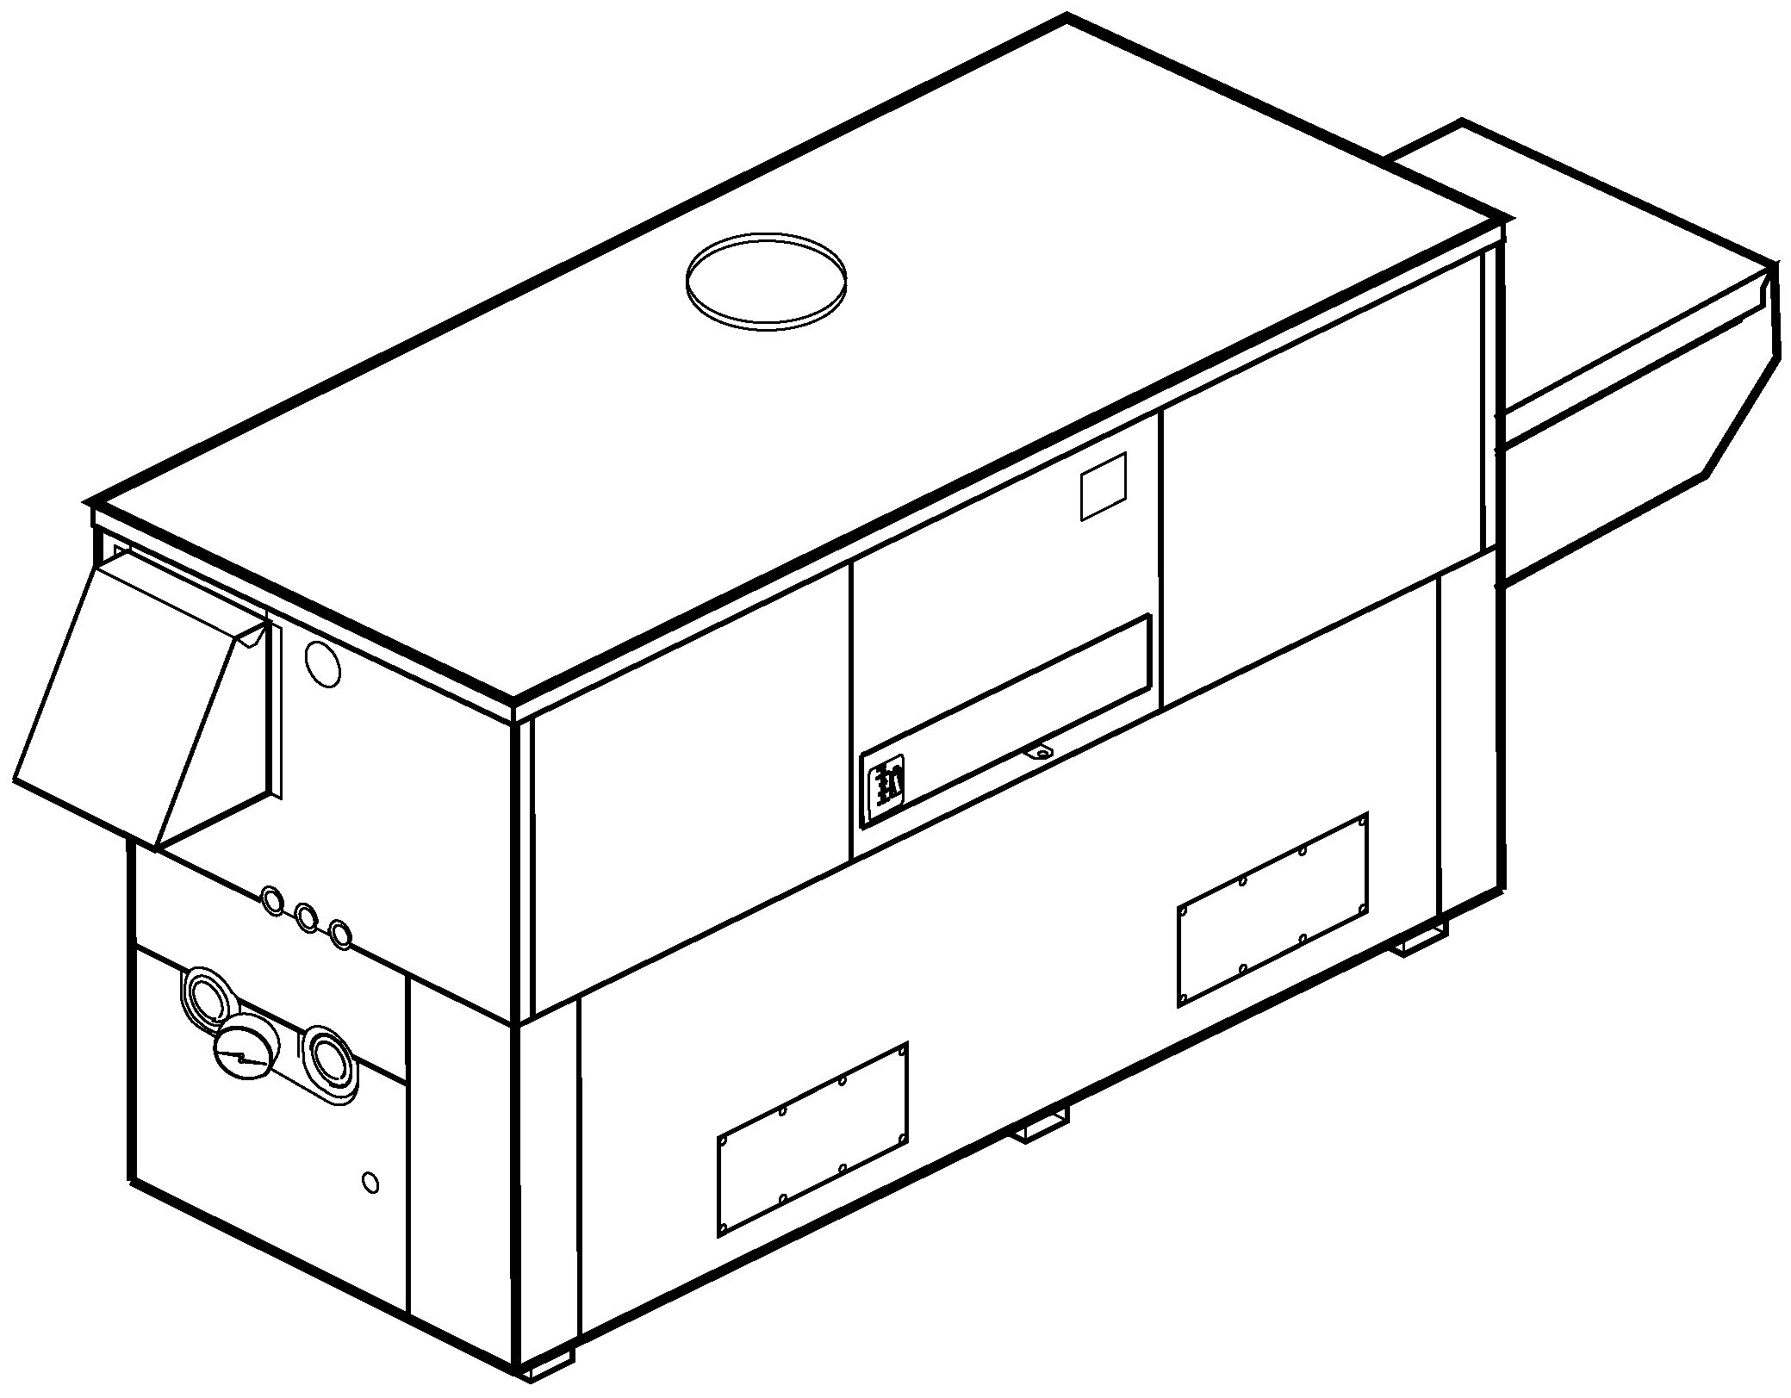

* 100% Factory Fire Tested
* Thermal Efficiency: 84%
* Versa IC® Controller with LCD Display
* Maximum Setpoint: 220°F
* Maximum Outlet Temperature: 240°F
* Minimum Non-Condensing Inlet Temperature: 105°F
* Thermal Shock Proof Heat Exchanger
* Limited Twenty-Year Thermal Shock Warranty
* Limited Five-Year Heat Exchanger Warranty
* Full Safety Diagnostics with Fault History
* PolyTuf Powder Coated Cabinet
* No Combustible Floor Shield Required
* Fan-Assisted
* Patented Burner Security Blanket

Proudly Assembled in the USA



* Cascade up to 4 Heaters – No External Sequencer Needed
* Ultra-Low NOx – SCAQMD 1146.2 Certified (992C – 2002C)

#### Heat Exchanger

* Headers

Glass-Lined Cast Iron – Standard

A-1 Brass

* ASME Inspected and H Stamped  
  160 PSIG Working Pressure
* National Board Approved
* Fin Tubing

Copper – Standard

A-3 Cupro Nickel

* ASME Steel Tube Sheet
* Silicone High Temp. O-Rings
* ASME Pressure Relief Valve

60 PSIG – Standard

      PSIG – Optional

* Temperature and Pressure Gauge
* Water Connections

Left – Standard

A-6 Right

#### Controls

* 120V, 60Hz, 1∅ Power Supply
* 120/24V 60Hz Transformer
* Versa IC® Integrated Control
* 100% Shut-Off/Lockout
* Hot Surface Ignition
* Ignition Module

3-Try – Standard

C-6 Single Try

* Remote Flame Sensor
* Fixed High Limit, Manual Reset 240°F
* On/Off Power Switch
* Flow Switch
* Blocked Vent Pressure Switch
* Combustion Air Proving Switch
* Programmable Pump Time Delays
* Pump Outputs
* Boiler
* System – Pilot Duty
* DHW Indirect – Pilot Duty
* Enable/Disable

#### Raypak-Rheem%20logo_submittals

* LCD Display; Status, Fault and Diagnostics
* Modbus RTU BMS Port (Up to 115K Baud, See Cat. 5000.73)

B-85 – BMS Gateway – BACnet MS/TP, BACnet IP, N2 Metasys or Modbus TCP

B-86 – BMS Gateway – LonWorks

* Cold Water Protection Function

CWR Variable-Speed Pump

CWS Proportional Valve

#### Gas Train

* Manual Gas Shut-Off Valve(s)
* Combo Valve(s)
* Firing Mode

3-Stage (H8): Model 992C

4-Stage (H9): Models 1262C – 2342C

* Fuel

Natural Gas

Propane Gas (HD-5) (Excludes 2002C)

4” WC Nat Supply Pressure   
(G-20)

* Design Certified - ANSI Z21.13/CSA 4.9

#### Construction

* Indoor/Outdoor Construction
* Enclosed Front Controls

CSA Low Lead Certified (≤ .25% Lead

#### Venting

* Vent Location

Top – Standard

D-14 Rear

* Vent Termination Cap

D-11 Outdoor

D-15 Indoor, Horizontal

Indoor, Vertical (by others)

* Combustion Air

D-17 In-Line Filter Kit (TruSeal only)

D-16 Air Intake Elbow

* Extractor – Optional

By others

 Not required

#### Burner

#### Ultra-Low NOx: Less than 20 PPM

#### Options

D-21 TruSeal® Direct Vent

F-10 Low Water Cut-Off, Remote Probe

I-1 High Limit Control, Auto Reset (240°F)

I-2 Adjustable High Limit Control, Manual Reset (240°F)

P-   Pump:       HP, 120V, 1∅, 60Hz

Bronze  Cast Iron  
 Mounted  Loose

Front  Rear

S-1 Low Gas Pressure Switch, Manual

S-2 High Gas Pressure Switch, Manual

X-1 SureRack® Kit

X-2 SureRack Add-on

    



*For Metric information, see Catalog*

#### Additional Options or Accessories



*For Metric information, see Catalog*

#### Multi-Boiler Temperature Controllers

TempTracker Mod+ Hybrid

B-36, 2-4 Heaters

B-37, 5-10 Heaters

B-38, 11-16 Heaters

B-39 EMS 4-20mA Remote Setpoint Interface Module

B-62 BACnet MS/TP Interface

#### Hi Delta – Type H

**Models 992C-2342C Model**

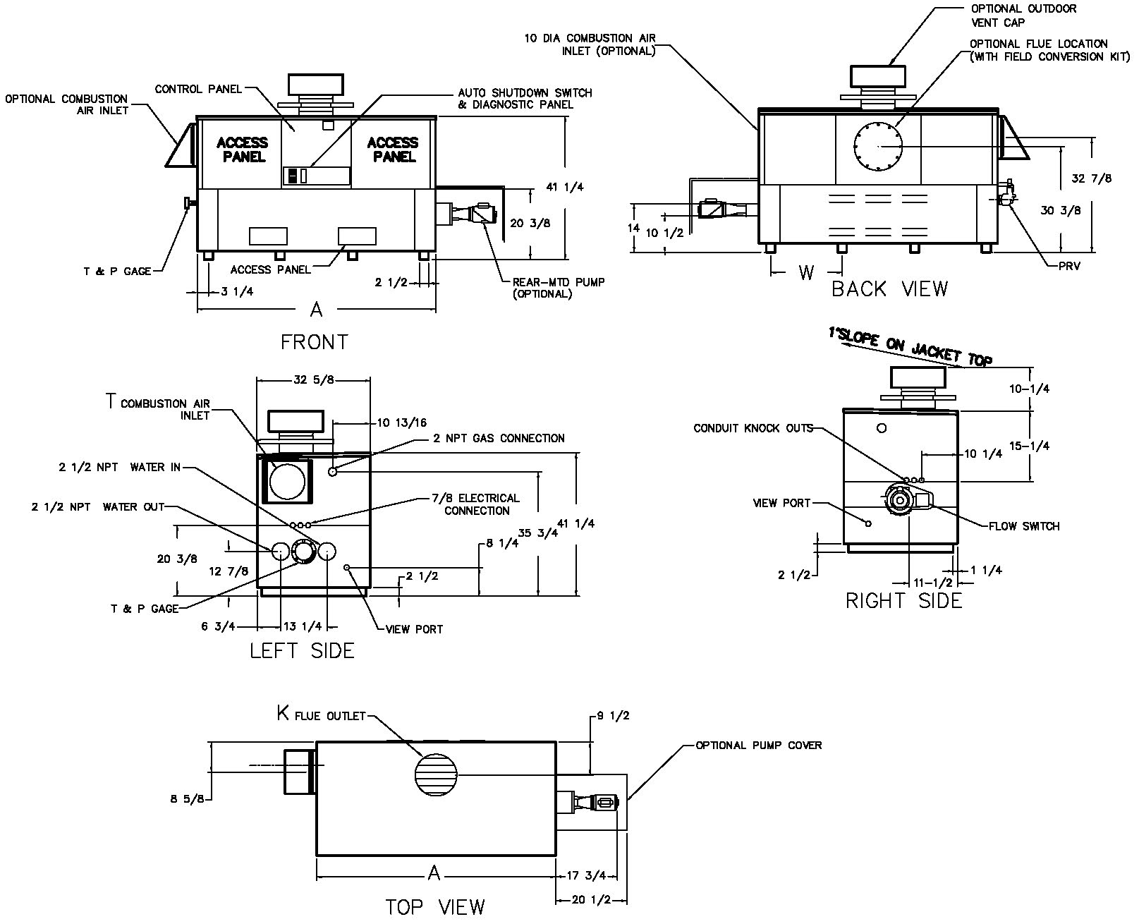

NOTE: Pump location varies based on model and application

Raypak, Inc. ▪ 2151 Eastman Avenue, Oxnard, CA 93030 ▪ (805) 278-5300 ▪ Fax (800) 872-9725 ▪ www.raypak.com

|  |  |  |  |  |  |  |  |  |  |  |
| --- | --- | --- | --- | --- | --- | --- | --- | --- | --- | --- |
|  | **RATES OF FLOW AND PRESSURE DROPS** | | | | | | | | | |
| **Model** | **20°F ΔT** | | **30°F ΔT** | | **Min. Flow** | | | **Max. Flow** | | |
| **GPM** | **ΔP (FT.)** | **GPM** | **ΔP (FT.)** | **GPM** | **ΔP (FT.)** | **ΔT** | **GPM** | **ΔP (FT.)** | **ΔT** |
| 992C | 84 | 5.6 | 56 | 2.5 | 43 | 1.5 | 39 | 132 | 14.0 | 13 |
| 1262C | 107 | 10.0 | 71 | 4.5 | 54 | 2.6 | 39 | 132 | 15.5 | 16 |
| 1532C | 130 | 16.0 | 86 | 7.1 | 66 | 4.1 | 39 | 132 | 16.5 | 20 |
| 1802C | N/A | N/A | 102 | 10.8 | 78 | 6.0 | 39 | 132 | 18.0 | 23 |
| 2002C | N/A | N/A | 113 | 14.0 | 86 | 8.1 | 39 | 132 | 19.5 | 26 |
| 2072C | N/A | N/A | 117 | 15.0 | 89 | 8.7 | 39 | 132 | 19.5 | 27 |
| 2342C | N/A | N/A | 132 | 21.0 | 101 | 12.0 | 39 | 132 | 21.0 | 30 |

Basis is 39°F ΔT for minimum flow, 132 GPM for maximum flow.

|  |  |  |  |  |  |  |  |  |  |
| --- | --- | --- | --- | --- | --- | --- | --- | --- | --- |
| **SPECIFICATIONS** | | | | | | | | | |
| **Model** |  |  | **Firing**  **Stages** | **A**  **Width** | **K** | **T** | **W** | **Amp.**  **Draw\*** | **Approx.**  **Shipping**  **Wt. (Lbs.)** |
| **Input** | **Output** |
| 992C | 990 | 832 | 3 | 57-1/8 | 10 | 10 | 16-13/16 | <12 | 900 |
| 1262C | 1260 | 1058 | 4 | 68-1/2 | 12 | 10 | 20-9/16 | <12 | 1010 |
| 1532C | 1530 | 1285 | 4 | 79-7/8 | 12 | 10 | 24-3/8 | <12 | 1225 |
| 1802C | 1800 | 1512 | 4 | 91-1/8 | 14 | 10 | 28-1/8 | <12 | 1350 |
| 2002C | 1999 | 1679 | 4 | 102-1/2 | 14 | 10 | 31-15/16 | <12 | 1450 |
| 2072C | 2070 | 1739 | 4 | 102-1/2 | 14 | 10 | 31-15/16 | <12 | 1450 |
| 2342C | 2340 | 1966 | 4 | 113-7/8 | 16 | 10 | 35-11/16 | <12 | 1520 |

\*Without pump.

Dimensions are in inches.

NOTES: 1. Rates shown are for natural or propane gas, and elevations up to 4,500 feet. For installation above 4,500 feet, please contact manufacturer.

2. Required natural gas pressure is 7 – 10.5” WC. Required propane gas pressure is 11 - 13” WC.