Job:

# Hi Delta® - Type H

## Space Heating/Hot Water Boilers Models 302C-902C

Engineer:

Contractor:

Prepared By:       Date:

Model:       Indoor/Outdoor:       MBTUH Input:

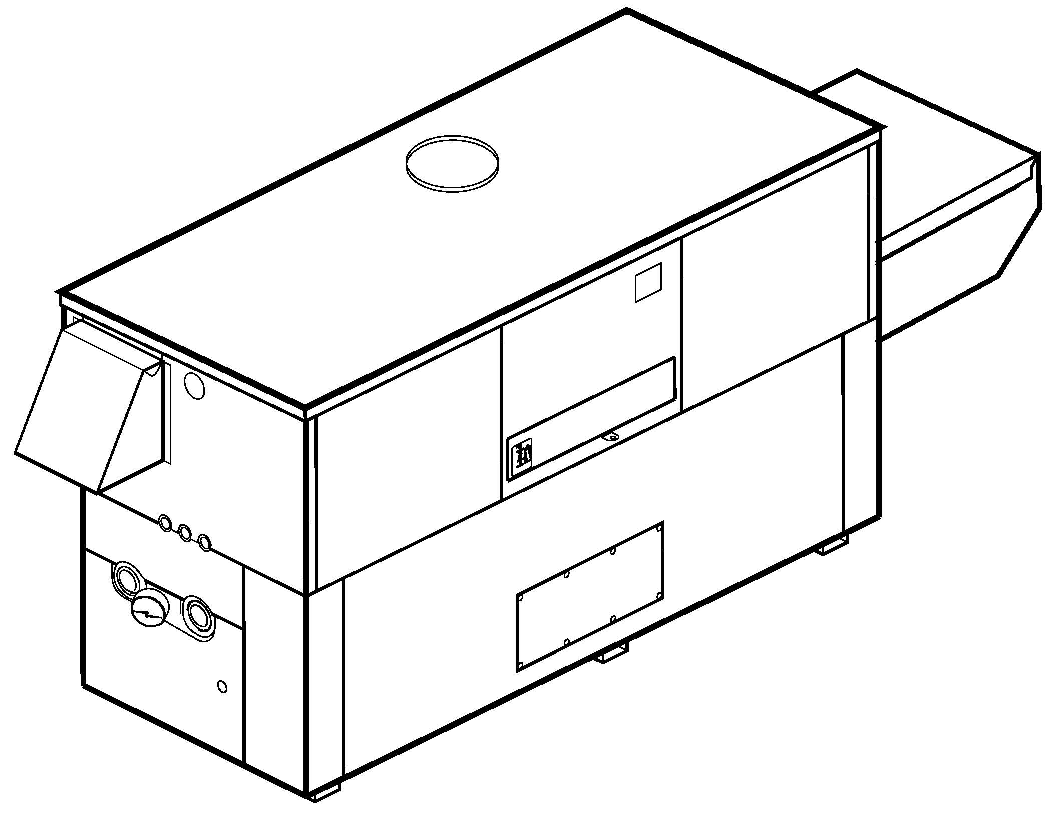

* 100% Factory Fire Tested
* Thermal Efficiency: 84%
* Versa IC® Controller with LCD Display
* Maximum Setpoint: 220°F
* Maximum Outlet Temperature: 230°F
* Minimum Non-Condensing Inlet Temperature: 105°F
* Thermal Shock Proof Heat Exchanger
* Limited Twenty-Year Thermal Shock Warranty
* Limited Ten-Year Closed-System Heat Exchanger Warranty
* Cascade up to 4 Heaters – No External Sequencer Required
* Full Safety Diagnostics with Fault History
* PolyTuf Powder Coated Cabinet

Proudly Assembled in the USA



* No Combustible Floor Shield Required
* Fan-Assisted
* Patented Burner Security Blanket
* Ultra-Low NOx – SCAQMD 1146.2 Certified

#### Heat Exchanger

* Headers

Glass-Lined Cast Iron – Standard

A-1 Brass

* ASME Inspected and H Stamped  
  160 PSIG Working Pressure
* National Board Approved
* Fin Tubing

Copper – Standard

A-3 Cupro-Nickel

* ASME Steel Tube Sheet
* Silicone High-Temp. O-Rings
* ASME Pressure Relief Valve

45 PSIG – Standard on Models 302C and 402C

60 PSIG – Standard on Models 502C-902C

      PSIG – Optional

* Temperature and Pressure Gauge
* Water Connections

Left – Standard

A-6 Right Hand

#### Controls

* 120V, 60Hz, 1∅ Power Supply
* 120/24V 60Hz Transformer
* Versa IC® Integrated Control
* 100% Shut-Off/Lockout
* Hot Surface Ignition
* Ignition Module

3-Try – Standard

C-6 Single Try

* Remote Flame Sensor
* Fixed High Limit, Manual Reset 240°F
* On/Off Power Switch
* Flow Switch
* Blocked Vent Pressure Switch
* Combustion Air Proving Switch
* Programmable Pump Time Delays
* Boiler
* Indirect Storage Tank
* System



* Enable/Disable
* LCD Display; Status, Fault and Diagnostics
* Cold Water Protection Function

CWS Three-Way Valve

CWR Variable-Speed Pump

* Modbus RTU BMS Port (Up to 115K Baud, See Cat. 5000.73)

B-85 – BMS Gateway – BACnet MS/TP, BACnet IP, N2 Metasys or Modbus TCP

B-86 – BMS Gateway - LonWorks

#### Gas Train

* Manual Gas Shut-Off Valve(s)
* Combo Valve(s)
* Firing Mode

2-Stage (H3): Models 302B-902B

* Fuel

Natural Gas

Propane Gas (HD-5)

G – 20 4” WC Nat Supply

* Design Certified ANSI Z21.13/CSA 4.9

#### Construction

* Indoor/Outdoor Construction
* Enclosed Front Controls
* CSA Low Lead Certified (≤ .25% Lead)

#### Venting

* Vent Location

Top – Standard

D-14 Rear

* Vent Termination Cap

D-11 Outdoor

D-15 Indoor, Horizontal

Indoor, Vertical (by others)

* Combustion Air

D-17 In-Line Filter Kit (TruSeal only)

D-16 Air Intake Elbow

* Extractor – Optional

 By others

Not required

#### Options

D-21 TruSeal® Direct Vent

F-10 Low Water Cut-Off, Remote Probe

I-1 High Limit Control, Auto Reset

P-   Pump:       HP, 120V, 1∅, 60Hz

Cast Iron  Bronze  
 Mounted  Loose

Front  Rear

S-1 Low Gas Pressure Switch, Manual

S-2 High Gas Pressure Switch, Manual

X-1 SureRack® Kit

X-2 SureRack Add-on

    



*For Metric information, see Catalog*

#### Additional Options or Accessories



*For Metric information, see Catalog*

#### Multi-Boiler Temperature Controllers

TempTracker Mod+ Hybrid

B-36, 2-4 Heaters

B-37, 5-10 Heaters

B-38, 11-16 Heaters

B-39 EMS 4-20mA Remote Setpoint Interface Module

B-62 BACnet MS/TP Interface

#### Hi Delta – Type H

#### Models 302C-902C Model

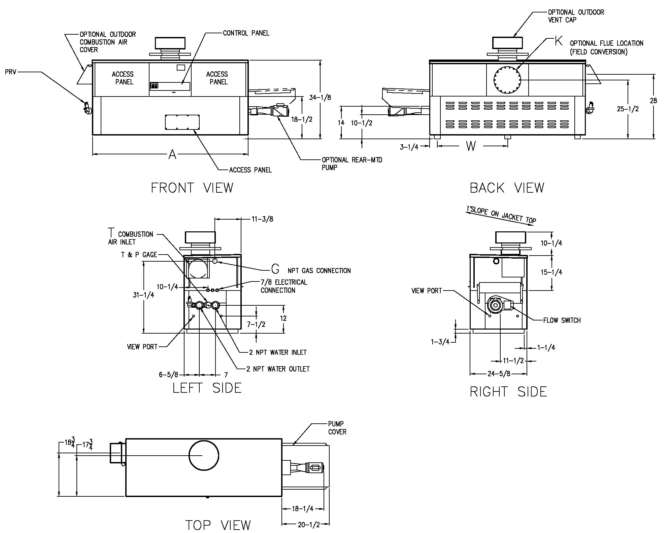

NOTE: Pump location varies based on model and application

|  |  |  |  |  |  |  |  |  |  |
| --- | --- | --- | --- | --- | --- | --- | --- | --- | --- |
| **SPECIFICATIONS** | | | | | | | | | Approx.  Shipping  Wt. (Lbs.) |
| Model | MBTUH | | A  Width | G  NPT | H  NPT | K | W | Amp.  Draw |
| Input | Output |
| 302C | 300 | 252 | 36 | 3/4 | 2 | 6 | 14-3/4 | 6 | 380 |
| 402C | 399 | 335 | 43 | 3/4 | 2 | 6 | 18-1/2 | 6 | 445 |
| 502C | 500 | 420 | 50 | 1-1/4 | 2 | 6 | 22 | 6 | 545 |
| 652C | 650 | 546 | 60-1/2 | 1-1/4 | 2 | 8 | 27-1/4 | 6 | 590 |
| 752C | 750 | 630 | 67-1/2 | 1-1/4 | 2 | 8 | 30-3/4 | 6 | 675 |
| 902C | 900 | 756 | 78 | 1-1/4 | 2 | 8 | 36 | 7 | 740 |

Raypak, Inc. ▪ 2151 Eastman Avenue, Oxnard, CA 93030 ▪ (805) 278-5300 ▪ Fax (800) 872-9725 ▪ www.raypak.com

NOTES: 1. Rates shown are for natural or propane gas, and elevations up to 4,500 feet. For installation above 4,500 feet, please contact manufacturer.

2. Required natural gas pressure is 7 – 10.5” WC. Required propane gas pressure is 11 - 13” WC.

Dimensions are in inches.

|  |  |  |  |  |  |  |  |  |  |  |  |  |
| --- | --- | --- | --- | --- | --- | --- | --- | --- | --- | --- | --- | --- |
| **RATES OF FLOW AND PRESSURE DROPS** | | | | | | | | | | | | |
| Model | 10°F ΔT | | 20°F ΔT | | 30°F ΔT | | Min. Flow | | | Max. Flow | | |
| GPM | ΔP (ft.) | GPM | ΔP (ft.) | GPM | ΔP (ft.) | GPM | ΔP (ft.) | ΔT | GPM | ΔP (ft.) | ΔT |
| 302C | 51 | 3.2 | 25 | <1.0 | N/A | N/A | 20 | <1.0 | 25 | 90 | 9.8 | 6 |
| 402C | 68 | 5.4 | 34 | 1.5 | 22 | <1.0 | 20 | <1.0 | 34 | 90 | 10.0 | 7 |
| 502C | 85 | 9.2 | 42 | 2.3 | 28 | 1.1 | 21 | <1.0 | 39 | 90 | 10.5 | 9 |
| 652C | N/A | N/A | 55 | 4.0 | 36 | 1.8 | 28 | 1.1 | 39 | 90 | 10.7 | 12 |
| 752C | N/A | N/A | 64 | 5.5 | 42 | 2.5 | 32 | 1.6 | 39 | 90 | 11.0 | 14 |
| 902C | N/A | N/A | 76 | 8.5 | 51 | 3.8 | 38 | 2.2 | 39 | 90 | 11.8 | 17 |

**NOTES:**

1. Rates shown are for natural or propane gas, and elevations up to 4,500 feet. For installations above 4,500 feet, please contact manufacturer.
2. Required natural gas pressure is 7 – 10.5” WC. Required propane gas pressure is 11 – 13” WC.

Basis is 20 GPM or 39°F ΔT for minimum flow, 90 GPM for maximum flow

RATES OF FLOW AND PRESSURE DROPS

|  |  |  |  |  |  |  |  |  |  |  |  |  |
| --- | --- | --- | --- | --- | --- | --- | --- | --- | --- | --- | --- | --- |
|  | **10°F ∆T** | | **20°F ∆T** | | **30°F ∆T** | | Min. Flow | | | Max. Flow | | |
| Model | GPM | **∆P (ft)** | GPM | **∆P (ft)** | GPM | **∆P (ft)** | GPM | **∆P (ft)** | ∆T | GPM | **∆P (ft)** | ∆T |
| 302C | 51 | 3.2 | 25 | <1.0 | N/A | N/A | 20 | <1 | 25 | 90 | 9.8 | 6 |
| 402C | 68 | 5.4 | 34 | 1.5 | 22 | <1 | 20 | <1 | 34 | 90 | 10.0 | 7 |
| 502C | 85 | 9.2 | 42 | 2.3 | 28 | 1.1 | 21 | <1 | 39 | 90 | 10.5 | 9 |
| 652C | N/A | N/A | 55 | 4.0 | 36 | 1.8 | 28 | 1.1 | 39 | 90 | 10.7 | 12 |
| 752C | N/A | N/A | 64 | 5.5 | 42 | 2.5 | 32 | 1.6 | 39 | 90 | 11.0 | 14 |
| 902C | N/A | N/A | 76 | 8.5 | 51 | 3.8 | 38 | 2.2 | 39 | 90 | 11.8 | 17 |

Basis is 20 GPM or 39°F ∆T for minimum flow, 90 GPM for maximum flow.