Job:

# Hi Delta® - Type WH

## Water Heaters Models 992C-2342C

Engineer:

Contractor:

Prepared By:       Date:

Model:       Indoor/Outdoor:       MBTUH Input:

* 100% Factory Fire Tested

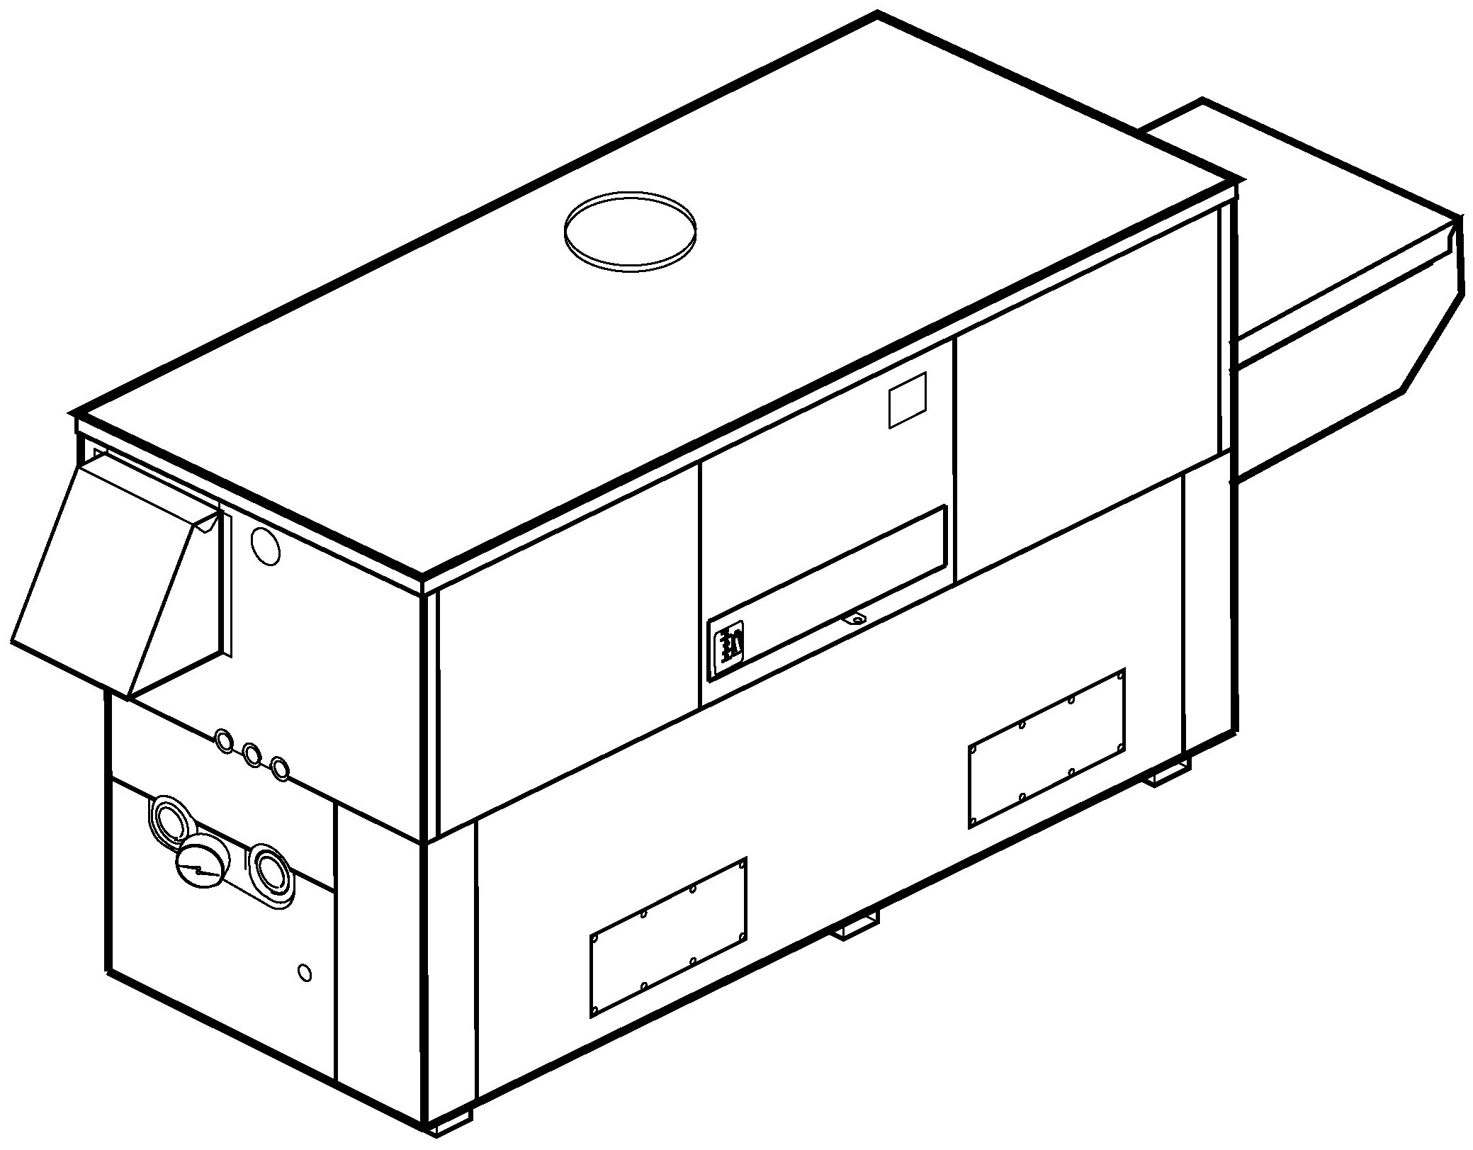

* Thermal Efficiency: Up to 85%
* Versa IC® Controller with LCD Display
* Maximum Setpoint: 150°F
* Maximum Outlet Temperature: 200°F
* Minimum Non-Condensing Inlet Temperature: 105°F
* Thermal Shock Proof Heat Exchanger
* Limited Twenty-Year Thermal Shock Warranty
* Limited Ten-Year Cupro-Nickel Heat Exchanger Warranty
* Limited Five-Year Copper Heat Exchanger Warranty
* Full Safety Diagnostics with Fault History
* PolyTuf Powder Coated Cabinet
* No Combustible Floor Shield Required
* Fan-Assisted
* Patented Burner Security Blanket
* Ultra-Low NOx – SCAQMD 1146.2 Certified (992C – 2002C)



Proudly Assembled in the USA

* Cascade up to 4 Heaters – No External Sequencer Required

#### Heat Exchanger

* Headers

Brass – Standard

A-2 Glass-Lined Cast Iron

* ASME Inspected and HLW Stamped  
  160 PSIG Working Pressure
* National Board Approved
* Fin Tubing

Copper (Std.) 85%

Cupro-Nickel 83.1%

* ASME Steel Tube Sheet
* Silicone High-Temp. O-Rings
* ASME Pressure Relief Valve

125 PSIG – Standard

      PSIG – Optional

* Temperature and Pressure Gauge
* Water Connections

Left – Standard

#### A-6 Right Hand

#### Controls

* 120V, 60Hz, 1∅ Power Supply
* 120/24V 60Hz Transformer
* Versa IC® Integrated Control
* 100% Shut-Off/Lockout
* Hot Surface Ignition
* Ignition Module

3-Try – Standard

C-6 Single Try

* Remote Flame Sensor
* Fixed High Limit, Manual Reset 240°F
* On/Off Power Switch
* Flow Switch
* Blocked Vent Pressure Switch
* Combustion Air Proving Switch
* Programmable Pump Time Delays
* Heater
* Recirculation
* Enable/Disable



* LCD Display; Status, Fault and Diagnostics
* Modbus RTU BMS Port (Up to 115K Baud, See Cat. 5000.73)

B-85 – BMS Gateway – BACnet MS/TP, BACnet IP, N2 Metasys or Modbus TCP

B-86 – BMS Gateway - LonWorks

* Cold Water Protection Function

#### CWR Variable-Speed Pump

#### Gas Train

* Manual Gas Shut-Off Valve(s)
* Combo Valve(s)
* Firing Mode

3-Stage (WH8): Model 992C

4-Stage (WH9): Models 1262C – 2342C

* Fuel

Natural Gas

Propane Gas (HD-5) (excludes 2002C)

4” WC Nat Supply Pressure   
(G-20)

* Design Certified - ANSI Z21.10.3/CSA 4.3

#### Construction

* Indoor/Outdoor Construction
* Enclosed Front Controls
* CSA Low Lead Certified (≤ .25% Lead)

#### Venting

Vent Category I/III Cupro-Nickel

Vent Category II/IV Copper

* Vent Location

Top – Standard

D-14 Rear

* Vent Termination Cap

D-11 Outdoor

D-15 Indoor, Horizontal

 Indoor, Vertical (by others)

* Combustion Air

D-17 In-Line Filter Kit (TruSeal only)

D-16 Air Intake Elbow

* Extractor – Optional

By others

Not required

#### Burner

Ultra-Low NOx: Less than 20 PPM

**Options**

D-21 TruSeal® Direct Vent

F-10 Low Water Cut-Off, Remote Probe

I-1 High Limit Control, Auto Reset

P-   Pump:       HP, 120V, 1∅, 60Hz

Bronze  
 Mounted  Loose

Front  Rear

S-1 Low Gas Pressure Switch, Manual

S-2 High Gas Pressure Switch, Manual

X-1 SureRack® Kit

X-2 SureRack Add-on



*For Metric information, see Catalog*

Additional Options or Accessories



*For Metric information, see Catalog*

#### Multi-Boiler Temperature Controllers

TempTracker Mod+ Hybrid

B-36, 2-4 Heaters

B-37, 5-10 Heaters

B-38, 11-16 Heaters

B-39 EMS 4-20mA Remote Setpoint Interface Module

B-62 BACnet MS/TP Interface



*For Metric information, see Catalog*



*For Metric information, see Catalog*

#### Hi Delta – Type WH Models 992C-2342C Model _     _____

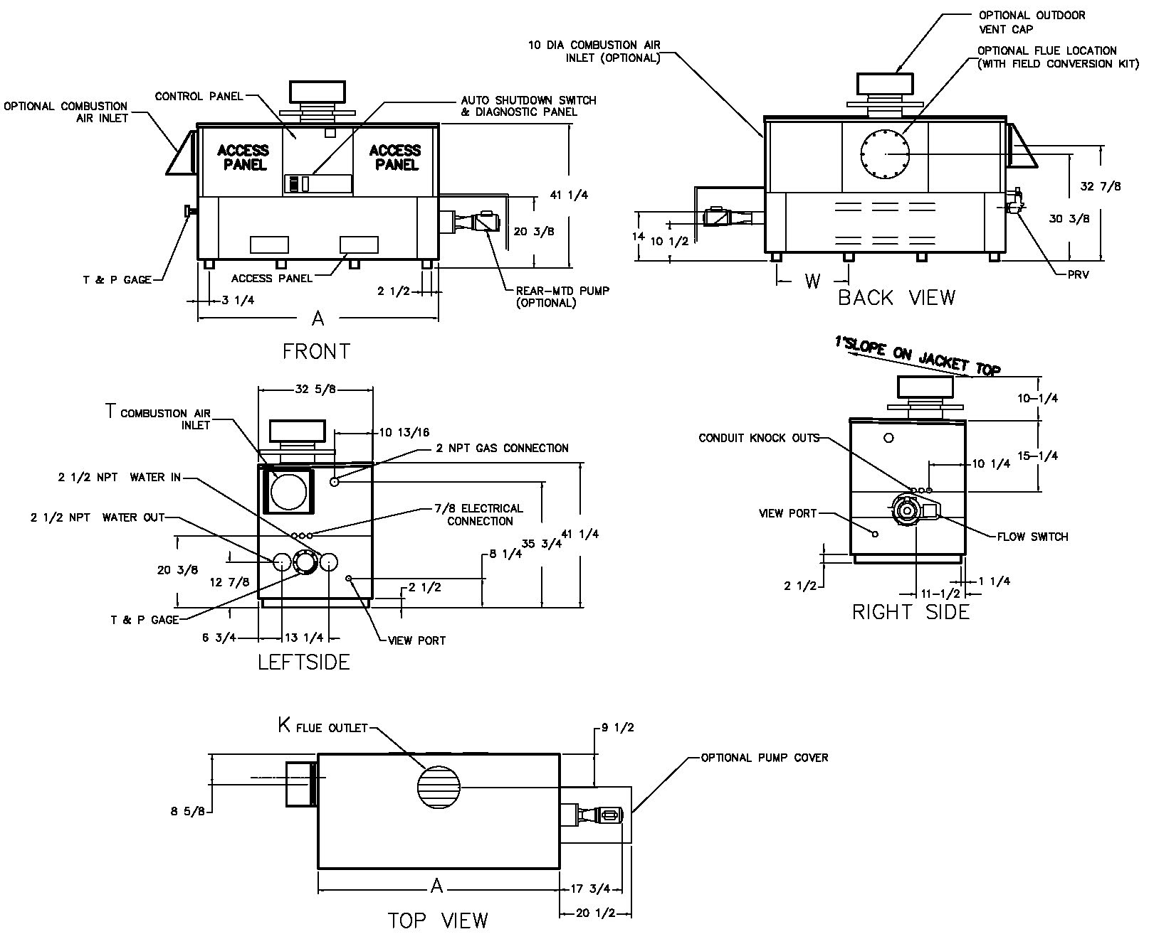

NOTE: Pump location varies based on model and application.

|  |  |  |  |  |  |  |  |  |  |  |
| --- | --- | --- | --- | --- | --- | --- | --- | --- | --- | --- |
|  | **SPECIFICATIONS** | | | | | | | | | |
| **Model** | **MBTUH** | | | **Firing**  **Stages** | **A**  **Width** | **K** | **T** | **W** | **Amp.**  **Draw\*** | **Approx.**  **Shipping**  **Wt. (Lbs.)** |
| **Input** | **Output**  **85%** | **Output**  **83.1%** |
| 992C | 990 | 842 | 823 | 3 | 57-1/8 | 10 | 10 | 16-13/16 | <12 | 900 |
| 1262C | 1260 | 1071 | 1047 | 4 | 68-1/2 | 12 | 20-9/16 | 1010 |
| 1532C | 1530 | 1301 | 1271 | 4 | 79-7/8 | 12 | 24-3/8 | 1225 |
| 1802C | 1800 | 1530 | 1496 | 4 | 91-1/8 | 14 | 28-1/8 | 1350 |
| 2002C | 1999 | 1699 | 1661 | 4 | 102-1/2 | 14 | 31-15/16 | 1450 |
| 2072C | 2070 | 1760 | 1720 | 4 | 102-1/2 | 14 | 31-15/16 | 1450 |
| 2342C | 2340 | 1989 | 1945 | 4 | 113-7/8 | 16 | 35-11/16 | 1520 |

Dimensions are in inches.

*Without pump.

NOTES: 1. Rates shown are for natural or propane gas, and elevations up to 4,500 feet. For installation above 4,500 feet, please contact manufacturer.

2. Required natural gas pressure is 7 – 10.5” WC. Required propane gas pressure is 11 - 13” WC.

#### Hi Delta – Type WH Models 992C-2342C Model

|  |  |  |  |  |  |  |  |  |  |  |  |  |  |  |  |
| --- | --- | --- | --- | --- | --- | --- | --- | --- | --- | --- | --- | --- | --- | --- | --- |
| **Model** | **83.1% System Flow and Head Loss** | | | | | | | | | | | | | | |
| **3-4 Grains Per Gallon** | | | | | **5-15 Grains Per Gallon** | | | | | **16-25** Grains Per Gallon** | | | | |
| ΔT  (°F) | GPM | ΔP  (FT WC) | MTS  (IN) | SHL  (FT WC) | ΔT  (°F) | GPM | ΔP  (FT WC) | MTS  (IN) | SHL  (FT WC) | ΔT  (°F) | GPM | ΔP  (FT WC) | MTS  (IN) | SHL  (FT WC) |
| 992C | 28 | 60 | 2.7 | 2 1/2 | 5.2 | 17 | 98 | 7.3 | 2 1/2 | 13.3 | 13 | 132 | 13.1 | 2 1/2 | 23.6 |
| 1262C | 28 | 75 | 4.8 | 2 1/2 | 8.5 | 18 | 115 | 11.3 | 2 1/2 | 19.4 | 16 | 132 | 14.8 | 2 1/2 | 25.3 |
| 1532C | 30 | 86 | 7.1 | 2 1/2 | 11.9 | 21 | 120 | 13.7 | 2 1/2 | 22.5 | 19 | 132 | 16.5 | 2 1/2 | 27.0 |
| 1802C | 30 | 102 | 10.9 | 2 1/2 | 17.4 | 25 | 120 | 15.1 | 2 1/2 | 23.9 | 23 | 132 | 18.3 | 2 1/2 | 28.7 |
| 2002C | 30 | 112 | 13.9 | 2 1/2 | 21.6 | 25 | 132 | 19.0 | 2 1/2 | 29.5 | 25 | 132 | 19.0 | 2 1/2 | 29.5 |
| 2072C | 30 | 117 | 15.1 | 2 1/2 | 23.4 | 26 | 132 | 19.0 | 2 1/2 | 29.5 | 26 | 132 | 19.0 | 2 1/2 | 29.5 |
| 2342C | 30 | 132 | 21.4 | 2 1/2 | 31.8 | 30 | 132 | 21.4 | 2 1/2 | 31.8 | 30 | 132 | 21.4 | 2 1/2 | 31.8 |

|  |  |  |  |  |  |  |  |  |  |  |  |  |  |  |  |
| --- | --- | --- | --- | --- | --- | --- | --- | --- | --- | --- | --- | --- | --- | --- | --- |
| **Model** | **85% System Flow and Head Loss** | | | | | | | | | | | | | | |
| **3-4 Grains Per Gallon** | | | | | **5-15 Grains Per Gallon** | | | | | **16-25** Grains Per Gallon** | | | | |
| ΔT  (°F) | GPM | ΔP  (FT WC) | MTS  (IN) | SHL  (FT WC) | ΔT  (°F) | GPM | ΔP  (FT WC) | MTS  (IN) | SHL  (FT WC) | ΔT  (°F) | GPM | ΔP  (FT WC) | MTS  (IN) | SHL  (FT WC) |
| 992C | 28 | 60 | 2.7 | 2 1/2 | 5.2 | 17 | 98 | 7.3 | 2 1/2 | 13.3 | 13 | 132 | 13.1 | 2 1/2 | 23.6 |
| 1262C | 28 | 76 | 4.8 | 2 1/2 | 8.5 | 19 | 115 | 11.3 | 2 1/2 | 19.4 | 16 | 132 | 14.8 | 2 1/2 | 25.3 |
| 1532C | 32 | 83 | 7.1 | 2 1/2 | 11.9 | 22 | 120 | 13.7 | 2 1/2 | 22.5 | 20 | 132 | 16.5 | 2 1/2 | 27.0 |
| 1802C | 32 | 98 | 10.9 | 2 1/2 | 17.4 | 26 | 120 | 15.1 | 2 1/2 | 23.9 | 23 | 132 | 18.3 | 2 1/2 | 28.7 |
| 2002C | 32 | 108 | 13.9 | 2 1/2 | 21.6 | 26 | 132 | 19.0 | 2 1/2 | 29.5 | 26 | 132 | 19.0 | 2 1/2 | 29.5 |
| 2072C | 32 | 112 | 15.1 | 2 1/2 | 23.4 | 27 | 132 | 19.0 | 2 1/2 | 29.5 | 27 | 132 | 19.0 | 2 1/2 | 29.5 |
| 2342C | 32 | 126 | 21.4 | 2 1/2 | 31.8 | 30 | 132 | 21.4 | 2 1/2 | 31.8 | 30 | 132 | 21.4 | 2 1/2 | 31.8 |

SHL includes 50 ft of tubing each way (100 total)

** Must use optional cupro-nickel tubes. For hardness exceeding 25 GPG, must use water softener

Basis for minimum flow is 55 GPM or 30°F ∆T, 132 GPM for maximum flow

|  |  |  |  |  |  |  |  |  |  |
| --- | --- | --- | --- | --- | --- | --- | --- | --- | --- |
| **Model** | **83.1% RECOVERY RATES (GPH)** | | | | | | | | |
| **Temperature Rise (°F)** | | | | | | | | |
| **20°** | **30°** | **40°** | **50°** | **60°** | **70°** | **80°** | **90°** | **100°** |
| 992C | 4986 | 3324 | 2493 | 1994 | 1662 | 1425 | 1247 | 1108 | 997 |
| 1262C | 6346 | 4231 | 3173 | 2538 | 2115 | 1813 | 1586 | 1410 | 1269 |
| 1532C | 7706 | 5137 | 3853 | 3082 | 2569 | 2202 | 1926 | 1712 | 1541 |
| 1802C | 9065 | 6044 | 4533 | 3626 | 3022 | 2590 | 2266 | 2015 | 1813 |
| 2002C | 10068 | 6712 | 5034 | 4027 | 3356 | 2876 | 2517 | 2237 | 2014 |
| 2072C | 10425 | 6950 | 5213 | 4170 | 3475 | 2979 | 2606 | 2317 | 2085 |
| 2342C | 11785 | 7857 | 5893 | 4714 | 3928 | 3367 | 2946 | 2619 | 2357 |

|  |  |  |  |  |  |  |  |  |  |
| --- | --- | --- | --- | --- | --- | --- | --- | --- | --- |
| **Model** | **85% RECOVERY RATES (GPH)** | | | | | | | | |
| **Temperature Rise (°F)** | | | | | | | | |
| **20°** | **30°** | **40°** | **50°** | **60°** | **70°** | **80°** | **90°** | **100°** |
| 992C | 5100 | 3400 | 2550 | 2040 | 1700 | 1457 | 1275 | 1133 | 1020 |
| 1262C | 6491 | 4327 | 3245 | 2596 | 2164 | 1855 | 1623 | 1442 | 1298 |
| 1532C | 7882 | 5255 | 3941 | 3153 | 2627 | 2252 | 1970 | 1752 | 1576 |
| 1802C | 9273 | 6182 | 4636 | 3709 | 3091 | 2649 | 2318 | 2061 | 1855 |
| 2002C | 10298 | 6865 | 5149 | 4119 | 3433 | 2942 | 2574 | 2288 | 2060 |
| 2072C | 10664 | 7109 | 5332 | 4265 | 3555 | 3047 | 2666 | 2370 | 2133 |
| 2342C | 12055 | 8036 | 6027 | 4822 | 4018 | 3444 | 3014 | 2679 | 2411 |

Raypak, Inc. ▪ 2151 Eastman Avenue, Oxnard, CA 93030 ▪ (805) 278-5300 ▪ Fax (800) 872-9725 ▪ www.raypak.com