Job:

# Hi Delta FlexGas® - Type WH

## Dual Fuel Water Heaters Models 302CD-902CD

Engineer:

Contractor:

Prepared By:       Date:

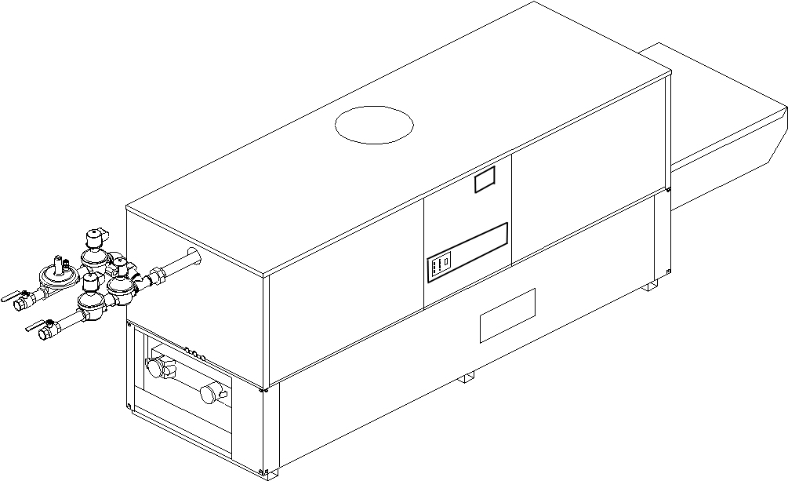Model:       Indoor/Outdoor:       MBTUH Input:

* 100% Factory Fire Tested
* Thermal Efficiency: Up to 85%
* Versa IC® Controller with LCD Display
* Maximum Setpoint: 150°F
* Maximum Outlet Temperature: 200°F
* Minimum Non-Condensing Inlet Temperature: 105°F
* Thermal Shock Proof Heat Exchanger
* Limited Twenty-Year Thermal Shock Warranty
* Limited Ten-Year Cupro-Nickel Heat Exchanger Warranty
* Limited Five-Year Copper Heat Exchanger Warranty
* Full Safety Diagnostics with Fault History
* PolyTuf Powder Coated Cabinet

Patent Nos. 6,904,873 & 7,044,124; other patents pending

* No Combustible Floor Shield Required
* Fan-Assisted
* Patented Burner Security Blanket

Proudly Assembled in the USA



* Ultra-Low NOx – SCAQMD 1146.2 Certified
* Cascade up to 4 Heaters – No External Sequencer Required

#### Heat Exchanger

* Headers

Brass – Standard

A-2 Glass-Lined Cast Iron

* ASME Inspected and HLW Stamped  
  160 PSIG Working Pressure
* National Board Approved
* Fin Tubing

Copper (Std.) 85%

Cupro-Nickel 83.1%

* ASME Steel Tube Sheet
* Silicone High-Temp. O-Rings
* ASME Pressure Relief Valve

125 PSIG – Standard

      PSIG – Optional

* Temperature and Pressure Gauge
* Water Connections

Left – Standard

A-6 Right Hand

#### Controls

* 120V, 60Hz, 1∅ Power Supply
* 120/24V 60Hz Transformer
* Versa IC® Integrated Control
* 100% Shut-Off/Lockout
* Hot Surface Ignition
* Ignition Module

3-Try – Standard

C-6 Single-Try

* Remote Flame Sensor
* Fixed High Limit, Manual Reset 240°F
* On/Off Power Switch
* Flow Switch
* Blocked Vent Pressure Switch
* Combustion Air Proving Switch
* Programmable Pump Time Delays
* Heater
* Recirculation
* Enable/Disable



#### Controls – cont.

* LCD Display; Status, Fault and Diagnostics
* Cold Water Protection Function

Optional CWR Variable-Speed Pump

(See Cat. 5000.73)

* Modbus RTU BMS Port (Up to 115K Baud,

B-85 – BMS Gateway – BACnet MS/TP, BACnet IP, N2 Metasys or Modbus TCP

B-86 – BMS Gateway – LonWorks

#### Gas Train

* Manual Gas Shut-Off Valve(s)
* Gas Pressure Regulator
* Safety Shut-off Valve
* Firing Control Valve
* Firing Mode: 2-Stage (WH3)
* Natural/Propane Gas
* Gas Connection

Left - Standard

Z-1 Right

* Design Certified - ANSI Z21.10.3/CSA 4.3

#### Construction

* Indoor/Outdoor Construction
* Enclosed Front Controls
* Powder Coat Finish
* CSA Low Lead Certified (≤ .25% Lead)

#### Venting

Vent Category I/III Cupro-Nickel

Vent Category II/IV Copper

* Vent Location

Top – Standard

D-14 Rear

* Vent Termination Cap

D-11 Outdoor

D-15 Indoor, Horizontal

Indoor, Vertical (by others)

* Combustion Air

D-17 In-Line Filter Kit (TruSeal only)

D-16 Air Intake Elbow

#### Venting – cont.

* Extractor – Optional

By others

Not required

#### Burner

* Ultra-Low NOx: Less Than 20 PPM

#### Options

C-6 Ignition Module, Manual Rest

D-21 TruSeal® Direct Vent

F-10 Low Water Cut-Off, Remote Probe

I-1 High Limit Control, Auto Reset

P-   Pump Bronze

      HP, 120V, 1∅, 60Hz

Water Hardness       GPG  
 Mounted  Loose

Front  Rear

P-   Cold Water Run (See 1000.19)

S-1 Low Gas Pressure Switch, Manual

S-2 High Gas Pressure Switch, Manual

X-1 SureRack® Kit

X-2 SureRack Add-on



*For Metric information, see Catalog*

**Additional Options or Accessories**



*For Metric information, see Catalog*

#### Multi-Boiler Temperature Controllers

TempTracker Mod+ Hybrid

B-36, 2-4 Heaters

B-37, 5-10 Heaters

B-38, 11-16 Heaters

B-39 EMS 4-20mA Remote Setpoint Interface Module

B-62 BACnet MS/TP Interface



#### Hi Delta Flex Gas – Type WH Models 302CD-902CD Model

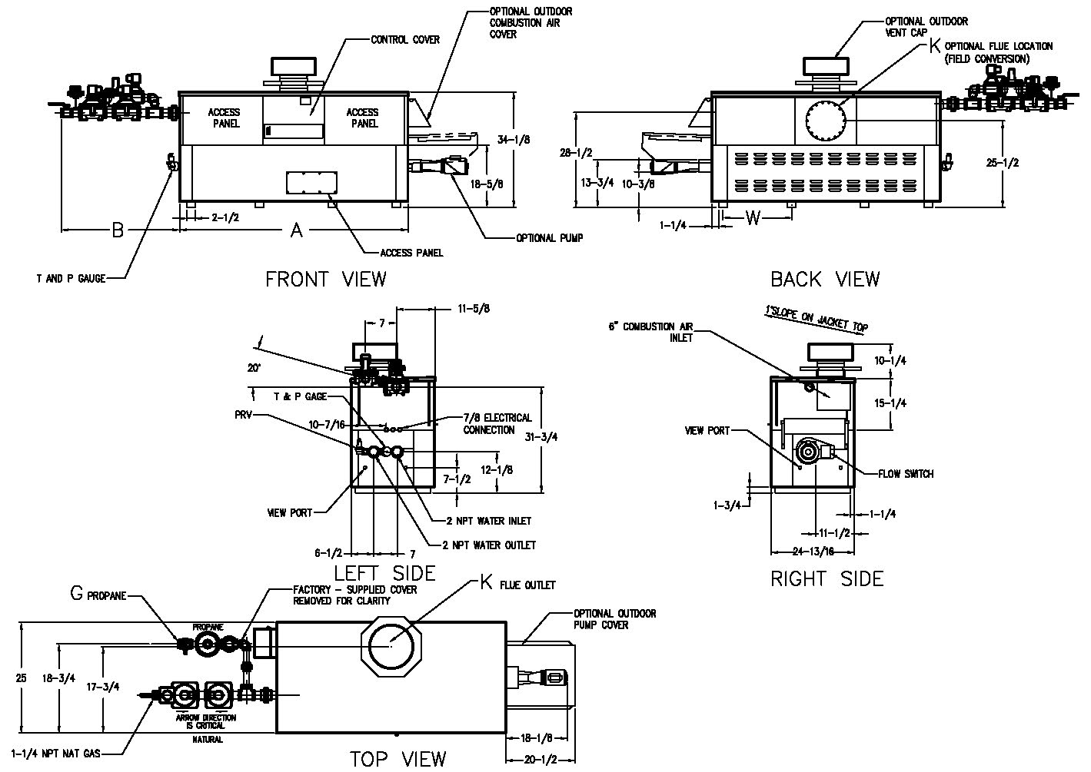

3-3/4

NOTE: Pump location varies based on model and application.

|  |  |  |  |  |  |  |  |  |  |
| --- | --- | --- | --- | --- | --- | --- | --- | --- | --- |
|  | **SPECIFICATIONS** | | | | | | | | **Approx.**  **Shipping**  **Wt. (lbs.)** |
| **Model** | **MBTUH** | | | **A**  **Width** | **G**  **NPT** | **K** | **W** | **Amp.**  **Draw\*** |
| **Input** | **Output**  **85%** | **Output**  **83.1%** |
| 302CD | 300 | 255 | 249 | 36 | 3/4 | 6 | 14-3/4 | 6 | 380 |
| 402CD | 399 | 339 | 332 | 43 | 3/4 | 6 | 18-1/2 | 6 | 445 |
| 502CD | 500 | 425 | 416 | 50 | 1-1/4 | 6 | 22 | 6 | 545 |
| 652CD | 650 | 553 | 540 | 60-1/2 | 1-1/4 | 8 | 27-1/4 | 6 | 590 |
| 752CD | 750 | 638 | 623 | 67-1/2 | 1-1/4 | 8 | 30-3/4 | 6 | 675 |
| 902CD | 900 | 765 | 748 | 78 | 1-1/4 | 8 | 36 | 7 | 740 |

* Without pump

NOTES: 1. Dimensions are in inches.

2. Rates shown are for natural or propane gas, and elevations up to 4,500 feet. For installation above 4,500 feet, please contact manufacturer.

3. Required natural gas pressure is 7 – 10.5” WC. Required propane gas pressure is 11 - 13” WC.

#### Hi Delta Flex Gas – Type WH Models 302CD-902CD Model

SHL includes 50 ft of tubing each way (100 total)

** Must use optional cupro-nickel tubes. For hardness exceeding 25 GPG, must use water softener

Basis for minimum flow is 40 GPM or 30°F ∆T, 90 GPM for maximum flow

|  |  |  |  |  |  |  |  |  |  |  |  |  |  |  |  |
| --- | --- | --- | --- | --- | --- | --- | --- | --- | --- | --- | --- | --- | --- | --- | --- |
| **Model** | **83.1% System Flow and Head Loss** | | | | | | | | | | | | | | |
| **3-4 Grains Per Gallon** | | | | | **5-15 Grains Per Gallon** | | | | | **16-25** Grains Per Gallon** | | | | |
| ΔT  (°F) | GPM | ΔP  (FT WC) | MTS  (IN) | SHL  (FT WC) | ΔT  (°F) | GPM | ΔP  (FT WC) | MTS  (IN) | SHL  (FT WC) | ΔT  (°F) | GPM | ΔP  (FT WC) | MTS  (IN) | SHL  (FT WC) |
| 302CD | 13 | 40 | 2.0 | 2 | 5.1 | 10 | 50 | 3.0 | 2 | 7.7 | 6 | 90 | 9.8 | 2 | 23.7 |
| 402CD | 17 | 40 | 2.0 | 2 | 5.1 | 13 | 52 | 3.4 | 2 | 8.4 | 7 | 90 | 10.0 | 2 | 23.8 |
| 502CD | 21 | 40 | 2.1 | 2 | 5.2 | 16 | 52 | 3.5 | 2 | 8.6 | 9 | 90 | 10.4 | 2 | 24.2 |
| 652CD | 27 | 40 | 2.2 | 2 | 5.3 | 21 | 52 | 3.7 | 2 | 8.7 | 12 | 90 | 10.8 | 2 | 24.7 |
| 752CD | 28 | 45 | 3.0 | 2 | 6.8 | 23 | 55 | 4.4 | 2 | 9.9 | 14 | 90 | 11.3 | 2 | 25.1 |
| 902CD | 28 | 54 | 4.3 | 2 | 9.7 | 21 | 73 | 7.8 | 2 | 17.2 | 17 | 90 | 11.7 | 2 | 25.5 |

SHL includes 50 ft of tubing each way (100 total)

** Must use optional cupro-nickel tubes. For hardness exceeding 25 GPG, must use water softener

Basis for minimum flow is 40 GPM or 30°F ∆T, 90 GPM for maximum flow

|  |  |  |  |  |  |  |  |  |  |  |  |  |  |  |  |
| --- | --- | --- | --- | --- | --- | --- | --- | --- | --- | --- | --- | --- | --- | --- | --- |
| **Model** | **85% System Flow and Head Loss** | | | | | | | | | | | | | | |
| **3-4 Grains Per Gallon** | | | | | **5-15 Grains Per Gallon** | | | | | **16-25** Grains Per Gallon** | | | | |
| ΔT  (°F) | GPM | ΔP  (FT WC) | MTS  (IN) | SHL  (FT WC) | ΔT  (°F) | GPM | ΔP  (FT WC) | MTS  (IN) | SHL  (FT WC) | ΔT  (°F) | GPM | ΔP  (FT WC) | MTS  (IN) | SHL  (FT WC) |
| 302CD | 13 | 40 | 2.0 | 2 | 5.1 | 10 | 50 | 3.0 | 2 | 7.7 | 6 | 90 | 9.8 | 2 | 23.7 |
| 402CD | 17 | 40 | 2.0 | 2 | 5.1 | 13 | 52 | 3.4 | 2 | 8.4 | 8 | 90 | 10.0 | 2 | 23.8 |
| 502CD | 21 | 40 | 2.1 | 2 | 5.2 | 17 | 52 | 3.5 | 2 | 8.6 | 10 | 90 | 10.4 | 2 | 24.2 |
| 652CD | 28 | 40 | 2.2 | 2 | 5.3 | 21 | 52 | 3.7 | 2 | 8.7 | 12 | 90 | 10.8 | 2 | 24.7 |
| 752Cd | 29 | 45 | 3.0 | 2 | 6.8 | 23 | 55 | 4.4 | 2 | 9.9 | 14 | 90 | 11.3 | 2 | 25.1 |
| 902CD | 29 | 54 | 4.3 | 2 | 9.7 | 21 | 73 | 7.8 | 2 | 17.2 | 17 | 90 | 11.7 | 2 | 25.5 |

|  |  |  |  |  |  |  |  |  |  |
| --- | --- | --- | --- | --- | --- | --- | --- | --- | --- |
| **Model** | **83.1 % Recovery Rates** | | | | | | | | |
| **20°** | **30°** | **40°** | **50°** | **60°** | **70°** | **80°** | **90°** | **100°** |
| 302CD | 1511 | 1007 | 755 | 604 | 504 | 432 | 378 | 336 | 302 |
| 402CD | 2010 | 1340 | 1005 | 804 | 670 | 574 | 502 | 447 | 402 |
| 502CD | 2518 | 1679 | 1259 | 1007 | 839 | 709 | 630 | 560 | 504 |
| 652CD | 3274 | 2182 | 1637 | 1309 | 1091 | 935 | 818 | 727 | 655 |
| 752CD | 3777 | 2518 | 1889 | 1511 | 1259 | 1079 | 944 | 839 | 755 |
| 902CD | 4533 | 3022 | 2266 | 1813 | 1511 | 1295 | 1133 | 1007 | 907 |

|  |  |  |  |  |  |  |  |  |  |
| --- | --- | --- | --- | --- | --- | --- | --- | --- | --- |
| **Model** | **85 % Recovery Rates** | | | | | | | | |
| **20°** | **30°** | **40°** | **50°** | **60°** | **70°** | **80°** | **90°** | **100°** |
| 302CD | 1545 | 1030 | 773 | 618 | 515 | 442 | 386 | 343 | 309 |
| 402CD | 2055 | 1370 | 1028 | 822 | 685 | 587 | 514 | 457 | 411 |
| 502CD | 2576 | 1717 | 1288 | 1030 | 859 | 736 | 644 | 572 | 515 |
| 652CD | 3348 | 2232 | 1674 | 1339 | 1116 | 957 | 837 | 744 | 670 |
| 752CD | 3864 | 2576 | 1932 | 1545 | 1288 | 1104 | 966 | 859 | 773 |
| 902CD | 4636 | 3091 | 2318 | 1855 | 1545 | 1325 | 1159 | 1030 | 927 |

Raypak, Inc. ▪ 2151 Eastman Avenue, Oxnard, CA 93030 ▪ (805) 278-5300 ▪ Fax (800) 872-9725 ▪ www.raypak.com