Job:

# Raypak Header

# Mounted Pumps

## Boilers, Water Heaters & Pool Heaters Raytherm™ & Hi Delta™

Engineer:

Contractor:

Prepared By:       Date:

Model:       Indoor/Outdoor:

One Piece Low Lead Cast Bronze Impeller

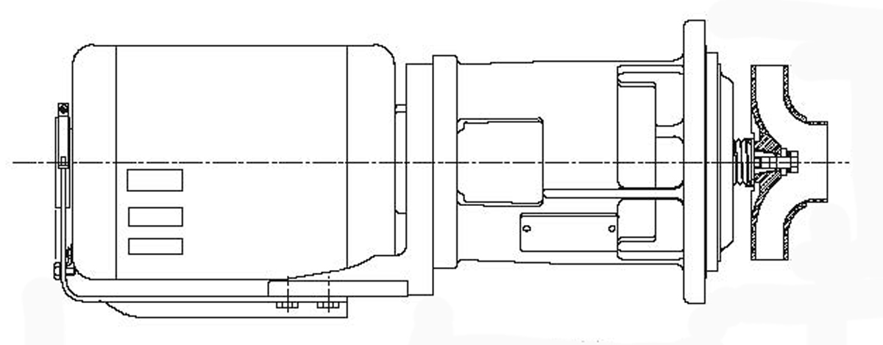

Cast Iron Pump Body

100% Factory Tested

5/8” Steel Alloy Shaft

Ceramic Mechanical Seal

Permanently Lubricated Ball Bearings



Resilient Mount Motor

Proudly Assembled in the USA

175 PSI Max Pressure Rating

250#F Maximum Temperature Rating

|  |  |  |  |  |  |  |  |  |  |  |  |
| --- | --- | --- | --- | --- | --- | --- | --- | --- | --- | --- | --- |
| Part Number | HP | Speed RPM | Volts | Hz | Ph | Service Factor | Ambient Temp. | A | B | C | Amps |
| 004844F | 1/2 | 1725 | 115 | 60 | 1 | 1.00 | 60#C/140#F | 8.92 | 4.25 | 18.45 | 7.9 |
| 004845F | 1/2 | 1725 | 115 | 60 | 1 | 1.25 | 60#C/140#F | 9.67 | 4.70 | 19.20 | 7.3 |
| 009296F | 1/2 | 1725 | 115 | 60 | 1 | 1.00 | 60#C/140#F | 8.92 | 4.00 | 18.45 | 7.9 |

Raypak-Rheem logo, submittals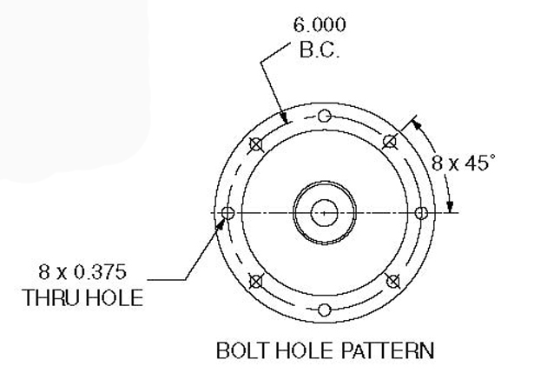Raypak Header

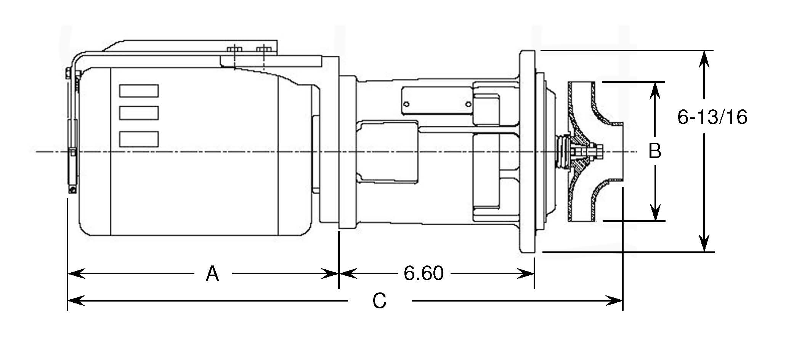

Mounted Pumps Part Number

|  |  |  |
| --- | --- | --- |
| Raytherm Configuration | | |
| Model | 004844F | 004845F |
| 514 |  |  |
| 624 |  |  |
| 724 |  |  |
| 824 |  |  |
| 926/962 |  |  |
| 1083/1125 |  |  |
| 1287/1336 |  |  |
| 1414/1468 |  |  |
| 1571/1631 |  |  |
| 1758/1826 |  |  |

|  |  |  |  |
| --- | --- | --- | --- |
| Hi Delta Configuration | | | |
| Model | 004844F | 004845F | 009296F |
| 302 | N/A |  | N/A |
| 402 | N/A |  | N/A |
| 502 | N/A |  |  |
| 652 | N/A |  |  |
| 752 |  | N/A | N/A |
| 902 | N/A |  |  |
| 992 |  | N/A |  |
| 1262 | N/A | N/A |  |
| 1532 | N/A |  | N/A |

Raypak, Inc. ▪ 2151 Eastman Ave., Oxnard, CA 93030 ▪ (805) 278-5300 ▪ Fax (800) 872-9725 ▪ www.raypak.com

Pump selection is based on a maximum 75 equivalent feet of tubing equal to the connection size of the appliance. Refer to the product I&O manual for allowable water hardness when used on Domestic Hot Water systems.