Job:

Cold Water Start

For Hi Delta®
Models 992C-2342C

Engineer:

Contractor:
Prepared By: Date:
Model: Indoor/Outdoor: MBTUH Input:

- Approved for hydronic systems ONLY
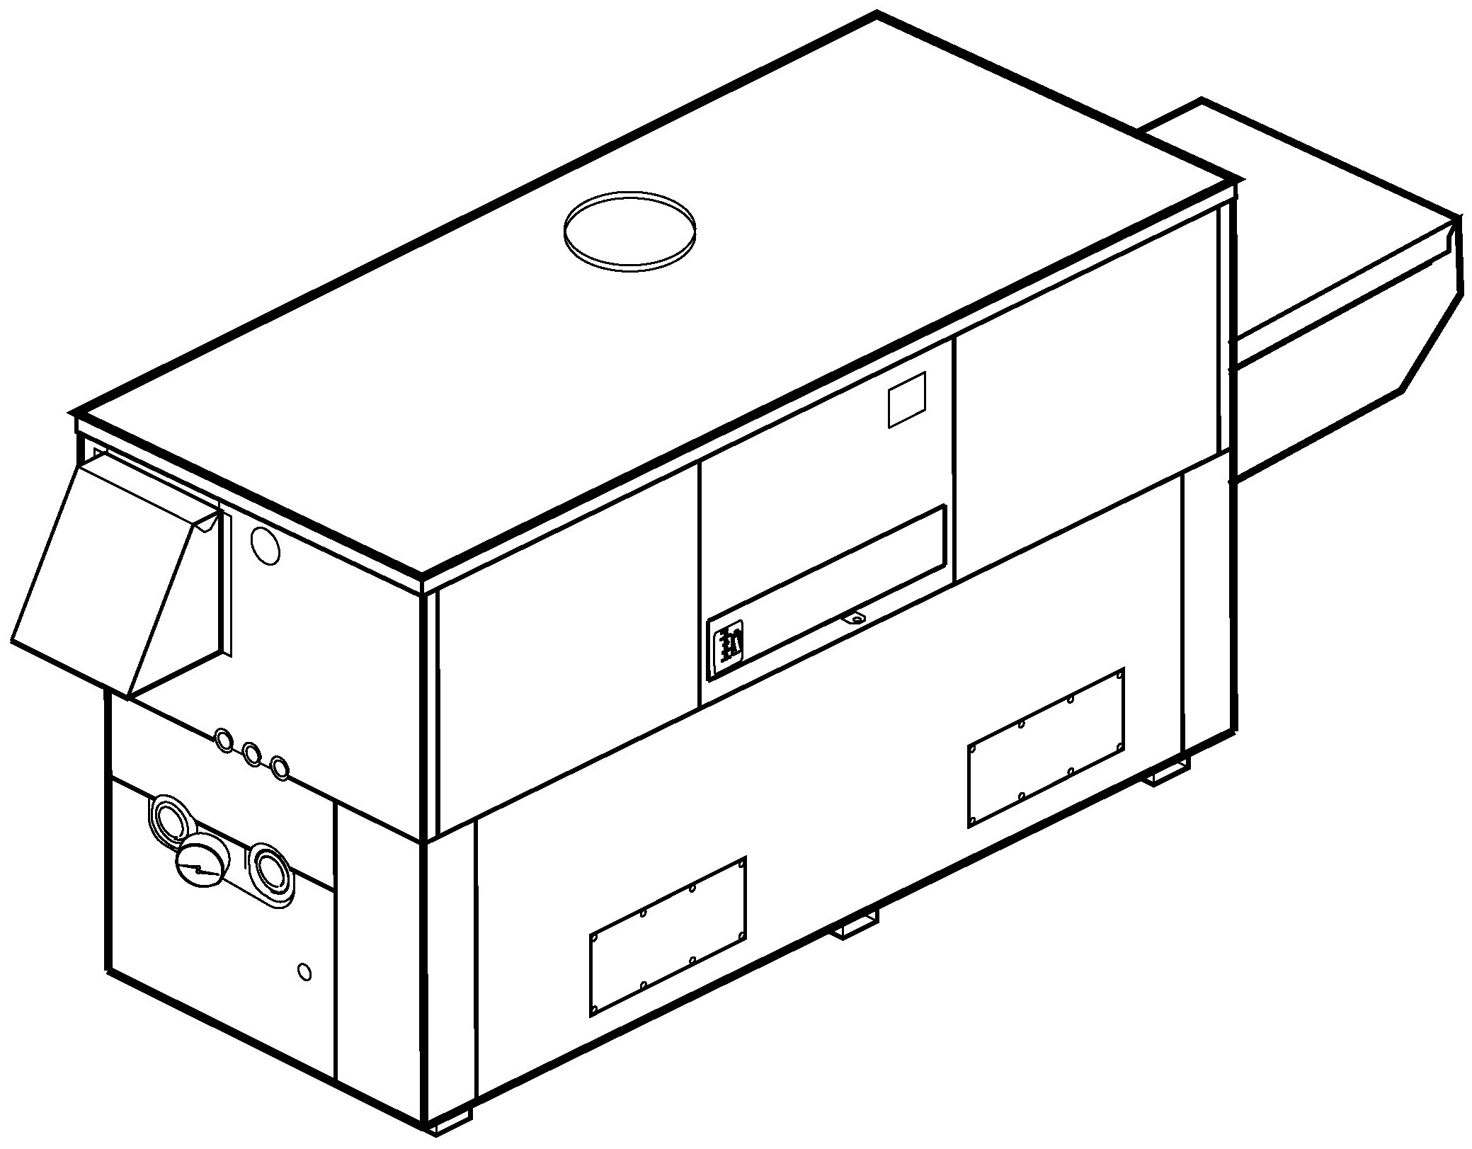
- 100% Factory Fire Tested System
- PID Control Logic
- Fail-Safe Operation
- Spring-Return Actuator
- Adjustable Inlet Temperature (105° - 120°F)
- Microprocessor Start-up Sequence
Hi Delta Boiler
- In-line Pump Available for Models 1262C–2342C;
Integral Pump Available for Model 992C Only
*Pump selection based on 75 equivalent feet of piping equal to connection size.
Proudly Made in the USA

Inline Pump
Models 1262C – 2342C

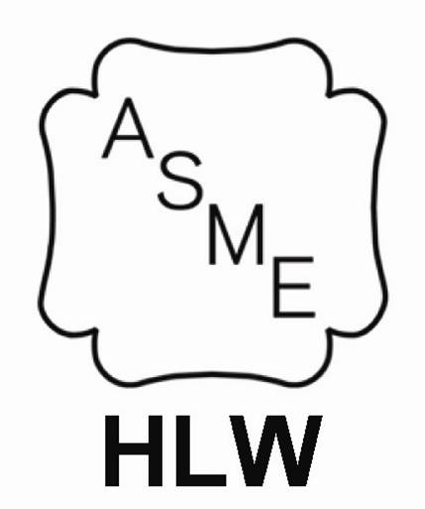
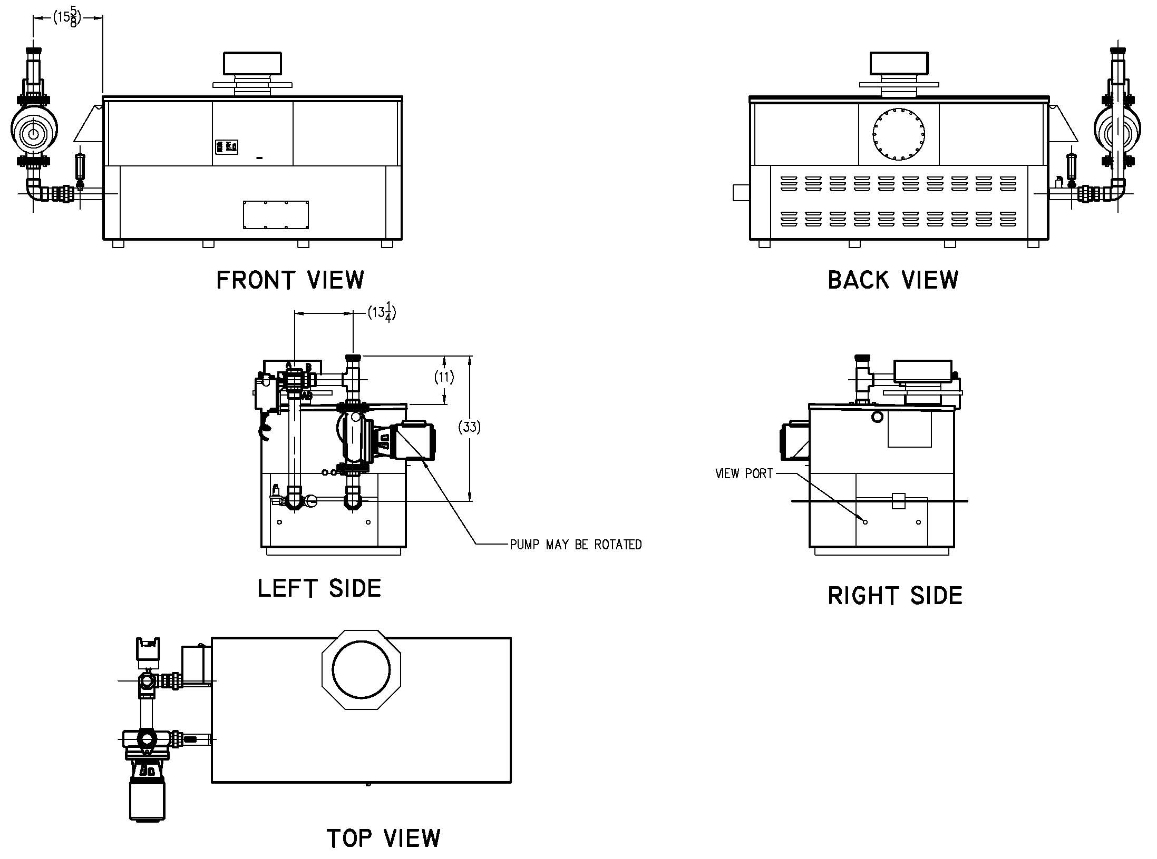

Cold Water Start

For Hi Delta 992C-2342C Model

Integral Pump
Models 992C Only

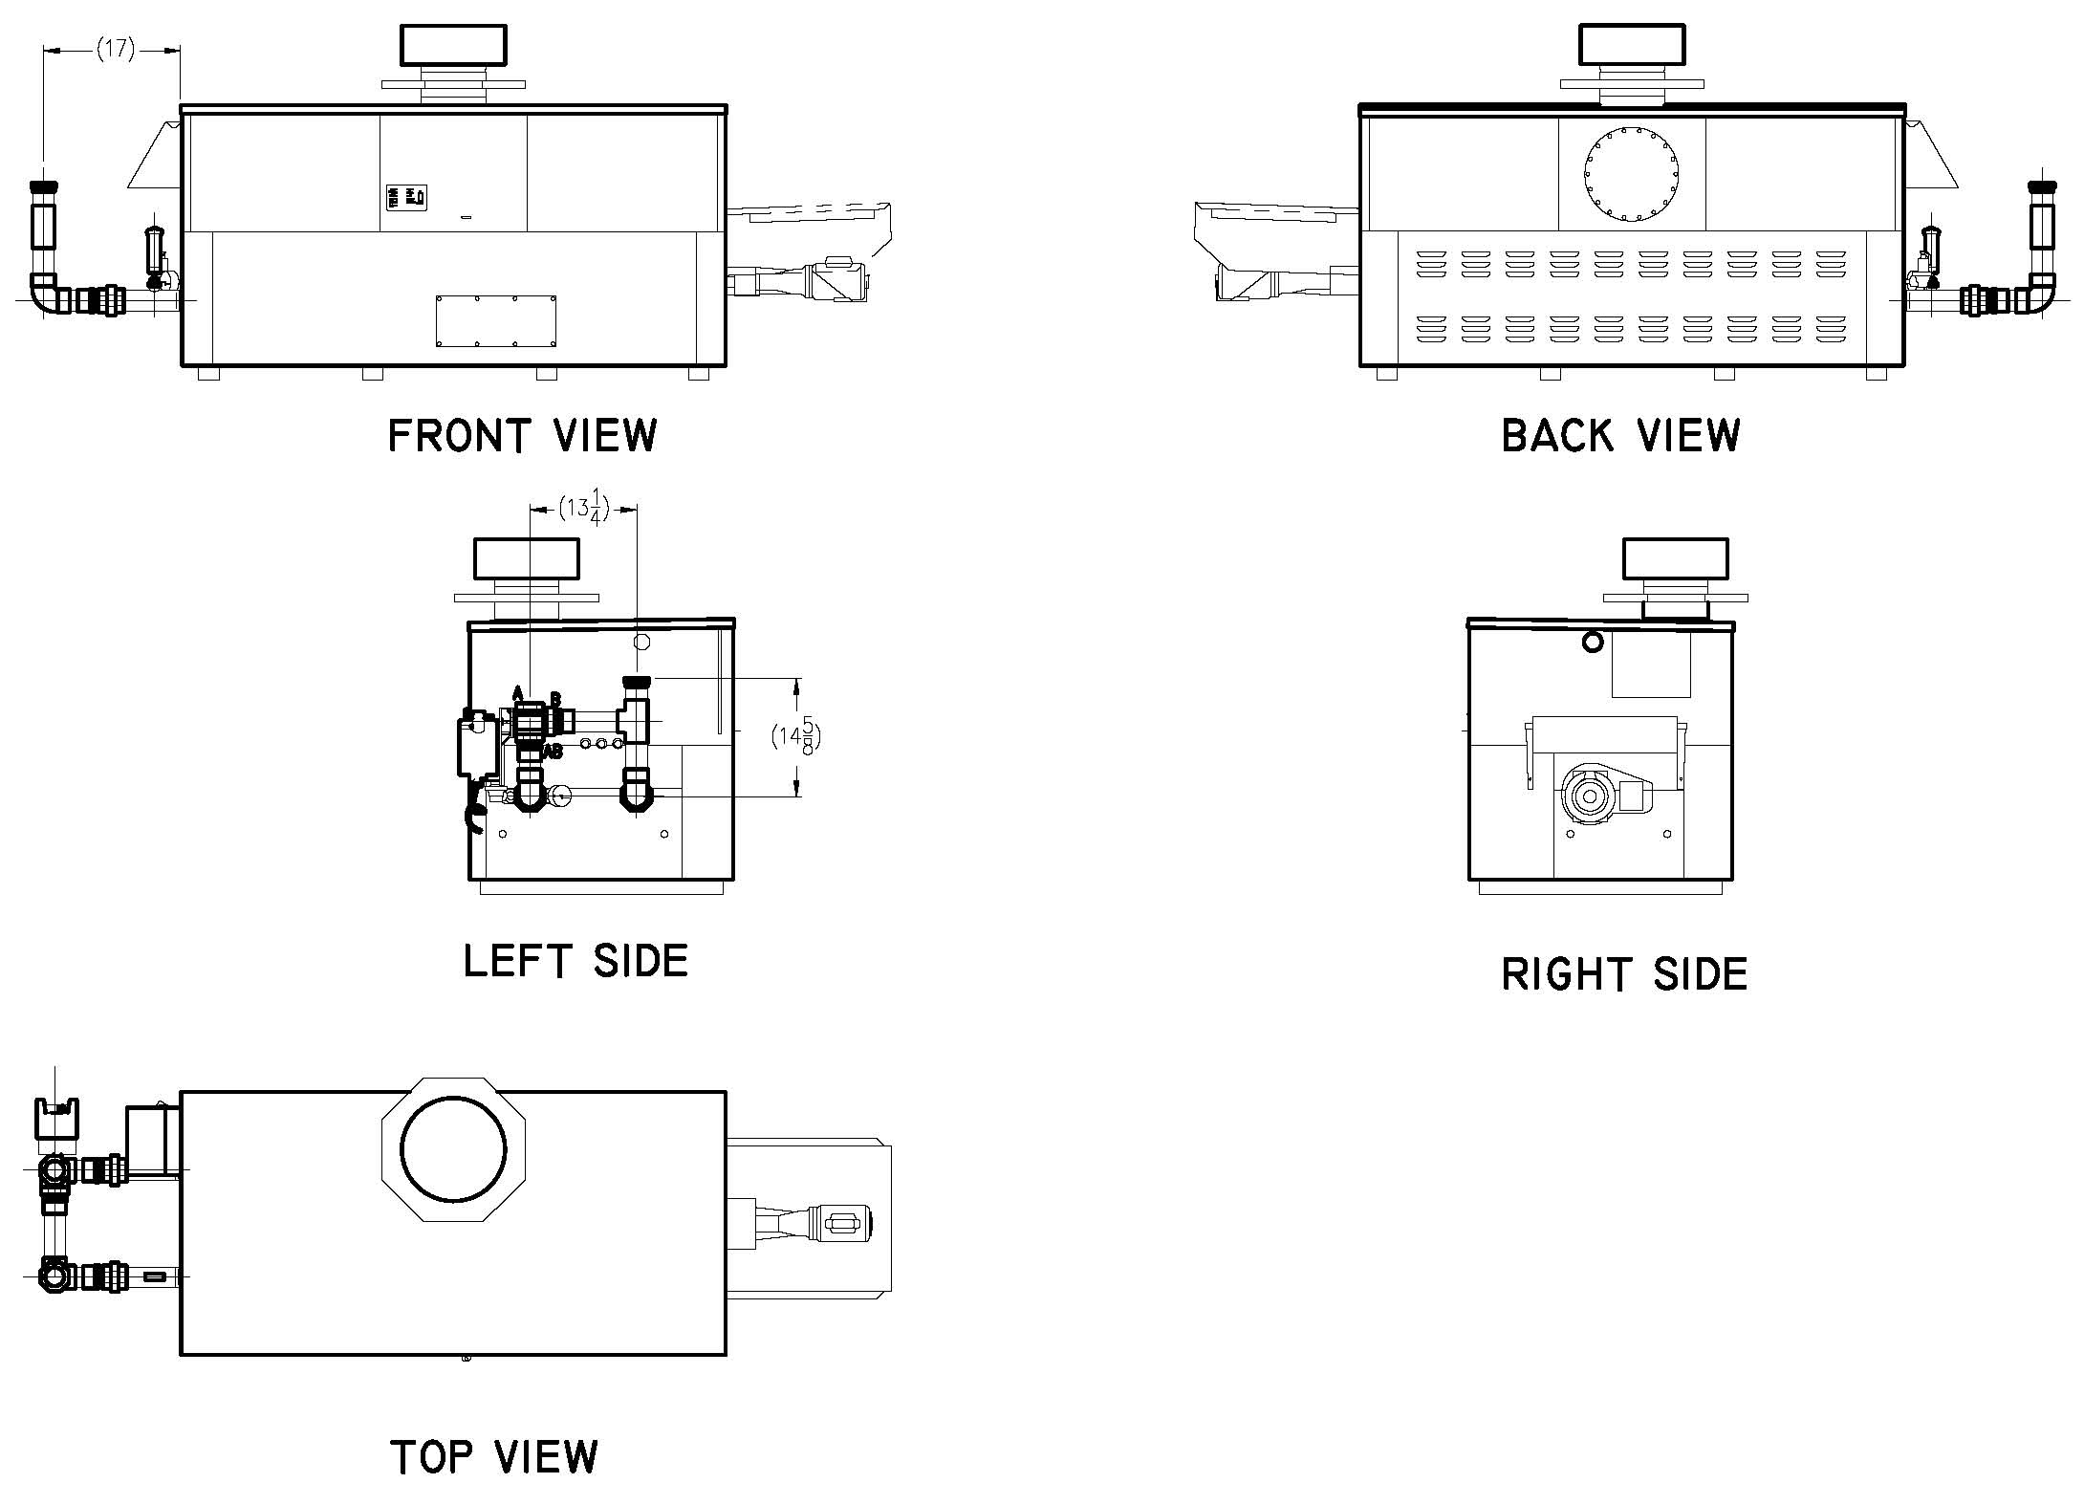
See also these submittals:
Hi Delta Models H 992C-2342C – Catalog No. 2000.312
Delta Ltd Models H 989B-2339B Catalog No. 2000.471
Raypak, Inc. 2151 Eastman Avenue, Oxnard, CA 93030 (805) 278-5300 Fax (800) 872-9725 www.raypak.com

