Job:

XPAK-FT®

Condensing Boiler

Hydronic Heating Boilers

Residential - Commercial

Models 88AR, 108AR, 198AR, 278AR & 398A

Engineer:

Contractor:
Prepared By: Date:
Model:
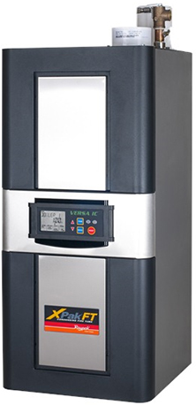

VERSA IC® Integrated Control Platform
Soft Start, Electronic Modulation, up to 10:1 Turndown
LCD Status Display with Full Diagnostics and Fault Memory
Zero Clearance to Combustibles
3-in-1 Vent adapter (PVC/CPVC - Duravent® Polypro - SS)
Meets 2012 NOx Requirements (< 14 ng/J (< 55 PPM NO_{x}))
Maximum Outlet Water Temperature: 195ºF
Maximum System Temperature: 190ºF
Limited 25-Year Thermal Shock Warranty
Limited 10-Year Heat Exchanger Warranty
Proudly Assembled in the USA
Modbus RTU RS485 Port

Heat Exchanger
- All Stainless Steel Construction
- Gasketless Heat Exchanger Design
- ASME H Stamped
80 PSIG Working Pressure
- National Board Approved
- ASME Pressure Relief Valve
30 PSIG – Standard
- Temperature and Pressure Gauge,
Shipped Loose

Control
- 120V, 60Hz, 1Ø, Power Supply
- Versa IC Operating Control with LCD display.
- Outdoor reset with Indirect Priority
- 0-10 VDC input for BMS
- Cascade up to 4 boilers
- Spark Ignition (DSI)
- Remote Flame Sensor
- High Limit, Manual Reset, Fixed, 200ºF
- Alarm Dry Contact Connection
- On/Off Power Switch
- Blocked Vent Pressure Switch
- Boiler, DHW & System Pump Contacts
- Water Temperature Sensors (4)10kΩ (2 shipped loose)
- Outdoor Air Sensor (1) 10kΩ (shipped loose)

Burner
- Ultra-Low NOx: Less than 14 ng/J

Gas Train
- Fuel
Natural Gas
Propane
- Dual-Seat Combination Valve
- Electronic Modulating Firing Mode (H7)

Construction
- Indoor Construction
- Front Controls Enclosed
- PolyTuf Powder Coat Finish
- Bottom Connections (Electrical, Gas, Water)
- Top Connections (Combustion Air, Vent)
- Design Certified ANSI Z21.13/
CSA 4.9
- Condensate Trap

Venting (PVC/CPVC*-Duravent Polypropylene – Centrotherm Polypropylene – Stainless Steel)
- Vent Termination
D-11 - SS Termination
D-94 - Horizontal twin pipe Poly
D-95 - Horizontal Concentric Poly
D-96 - Vertical Concentric Poly
D-92 - Polypro reducer (88AR & 398A only)

Options – Shipped Loose
F-1 Flow Switch – (Loose)

F-10 Low Water Cut-Off, Manual Reset (88AR to 278AR)
P- Pump: HP, 120V,1∅, 60Hz
Cast Iron
Bronze/SS
S-1/S-2 High/Low Gas Pressure Switch, Manual Reset
Z-12 Condensate Neutralizer Kit

Additional Options or Accessories

*Configured for PVC Vent Standard. Maximum System Temperature of 170ºF for PVC Vent.

Raypak® XPak-FT® Residential

Residential - Commercial

Condensing Boiler Model

Models 88AR, 108AR, 198AR, 278AR & 398A

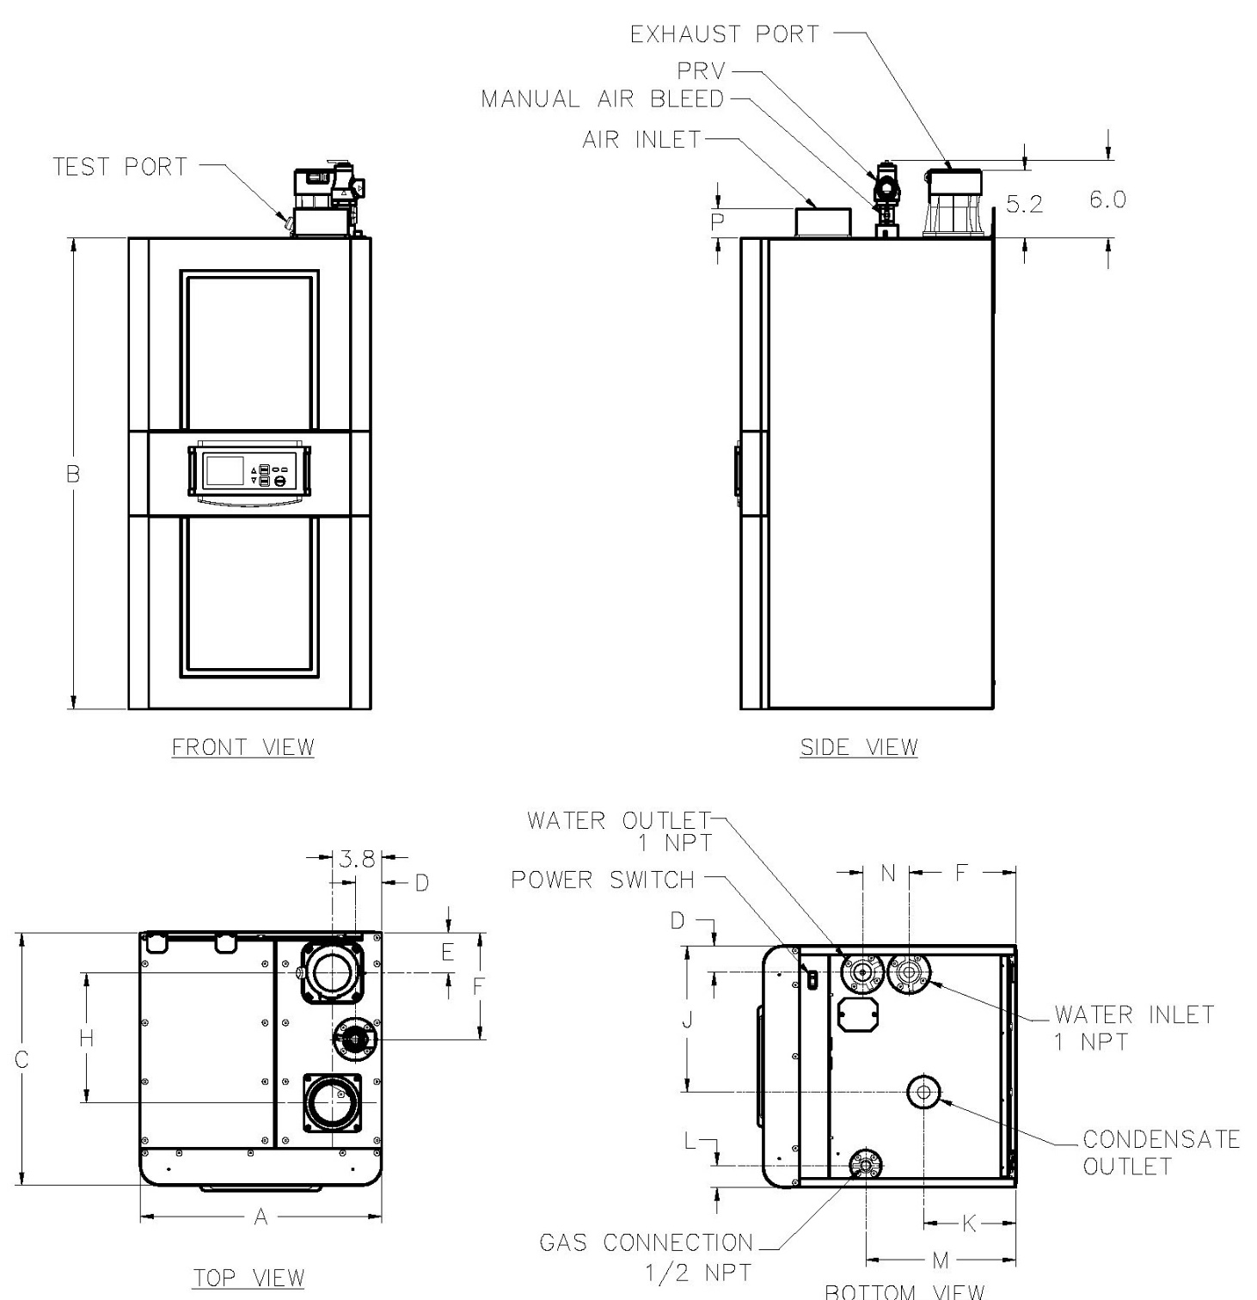

Model No. | A | B | C | D | E | F | H | J | K | L | M | N | P
88AR | 16-7/16 | 35-7/8 | 16-1/2 | 2-1/8 | 2-3/4 | 6-3/8 | 7-7/8 | 9-1/2 | 5-1/2 | 1-1/2 | 4-5/8 | 2-7/8 | 2-3/8
108AR
198AR | 18-5/8 | 36-1/4 | 19-7/16 | 2 | 3-1/8 | 8-1/4 | 10 | 11-3/8 | 7-1/8 | 1-3/4 | 12-3/8 | 3-5/8 | 2-3/8
278AR
398A | 21-7/16 | 38-5/8 | 22-1/8 | 2-3/4 | 4 | 10-1/8 | 12 | 13 | 8-15/16 | 2-5/8 | 15-3/8 | 4 | 2-1/8

Model  No. | AFUE Rating |  |  | Minimum  Operating  Input  (MBH) | Water  Conn.  (NPT) | Gas Conn. (NPT) |  | Vent Size (In.)
 | Input (MBH) |  | % |  |  | Nat. | Pro. | Flue | Intake
 | Min | Max
H7-88AR | 17.0 | 85.0 | 95 | 12.0 | 1” | 1/2” | 1/2” | 2” / 3” ** | 2” / 3” **
H7-108AR | 22.0 | 110.0 | 95 | 13.0 | 1” | 1/2" | 1/2" | 3” | 3”
H7-198AR | 39.8 | 199.0 | 95 | 28.4 | 1-1/4” | 3/4" | 3/4" | 3” | 3”
H7-278AR | 55.0 | 275.0 | 94.8 | 36.6 | 1-1/4” | 3/4” | 3/4” | 3” | 3”
H7-398A | 39.9 | 399.0 | 96* | 39.9 | 1-1/2” | 3/4” | 3/4” | 3” / 4” *** | 3” / 4” ***

*Model 398A value is Thermal Efficiency.
**Model 88AR vent is 3” standard and can be reduced to 2” with shorter run.
***Model 398A vent is 4” standard and can be reduced to 3” with shorter run.

Model No. | Maximum Flow |  |  | Minimum Flow |  |  | 30ºF ΔT |  | 40ºF ΔT |  | 50ºF ΔT
 | GPM | ΔP (ft) | ΔT | GPM | ΔP (ft) | ΔT | GPM | ΔP (ft) | GPM | ΔP (ft) | GPM | ΔP (ft)
H7-88AR | 8.1 | 5.4 | 20 | 2.7 | 1.4 | 60 | 5.4 | 3.3 | 4.0 | 2.3 | 3.2 | 1.8
H7-108AR | 10.5 | 7.4 | 20 | 3.5 | 2.0 | 60 | 7.0 | 4.5 | 5.2 | 3.2 | 4.2 | 2.4
H7-198AR | 18.9 | 11.6 | 20 | 6.3 | 3.0 | 60 | 12.6 | 6.2 | 9.5 | 4.3 | 7.6 | 3.5
H7-278AR | 26.1 | 20.3 | 20 | 8.7 | 4.0 | 60 | 17.4 | 10.1 | 13.1 | 6.5 | 10.5 | 4.9
H7-398A | 38.3 | 14.1 | 20 | 12.8 | 3.4 | 60 | 25.5 | 7.4 | 19.2 | 5.0 | 15.3 | 4.0

Model No. | Standard Boiler Pump *
 | Pump | HP
H7-88AR | Taco 007 | 1/25
H7-108AR | Taco 007 | 1/25
H7-198AR | Taco 0010 | 1/8
H7-278AR | Taco 0012 | 1/8
H7-398A | Taco 0012 | 1/8
*Pump selection based on 30ºF ΔT with up to 50 eq. ft. of tubing

Raypak, Inc. 2151 Eastman Avenue, Oxnard, CA 93030 (805) 278-5300 Fax (800) 872-9725 www.raypak.com

