Job:

XTherm® - Type WH

Water Heaters
Models 1005A-2005A

Engineer:

Contractor:
Prepared By: Date:
Model: Indoor/Outdoor:
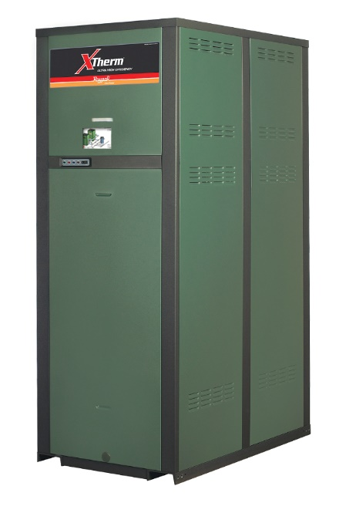
97% Thermal Efficiency at Full Rate
100% Factory Fire Tested
VERSA IC® Modulating Controller with 7” color touchscreen display
Raymote™ remote connectivity provided standard
Soft-Start Ignition; 60% Min Fire
Full Safety Diagnostics with History
Status Display Lights
Cascade up to 4 Heaters – No External Sequencer Required
Modbus RTU BMS Port
Maximum Outlet Water Temperature: 180°F
Maximum Tank Setpoint: 150°F
Limited Twenty-Five-Year Thermal Shock Warranty

Limited Five-Year Copper/Ten-Year Cupro-Nickel Primary Heat Exch. Warranty
Proudly Assembled in the USA


Limited Ten-Year Secondary Heat Exchanger Warranty

Heat Exchanger
- Bronze Headers
- ASME HLW Stamped; 160 PSIG MAWP
- National Board Listed
- Fin Tubing
Copper – Standard
A-3 Cupro-Nickel
- ASME Powder-Coated Tube Sheet
- Silicone High-Temp O-Rings
- ASME Pressure Relief Valve
125 PSIG – Standard
PSIG – Optional
- Manual Air Bleed Valve
- T&P Gauge
- Stainless Steel Condensing Heat Exchanger – U stamped
- Stainless Steel Evaporator Plate
- Boiler Pump: Bronze, 120V, 1∅, 60Hz
Water Hardness: GPG

Control
- 120V, 60Hz, 1Ø, Power Supply
- 120/24V 60Hz Transformer
- VERSA IC®
- 7” color HD touchscreen display
- Raymote™ Wi-Fi remote connectivity
- Ignition Module
3-Try – Standard
C-6 Single-Try
- Remote Flame Sensor
- Fixed High Limit, Manual Reset, 200ºF
- On/Off Power Switch
- Flow Switch
- Blocked Vent Pressure Switch
- Freeze Protection
- Alarm Dry Contact
- Pump Outputs – Pilot Duty
- System
- Programmable Pump Time Delays
- Water Temperature Sensors (3)
- Cold Water Protection
- Blocked Condensate Switch
- Modbus RTU BMS Port (Up to 115K Baud Rate, See Cat. 5000.73)
- B-85 BMS Gateway, Modbus RTU to Modbus TCP, N2 Metasys, BACnet IP, or BACnet MS/TP.
- B-86 BMS Gateway, Modbus RTU to LonWorks.

Burner
- Hot Surface Ignition (HSI)
- Radially-Fired Knitted Burner

Gas Train
- Fuel
Natural Gas
Propane (Grade HD-5)
- Dual-Seat Combination Valve
- Electronic Modulating Firing Mode (WH7)

Construction
- Indoor/Outdoor Construction
- Enclosed Front Controls
- PolyTuf Powder Coat Finish
- Rear Connections (Water, Gas, Vent, Electrical, Comb. Air, Cond. Drain)
- Combustion Air Filter
- Design Certified ANSI Z21.10.3/CSA 4.3
- CSA Low Lead Certified ≤ .25% Lead
- Front Connection Low Voltage Wiring

Venting
- Vent Termination, Cat IV

D-11 Outdoor or Indoor, Vertical
D-15 Indoor, Horizontal

- Extractor – Optional, Cat II
By others
Not required

Options
D-32 PVC Vent Adapter, maximum return water temperature allowed 170ºF (Factory Mounted Only)
D-33 Centrotherm® Polypropylene Vent Adapter, maximum return water temperature allowed 190ºF (Includes Manual Vent Limit, Shipped Loose)
F-10 Low Water Cut-Off, Remote Probe
I-6 High Limit, Manual Reset, Adj., 100-200°F
I-14 High Limit, Auto Reset, Adj., 40-180°F
S-1 Low Gas Pressure Switch,
Manual Reset
S-2 High Gas Pressure Switch, Manual Reset
Z-12 Condensate Treatment Kit

Additional Options or Accessories


XTherm – Type WH

Models 1005A-2005A Model
NOTE: Use in conjunction with storage tank for proper operation.
CLEARANCES (in.)
 | Front | Rear | Right | Left | Top | Floor | Vent
Certified Minimum | 24 | 12 | 1 | 1 | 0 | 0 | 1
Minimum Service | 24 | 36 | 24 | 1 | 10 | N/A | N/A

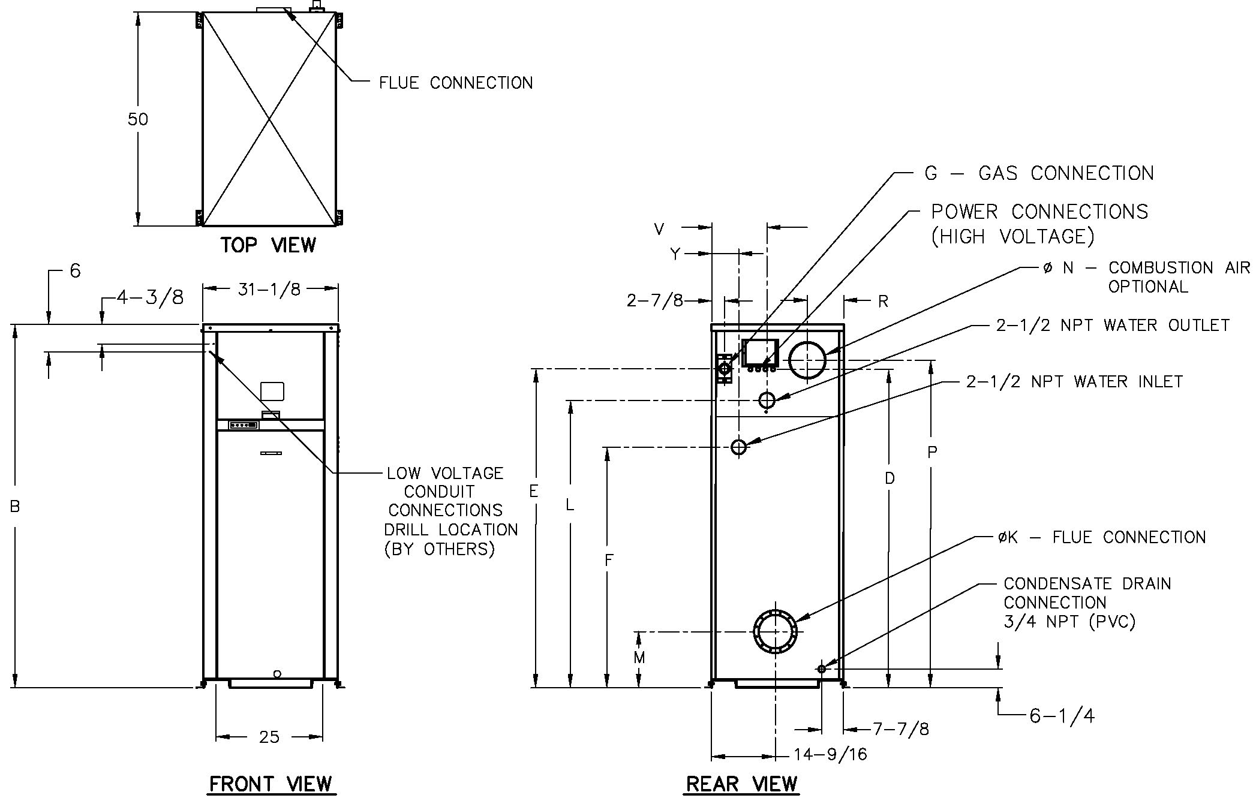
POWER REQUIREMENTS – AMPS†
Model  (WH7-) | Heater Amp Draw † | Pump Amp Draw †
Model  (WH7-) | Heater Amp Draw † | Soft  1-4 Gr. | Medium  5-15 Gr. | Hard  16-25 Gr.
1005A | 12 ** | 10 | 10 | 14
1505A | 12 ** | 10 | 14 | 17
2005A | 18 ** | 17 | 17 | N/A

† Separate power connections are factory supplied and separate supply breakers must be field supplied.
** Current draw is for heater only (Supply breaker must have delayed trip).
Model  (WH7-) | MBTUH |  | Dimensions (in) |  |  |  |  |  |  |  |  |  |  |  |  | Ship  Weight  (Lbs.)
Model  (WH7-) |  |  | B  Height | D | E | F | G*  NPT | K  Flue  Ø | L | M | N  C/A  Ø | P | R | V | Y | Ship  Weight  (Lbs.)
Model  (WH7-) | In | Out
1005A | 999 | 969 | 55-1/4 | 45 | 47 | 37 | 1-1/4 | 6 | 41 | 11-1/2 | 6 | 47-1/8 | 8-5/16 | 13 | 6-1/4 | 1065
1505A | 1500 | 1455 | 67-1/8 | 57 | 59 | 38-5/8 | 1-1/4 | 8 | 53 | 12-5/8 | 8 | 59-1/8 | 8-3/16 | 13 | 6-1/4 | 1234
2005A | 1999 | 1939 | 81-1/8 | 71 | 72 | 39-5/8 | 2 | 8 | 65-1/2 | 12-5/8 | 8 | 73-1/8 | 8-3/16 | 10 | 6-1/2 | 1461

Note: Ratings shown are for elevations up to 4,500 feet. For installations at elevations  above 4,500 feet, please consult the factory for additional instructions. | * For Propane Gas, all models are 1” NPT

Model  (WH7-) | RECOVERY RATES
Model  (WH7-) | Temperature Rise (°F)
Model  (WH7-) | 20 | 30 | 40 | 50 | 60 | 70 | 80 | 90 | 100 | 110
1005A | 5873 | 3915 | 2936 | 2349 | 1958 | 1678 | 1468 | 1305 | 1175 | 1068
1505A | 8818 | 5879 | 4409 | 3527 | 2939 | 2519 | 2205 | 1960 | 1764 | 1603
2005A | 11752 | 7834 | 5876 | 4701 | 3917 | 3358 | 2938 | 2611 | 2350 | 2137

