Job:

Hi Delta® - Type H

Space Heating/Hot Water Boiler Models 122-322

Engineer:
Contractor:
Prepared By: Date:
Model: Indoor/Outdoor: MBTUH Input:

TruSeal® Direct Vent
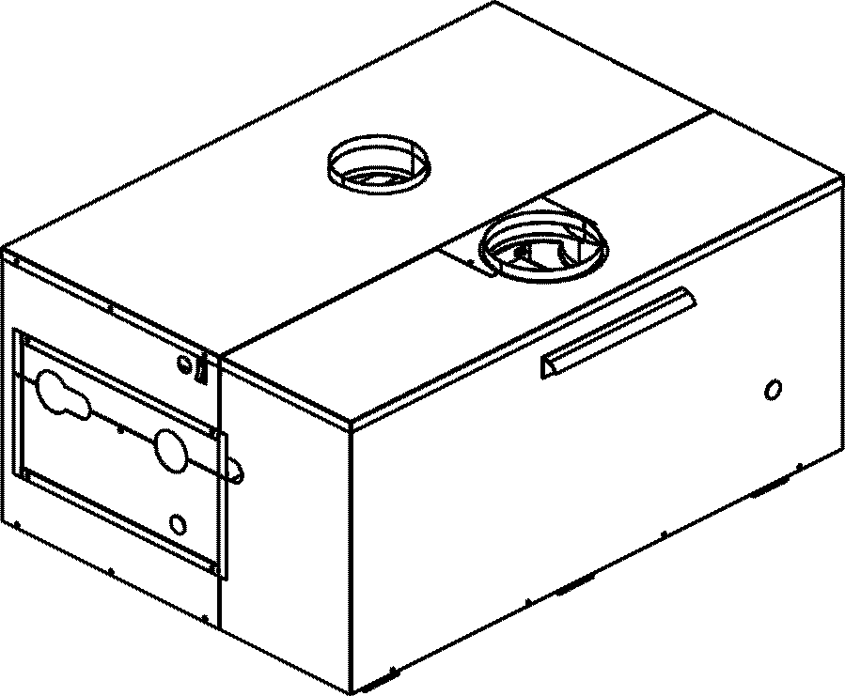
Sealed Combustion Chamber
100% Factory Fire Tested
Efficiency: 84%
Maximum Outlet Temperature: 230°F
Minimum Non-condensing Inlet Temperature: 105°F
Thermal Shock Proof Heat Exchanger
Limited Twenty-year Thermal Shock Warranty
Limited Five-year Closed-System Heat Exchanger Warranty
Fault Indicator LED
PolyTuf Powder Coated Cabinet
No Combustible Floor Shield Required
Fan-assisted

Heat Exchanger
- Headers
Cast Iron, Glass-lined – Standard
Bronze – Option A-1
- ASME Inspected and Stamped
160 PSIG Working Pressure
- National Board Approved
- Finned Tubing
Copper – Standard
Cupro Nickel – Option A-3
- ASME Steel Tube Sheet
- Silicone High Temp O-Rings
- Pressure Relief Valve - ASME
45 PSIG - Standard
PSIG - Optional
- Temperature and Pressure Gauge (shipped loose)
- Left-hand Water Connections

Controls
- 120V, 60Hz, 1∅ Power Supply
- 120/24V 60Hz Transformer
- 100% Pilot Shutoff/Lockout
- Hot Surface Ignition
- Remote Flame Sensor
- Fixed High Limit Control, Auto Reset
- Fixed High Limit Control, Manual Reset
- On/Off Power Switch
- Blocked Vent Pressure Switch
- Combustion Air Proving Switch
- Pump Relay

Gas Train
- Manual Gas Shut-off Valve(s)
- Gas Pressure Regulator
- Safety Shut-off Valve
- Firing Control Valve
- Firing Mode
Two-stage (H3) - Standard
On/Off (H4) - Optional
- Fuel
Natural Gas
Propane Gas
- Design Certified
ANSI Z21.13/CSA 4.9

Burner
- Ultra-low NOx (<30 ppm)

Construction
- Indoor/Outdoor Construction
- Front Controls Enclosed
- PolyTuf Powder Coat Finish
- TruSeal® Direct Vent
- Filter Kit

Venting
- Vent Termination Cap
Outdoor – Option D-11
Indoor, Horizontal – Option D-15
Indoor, Vertical (by others)
- Combustion Air
Air Intake Elbow – Option D-16
In-line Filter Kit – Option D-17
- Extractor – Optional
By others
Not required

Temperature Controls
B-3 1-Stage Controller, 100-200°F
B-4 2-Stage Outdoor Reset Control
B-6 2-Stage Controller, 130-230°F
B- Remote Controller
By others:

Options
F-1 Flow Switch (shipped loose)
F-10 Low Water Cut-off, Remote Probe
I-1 Adjustable High Limit Control, Auto Reset
I-2 Adjustable High Limit Control, Manual Reset
P- Pump: HP, 120V, 1∅, 60 Hz
Bronze Mounted
Cast Iron Loose
X-1 SureRack™ Kit
Two-high
Three-high



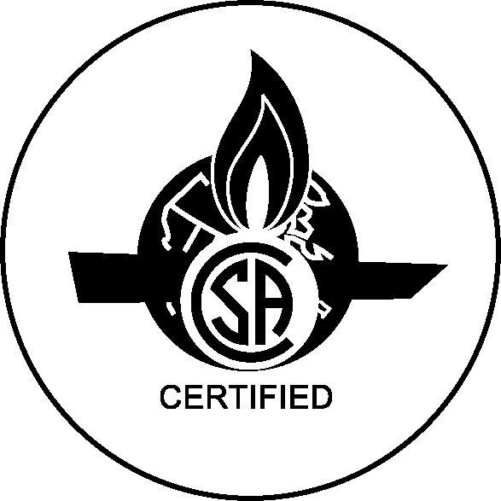

Hi Delta 122-322

Type H - Hydronic Heating Model

 |  |  |  |  |  |  |  |  |  | APPROX.
 | MBTUH |  | AFUE | FIRING | A | B | H | K | T | SHIP WT.
MODEL | INPUT | OUTPUT | (%) | STAGES |  |  | NPT |  |  | (LBS.)
H 122 | 120 | 101 | 84 | 2* | 24-7/8 | 10-3/4 | 1-1/4 | 4 | 5 | 225
H 162 | 160 | 134 | 84 | 2* | 28-1/2 | 12-9/16 | 1-1/4 | 5 | 5 | 240
H 202 | 199 | 167 | 84 | 2* | 32-1/8 | 14-3/8 | 1-1/4 | 5 | 5 | 255
H 242 | 240 | 202 | 84 | 2* | 35-1/2 | 16-3/16 | 1-1/2 | 5 | 5 | 270
H 322 | 320 | 269 | N/A | 2* | 42-5/8 | 19-13/16 | 1-1/2 | 6 | 5 | 300
Dimensions are in inches. * 1 stage optional

RATES OF FLOW AND PRESSURE DROPS

 | 10ºF T |  | 20ºF T |  | 30ºF T |  | MIN. FLOW |  |  | MAX. FLOW
MODEL | GPM | P (ft) | GPM | P (ft) | GPM | P (ft) | GPM | P (ft) | T | GPM | P (ft) | T
H 122 | 20 | 2.5 | 10 | <1.0 | N/A | N/A | 10 | <1.0 | 20 | 30 | 5.3 | 7
H 162 | 27 | 4.5 | 13 | 1.1 | N/A | N/A | 10 | <1.0 | 27 | 30 | 5.4 | 9
H 202 | 34 | 7.2 | 17 | 1.85 | 11 | <1.0 | 10 | <1.0 | 34 | 30 | 5.5 | 11
H 242 | 40 | 10.0 | 20 | 2.65 | 14 | 1.3 | 10 | <1.0 | 40 | 44 | 11.8 | 9
H 322 | N/A | N/A | 27 | 4.7 | 18 | 2.2 | 14 | 1.35 | 40 | 44 | 12.2 | 12
Basis is 10 GPM or 40°F T for minimum flow, 44 GPM for maximum flow (except for 1.25” header).

NOTES: 1. Rates shown are for natural or propane gas, and elevations up to 5,000 feet. For installations above 5,000 feet, please contact manufacturer.
2. Recommended natural gas pressure is 7 – 10.5” WC. Recommended propane gas pressure is 11 - 13” WC.
Raypak, Inc. ▪ 2151 Eastman Avenue, Oxnard, CA 93030 ▪ (805) 278-5300 ▪ Fax (800) 872-9725 ▪ www.raypak.com

