Job:

Outdoor Stack Assembly

For Hi Delta®
Models 302B – 2342B

Engineer:
Contractor:
Prepared By: Date:

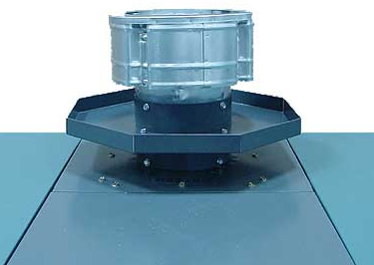
Features
- Low-profile
- Wind-resistant
- Lightweight
- Outdoor use
- Includes covers for combustion air inlet,
flow switch and pump


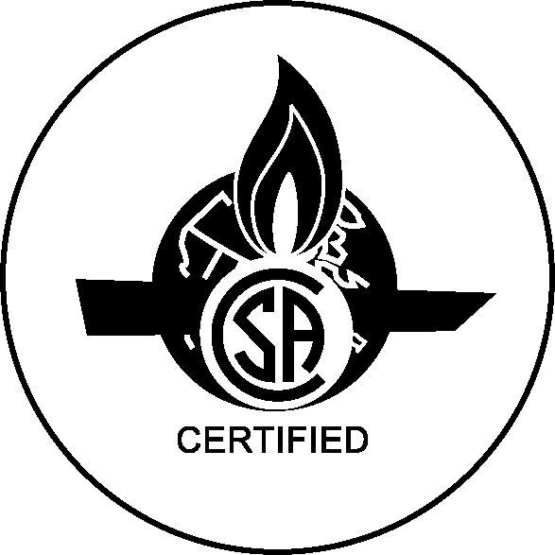
Hi Delta  Model No. | Part  No. | D | E | K
302B | 010793 | 9 ½ | 7 ½ | 5
402B-502B | 010794 | 11 | 9 | 6
652B-902B | 010795 | 12 | 10 | 8
992B | 010796 | 12 ½ | 10 ½ | 10
1262B-1532B | 010797 | 14 | 12 | 12
1802B-2072B | 010798 | 16 | 14 | 14
2342B | 010799 | 17 | 16 | 16

Raypak, Inc. ▪ 2151 Eastman Avenue, Oxnard, CA 93030 ▪ (805) 278-5300 ▪ Fax (800) 872-9725 ▪ www.raypak.com

