Job:

Condensing 90+

XPak™ Residential

Hydronic Heating Boilers

Models 85 &120
Engineer:
Contractor:
Prepared By: Date:
Model:

Applications
- Radiant Heating
- Hydronic Space Heating
- Snow Melting
- DHW via indirect
High Efficiency
Infinitely modulating, Condensing design meets or exceeds Energy Star Standards.
Low Emissions
Low NOx design meets all current Green Legislation in North America.
Factory Installed Circulator
w/ Bypass and Condensate Siphon
Thermostatically-controlled circulator maintains proper flow through the boiler. As a packaged system, installation is fast and easy. Twin chamber ball type
Siphon, the best flue seal.
Electronic Ignition
Direct Spark Ignition
Compact, Lightweight Design
Mounts easily onto walls without heavy bracing.
Easy to Plumb, Easy to Service
Vent on top. Inlet and outlet water piping, gas connections, wiring and condensate drain at bottom. Controls are up front for easy access.
Safe Operation
Sealed combustion chamber runs cool and sensors shut down the boiler in the event of a fault.
Electronic Thermostat with Diagnostics
Electronic solid state thermostatic control operates the boiler in the most efficient manner. Faults are displayed on two digit display.
Whisper Quiet Operation
Less than 60 dba
DHW Temp Controller Up Front

Heat Exchanger
- ASME Inspected and Stamped
45 PSIG
- National Board Approved
- Extruded 6063-T1 Aluminum Alloy Single Pass Heat Exchanger
- 45 PSIG ASME Pressure Relief Valve
- Pressure Gauge
- 3 Speed Non-Ferrous Pump
120 VAC, Mounted
- Two Automatic Air Vents

AFUE Ratings
Model | AFUE
85 | 90.3
120 | 90.5

Controls
- 120V, 60Hz, 1φPower Supply
- 120/24V Transformer
- Electronic, Direct Spark Ignition (DSI)
- 100% Flame Monitor Shut-off/Lockout
- High Limit Control
- Operating Limit Control
- Pressure Switch
- Condensate High Level Sensor
- Flue Sensor
- Flue Limit

Venting Options
- AL29-4C Stainless Steel Vent
- CPVC Plastic Vent
- Polypropylene Plastic Vent
- Concentric Vent or Twin Penetrations
- Horizontal or Vertical Vent

Gas Control Train
- Natural Gas (Propane Conversion
Kit w/ Every Unit)
- 4 to 1 Modulation
- Zero Governor Gas Valve
- Manual Gas Shut-Off Valve
- Redundant Valve Feature
- Negative Pressure Gas Regulator

Construction
- Indoor Construction
- Enclosed Front Controls
- Cylindrical Stainless Steel Burner
- Appliance Grade Finish




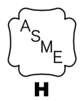



Raypak XPak Residential

Hydronic Heating Boilers Model

Models 85 &120

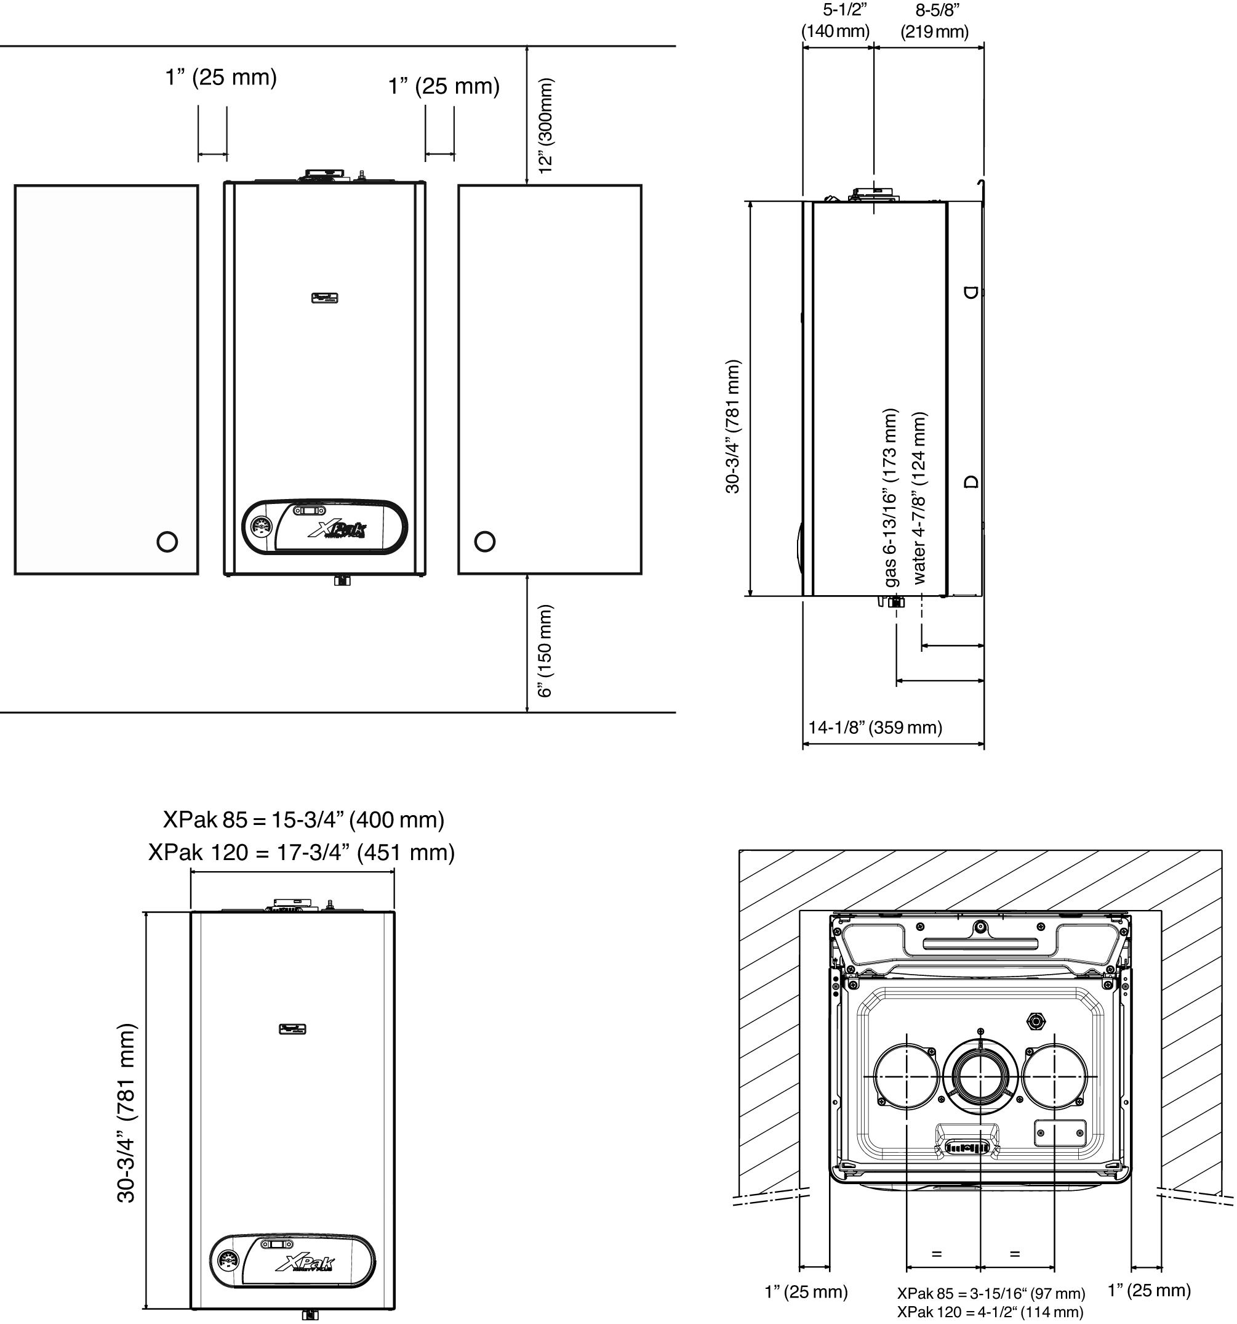

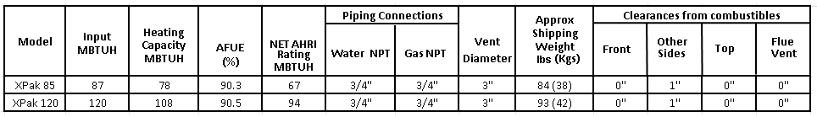

Note:
1. DHW capability provided via following options: three way valve or pump and indirect tank

Raypak, Inc. 2151 Eastman Avenue, Oxnard, CA 93030 (805) 278-5300 Fax (800) 872-9725 www.raypak.com

