Job:

Hi Delta® - Type H

Hydronic Heating Boiler Models 302BE-902BE

87% Efficiency

Engineer:
Contractor:
Prepared By: Date:
Model: Indoor/Outdoor: MBTUH Input:

- 100% Factory Fire Tested
- Efficiency: 87%
- Maximum Outlet Temperature: 230°F
- Minimum Non-Condensing Inlet Temperature: 120°F
- Thermal Shock Proof Heat Exchanger
- Limited Twenty-Year Thermal Shock Warranty
- Limited Ten-Year Heat Exchanger Warranty
- Full Safety Diagnostics with Fault History
- PolyTuf Powder Coated Cabinet
- No Combustible Floor Shield Required

- Fan-Assisted
Proudly Made in the USA

Patented Burner Security Blanket

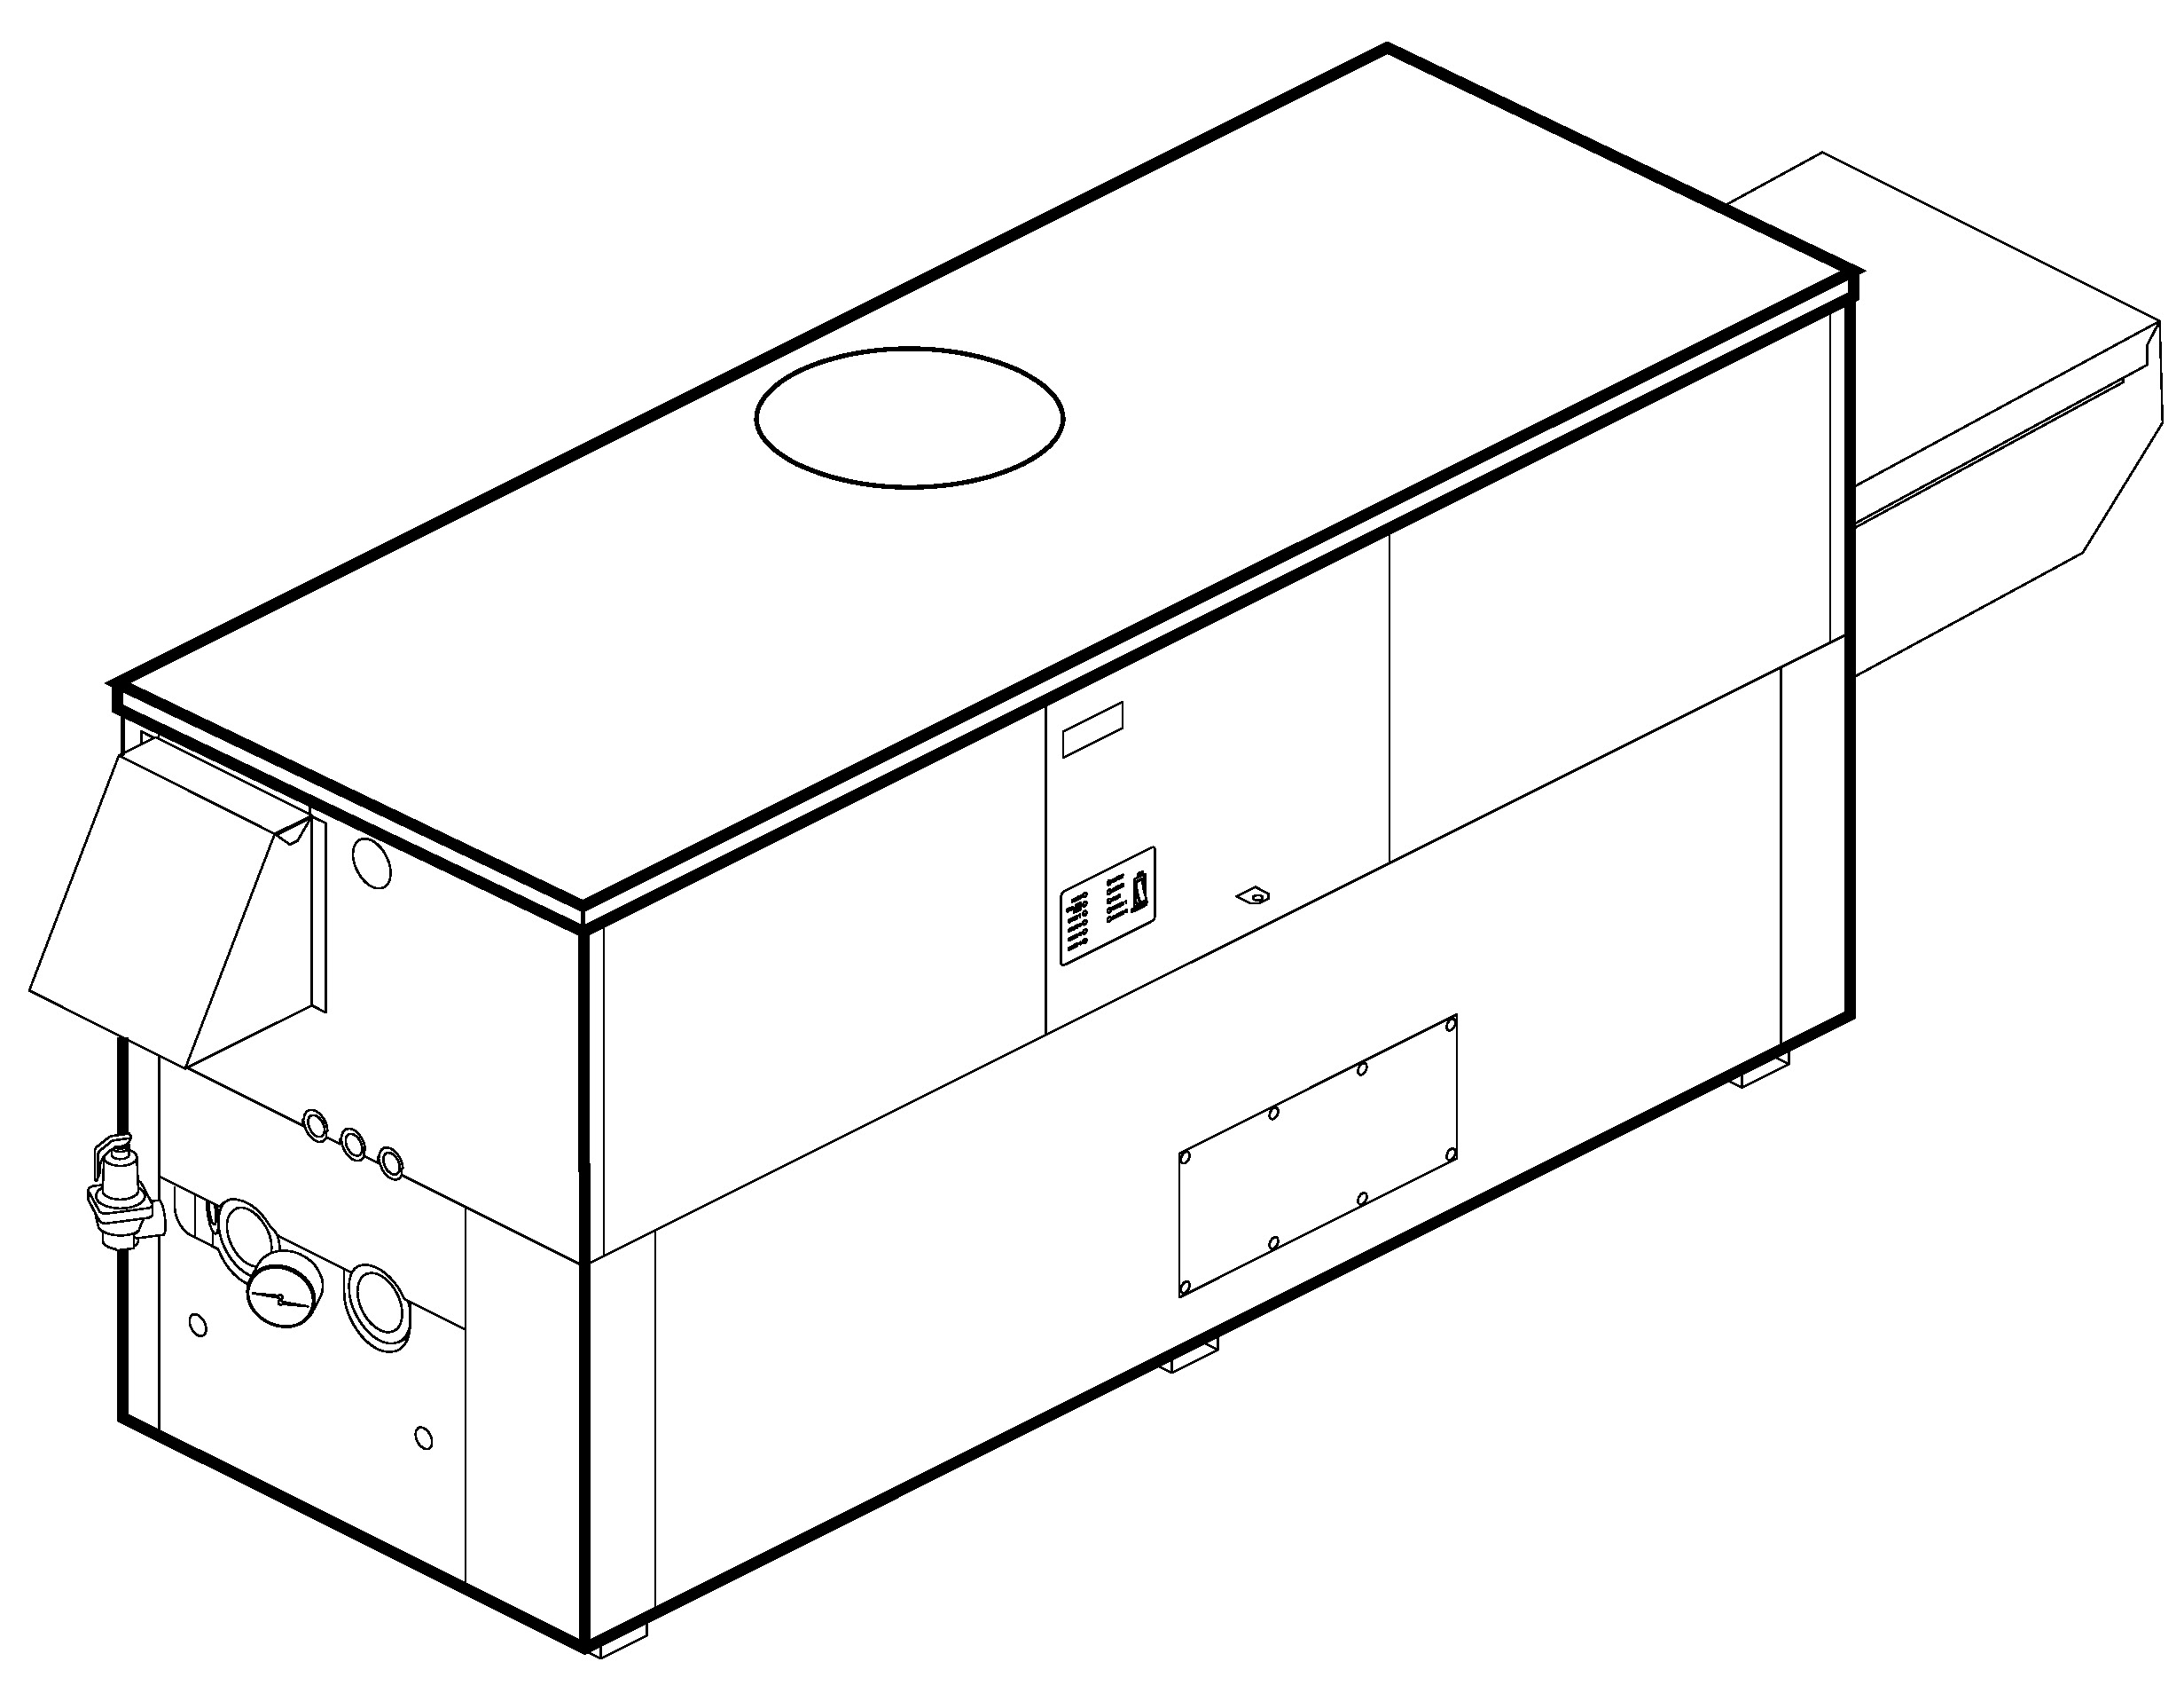
Patent No. 7,044,124

Heat Exchanger
- H Stamp
- Headers
Glass-Lined Cast Iron – Standard
Brass – Option A-1
- ASME Inspected and Stamped
160 PSIG Working Pressure
- National Board Approved
- Fin Tubing
Copper – Standard
Cupro Nickel – Option A-3
- ASME Steel Tube Sheet
- Silicone High Temp O-Rings
- Pressure Relief Valve, ASME
45 PSIG – Standard on Models 302BE and 402BE
60 PSIG – Standard on Models 502BE-902BE
PSIG – Optional
- Temperature and Pressure Gauge
- Water Connections
Left – Standard
Right – Option A-6

Controls
- 120V, 60Hz, 1∅ Power Supply
- 120/24V 60Hz Transformer
- 100% Shutoff/Lockout
- Hot Surface Ignition
- Remote Flame Sensor
- High Limit Control, Manual Reset
- On/Off Power Switch
- Manual Shut-Off, Front-Mounted
- Flow Switch
- Blocked Vent Pressure Switch
- Combustion Air Proving Switch
- Economaster Pump Time Delay
- Diagnostics Panel with LCD Display, 2Lines, 20 Characters

Gas Train
- Manual Gas Shut-Off Valve(s)
- Combo Valve(s)
- Firing Mode
On/Off (H4): Models 302BE
and 402BE
2-Stage (H3): Models 302BE - 902BE
- Fuel
Natural Gas
Propane Gas
- Design Certified ANSI Z21.13/
CSA 4.9

Venting
- Vent Location
Top – Standard
Rear – Option D-14
- Vent Termination Cap
Outdoor D-11
Indoor, Horizontal D-15
Indoor, Vertical (by others)
- Combustion Air
In-Line Filter Kit (Recommended
with Ducted-In Air Only) D-17
Air Intake Elbow D-16
- Extractor - Optional
By Others
Not Required

Construction
- Indoor/Outdoor Construction
- Enclosed Front Controls
- CSA Low Lead (≤ .25 Pb)


Burner
- Ultra-Low NOx: Less than 20 PPM

Temperature Controls
B-6 Aquastat, 2-Stage (100-200°F)
B- TempTracker Digital Controller,
2-Stage
B- TempTracker Digital Controller,
4-Stage
B- TempTracker Mod+ Hybrid (2-16 Boilers)
B-60 Stage Interface

Options
C-6 Ignition Module, Manual Reset
D-21 TruSeal® Direct Vent
F-10 Low Water Cut-Off, Remote Probe
I-1 High Limit Control, Auto Reset
P- Pump: HP, 120V, 1∅, 60Hz
Cast Iron Bronze
Mounted Loose
Front Rear
P- Cold Water Start (See 2000.48)
S-1 Low Gas Pressure Switch, Manual
S-2 High Gas Pressure Switch, Manual
X-1 SureRack™ Kit
X-2 SureRack Add-on
For Metric information, see Catalog

Regulatory Agency Requirements
For Metric information, see Catalog

Hi Delta – Type H

Models 302BE-902BE, 87% Efficiency Model

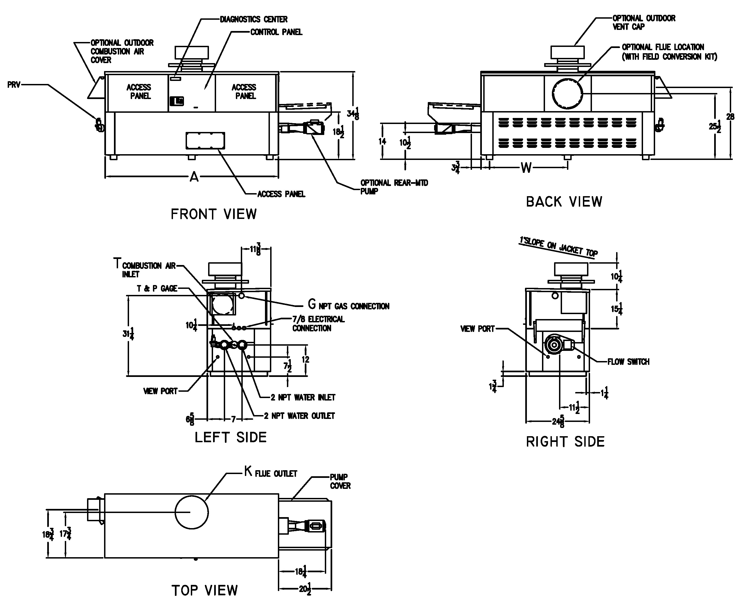
RATES OF FLOW AND PRESSURE DROPS
 | 10°F ∆T |  | 20°F ∆T |  | 30°F ∆T |  | Min. Flow |  |  | Max. Flow
Model | GPM | ∆P (ft) | GPM | ∆P (ft) | GPM | ∆P (ft) | GPM | ∆P (ft) | ∆T | GPM | ∆P (ft) | ∆T
302BE | 52 | 3.4 | 26 | <1 | N/A | N/A | 20 | <1 | 26 | 90 | 9.8 | 6
402BE | 69 | 5.8 | 35 | 1.5 | 23 | <1 | 20 | <1 | 35 | 90 | 10.0 | 8
502BE | 87 | 9.9 | 44 | 2.5 | 29 | 1.2 | 22 | <1 | 40 | 90 | 10.5 | 10
652BE | N/A | N/A | 57 | 4.3 | 38 | 2.0 | 28 | 1.2 | 40 | 90 | 10.7 | 13
752BE | N/A | N/A | 65 | 5.8 | 44 | 2.7 | 33 | 1.7 | 40 | 90 | 11.0 | 15
902BE | N/A | N/A | 78 | 9.0 | 52 | 4.1 | 39 | 2.4 | 40 | 90 | 11.8 | 17
Basis is 20 GPM or 40°F ∆T for minimum flow, 90 GPM for maximum flow.
NOTE: Pump location varies based on model and application
NOTES: 1. Rates shown are for natural or propane gas, and elevations up to 4,500 feet. For installation above 4,500 feet, please contact manufacturer.
2. Required natural gas pressure is 7 – 10.5” WC. Required propane gas pressure is 11 – 13” WC.

SPECIFICATIONS
 |  |  |  |  |  |  |  |  |  | Approx.
 | MBTUH |  | A | G | H | K | T | W | Amp. | Shipping
Model | Input | Output | Width | NPT | NPT |  |  |  | Draw | Wt. (Lbs)
302BE | 300 | 261 | 36 | 3/4 | 2 | 5 | 6 | 18 | 6 | 380
402BE | 399 | 347 | 43 | 3/4 | 2 | 6 | 6 | 18-1/2 | 6 | 445
502BE | 500 | 435 | 50 | 1-1/4 | 2 | 6 | 6 | 22 | 6 | 545
652BE | 650 | 566 | 60-1/2 | 1-1/4 | 2 | 8 | 6 | 27-1/4 | 6 | 590
752BE | 750 | 653 | 67-1/2 | 1-1/4 | 2 | 8 | 6 | 30-3/4 | 6 | 675
902BE | 900 | 783 | 78 | 1-1/4 | 2 | 8 | 6 | 36 | 7 | 740
Dimensions are in inches.
Raypak, Inc. ▪ 2151 Eastman Avenue, Oxnard, CA 93030 ▪ (805) 278-5300 ▪ Fax (800) 872-9725 ▪ www.raypak.com

