Job:

B-60 Stage Interface
Up to 4-Stage Controller

For Hi Delta® and Raytherm® Boilers & Water Heaters

Engineer:
Contractor:
Prepared By:
Date:
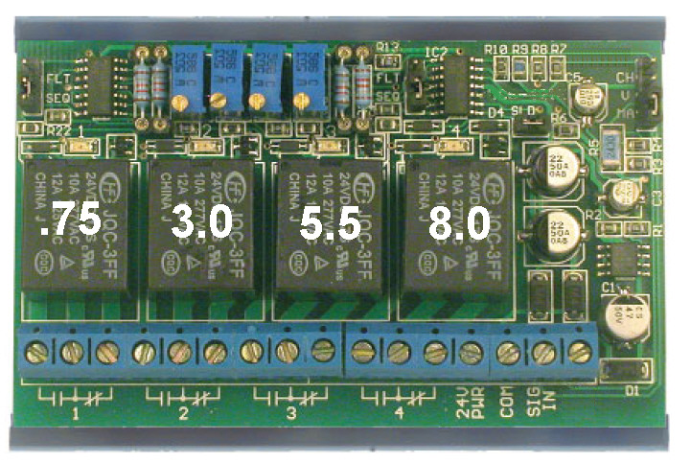
B-60 Stage Interface is designed to stage a single boiler of up to four total stages using a proportional DC voltage or milliamp current signal from a building management system or multi-boiler controller such as our TempTracker MOD+ Hybrid. It is available factory-mounted on Hi Delta and Raytherm stage fired boilers as well as available as a field install kit.

Features
- Four stages of relay control
- Voltage or current input
- 24 VAC/VDC power
- LED indication of relay status
- Adjustable relay setpoints
- Adjustable relay differentials
- Snap-track mounted
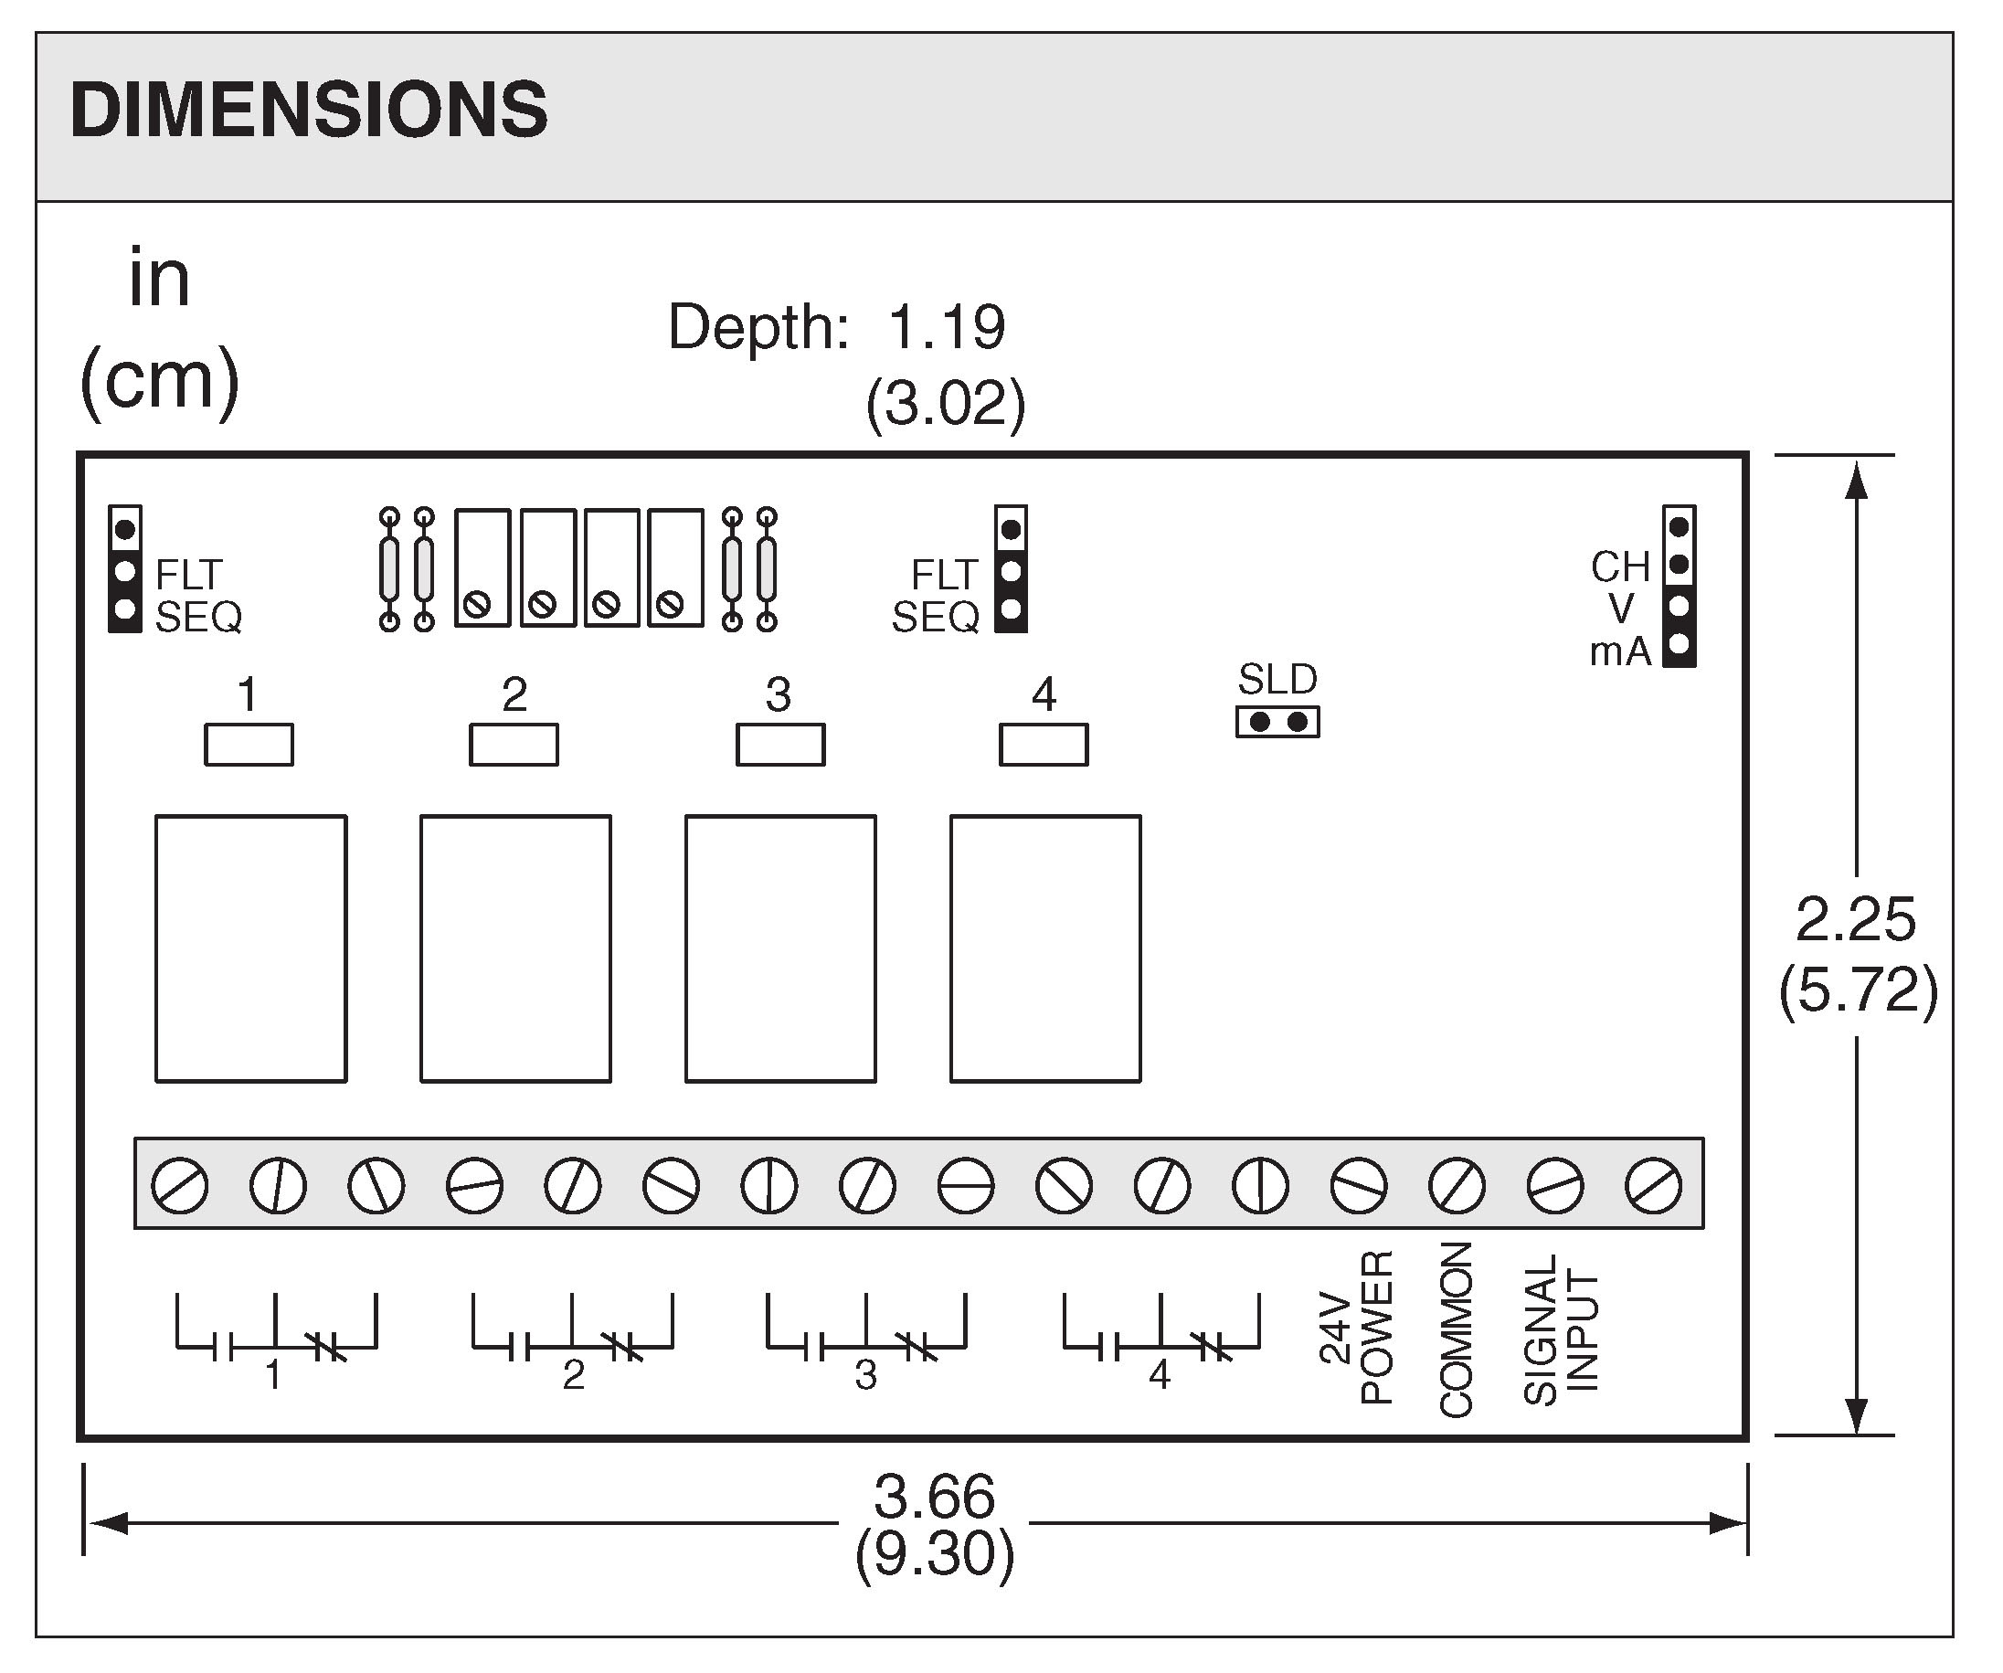

SPECIFICATIONS:

Supply Voltage 24VAC±10%@160mA
Raypak, Inc. ▪ 2151 Eastman Avenue, Oxnard, CA 93030 ▪ (805) 278-5300 ▪ Fax (800) 872-9725 ▪ www.raypak.com
24VDC±10%@80mA
Input Signal 0-20mA or 0-10VDC
(15VDC Max)
jumper selectable
Output Four SPDT relays
Relay Rating 10A@120VAC
Input Impedance 250Ω (mA input)
49.7 KΩ (VAC input)
Operating Temp 32° to 158°F (0° to 70°C)
Humidity Limit 5% to 95% RH non-condensing
Relay Differential .5mA or .375V

Model Information
Factory Mounted
Field Install Kit

Relay | Relay Pull-In Voltage | Relay Pull-In Current | 2 Stage | 3 Stage | 4 Stage
1 | 0.75 VDC | 1.5 mA | ■ | ■ | ■
2 | 3.0 VDC | 6.1 mA |  | ■ | ■
3 | 5.5 VDC | 11.12 mA | ■ |  | ■
4 | 8.0 VDC | 16.23 mA |  | ■ | ■

