Job:

Condensing Heat Exchanger (CHX)

For use with the ADB™
Metric Data
Engineer:
Contractor:
Prepared By: Date:
Model:

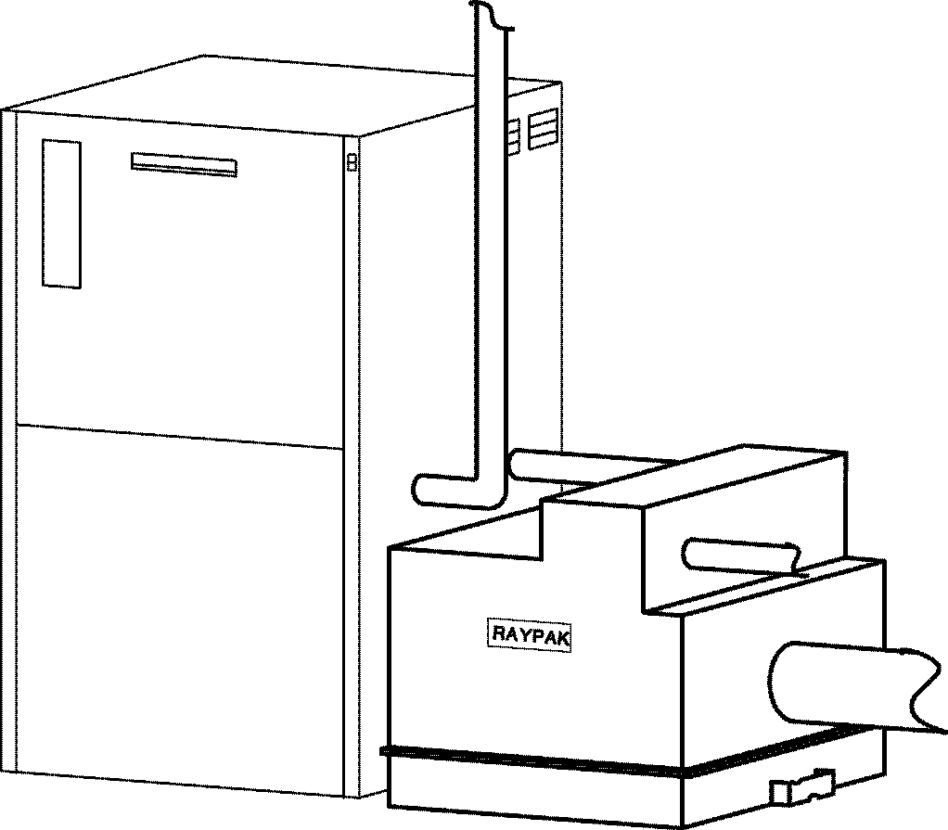

Exclusively for use with Raypak’s
ADVANCED DESIGN BOILER™ (ADB)

Boosts ADB efficiency to 97%!
The Raypak Condensing Heat Exchanger utilizes exhaust heat, which is normally wasted, and converts it to useful energy that increases overall operating efficiency.

Applications
- Hydronic Space Heating
- Hot Water Supply
- Pool Heating
Advanced Design Boiler with CHX

FEATURES

- Finned cupro nickel tubes
- Patented epoxy coating
- All bronze headers
- AL29-4C stainless steel tube bundle casing
- Polytuf powder coating on outer shell
- AL29-4C Stainless Steel vent adapter between the CHX and Advanced Design Boiler included
- ASME tested to 10.3 Bars working pressure
- Traditional Raypak tube sheet design with high-temperature silicone O-rings
- Condensate drain connection
- Indoor/outdoor construction
- Limited 20 year thermal shock warranty
- Footprint: less than .45 m2
- Ten year limited warranty
- National Board approved



For non-metric information,
see Catalog No.: 1000.90

Condensing Heat Exchanger (CHX)

Metric Data Model

MODEL | FITS ADB UNIT | A  WIDTH | B*  HEIGHT | F* | P* | U* | M* | T** | K | H** | X  MIN. | Y | Z | SHIP WT. (kg)
CHX 500 | ADB 500 | 59 | 63 | 48 | 28 | 56 | 35 | ½ | 15.2 | 2 | 71 | 21 | 9 | 113
CHX 750 | ADB 750 | 59 | 78 | 61 | 38 | 70 | 42 | ½ | 20.3 | 2 | 71 | 25 | 8 | 125
CHX 1000 | ADB 1000 | 73 | 99 | 84 | 55 | 93 | 52 | ½ | 25.4 | 2 ½ | 86 | 28 | 18 | 136
- 0.00
+2.54
Dimensions are in Centimeters (2.54 cm = 1 inch) * Heights vary by centimeters, using adjustable feet
** Gas and water connections are in NPT inches

ADB / ADB WITH CHX RATE OF FLOW AND PRESSURE DROP
 | 11°C ΔT |  | 17°C ΔT |  | 22°C ΔT |  | MAX FLOW |  |  | MIN FLOW
MODEL | LPM | ΔP | LPM | ΔP | LPM | ΔP | LPM | ΔP | ΔT | LPM | ΔP | ΔT
ADB 500 W/ CHX | 159  185 | 7.8  13.5 | X  121 | X  6.9 | X  X | X  X | 318  318 | 26.3  33.8 | 6°C  7°C | 114  114 | 4.8  6.3 | 16°C  18°C
ADB 750 W/ CHX | 238  276 | 17.3  29.9 | 159  185 | 8.7  15.5 | X  136 | X  10.5 | 416  416 | 50.8  66.1 | 6°C  7°C | 121  121 | 5.4  7.2 | 22°C  25°C
ADB 1000 W/ CHX | 318  367 | 35.3  46.6 | 212  246 | 16.7  30.8 | 159  185 | 10.2  18.5 | 416  416 | 59.8  77.7 | 8°C  10°C | 159  159 | 10.2  13.5 | 22°C  26°C

CHX RATE OF FLOW AND PRESSURE DROP
MODEL | LPM | 114 | 125 | 159 | 197 | 318
500 | ΔP | 1.5 | 1.8 | 2.7 | 3.3 | 7.5
MODEL | LPM | 121 | 140 | 159 | 189 | 238 | 291 | 416
750 | ΔP | 1.8 | 3.6 | 3.9 | 4.2 | 5.4 | 7.5 | 15.3
MODEL | LPM | 159 | 193 | 212 | 250 | 318 | 367 | 416
1000 | ΔP | 3.3 | 4.8 | 5.4 | 8.4 | 13.2 | 15.2 | 17.9

Raypak, Inc. ▪ 31111 Agoura Road, Westlake Village, CA 91361-4699 ▪ (818) 889-1500 ▪ Fax (818) 889-4522 ▪ www.raypak.com
Raypak Canada LTD. ▪ 2805 Slough Street, Mississauga, Ontario, Canada L4T 1G2 ▪ (905) 677-7999 ▪ Fax: (905) 677-8036 ▪ www.raypakcanada.com
Raypak Australia Pty. Ltd ▪ 7 Geddes Street, Mulgrave, Victoria, Australia 3170 ▪ (6139) 560 4944 ▪ Fax (6139) 560 4974 ▪ www.raypak.com.au

