Job:

Raytherm™ Residentials

Hydronic Heating Boilers

Models 42-180
Engineer:
Contractor:
Prepared By: Date:
Model:

Applications
- Radiant Heating
- Hydronic Space Heating
- Snow Melting
High Efficiency
Heating efficiencies meet or exceed NAECA standards.
Factory Installed Circulator and Bypass
Thermostatically-controlled circulator maintains proper flow through the boiler. As a packaged system, installation is fast and easy.
Electronic Ignition
Intermittent pilot ignition improves system efficiency by using fuel only when there is a call for heat.
Compact, Lightweight Design
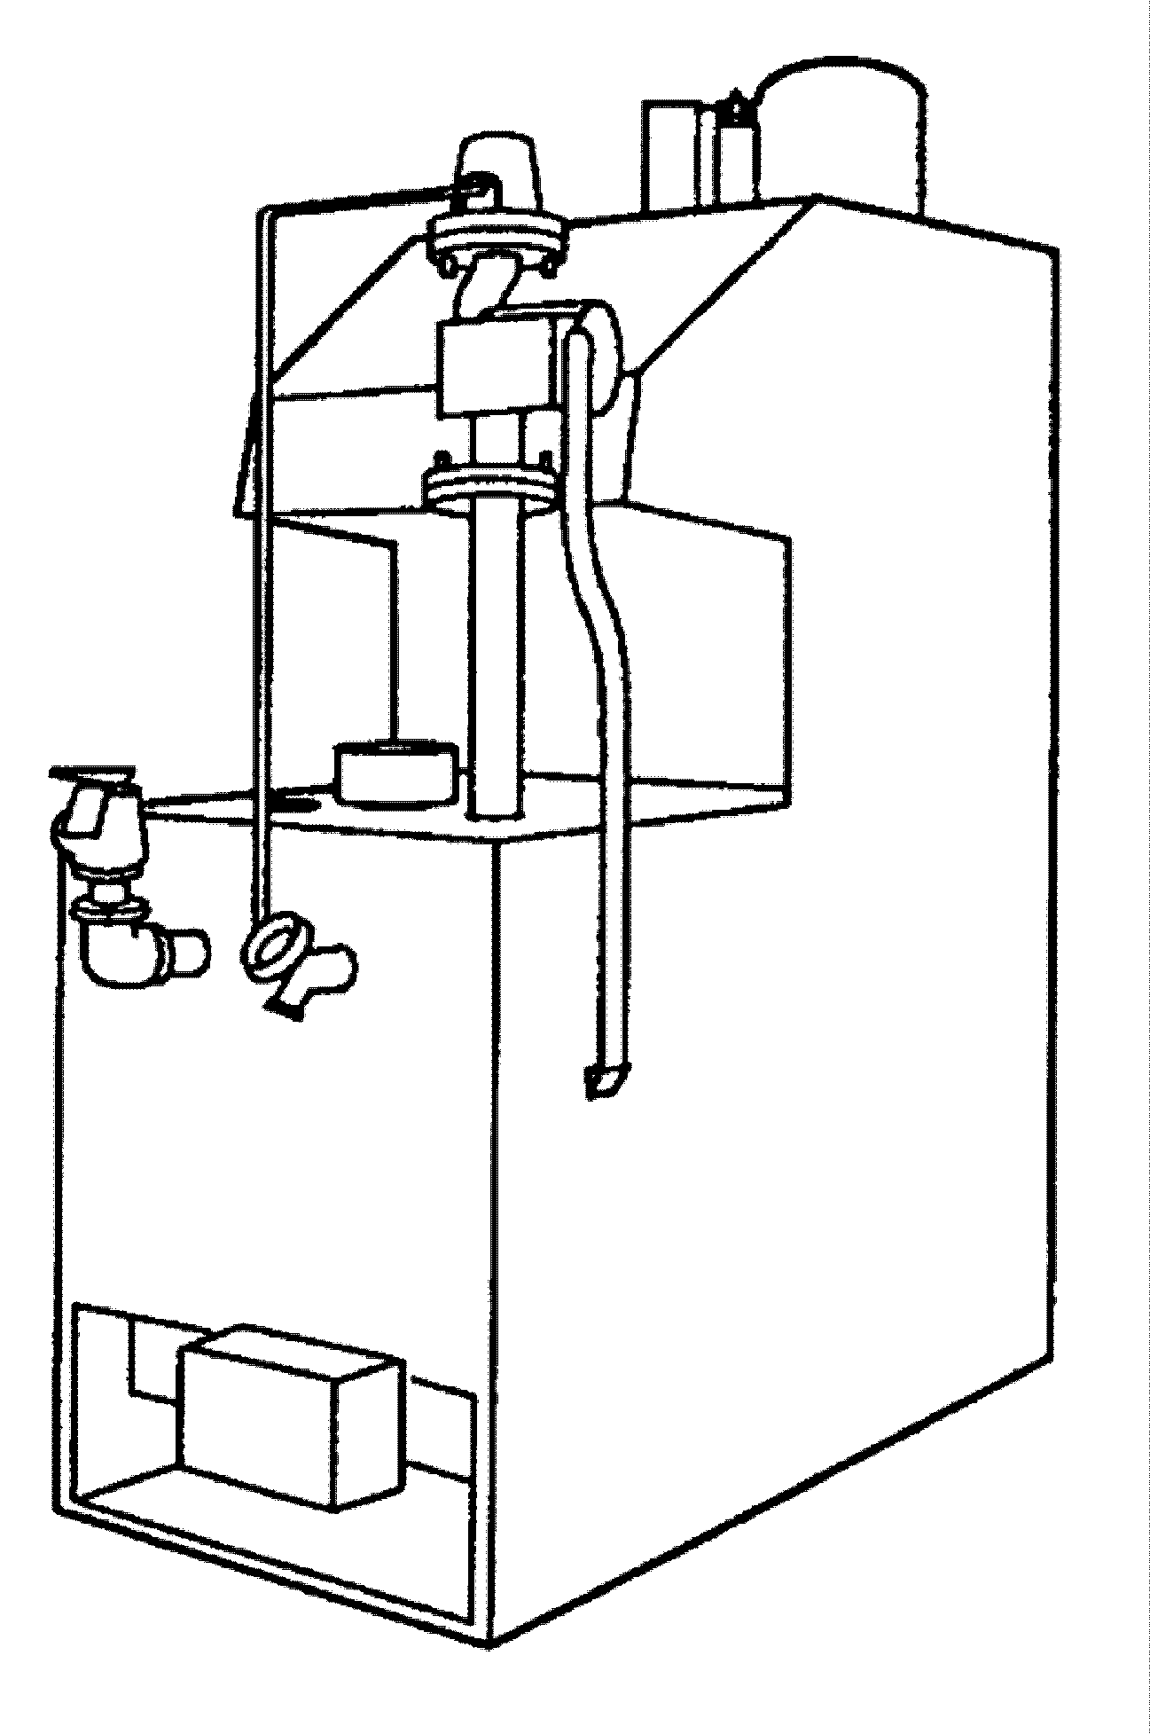
Even the largest model slips easily into tight spaces.
Fig. #8942
Easy to Plumb, Easy to Service
Inlet and outlet water piping, gas connection, wiring and controls are all up front for easy access.
Safe Operation
Built-in manual reset safety sensors shut down the boiler in the event of a flame roll-out or flue gas spillage. Normal working pressure is 125 PSI max.
Fast Response Temperature Sensor
Electronic solid state auto-reset control shuts down the boiler in the event of over-heating caused by a low-flow condition.

Heat Exchanger
- ASME Inspected and Stamped
160 PSIG
- National Board Approved
- Glass-lined Cast Iron Headers
- Copper Finned Tubing
- ASME Steel Tube Sheet
- Silicone O-Rings
- 30 PSIG ASME Pressure Relief Valve
- Temperature and Pressure Gauge
- Cast Iron Pump – 120 VAC, Mounted
- Bypass Assembly

Stainless Options
- All Stainless Pump, 120 VAC, Mounted Stainless Fittings
AFUE Ratings
Model | AFUE
0042 | 84.0
0066 | 83.0
0090 | 82.7
0135 | 82.8
0180 | 83.2

Controls
- 120V, 60Hz, 1 Ø Power Supply
- 120/24V Transformer
- Electronic, Intermittent Ignition
(IID) - Standard
- 100% Pilot Shut-off/Lockout (IID only)
- High Limit Control
- Operating Limit Control
- Flow Sensor
- Flue Gas Spillage Sensor
- Flame Rollout Sensor
- Automatic Vent Damper
- Electronic Outdoor Reset Control

Gas Control Train
- Fuel
Natural Gas
Propane Gas
- Firing Mode
- On/Off - Models 42-66
- Two-stage Firing - Models 90-180
- Combination Gas Valve
- Manual Shut-off
- Redundant Valve Features
- Gas Pressure Regulator

Construction
- Indoor Construction
- Enclosed Front Controls
- Stainless Steel Burners
- Polytuf Powder Coat Finish
- Built-in Draft Diverter
- Certified for combustible flooring


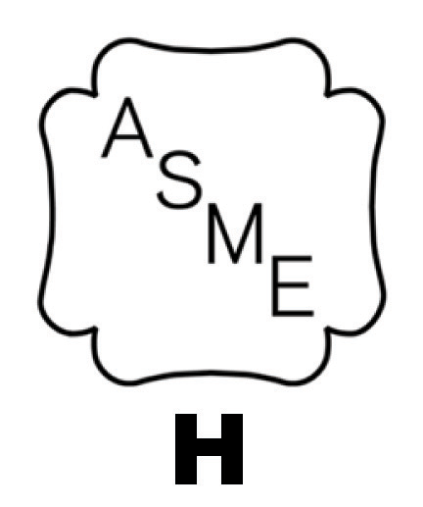



Raypak Residentials

Hydronic Heating Boilers Model

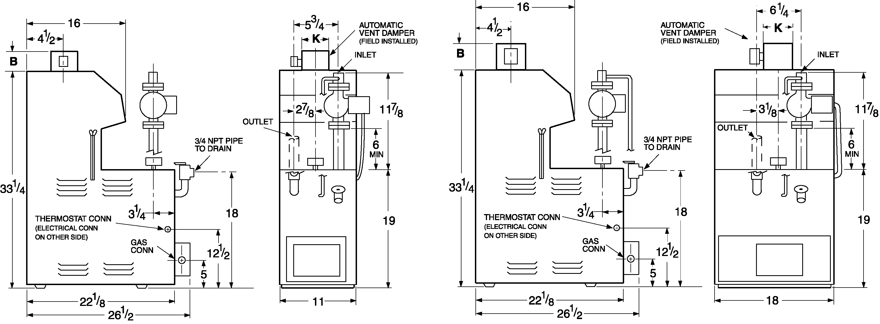

Models 42, 66 & 90

Models 135 & 180

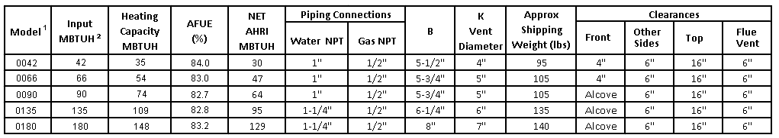

Raypak, Inc. ▪ 2151 Eastman Avenue, Oxnard, CA 93030 ▪ (805) 278-5300 ▪ Fax (800) 872-9725 ▪ www.raypak.com

Notes:
1. Standard models, use “H-” prefix (e.g., H-0042); Non-ferrous models, use “HB-” prefix (e.g., HB-0042)
2. Per Section 11.1.2 of the National Fuel Gas Code, derate the appliance firing rate 4% per 1,000 feet above sea level for installations above 2,000 feet.

