Job:

Raytherm® - Type WH

Water Heaters
Commercial

Models 962-1826 (Indoor)
Engineer:
Contractor:
Prepared By: Date:
Model:
EFFICIENT

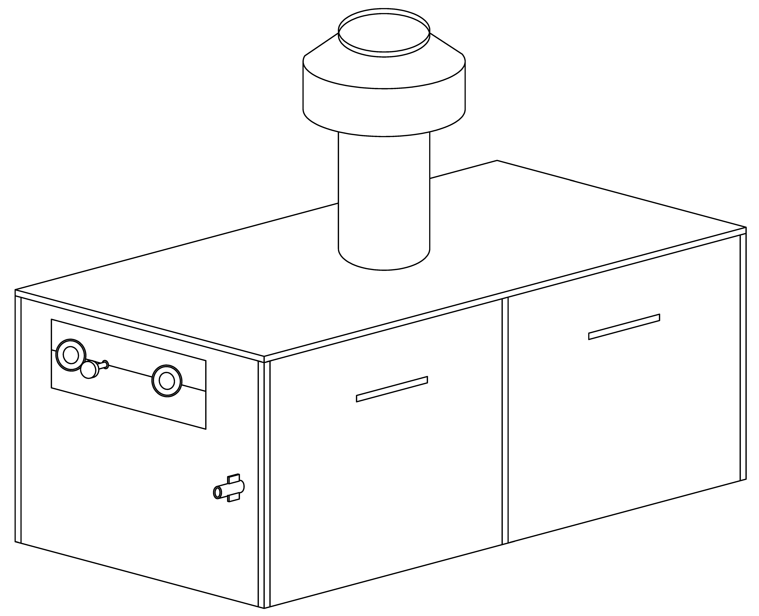
- 82% thermal efficiency – highest of any atmospheric
water heater available today
THERMAL SHOCK PROOF
- Twenty-year warranty against thermal shock damage
up to 150°F differential
- Maximum outlet temperature: 210°F
LIGHTWEIGHT
- A floor load of 70 lbs./sq. ft. or less
HIGH RECOVERY
- Cuts fuel costs substantially because the standby and
radiation losses associated with tank-type
water heaters are eliminated
LOW WATER OPERATING TEMPERATURE

Proudly Assembled in the USA
- Operates with water temperature as low as 105°F
without condensing

Heat Exchanger
- ASME Inspected and Stamped
160 PSIG
- National Board Approved
- Headers
Bronze – Standard
Glass-lined Cast Iron – Option A-2
- Fin Tubing
Copper – Standard
Cupro Nickel – Option A-3
- ASME Steel Tube Sheet
- Silicone O-Rings
- 125 PSIG ASME Pressure Relief Valve
- Temperature and Pressure Gauge
- Water Connections
Left Hand – Standard
Right Hand – Option A-6
- Two-pass Flow Configuration
- Pump, Rear-mounted, 1/2 HP,
120 VAC, 1∅, 60 Hz – Optional
4.25” Impeller
4.7” Impeller

Controls
- 120V, 60Hz, 1 Ph Power Supply
- 120/24V Transformer
- 100% Pilot Shut-off/Lockout
- Electronic, Intermittent Ignition (IID) Pilot

Controls (cont.)
- High Limit Control, Manual Reset –
200°F
- On/Off Switch
- Flow Switch
- Economaster II Pump Time Delay

Gas Control Train
- Manual Main Gas Shut-off Cock
- Main Gas Pressure Regulator
- Redundant Safety Shut-off Valve
- Control Valve
- Firing Mode
On/Off
2-stage Firing
Mechanical Modulation
- Fuel
Natural Gas
Propane Gas
- Design Certified ANSI Z21.10.3

Construction
- Front Controls
- Stainless Steel Burners
- PolyTuf Powder Coat Finish
- Vent Selection
Drafthood – Option D-10
Motorized Draft Inducer –
Option D-2
- Base – Optional




Combustible Floor Shield –
Option J-1
- CSA Low Lead Certified ≤ .25% Lead

Temperature Controls
B-2 Single-Stage Tankstat
(100-180°F)
B-3 2-Stage Tankstat (100-180°F)
B-26 2-Stage Digital
B-21 4-Stage Digital

Additional Safety Controls
F-9 Low Water Cut-off Probe
I-3 High Limit Control, Auto Reset, 180°F
S-1 Low Gas Pressure Switch, Manual
S-2 High Gas Pressure Switch, Manual

Regulatory Agency Requirements

Raytherm - Type WH

Models 962-1826 Model

Electrical Requirements 120 VAC
Model | With Pump | W/O Pump
962-1826 | < 10 Amps | < 4 Amps

MODELS 962 THRU 1826

 |  |  | Dimensions (Inches)
Model | MBTUH |  |  | Overall | Jacket | Gas | Water |  | Flue |  | Shipping Weight
No. | Natural Gas |  | Width | Height | Height | Conn. | Conns. |  | Dia. |  | Lbs. (Approx.)
 | Input | Output | A | B | C | G | H | J | K | L | Less Pump | w/Pump
WH-962 | 961.7 | 788.6 | 52-3/8 | 76-1/8 | 33-1/2 | 1 | 2-1/2 | 23-5/8 | 14 | 28 | 705 | 760
WH-1125 | 1124.7 | 922.0 | 59-1/4 | 78-1/8 | 33-1/2 | 1 | 2-1/2 | 23-5/8 | 16 | 32 | 745 | 800
WH-1223 | 1222.5 | 1002.4 | 63-5/8 | 78-1/8 | 33-1/2 | 1-1/4 | 2-1/2 | 23-5/8 | 16 | 32 | 805 | 860
WH-1336 | 1336.6 | 1096.0 | 68-5/8 | 80-1/8 | 33-1/2 | 1-1/4 | 2-1/2 | 23-5/8 | 18 | 36 | 875 | 930
WH-1468 | 1467.0 | 1203.0 | 74-7/8 | 80-1/8 | 33-1/2 | 1-1/4 | 2-1/2 | 23-5/8 | 18 | 36 | 945 | 1000
WH-1631 | 1630.0 | 1336.6 | 81-1/8 | 83-1/8 | 36-1/2 | 1-1/4 | 2-1/2 | 23-5/8 | 18 | 36 | 985 | 1040
WH-1826 | 1825.6 | 1497.0 | 89-3/8 | 85-1/8 | 36-1/2 | 1-1/4 | 2-1/2 | 23-5/8 | 20 | 40 | 1035 | 1090
NOTES: Ratings are shown for elevations up to 2,000 feet. For elevations over 2,000 feet, reduce ratings 4% for each 1,000 feet above sea level.

HEATER RECOVERY RATES (GPH)

Model  No. | Temperature Rise
Model  No. | 20°F | 30°F | 40°F | 50°F | 60°F | 80°F | 100°F
WH-962 | 4733 | 3156 | 2367 | 1893 | 1578 | 1183 | 947
WH-1125 | 5536 | 3690 | 2768 | 2214 | 1845 | 1384 | 1107
WH-1223 | 6017 | 4011 | 3009 | 2407 | 2006 | 11504 | 1203
WH-1336 | 6579 | 4386 | 3289 | 2631 | 2193 | 1645 | 1316
WH-1468 | 7221 | 4818 | 3610 | 2888 | 2407 | 1805 | 1444
WH-1631 | 8023 | 5349 | 4011 | 3209 | 2674 | 2006 | 1605
WH-1826 | 8986 | 5990 | 4493 | 3594 | 2995 | 2246 | 1797

HEATER RATES OF FLOW AND PRESSURE DROPS

Model  No. | 20° ΔT |  | 30° ΔT |  | 40° ΔT
Model  No. | GPM | ΔP (ft) | GPM | ΔP (ft) | GPM | ΔP (ft)
WH-962 | 79 | 8.5 | 53 | 3.8 | N/A | N/A
WH-1125 | N/A | N/A | 61 | 5.5 | 46 | 3.1
WH-1223 | N/A | N/A | 67 | 7.0 | 50 | 3.9
WH-1336 | N/A | N/A | 73 | 8.6 | 55 | 4.9
WH-1468 | N/A | N/A | 80 | 11.0 | 60 | 6.2
WH-1631 | N/A | N/A | 90 | 14.8 | 67 | 8.0
WH-1826 | N/A | N/A | N/A | N/A | 75 | 10.6
NOTE: Maximum acceptable flow through heat exchanger tubes is 90GPM.
Raypak, Inc. ▪ 2151 Eastman Avenue, Oxnard, CA 93030 ▪ (805) 278-5300 ▪ Fax (800) 872-9725 ▪ www.raypak.com

