Job:

Hi Delta® FlexGas® - Type WH

Dual-Fuel Water Heaters
Models 992BD-2342BD

Engineer:

Contractor:
Prepared By: Date:
Model: Indoor/Outdoor: MBTUH Input:
Fast, Economical Natural-to-Propane Gas Switchover
100% Factory Fire Tested
Efficiency: 85%
Maximum Outlet Temperature: 200°F
Minimum Non-Condensing Inlet Temperature: 105°F
Thermal Shock Proof Heat Exchanger
Limited Twenty-Five-Year Thermal Shock Warranty
Limited Five-Year Heat Exchanger Warranty
Diagnostic Center with Fault History
Patent Nos. 6,904,873 & 7,044,124; other patents pending
PolyTuf Powder Coated Cabinet
No Combustible Floor Shield Required
Fan-Assisted
 Proudly Assembled in the USA
Patented Burner Security Blanket

Heat Exchanger
- HLW Stamp
- Headers
Bronze – Standard
Glass-Lined Cast Iron –
Option A-2
- ASME Inspected and Stamped
160 PSIG Working Pressure
- National Board Approved
- Fin Tubing
Copper – Standard
Cupro Nickel – Option A-3
- ASME Steel Tube Sheet
- Silicone High Temp. O-Rings
- ASME Pressure Relief Valve
125 PSIG – Standard
A6 – 150 PSIG – Optional
- Temperature and Pressure Gauge
- Water Connections
Left – Standard
Right – Option A-6

Controls
- 120V, 60Hz, 1∅ Power Supply
- 120/24V 60Hz Transformer
- 100% Shut-Off/Lockout
- Hot Surface Ignition
- Remote Flame Sensor
- High Limit Control, Manual Reset
- On/Off Power Switch
- Manual Shut-Off, Front-Mounted
- Flow Switch
- Blocked Vent Pressure Switch
- Combustion Air Proving Switches
- Economaster Pump Time Delay
- Enable/Disable

Gas Train
- Manual Gas Shut-Off Valve(s)
- Low Gas Pressure Switch - Manual
- Safety Shut-Off Valve
- Firing Control Valve
- Firing Mode
3-Stage: Model 992BD
4-Stage: Models 1262BD -
2342BD
- Natural/Propane Gas
- Gas Connection
Left – Standard
Right – Option Z-1
- Design Certified - ANSI Z21.10.3/
CSA 4.3

Construction
- Indoor/Outdoor Construction
- Enclosed Front Controls
- CSA Low Lead Certified ≤ .25% Lead

Venting
- Vent Location
Top – Standard
Rear – Option D-14
- Vent Termination Cap
Outdoor D-11
Indoor, Horizontal D-15
Indoor, Vertical (by others)
- Combustion Air
In-Line Filter Kit (TruSeal
only) D-17
Air Intake Elbow D-16
- Extractor – Optional
By others
Not required

Burner
- Ultra-Low NOx: Less than 20 PPM

Temperature Controls
B-2 Tankstat, Single-Stage (100-200°F)
B-3 Tankstat, 2-Stage (100-200°F)
B-21 TempTracker Digital Controller,
4-Stage
B-26 TempTracker Digital Controller,
2-Stage (Mtd)
B- TempTracker Mod+ Hybrid,
(up to 16 heaters)
B-60 Stage Interface Card

Options
C-6 Ignition Module, Manual Reset
D-21 TruSeal® Direct Vent
F-10 Low Water Cut-Off, Remote Probe
I-1 High Limit Control, Auto Reset
P- Pump: HP, 120V, 1∅, 60Hz Water Hardness: GPG
Bronze
Mounted Loose
Front Rear
P- Cold Water Run (See 1000.19)
S-2 High Gas Pressure Switch, Manual
X-1 SureRack™ Kit
X-2 SureRack Add-on
For Metric information, see Catalog

Regulatory Agency Requirements
For Metric information, see Catalog
For Metric information, see Catalog

For Metric information, see Catalog

Hi Delta FlexGas – Type WH
Models 992BD-2342BD Model
NOTE: Pump location varies based on model and application.
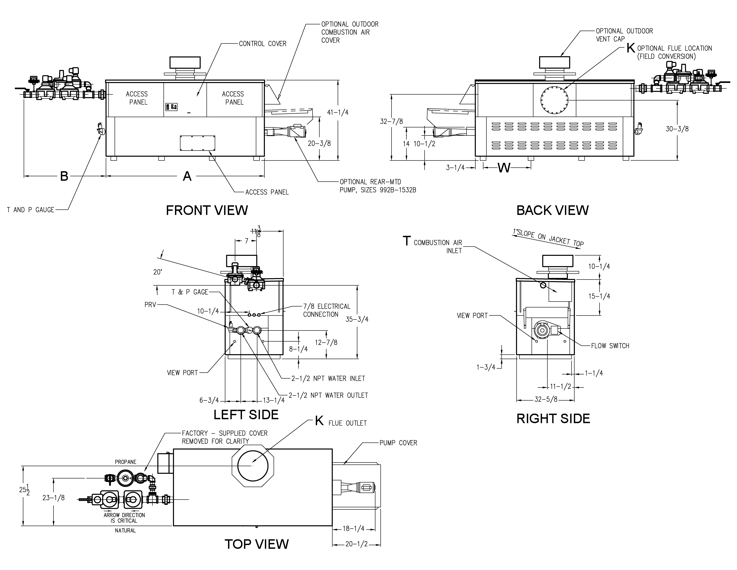
NOTES
1. Dimensions are in inches
2. Rates shown are for natural or propane gas, and elevations up to 4,500 feet. For installation above 4,500 feet, please contact manufacturer.
3. Required natural gas supply pressure is
7 - 10.5” WC. Required propane gas supply pressure is 11 - 13” WC.

SPECIFICATIONS
Model | MBTUH |  | Firing  Stages | A  Width | B | K | T | W | Amp  Draw* | Approx.  Shipping  Wt. (Lbs.)
Model | Input | Output
992BD | 990 | 842 | 3 | 57-1/8 | 41-3/8 | 10 | 10 | 16-13/16 | <12 | 930
1262BD | 1260 | 1071 | 4 | 68-1/2 | 41-1/2 | 12 | 10 | 20-9/16 | <12 | 1040
1532BD | 1530 | 1301 | 4 | 79-7/8 | 36 | 12 | 10 | 24-3/8 | <12 | 1255
1802BD | 1800 | 1530 | 4 | 91-1/8 | 33-1/2 | 14 | 10 | 28-1/8 | <12 | 1380
2072BD | 2070 | 1760 | 4 | 102-1/2 | 39 | 14 | 10 | 31-15/16 | <12 | 1480
2342BD | 2340 | 1989 | 4 | 113-7/8 | 34 | 16 | 10 | 35-11/16 | <12 | 1550
Raypak, Inc. 2151 Eastman Avenue, Oxnard, CA 93030 (805) 278-5300 Fax (800) 872-9725 www.raypak.com

*Without Pump

Model | RATES OF FLOW AND PRESSURE DROPS |  |  |  |  |  |  |  |  |  | RECOVERY RATES (GPH)
Model | 20ºT ΔT |  | 30ºT ΔT |  | Min. Flow |  |  | Max. Flow |  |  | Temperature Rise (ºF)
Model | GPM | ΔP (ft.) | GPM | ΔP (ft.) | GPM | ΔP (ft.) | ΔT | GPM | ΔP  (ft.) | ΔT | 20º | 30º | 40º | 50º | 60º | 70º | 80º | 90º | 100º
992BD | 85 | 5.7 | N/A | N/A | 60 | 2.7 | 28 | 132 | 13.1 | 13 | 5100 | 3400 | 2550 | 2040 | 1700 | 1457 | 1275 | 1133 | 1020
1262BD | 107 | 10.2 | 71 | 4.4 | 71 | 4.4 | 30 | 132 | 14.8 | 16 | 6491 | 4327 | 3245 | 2596 | 2164 | 1855 | 1623 | 1442 | 1298
1532BD | 130 | 16.2 | 87 | 7.2 | 87 | 7.2 | 30 | 132 | 16.5 | 20 | 7882 | 5255 | 3941 | 3153 | 2627 | 2252 | 1970 | 1752 | 1576
1802BD | N/A | N/A | 103 | 11.0 | 102 | 10.8 | 30 | 132 | 18.3 | 23 | 9273 | 6182 | 4636 | 3709 | 3091 | 2649 | 2318 | 2061 | 1855
2072BD | N/A | N/A | 118 | 15.3 | 117 | 15.0 | 30 | 132 | 19.0 | 27 | 10664 | 7109 | 5332 | 4265 | 3555 | 3047 | 2666 | 2370 | 2133
2342BD | N/A | N/A | 132 | 21.0 | 132 | 21.4 | 30 | 132 | 21.4 | 30 | 12055 | 8036 | 6027 | 4822 | 4018 | 3444 | 3014 | 2679 | 2411
Basis is 60 GPM or 30ºF ΔT for minimum flow, 132 GPM for maximum flow.

