Job:

Hi Delta® - Type H

Hydronic Heating Boiler Models 992BE-2342BE

87% Efficiency

Engineer:
Contractor:
Prepared By: Date:
Model: Indoor/Outdoor: MBTUH Input:

- 100% Factory Fire Tested
- Efficiency: 87%
- Maximum Outlet Temperature: 230°F
- Minimum Non-Condensing Inlet Temperature: 120°F
- Thermal Shock Proof Heat Exchanger
- Limited Twenty-Year Thermal Shock Warranty
- Limited Ten-Year Closed-System Heat Exchanger Warranty
- Diagnostic Center with Fault History
- PolyTuf Powder Coated Cabinet
- No Combustible Floor Shield Required

- Fan-Assisted
Proudly Made in the USA

- Patented Burner Security Blanket
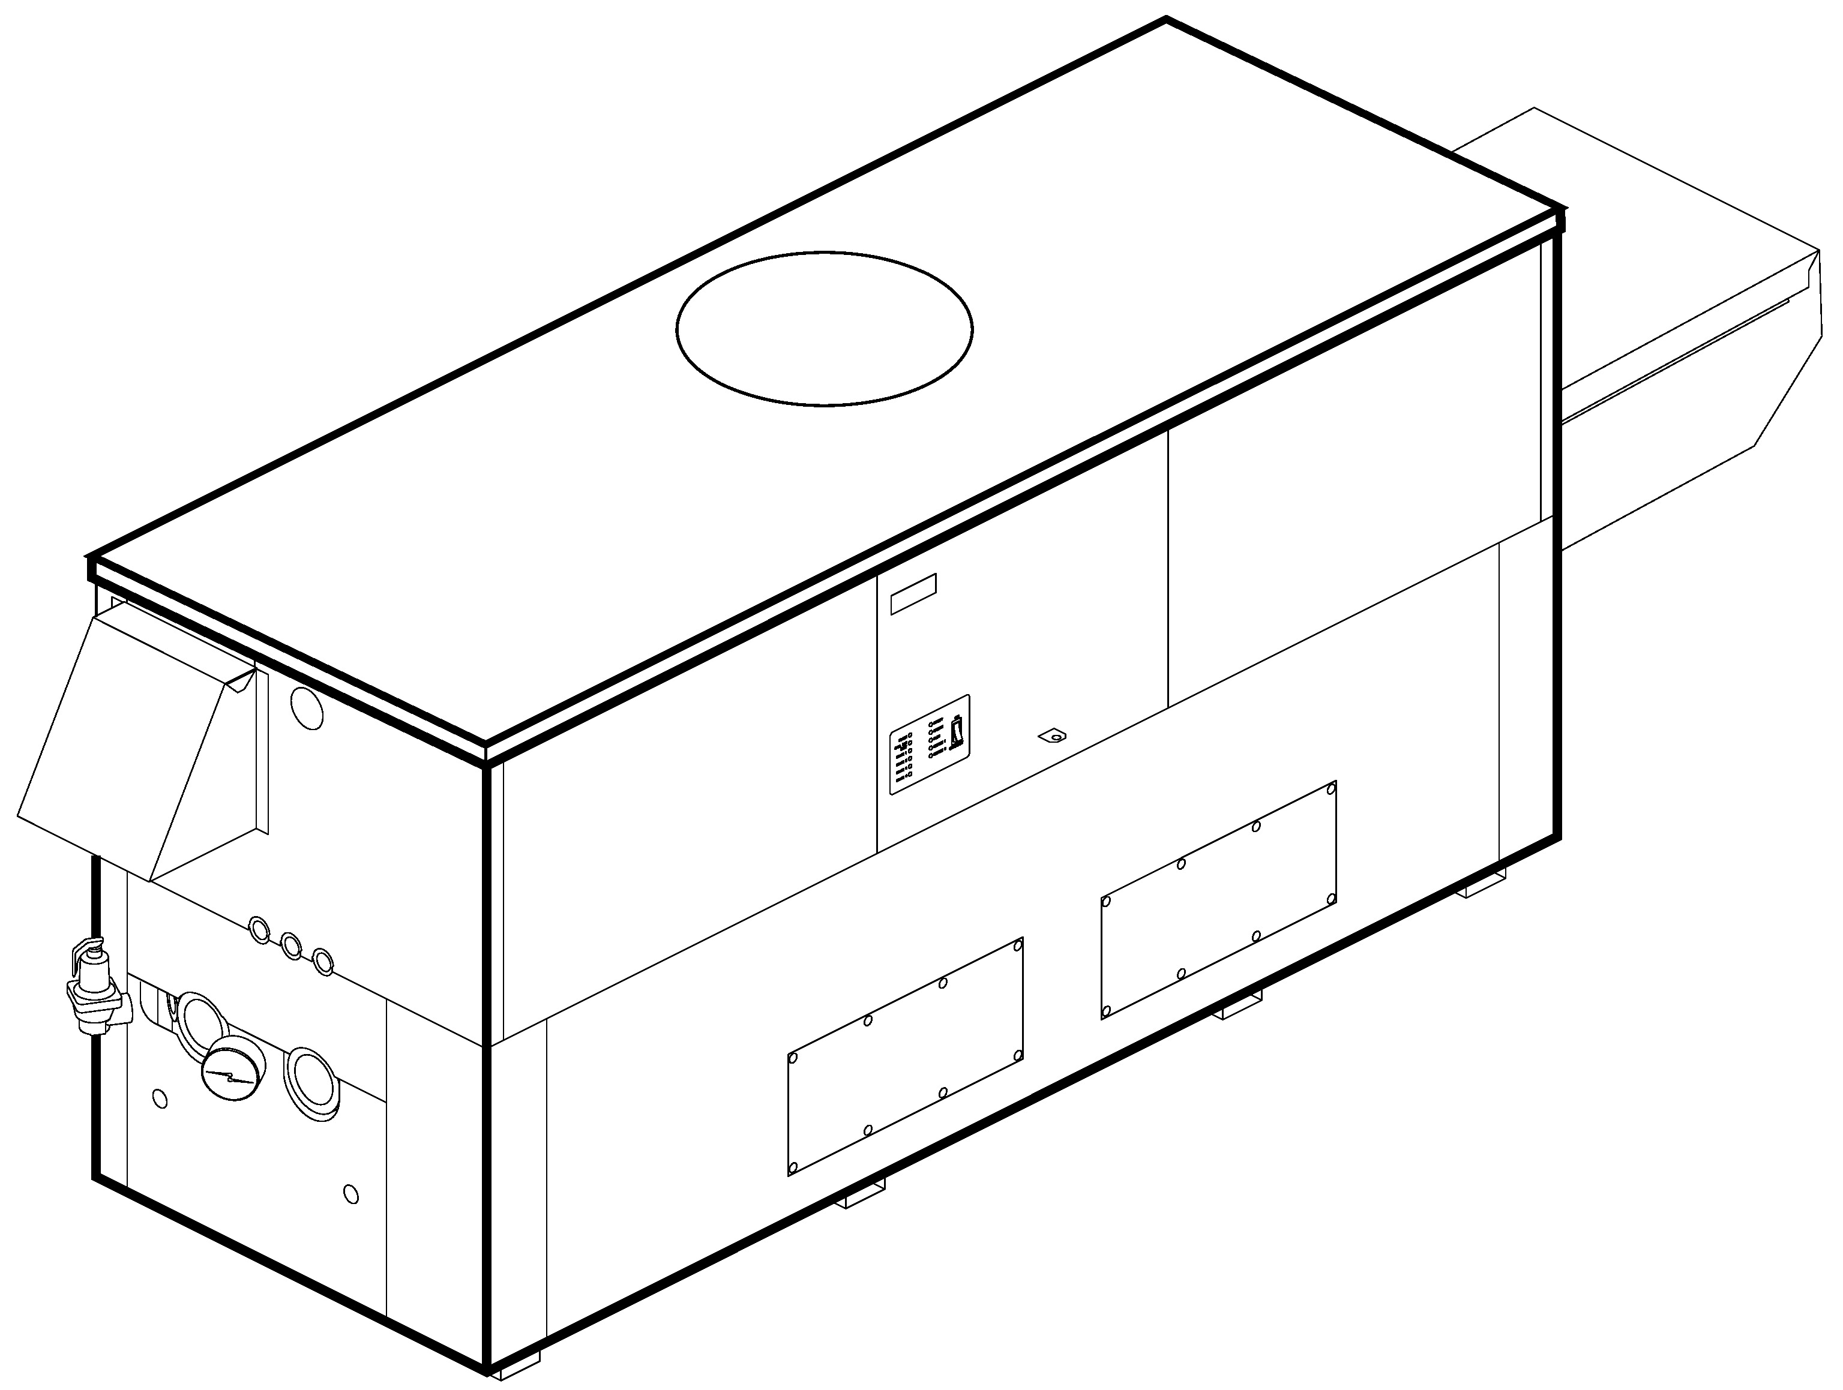
Patent No. 7,044,124

Heat Exchanger
- H Stamp
- Headers
Glass-Lined Cast Iron – Standard
Brass – Option A-1
- ASME Inspected and Stamped
160 PSIG Working Pressure
- National Board Approved
- Fin Tubing
Copper – Standard
Cupro Nickel – Option A-3
- ASME Steel Tube Sheet
- Silicone High Temp. O-Rings
- ASME Pressure Relief Valve
60 PSIG – Standard
PSIG – Optional
- Temperature and Pressure Gauge
- Water Connections
Left – Standard
Right – Option A-6

Controls
- 120V, 60Hz, 1∅ Power Supply
- 120/24V 60Hz Transformer
- 100% Shut-Off/Lockout
- Hot Surface Ignition
- Remote Flame Sensor
- High Limit Control, Manual Reset
- On/Off Power Switch
- Manual Shut-Off, Front-Mounted
- Flow Switch
- Blocked Vent Pressure Switch
- Combustion Air Proving Switches
- Economaster Pump Time Delay
- Enable/Disable
- Diagnostics Panel with LCD Display
2 Lines, 20 Characters

Gas Train
- Manual Gas Shut-Off Valve(s)
- Combo Valve(s)
- Low Gas Pressure Switch, Manual
- Firing Mode
3-Stage (H8): Model 992BE
4-Stage (H9): Models 1262BE -2342BE
- Fuel
Natural Gas
Propane Gas
- Design Certified ANSI Z21.13/
CSA 4.9

Construction
- Indoor/Outdoor Construction
- Enclosed Front Controls
- CSA Low Lead Certified (≤ .25 Pb)

Venting
- Vent Location
Top – Standard
Rear – Option D-14
- Vent Termination Cap
Outdoor D-11
Indoor, Horizontal D-15
Indoor, Vertical (by others)
- Combustion Air
In-Line Filter Kit (TruSeal only)
D-17
Air Intake Elbow D-16
- Extractor – Optional
By others
Not required


Burner
- Ultra-Low NOx: Less than 20 PPM

Temperature Controls
B- TempTracker Digital Controller, 2-Stage
B- TempTracker Digital Controller, 4-Stage
B- TempTracker Mod+ Hybrid (2-16 Boilers)
B-60 Stage Interface

Options
C-6 Ignition Module, Manual Reset
D-21 TruSeal® Direct Vent
F-10 Low Water Cut-Off, Remote Probe
I-1 High Limit Control, Auto Reset
P- Pump: HP, 120V, 1∅, 60Hz
Cast Iron Bronze
Mounted Loose
Front Rear
P- Cold Water Start (See 2000.49)
S-2 High Gas Pressure Switch, Manual
X-1 SureRack™ Kit
X-2 SureRack Add-on

Regulatory Agency Requirements
For Metric information, see Catalog

Hi Delta – Type H
Models 992BE-2342BE, 87% Efficiency Model

SPECIFICATIONS
 |  |  |  |  |  |  |  |  |  | Approx.
 | MBTUH |  | Firing | A | H | K | T | W | Amp. | Shipping
Model | Input | Output | Stages | Width | NPT |  |  |  | Draw* | Wt. (Lbs.)
992BE | 990 | 861 | 3 | 57-1/8 | 2-1/2 | 10 | 10 | 16-13/16 | <12 | 900
1262BE | 1260 | 1096 | 4 | 68-1/2 | 2-1/2 | 12 | 10 | 20-9/16 | <12 | 1010
1532BE | 1530 | 1331 | 4 | 79-7/8 | 2-1/2 | 12 | 10 | 24-3/8 | <12 | 1225
1802BE | 1800 | 1566 | 4 | 91-1/8 | 2-1/2 | 14 | 10 | 28-1/8 | <12 | 1350
2002BE | 1999 | 1739 | 4 | 102-1/2 | 2-1/2 | 14 | 10 | 31-15/16 | <12 | 1450
2072BE | 2070 | 1801 | 4 | 102-1/2 | 2-1/2 | 14 | 10 | 31-15/16 | <12 | 1450
2342BE | 2340 | 2036 | 4 | 113-7/8 | 2-1/2 | 16 | 10 | 35-11/16 | <12 | 1520
Dimensions are in inches. * Without pump
NOTE: Pump location varies based on model and application.
NOTES: 1. Rates shown are for natural or propane gas, and elevations up to 4,500 feet. For installation above 4,500 feet, please contact manufacturer.
2. Required natural gas pressure is 7 – 10.5” WC. Required propane gas pressure is 11 – 13” WC.

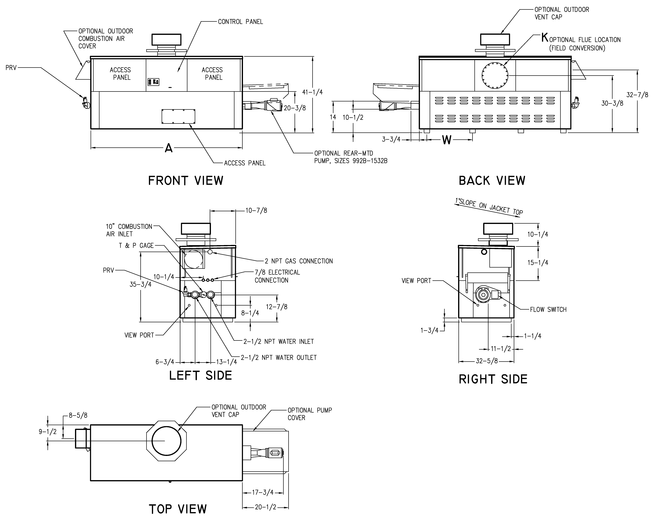

RATES OF FLOW AND PRESSURE DROPS

 | 20°F ∆T |  | 30°F ∆T |  | Min. Flow |  |  | Max. Flow
Model | GPM | ∆P (ft) | GPM | ∆P (ft) | GPM | ∆P (ft) | ∆T | GPM | ∆P (ft) | ∆T
992BE | 86 | 6.0 | 57 | 2.7 | 43 | 1.6 | 40 | 132 | 14.0 | 13
1262BE | 110 | 10.7 | 73 | 4.9 | 55 | 2.8 | 40 | 132 | 15.5 | 17
1532BE | 132 | 16.5 | 89 | 7.6 | 67 | 4.4 | 40 | 132 | 16.5 | 20
1802BE | N/A | N/A | 104 | 11.6 | 78 | 6.5 | 40 | 132 | 18.0 | 24
2002BE | N/A | N/A | 116 | 15.1 | 87 | 8.7 | 40 | 132 | 19.5 | 26
2072BE | N/A | N/A | 120 | 16.2 | 90 | 9.3 | 40 | 132 | 19.5 | 27
2342BE | N/A | N/A | N/A | N/A | 102 | 13.0 | 40 | 132 | 21.0 | 31
Basis is 30 GPM or 40°F ∆T for minimum flow, 132 GPM for maximum flow.
Raypak, Inc. ▪ 2151 Eastman Avenue, Oxnard, CA 93030 ▪ (805) 278-5300 ▪ Fax (800) 872-9725 ▪ www.raypak.com

