Job:

Hi Delta FlexGas® - Type WH

Dual-Fuel Water Heaters
Models 302BD-902BD

Engineer:
Contractor:
Prepared By: Date:
Model: Indoor/Outdoor: MBTUH Input:
Fast, Economical Natural-to-Propane Gas Switchover
100% Factory Fire Tested
85% Efficiency
Maximum Outlet Temperature: 200°F
Minimum Non-Condensing Inlet Temperature: 105°F
Thermal Shock Proof Heat Exchanger
Limited Twenty-Year Thermal Shock Warranty
Limited Five-Year Heat Exchanger Warranty
Diagnostic Center with Fault History
PolyTuf Powder Coated Cabinet
No Combustible Floor Shield Required
Patent Nos. 6,904,873 & 7,044,124; other patents pending

Fan-Assisted Low NOx Burners
Proudly Assembled in the USA

Patented Burner Security Blanket

Heat Exchanger
- HLW Stamp
- Headers
Bronze – Standard
Glass-Lined Cast Iron –
Option A-2
- ASME Inspected and Stamped
160 PSIG Working Pressure
- National Board Approved
- Fin Tubing
Copper – Standard
Cupro Nickel – Option A-3
- ASME Steel Tube Sheet
- Silicone High Temp. O-Rings
- ASME Pressure Relief Valve
125 PSIG – Standard
PSIG – Optional
- Temperature and Pressure Gauge
- Water Connections
Left – Standard
Right – Option A-6

Controls
- 120V, 60Hz, 1∅ Power Supply
- 120/24V 60Hz Transformer
- 100% Shut-Off/Lockout
- Hot Surface Ignition
- Remote Flame Sensor
- High Limit Control, Manual Reset
- On/Off Power Switch
- Manual Shut-Off, Front-Mounted
- Flow Switch
- Blocked Vent Pressure Switch
- Combustion Air Proving Switch
- Economaster Pump Time Delay
- Enable/Disable

Gas Train
- Manual Gas Shut-Off Valve(s)
- Gas Pressure Regulator
- Safety Shut-Off Valve
- Firing Control Valve
- Firing Mode
On/Off: Models 302BD-402BD
2-Stage: Models 302BD-902BD
- Natural/Propane Gas
- Gas Connection
Left – Standard
Right – Option Z-1
- Design Certified - ANSI Z21.10.3/
CSA 4.3

Construction
- Indoor/Outdoor Construction
- Front Controls Enclosed
- PolyTuf Powder Coat Finish
- CSA Low Lead Certified ≤ .25 Lead

Venting
- Vent Location
Top – Standard
Rear – Option D-14
- Vent Termination Cap
Outdoor D-11
Indoor, Horizontal D-15
Indoor, Vertical (by others)
- Combustion Air
In-Line Filter Kit (TruSeal
only) D-17
Air Intake Elbow D-16




- Extractor – Optional
By others
Not required

Burner
- Ultra-Low NOx: Less than 20 PPM

Temperature Controls
B-2 Tankstat, Single-Stage
(100-200°F)
B-3 Tankstat, 2-Stage (100-200°F)
B-21 TempTracker Digital Controller,
4-Stage
B- TempTracker Mod+ (Up to 16 Boilers)
B-60 Stage Interface

Options
C-6 Ignition Module, Manual Reset
D-21 TruSeal® Direct Vent
F-10 Low Water Cut-Off, Remote Probe
I-1 High Limit Control, Auto Reset
P- Pump, Bronze
HP, 120V, 1∅, 60Hz
Water Hardness: GPG
Mounted Loose
Front Rear
P- Cold Water Run (See 1000.19)
S-1 Low Gas Pressure Switch, Manual
S-2 High Gas Pressure Switch, Manual
X-1 SureRack™ Kit
X-2 SureRack Add-on
For Metric information, see Catalog

Regulatory Agency Requirements
For Metric information, see Catalog
For Metric information, see Catalog

Hi Delta FlexGas – Type WH
Models 302BD-902BD Model

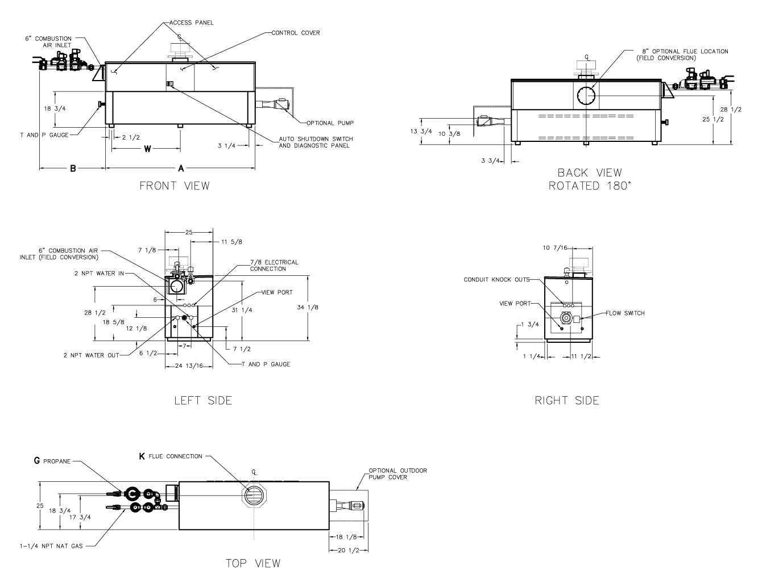
NOTE: Pump location varies based on model and application.
Model | RATES OF FLOW AND PRESSURE DROPS |  |  |  |  |  |  |  |  |  |  |  | RECOVERY RATES (GPH)
Model | 10°F ∆T |  | 20°F ∆T |  | 30°F ∆T |  | Min. Flow |  |  | Max. Flow |  |  | Temperature Rise (°F)
Model | GPM | ∆P (ft) | GPM | ∆P (ft) | GPM | ∆P (ft) | GPM | ∆P (ft) | ∆T | GPM | ∆P (ft) | ∆T | 20° | 30° | 40° | 50° | 60° | 70° | 80° | 90° | 100°
302BD | 52 | 3.3 | N/A | N/A | N/A | N/A | 40 | 2.0 | 13 | 90 | 9.8 | 6 | 1545 | 1030 | 773 | 618 | 515 | 442 | 386 | 343 | 309
402BD | 68 | 5.4 | N/A | N/A | N/A | N/A | 40 | 2.0 | 17 | 90 | 10.0 | 8 | 2055 | 1370 | 1028 | 822 | 685 | 587 | 514 | 457 | 411
502BD | 86 | 9.3 | 43 | 2.3 | N/A | N/A | 40 | 2.1 | 21 | 90 | 10.4 | 9 | 2576 | 1717 | 1288 | 1030 | 859 | 736 | 644 | 572 | 515
652BD | N/A | N/A | 56 | 4.2 | N/A | N/A | 40 | 2.2 | 28 | 90 | 10.8 | 12 | 3348 | 2232 | 1674 | 1339 | 1116 | 957 | 837 | 744 | 670
752BD | N/A | N/A | 64 | 5.3 | 42 | 2.6 | 42 | 2.6 | 30 | 90 | 11.3 | 14 | 3864 | 2576 | 1932 | 1545 | 1288 | 1104 | 966 | 859 | 773
902BD | N/A | N/A | 77 | 8.5 | 51 | 3.9 | 51 | 3.9 | 30 | 90 | 11.7 | 17 | 4636 | 3091 | 2318 | 1855 | 1545 | 1325 | 1159 | 1030 | 927
Basis is 40 GPM or 30°F ∆T for minimum flow, 90 GPM for maximum flow.
NOTES
1. Dimensions are in inches.
2. Rates shown are for natural or propane gas, and elevations up to 5,000 feet. For installation above 5,000 feet, please contact manufacturer.
3. Required natural gas supply pressure is 7 - 10.5” WC. Required propane gas supply pressure is 11 - 13” WC.

SPECIFICATIONS
 |  |  |  |  |  |  |  |  |  |  |  | Approx.
 | MBTUH |  | A | B | G - NPT |  | K |  | W |  | Amp. | Shipping
Model | Input | Output | Width |  | Pro. |  |  |  |  |  | Draw* | Wt. (Lbs)
302BD | 300 | 255 | 36 | 41 | 3/4 |  | 5 |  | 18 |  | 6 | 405
402BD | 399 | 339 | 43 | 41 | 3/4 |  | 6 |  | 18-1/2 |  | 6 | 470
502BD | 500 | 425 | 50 | 35-1/2 | 1-1/4 |  | 6 |  | 22 |  | 6 | 570
652BD | 650 | 553 | 60-1/2 | 30-1/2 | 1-1/4 |  | 8 |  | 27-1/4 |  | 6 | 615
752BD | 750 | 638 | 67-1/2 | 27-1/2 | 1-1/4 |  | 8 |  | 30-3/4 |  | 6 | 700
902BD | 900 | 765 | 78 | 34-1/2 | 1-1/4 |  | 8 |  | 36 |  | 7 | 765
* Without pump
Raypak, Inc. ▪ 2151 Eastman Avenue, Oxnard, CA 93030 ▪ (805) 278-5300 ▪ Fax (800) 872-9725 ▪ www.raypak.com

