Job:

Condensing Heat Exchanger (CHX)

For use with the
Advanced Design Boiler™
Engineer:
Contractor:
Prepared By: Date:
Model:

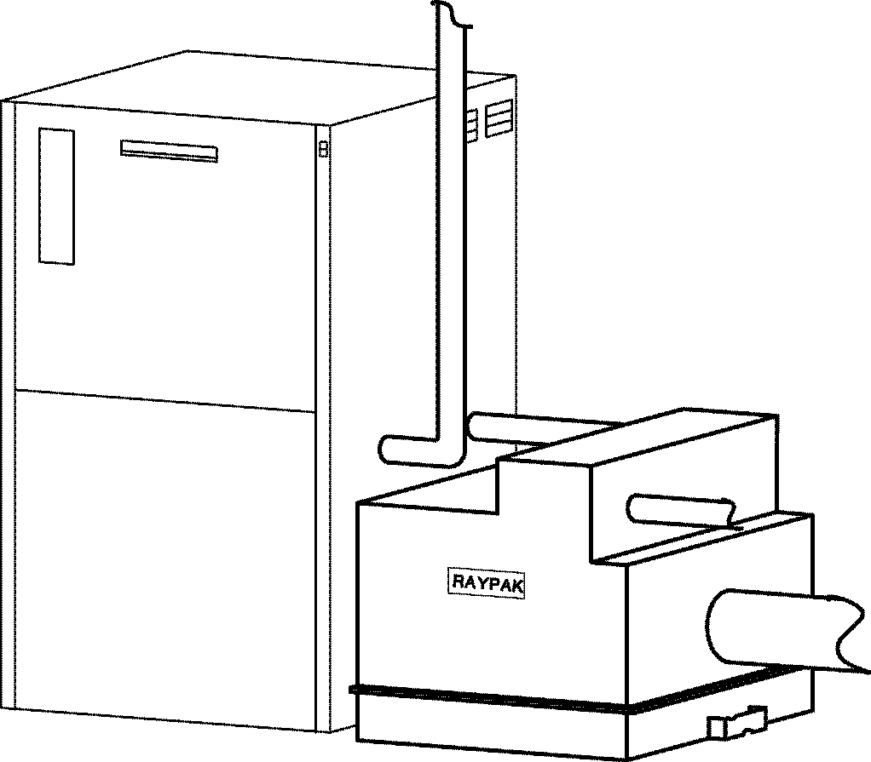

Exclusively for use with Raypak’s
ADVANCED DESIGN BOILER™

Boosts ADB efficiency to 98%!
The Raypak Condensing Heat Exchanger utilizes exhaust heat, which is normally wasted, and converts it to useful energy that increases overall operating efficiency.

Applications
- Hydronic Space Heating
- Hot Water Supply
- Pool Heating
Advanced Design Boiler with CHX

FEATURES

- Finned cupro nickel tubes
- Patented epoxy coating
- All bronze headers
- AL29-4C Stainless Steel casing
- Polytuf powder coating on outer shell
- AL29-4C Stainless Steel vent adapter between the CHX and Advanced Design Boiler included
- ASME tested to 150 PSIG working pressure
- Traditional Raypak tube sheet design with high-temperature silicone O-rings

- Condensate drain connection
- Indoor/outdoor construction
- Limited 20 year thermal shock warranty
- Footprint: less than 4.8 ft2
- Ten-year limited warranty
- National Board approved





Condensing Heat Exchanger (CHX) Model

MODEL | FITS ADB MODEL | A  WIDTH | B*  HEIGHT | F* | P* | U* | M* | T  NPT | K | H  NPT | X  MIN. | Y | Z | ZZ  MIN. | SHIP WT. (Lbs.)
CHX 500 | ADB 500 | 23-1/4 | 24-11/16 | 18-3/4 | 11 | 22-1/4 | 13-3/4 | 1/2 | 6 | 2 | 28 | 8-3/8 | 3-1/2 | 54 | 250
CHX 750 | ADB 750 | 23-1/4 | 30-11/16 | 24-1/8 | 15 | 27-3/4 | 16-1/2 | 1/2 | 8 | 2 | 28 | 9-3/4 | 3-1/4 | 54 | 275
CHX 1000 | ADB 1000 | 28-3/4 | 39 | 33 | 21-5/8 | 36-5/8 | 20-5/8 | 1/2 | 10 | 2-1/2 | 34 | 10-7/8 | 7-1/4 | 64 | 300
CHX 1500 | ADB 1500 | 34-1/4 | 49 | 42 | 19-1/2 | 46 | 20 | 3/4 | 12 | 2-1/2 | 36 | 14 | 3-1/2 | 64 | 350
Dimensions are in inches.
*These heights can be increased up to 2" using adjustable feet.

RATE OF FLOW AND PRESSURE DROP
ADB WITH CHX
ADB/CHX MODEL | 20˚F T |  | 30˚F T |  | 40˚F T |  | MAX. FLOW |  |  | MIN. FLOW
ADB/CHX MODEL | GPM | P | GPM | P | GPM | P | GPM | P | T | GPM | P | T
500 | 49 | 4.5 | 32 | 2.3 | N/A | N/A | 84 | 11.5 | 12˚F | 30 | 2.1 | 32˚F
750 | 73 | 10.0 | 49 | 5.2 | 36 | 3.5 | 110 | 22.1 | 13˚F | 32 | 2.4 | 45˚F
1000 | 97 | 20.7 | 65 | 10.3 | 49 | 6.8 | 110 | 26 | 18˚F | 42 | 5.2 | 46˚F
1500 | N/A | N/A | 97 | 26.6 | 73 | 15.8 | 126 | 41.8 | 23˚F | 73 | 15.8 | 41˚F

CHX
MODEL 500 | GPM | 30 | 33 | 42 | 52 | 84
MODEL 500 | P (Ft.) | 0.5 | 0.6 | 0.9 | 1.1 | 2.7

MODEL 750 | GPM | 32 | 37 | 42 | 50 | 63 | 77 | 110
MODEL 750 | P (Ft.) | 0.6 | 1.2 | 1.3 | 1.4 | 1.8 | 2.5 | 5.1

MODEL 1000 | GPM | 42 | 51 | 56 | 66 | 84 | 97 | 110
MODEL 1000 | P (Ft.) | 1.1 | 1.6 | 1.8 | 2.8 | 4.4 | 5.1 | 6.0

MODEL 1500 | GPM | 73 | 97 | 126
MODEL 1500 | P (Ft.) | 4.8 | 6.0 | 9.4

Ratings based on Natural gas and Propane gas.
Natural gas pressure recommended to be between 7 & 14” w.c.
Propane gas pressure recommended to be between 11 & 14” w.c.
Raypak, Inc., 31111 Agoura Road, Westlake Village, CA 91361-4699 (818) 889-1500 FAX: (818) 889-4522
Raypak Canada LTD., 2805 Slough Street, Mississauga, Ontario, Canada/L4T 1G2 (905) 677-7999 FAX: (905) 677-8036
Raypak Australia Pty. Ltd, 7 Geddes Street, Mulgrave, Victoria, Australia 3170 (6139) 560 4944 FAX: (6139) 560 4974
www.raypak.com
Litho in U.S.A.
Raypak, Inc. ▪ 2151 Eastman Avenue, Oxnard, CA 93030 ▪ (805) 278-5300 ▪ Fax (800) 872-9725 ▪ www.raypak.com

