Job:

XFyre® - Type H

Condensing Heating Boilers
Models 300A-850A

Engineer:

Contractor:
Prepared By: Date:
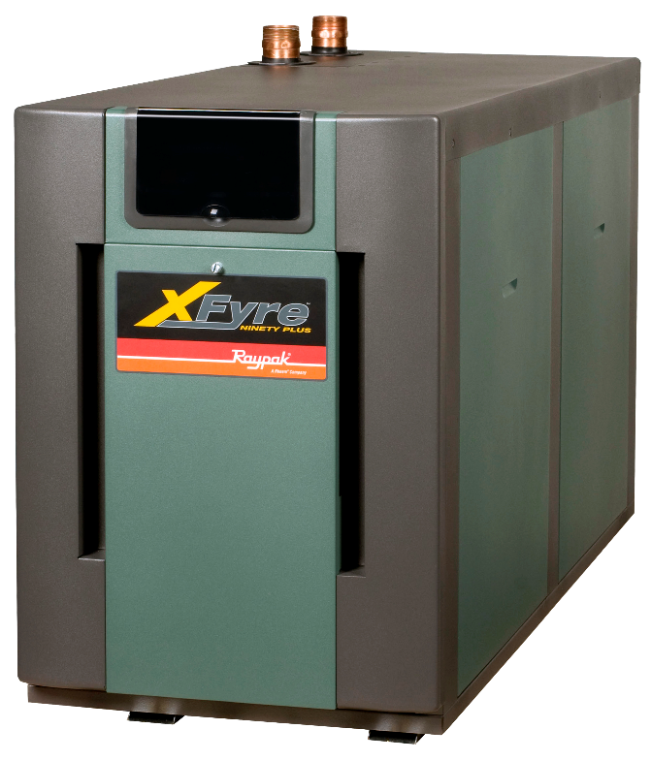
Model: Indoor/Outdoor:
Stainless Steel Water-tube Construction
94% Thermal Efficiency at Full Rate
VERSA IC® Modulating Controller
LCD Status Display with Full Diagnostics and Fault Memory
Cascade up to Four Heaters – No External Sequencer Required
Modbus RTU BMS Port
Soft Start, Electronic Modulation, 5:1 Turndown
Maximum Outlet Water Temperature: 195ºF
Maximum System Temperature: 190ºF
100% Factory Fire Tested
Zero Clearance to Combustibles
Indoor/Outdoor Construction Standard
PVC, CPVC, Centrotherm™ Polypropylene or Stainless Venting Certified¹
Meets 2012 NOx Requirements (< 20 ppm)

Limited Twenty-Five-Year Thermal Shock Warranty
Proudly Assembled in the USA

Limited Ten-Year Heat Exchanger Warranty

Heat Exchanger
- All Stainless Steel Construction with Copper Connections
- Gasketless Heat Exchanger Design
- ASME H Stamped
160 PSIG Working Pressure
- National Board Approved
- ASME Pressure Relief Valve, Loose
45 PSIG – Standard (300 & 400)
60 PSIG – Standard (500 – 850)
PSIG – Optional
- Temperature and Pressure Gauge,
Shipped Loose

Control
- 120V, 60Hz, 1Ø, Power Supply
- VERSA IC with LCD display
- Outdoor Reset with Indirect Priority
- 0-10 VDC input for BMS
- Cascade up to 4 boilers
- Remote Flame Sensor
- High Limit, Manual Reset, Fixed, 200ºF
- Alarm Dry Contact Connection
- On/Off Power Switch
- Flow Switch
- Blocked Vent Pressure Switch
- Boiler, DHW & System Pump Contacts
- Water Temperature Sensors (5)10kΩ (3 shipped loose)

Burner
- Spark Ignition (DSI)
- Ultra-Low NOx: Less than 20 PPM

Gas Train
- Fuel
Natural Gas
Propane
- Dual-Seat Combination Valve
- H7 Electronic Modulating Firing Mode

Construction
- Indoor/Outdoor Construction
- Front Controls Enclosed
- PolyTuf Powder Coat Finish
- Rear Connections (Electrical, Gas, Vent, Combustion Air)
- Top Connections (Water)
- Design Certified ANSI Z21.13/
CSA 4.9
- Combustion Air Filter
- Condensate Trap
- CSA Low Lead Certified (≤.25% Pb)

Venting (PVC-CPVC-Centrotherm™ Polypropylene - Stainless¹)
- Vent Termination
D-11 Outdoor
D-15 Indoor, Horizontal
D-33 Polypropylene Adapter
- Extractor - Optional
By others
Not required

Multi-Boiler System Controllers
B-36 TempTracker Mod+ Hybrid Digital
Controller, 2-4 Boilers, OA Reset
B-37 TempTracker Mod+ Hybrid Digital
Controller, 5-10 Boilers, OA Reset
B-38 TempTracker Mod+ Hybrid Digital
Controller, 11-16 Boilers, OA Reset

Options
B-31 Well Assembly
B-32 Outdoor Air Sensor (1) 10kΩ
D-21 TruSeal® Combustion Air Inlet (Mounted)
D-22 TruSeal® Combustion Air Inlet (Loose)
F-10 Low Water Cut-Off, Remote Probe
P- Pump: HP, 120V, 1∅, 60Hz
Cast Iron
Bronze/SS
S-1/S-2 High/Low Gas Pressure Switch,
Manual Reset
Z-12 Condensate Neutralizer Kit

Regulatory Agency Requirements



Note 1: PVC venting on Models H7-700A and H7-850A is acceptable with system temperatures below 130°F only.
See I & O Manual Cat. 1000.65

XFyre® – Type H

Models 300A-850A Model

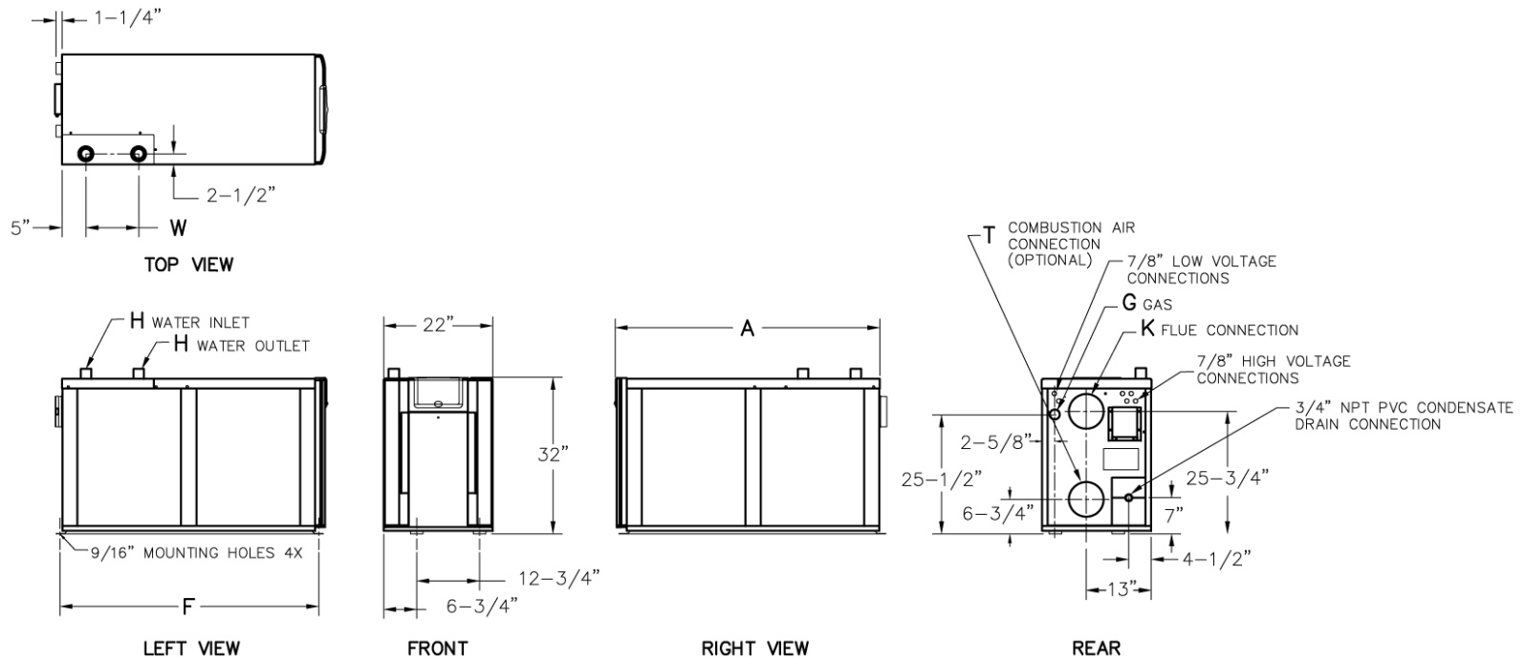

 | CLEARANCES (in.)
 | Certified  Minimum | Service  Minimum
Front | 24 | 24
Rear | 24 | 24
Right | 0 | 0
Left | 0 | 0
Top | 12 | 24
Floor | 0 | --
Vent | 1 | --

Model  (H7-) | MBTUH |  | Dimensions (in.)
Model  (H7-) | Input | Output | A  Length | F  Mounting | G  NPT | H  NPT | K  Flue Ø | T  C/A Ø | W  (Water)
300A | 300 | 282 | 28-1/4 | 27-9/16 | 3/4 | 1-1/2 | 4 | 4 | 8-1/2
400A | 399 | 375 | 30-3/4 | 32-5/16 | 1 | 2 | 4 | 4 | 7
500A | 500 | 470 | 37-1/4 | 36-9/16 | 1 | 2 | 4 | 4 | 8-1/2
700A | 700 | 658 | 47-3/4 | 49-5/16 | 1-1/4 | 2 | 6 | 6 | 10-5/8
850A | 850 | 799 | 54-1/4 | 53-9/16 | 1-1/4 | 2 | 6 | 6 | 10-5/8

RATES OF FLOW AND PRESSURE DROPS
Model  (H7-) | 20ºF ∆T |  | 30ºF ∆T |  | 35ºF ∆T |  | Min Flow |  |  | Max Flow
Model  (H7-) | GPM | ∆P** | GPM | ∆P** | GPM | ∆P | GPM | ∆P** | ∆T | GPM | ∆P** | ∆T
300A | 28 | 17 | 19 | 8 | 16 | 6 | 14 | 5 | 39 | 36 | 28 | 16
400A | 38 | 18 | 25 | 7 | 21 | 5 | 19 | 4 | 39 | 47 | 29 | 16
500A | 47 | 16 | 31 | 7 | 27 | 5 | 24 | 4 | 39 | 56 | 23 | 17
700A | 66 | 30 | 44 | 13 | 38 | 9 | 34 | 7 | 39 | 70 | 34 | 19
850A* | 80 | 40* | 53 | 17 | 46 | 12 | 41 | 10 | 39 | 80 | 40 | 20
Model  (H7-) | Amps* | Foot-  Print  (ft²) | Ship  Weight  (lbs.)
300A | 3 | 4.3 | 410
400A | 4 | 4.7 | 465
500A | 4 | 5.7 | 505
700A | 5 | 7.3 | 580
850A | 5 | 8.3 | 580
* Closed systems only
** Connected plumbing pressure drops are not included.
* Current draw is for heater only.
(Supply breaker must have delayed trip.)

