Job:

Hi Delta® FlexGas® - Type H

Dual-Fuel Hot Water Boilers
Models 992BD-2342BD

Engineer:

Contractor:
Prepared By: Date:
Model: Indoor/Outdoor: MBTUH Input:

Fast, Economical Natural-to-Propane Gas Switchover
100% Factory Fire Tested
84% Efficiency
Maximum Outlet Temperature: 230°F
Minimum Non-Condensing Inlet Temperature: 105°F
Thermal Shock Proof Heat Exchanger
Limited Twenty-Year Thermal Shock Warranty
Diagnostic Center with Fault History
PolyTuf Powder Coated Cabinet
No Combustible Floor Shield Required
Patent Nos. 6,904,873 & 7,044,124; other patents pending
Fan-Assisted Low NOx Burners

Proudly Assembled in the USA

Patented Burner Security Blanket

Heat Exchanger
- H Stamp
- Headers
Glass-Lined Cast Iron – Standard
Bronze – Option A-1
- ASME Inspected and Stamped
160 PSIG Working Pressure
- National Board Approved
- Fin Tubing
Copper – Standard
Cupro Nickel – Option A-3
- ASME Steel Tube Sheet
- Silicone High Temp. O-Rings
- ASME Pressure Relief Valve
60 PSIG – Standard
PSIG – Optional
- Temperature and Pressure Gauge
- Water Connections
Left – Standard
Right – Option A-6

Controls
- 120V, 60Hz, 1∅ Power Supply
- 120/24V 60Hz Transformer
- 100% Shut-Off/Lockout
- Hot Surface Ignition
- Remote Flame Sensor
- High Limit Control, Manual Reset
- On/Off Power Switch
- Manual Shut-Off, Front-Mounted
- Flow Switch
- Blocked Vent Pressure Switch
- Combustion Air Proving Switches
- Economaster Pump Time Delay
- Enable/Disable

Gas Train
- Manual Gas Shut-Off Valve(s)
- Combination Valve(s)
- Low Gas Pressure Switch, Manual
- Firing Mode
3-Stage (H8): Model 992BD
4-Stage (H9): Models 1262BD -
2342BD
- Natural/Propane Gas
- Gas Connection
Left – Standard
Right – Option Z-1
- Design Certified ANSI Z21.13/
CSA 4.9

Venting
- Vent Location
Top – Standard
Rear – Option D-14
- Vent Termination Cap
Outdoor D-11
Indoor, Horizontal D-15
Indoor, Vertical (by others)
- Combustion Air
In-Line Filter Kit (TruSeal only)
D-17
Air Intake Elbow D-16
- Extractor – Optional
By others
Not required

Construction
- Indoor/Outdoor Construction
- Enclosed Front Controls
- CSA Low Lead Certified (≤ .25 Pb)


Burner
- Ultra-Low NOx: Less than 20 PPM

Temperature Controls
B- TempTracker Digital Controller, 2-Stage
B- TempTracker Digital Controller, 4-Stage
B- TempTracker Mod+ Hybrid (2-16 Boilers)
B-60 Stage Interface

Options
C-6 Ignition Module, Manual Reset
D-21 TruSeal® Direct Vent
F-10 Low Water Cut-Off, Remote Probe
I-1 High Limit Control, Auto Reset
P- Pump: HP, 120V, 1∅, 60Hz
Cast Iron Bronze
Mounted Loose
Front Rear
P- Cold Water Start (See 2000.49)
S-2 High Gas Pressure Switch, Manual
X-1 SureRack™ Kit
X-2 SureRack Add-on

Regulatory Agency Requirements
For Metric information, see Catalog

Hi Delta FlexGas – Type H
Models 992BD-2342BD Model

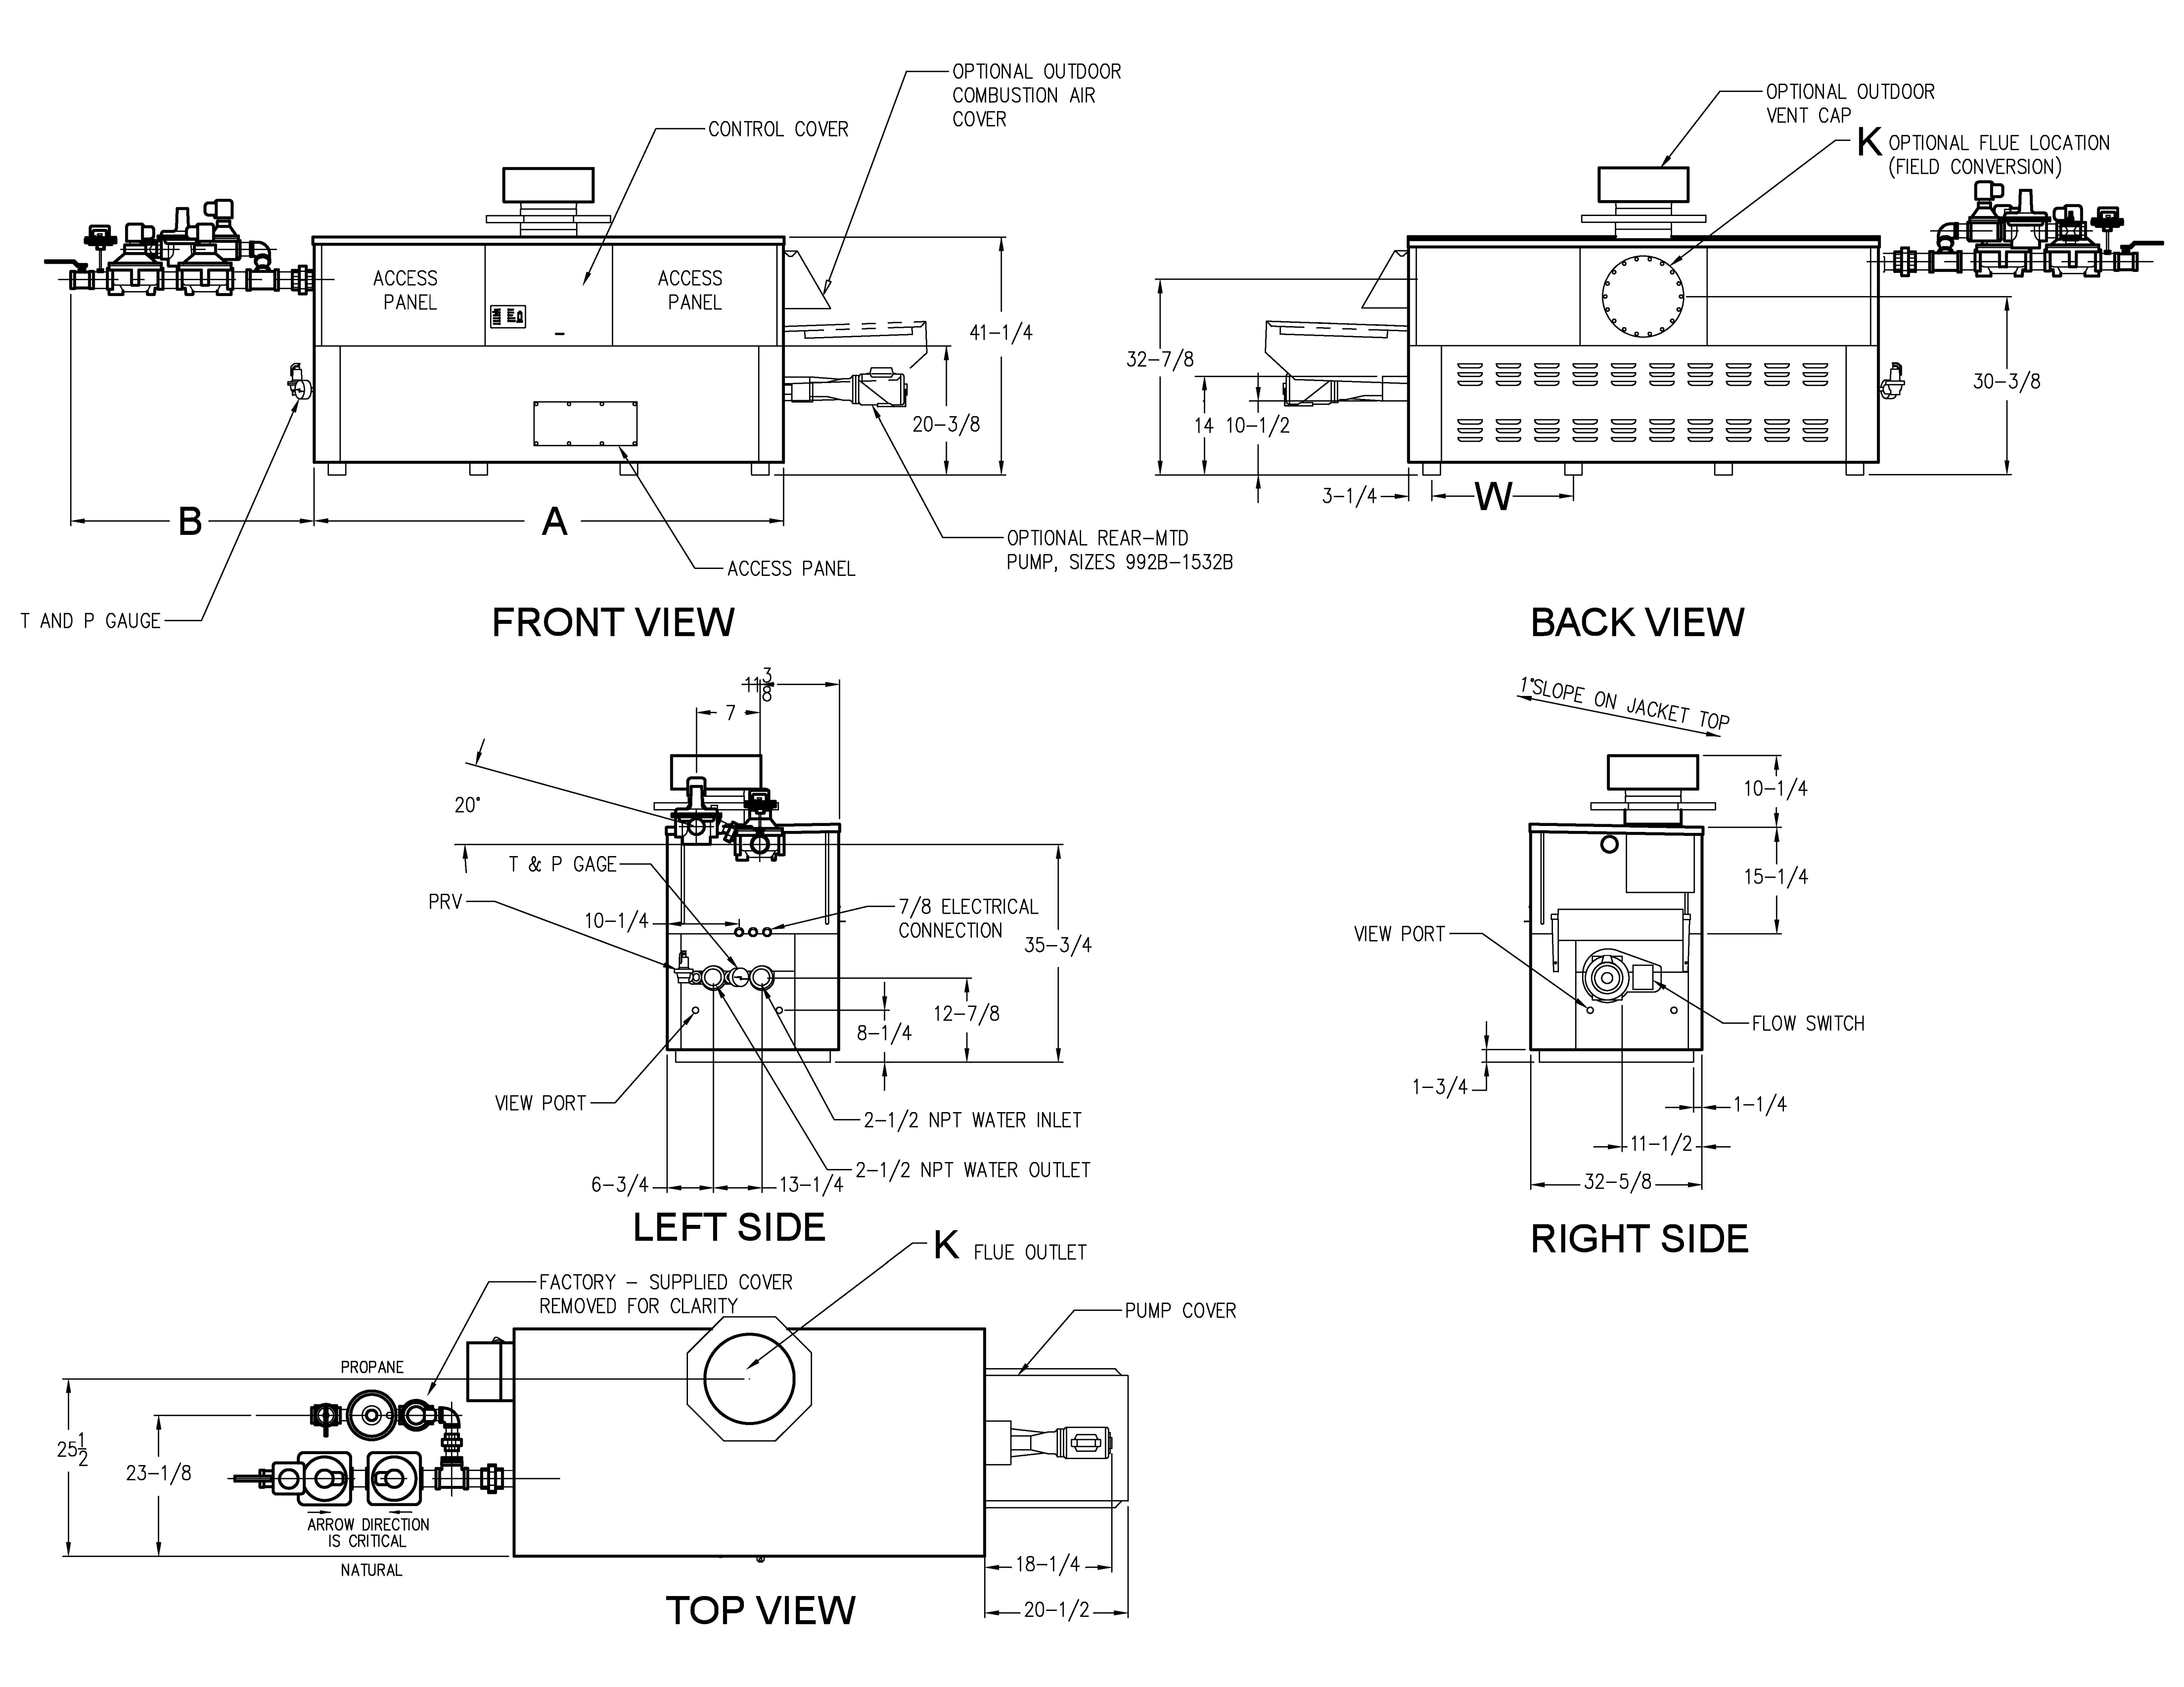
RATES OF FLOW AND PRESSURE DROPS
NOTE: Pump location varies based on model and application
Raypak, Inc. 2151 Eastman Avenue, Oxnard, CA 93030 (805) 278-5300 Fax (800) 872-9725 www.raypak.com
Model | 20ºF ΔT |  | 30ºF ΔT |  | Min. Flow |  |  | Max. Flow
Model | GPM | ΔP (FT) | GPM | ΔP (FT) | GPM | ΔP (FT) | ΔT | GPM | ΔP (FT) | ΔT
992BD | 84 | 5.6 | 56 | 2.5 | 42 | 1.5 | 40 | 132 | 14.0 | 13
1532BD | 107 | 10.0 | 71 | 4.5 | 53 | 2.6 | 40 | 132 | 15.5 | 16
1802BD | 130 | 16.0 | 86 | 7.1 | 65 | 4.1 | 40 | 132 | 16.5 | 20
2072BD | N/A | N/A | 117 | 15.0 | 88 | 8.7 | 40 | 132 | 19.5 | 27
2342BD | N/A | N/A | 132 | 21.0 | 99 | 12.0 | 40 | 132 | 21.0 | 30
Basis is 30 GPM or 40ºF ΔT for minimum flow, 132 GPM for maximum flow.
NOTES:
1. Dimensions are in inches.
2. Rates shown are for natural or propane gas, and elevations up to 4,500 feet. For installation above 4,500 feet, please contact manufacturer.
3. Required natural gas supply pressure is
7 - 10.5” WC. Required propane gas supply pressure is 11 - 13” WC.
Model | MBTUH |  | Firing  Stages | A  Width | B | K | T | W | Amp  Draw* | Approx.  Shipping  Wt. (Lbs.)
Model | Input | Output
992BD | 990 | 832 | 3 | 57-1/8 | 41-3/8 | 10 | 10 | 16-3/16 | <12 | 930
1262BD | 1260 | 1058 | 4 | 68-1/2 | 41-1/2 | 12 | 10 | 20-9/16 | <12 | 1040
1532BD | 1530 | 1285 | 4 | 79-7/8 | 36 | 12 | 10 | 24-3/8 | <12 | 1255
1802BD | 1800 | 1512 | 4 | 91-1/8 | 33-1/2 | 14 | 10 | 28-1/8 | <12 | 1380
2072BD | 2070 | 1739 | 4 | 102-1/2 | 39 | 14 | 10 | 31-15/16 | <12 | 1480
2342BD | 2340 | 1966 | 4 | 113-7/8 | 34 | 16 | 10 | 35-11/16 | <12 | 1550
*Without Pump

