Job:

Power Vent

For Raytherm®
Models 514-1826
Engineer:
Contractor:
Prepared By: Date:

Versatile
Suitable for use with hydronic heating boilers and hot water heaters
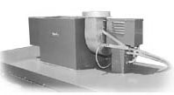
Permits sidewall venting
Allows use of smaller diameter vent pipe
Efficient
Maintains thermal efficiency of 82% on all appliance sizes
Multi-Position Capability
Fan discharge adjusts to match position of
vent pipe, reducing number of fittings
Draft Control
Barometric damper provides overfire draft
when necessary

Features
- Induced draft
- Barometric damper
- Plenum sized for appliance capacity
- Pre-wired and mounted, or shipped loose for field installation
- Air flow proving switch, mounted and wired
- Fan motor relay, mounted and wired
- Heavy-duty galvanized steel cabinet
- Polytuf powder coat finish
- Indoor construction

- Easy installation
- Limited one-year warranty

Options
Shipped loose for field mounting
Shipped mounted on unit

Power Vent

For Raytherm 514 - 1826 Model

FIVE DIFFERENT DISCHARGE POSITIONS
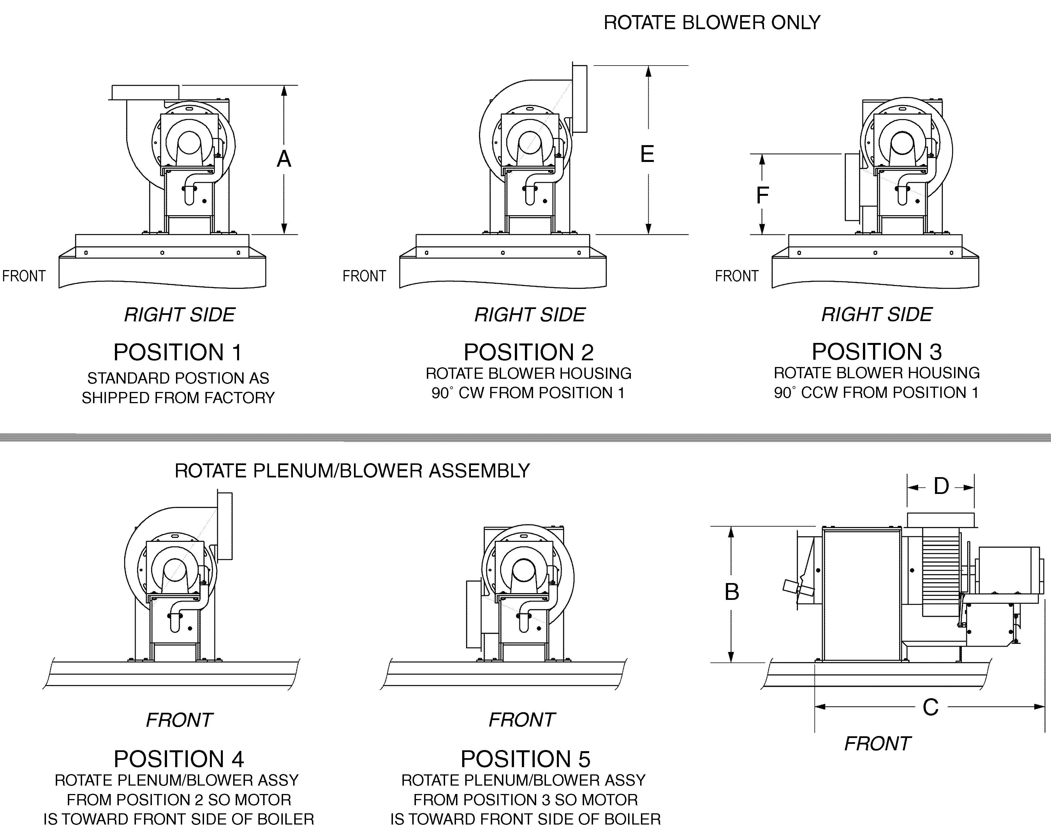

Raytherm Model | MBTU | Max. Run (ft.) |  | Dimensions (in.) |  |  |  |  |  | Electrical Ratings at 120V |  |  | Max. CFM @ 70ºF
Raytherm Model | MBTU | Vert. | Horiz. | A | B | C | D | E | F | W/out Pump | W/ Pump | HP | Max. CFM @ 70ºF
514 | 512 | 20 | 40 | 17-7/8 | 15-7/8 | 20 | 8 | 20-1/4 | 9-3/4 | < 10 Amps | < 16 Amps | 1/3 | 925
624 | 627 | 20 | 22 | 17-7/8 | 15-7/8 | 20 | 8 | 20-1/4 | 9-3/4 | < 10 Amps | < 16 Amps | 1/3 | 925
724 | 726 | 20 | 13 | 17-7/8 | 15-7/8 | 20 | 8 | 20-1/4 | 9-3/4 | < 10 Amps | < 16 Amps | 1/3 | 925
824 | 825 | 20 | 22 | 17-7/8 | 15-7/8 | 20 | 8 | 20-1/4 | 9-3/4 | < 10 Amps | < 16 Amps | 1/3 | 925
962 | 962 | 20 | 12 | 17-7/8 | 15-7/8 | 20 | 8 | 21-13/16 | 11-5/16 | < 10 Amps | < 16 Amps | 1/3 | 925
1125 | 1125 | 20 | 5* | 17-7/8 | 15-7/8 | 20 | 8* | 21-13/16 | 11-5/16 | < 10 Amps | < 16 Amps | 1/3 | 925
1223 | 1223 | 20 | 4** | 17-7/8 | 15-7/8 | 20 | 8** | 21-13/16 | 11-5/16 | < 10 Amps | < 16 Amps | 1/3 | 925
1336 | 1336 | 20 | 21 | 21 | 18-5/8 | 42 | 10 | 23-1/2 | 12-1/2 | < 18 Amps | < 24 Amps | 1 | 1425
1468 | 1468 | 20 | 15 | 21 | 18-5/8 | 42 | 10 | 23-1/2 | 12-1/2 | < 18 Amps | < 24 Amps | 1 | 1425
1631 | 1631 | 20 | 10 | 21 | 18-5/8 | 42 | 10 | 23-1/2 | 12-1/2 | < 18 Amps | < 24 Amps | 1 | 1425
1826 | 1826 | 20 | 5* | 21 | 18-5/8 | 42 | 10* | 23-1/2 | 12-1/2 | <18 Amps | < 24 Amps | 1 | 1425
* Maximum horizontal run can be increased to 70 ft. by using one size larger vent pipe. The larger pipe must be used starting at the power vent outlet. (Transition piece not supplied by Raypak.)
** Maximum horizontal run can be increased to 32 ft. by using two sizes larger vent pipe. The larger pipe must be used starting at the power vent outlet. (Transition piece not supplied by Raypak.)

NOTES: 1. Vent pipe sizes are based on: standard vertical discharge, using one 90° elbow and one tee with a 90° turn; 300°F nominal flue temperature; and sea-level operation. For installation under other conditions, please consult the factory.
2. Flue pipe must meet Category III appliance venting requirements.
3. Follow installation instructions provided by power vent manufacturer.
4. Vent terminal should be installed with the motor on the right or front side of the boiler.
5. Overhang dimensions extend over front of appliance, but do not exceed service clearances.
Raypak, Inc. ▪ 2151 Eastman Avenue, Oxnard, CA 93030 ▪ (805) 278-5300 ▪ Fax (800) 872-9725 ▪ www.raypak.com

