Job:

TempTracker™
2- and 4-Stage Controllers

For Hi Delta® and Raytherm® Boilers & Water Heaters

Engineer:
Contractor:
Prepared By:
Date:

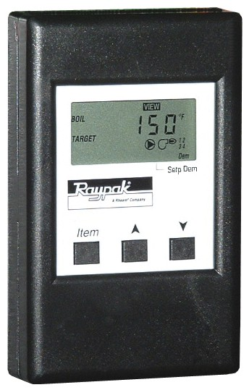
TempTracker is designed to sequence multiple boilers up to four total stages, whether it’s one to four on/off boilers, two two-stage boilers, or one boiler with up to four stages. It is available factory-mounted or loose on Hi Delta boilers, and loose on Raytherm boilers. This control can be used for space heating and hot water supply with six application-specific modes to meet various applications, including outdoor reset for heating systems. It monitors and displays inlet and outlet temperatures on all applications as well as monitors outdoor temperature when an outdoor reset mode is utilized.

Features
- 1-4 boilers/stages
- Selectable P or PID logic
- LCD display
- NEMA 1 enclosure
- Boiler-in and boiler-out water sensors
- System water sensor
- Outdoor air sensor
(Models B-27 and B-23)
- Alarm ready (pilot duty)
- 24 VAC, 60 Hz, 3 VA Supply Power
- Relay Ratings
Stage 1: 5A @ 120 VAC
Stages 2 to 4: 3A @ 120 VAC


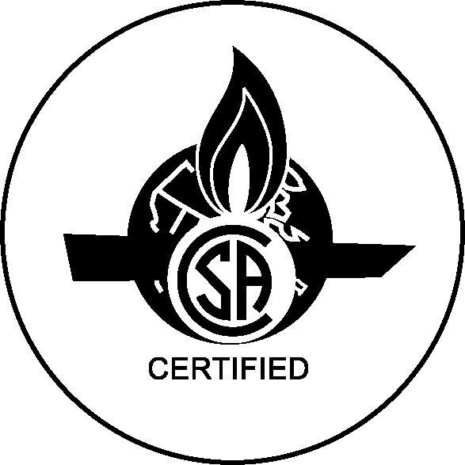
Programmable Functions
- 6 programming modes
- Adjustable outdoor reset
- Min. system water temperature (70 °F)
- Max. system water temperature
  - Heating – 220 °F
  - DHW – 190 °F
- Temperature differential (2 to 42 °F)
- Boiler target (70 to 220 °F)
- Outdoor cutoff (35 to 85 °F)
- Boiler mass (low, med, high)
- Stage-on delay (P mode)
(10 sec. to 8 min.)
- System pump-off delay (0 to 20 min.)
- Temperature measurement (°F or °C)

Model Information
B-26 2-stage setpoint
B-27 2-stage outdoor reset
B-21 4-stage setpoint
B-23 4-stage outdoor reset

Raypak, Inc. ▪ 2151 Eastman Avenue, Oxnard, CA 93030 ▪ (805) 278-5300 ▪ Fax (800) 872-9725 ▪ www.raypak.com

