Job: ______________

TempTracker Mod+ Hybrid™
Modulating Controllers

For Controlling Raypak Condensing and/or Non-Condensing Boilers and Water Heaters

Engineer: ______________
Contractor: ______________
Prepared By: ______________
Date: ______________
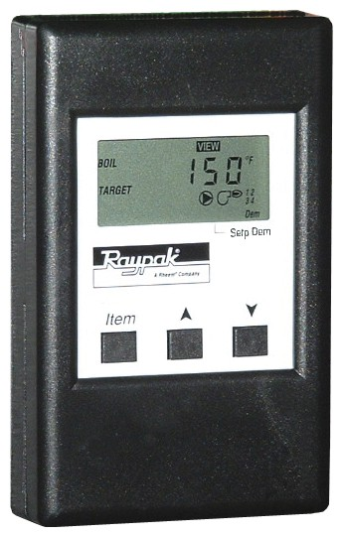
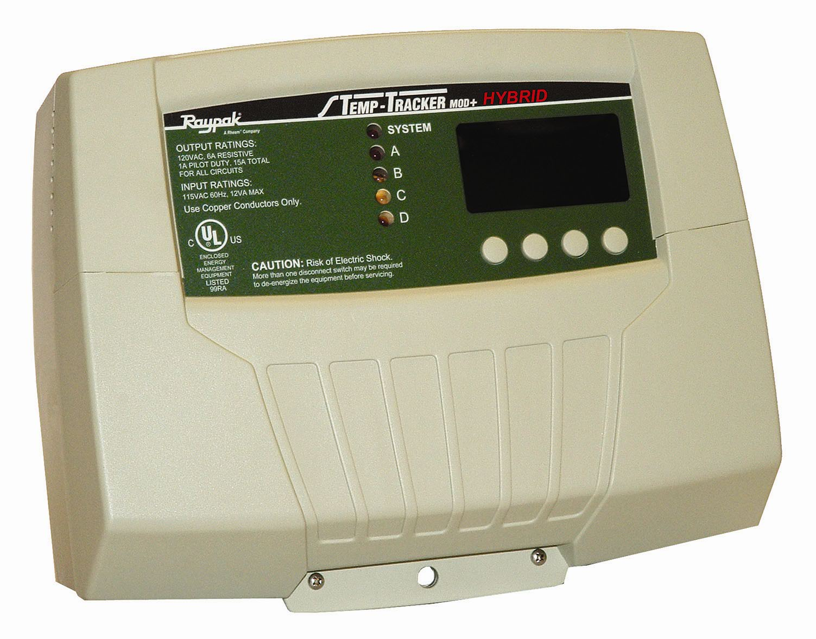
TempTracker Mod+ Hybrid is designed to sequence multiple condensing and/or non-condensing boilers up to 16 total units in a single system, and is capable of controlling Raypak modulating or stage-fired boilers. It is available loose with Hi Delta, Raytherm, MVB, XTherm and XFyre boilers and water heaters. This control can be used for space heating and hot water supply, including outdoor reset for heating systems. It monitors and displays system temperatures on all applications as well as monitors outdoor temperature when an outdoor sensor is utilized.

Proudly Made in the USA

Features
- 1-4 boilers/stages
- Lead/Lag Rotation
- PID logic
- 5 LED Status Lights
- LCD digital display
- System Pump Relay – Pilot Duty
- Remote Thermostat Connection
- NEMA 1 enclosure
- System water sensor
- Outdoor air sensor
- Reset Ratio 1:4 to 4:1
- 120 VAC, 60 Hz, 12 VA Supply Power
- Relay Ratings
1A Inductive, 6A Resistive at 120 VAC, 60 Hz
15A total for all circuits

Programmable Functions
- Adjustable outdoor reset
- 4-20 mA or 0-10 VDC output
- System water temperature
  - Heating – 50º - 220 °F
  - Temp to Indirect DHW – 140º - 200 °F
- Switch differential (5º to 20 °F)
- Outdoor cutoff (20 to 100 °F)
- Indirect Domestic Hot Water with/without Priority
- System pump-off delay (0 to 360 min.)
- Temperature measurement (°F or °C)
- BACnet compatible (requires B-62)

Model Information
B-36 Up to 4 Units
B-37 Up to 10 Units
B-38 Up to 16 Units

Options
B-39 4-20mA Remote Set Point
B-62 BACnet MS/TP


Specifications
Voltage Input: . . . . . . 120 VAC 60 Hz
Power Consumption: . . . . . 12 VA Max
Operating Temperature: . . . . 20°F/-6°C to 130°F/54°C
Operating Humidity: . . . . . 20% to 80% non-condensing
Dimensions: . . . . . . 11"W x 9" H x 3 ¾" D
Weight: . . . . . . . 2.5 pounds

TempTracker MOD+ Hybrid Specifications
Pump Output: . . . . . . 1 N.O. S.P.S.T
Modulating Boiler Modes: . . . . Auto, Manual, Standby, On, Off
Staging Boiler Modes: . . . . . Auto, Standby, On, Off
Modulating Output Types: . . . . 4-20mA and 0-10V
Sequencing Output Types: . . . . On/Off, 2-Stage, 3-Stage, or 4-Stage
Output Relay Ratings: . . . . . 1 Amp inductive (⅛ HP), 6 Amp resistive at 120 VAC

Add-On Extension Panels: . . . . up two Extension Panels using RS485 (RJ45 or RJ11)
Modulation Modes: . . . . . Normal or Parallel
Sequencing Modes: . . . . . Lo/Hi/Lo/Hi or Lo/lo/Hi/Hi
Temperature Display: . . . . . Fahrenheit or Celsius
Display: . . . . . . Graphical Alphanumeric (up to 7 rows x 21 char. each)
LED: . . . . . . . 1 System Output relay, 4 Boiler Output relays
Outdoor Cutoff Range: . . . . . 20°F/-6°C to 100°F, ON and OFF
Reset Ratio Range: . . . . . (1:4) to (4:1) (Outdoor : System Water)
Minimum Water Temperature: . . . . 50°F/10°C to 170°F/77°C
Maximum Water Temperature: . . . . 90°F/32°C to 240°F/116°C
Indirect Domestic Hot Water: . . . . with Priority or without Priority
Schedules: . . . . . . 1 Day and 1 Night (Setback) setting per day
Night Setback: . . . . . . 0°F°/0°C° to 75°F°/42°C°
Power Backup: . . . . . . Lithium coin battery, 100 days minimum 5 year

External Inputs: . . . . . Shutdown, Tstat, and Setback Input, and Prove and

Extension Specifications
(Each Extension can add up to (6) additional boiler stages. A maximum of two Extensions can be used.)
Boiler Outputs: . . . . . . (6) N.O. S.P.S.T.
Modulating Output Types: . . . . (6) 4-20mA and 0-10V
Output Relay Ratings: . . . . . 1 Amp inductive (⅛ HP), 6Amp resistive at 120 VAC 6

Connection to TempTracker mod+ Hybrid and another extension:
Two RS485 connections using 6 wire RJ11 cable (Cable is provided)
DHW Call Input. (Dry Contacts Only)
replacement (Maintains Clock in power outages)
DHW Call Input. (Dry Contacts Only)
60 Hz, 15 A total for all circuits
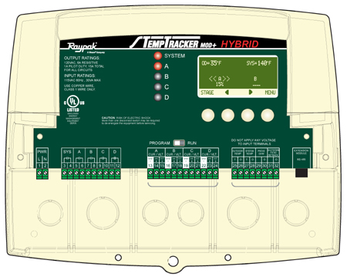
9”
11” TYP
