Job:

Raytherm® - Type WH

Water Heaters
Commercial

Models 2100 - 4001
Engineer:
Contractor:
Prepared By:
Model: Indoor Date:
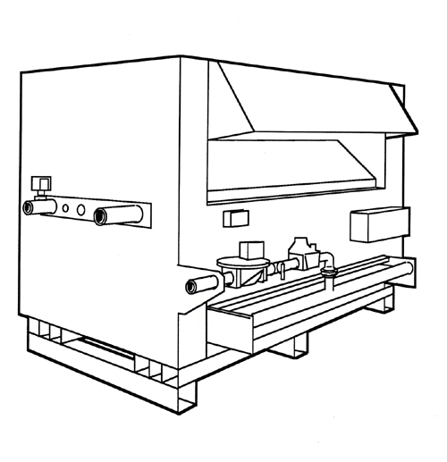
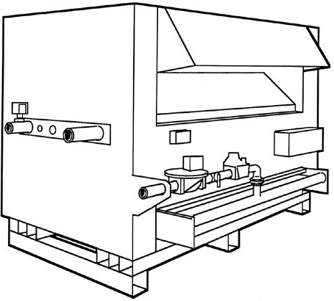
Efficient
82% thermal efficiency

Thermal shock proof
- Limited 25-year thermal shock warranty

- Lightweight
- A floor load of 70 lbs./sq. ft. or less
Dependable
- The simple atmospheric design provides a low cost and long life solution.

- Low water operating temperature

- Operates with water temperature as low as 105°F
without condensing
Proudly Assembled in the USA

Heat exchanger
- ASME HLW Stamped; 160 PSIG MAWP
- National Board
- Headers
Bronze (standard)
A-2 Glass-lined cast iron (optional)
- Fin tubing
Copper (standard)
A-3 Cupronickel (optional)
- ASME Steel tube sheet
- Silicone O-Rings
- Pressure relief valve
125 PSIG ASME (standard)
A-15 150 PSIG PRV (optional)
- T&P Gauge
- Water connections
Left hand (standard)
A-6 Right hand (optional)
- Two-pass Flow Configuration

Controls
- 120V, 60Hz, 1 Ph Power Supply
- 120/24V Transformer
- 100% Pilot shut-off/lockout
- Electronic, Intermittent Ignition (IID) Pilot
- High limit control, manual reset – 200°F
- High limit control, auto reset – 200°F
Models 3001-4001
- On/off switch
- Flow switch
- Economaster II pump time delay


Gas control train
- Manual main gas shut-off valve
- Main gas pressure regulator
- Redundant safety shut-off valve
- Control valve
- Firing mode
WH-1 On/off
WH-3 2-stage firing

- Fuel
Natural gas
Propane gas (min. grade HD-5)
- Design Certified ANSI Z21.10.3

Construction
- Front controls
- Stainless steel burners
- Baked enamel paint
- Built-in draft diverter
- Draft inducer (optional)
D-2 Motorized draft inducer –
indoor
- CSA Low Lead Certified ≤ .25% Lead

Water heater controllers
Required on Model WH2 only
B-2 Single-stage tankstat
(100-180°F), loose (WH1)
B-3 2-Stage tankstat (100-180°F), loose (WH3)
B-21 4-Stage digital (WH3)
B-26 2-Stage digital (WH3)
B-40 TempTracker MOD
modulating controller mounted (WH3)

Additional safety controls
F-9 Low water cut-off probe
I-3 High limit control, auto reset, 180°F
S-1 Low gas pressure switch, manual
S-2 High gas pressure switch, manual (standard on models 3001-4001)

Regulatory agency requirements

Raytherm - Type WH

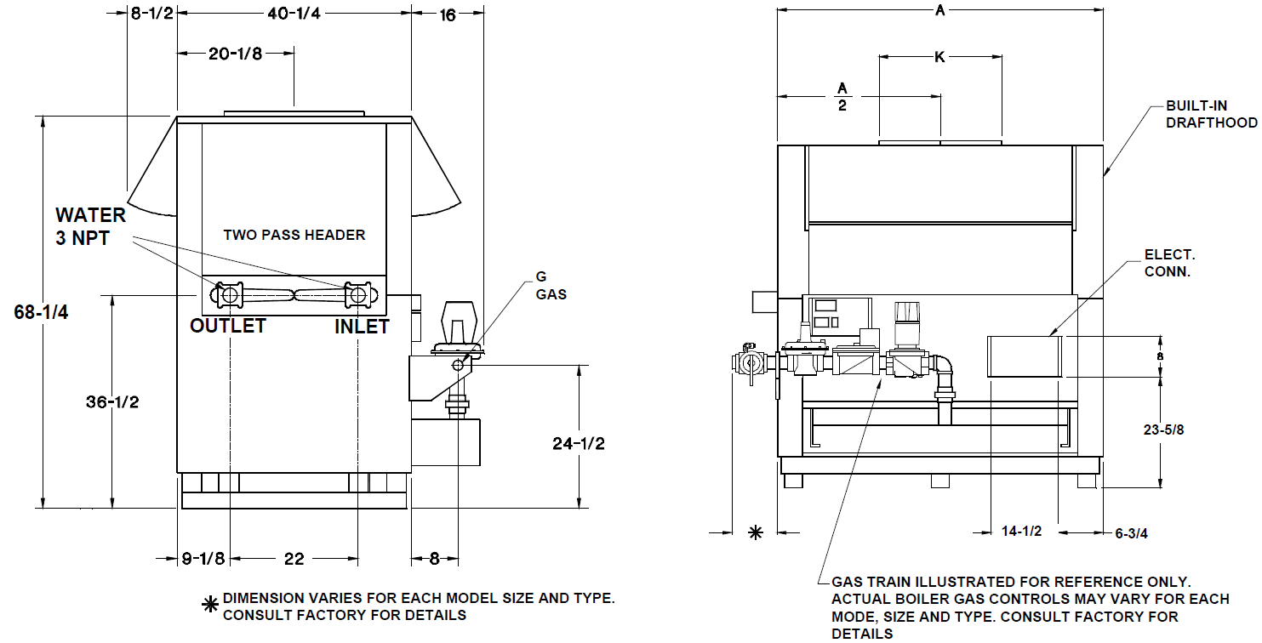
Models 2100-4100 Model
Models 2100 - 4001
Model | MBTUH (kW)  Natural & Propane Gas |  | Dimensions in. (mm) |  |  |  | Electrical Rating | Approx. Shipping Weight (Lbs.)
Model |  |  | Width | Gas Conn. | Water Conn. | Flue  Dia | Less than 8.0 amps without pump  at 120VAC | Approx. Shipping Weight (Lbs.)
Model | Input | Output | A | G | H | K | Less than 8.0 amps without pump  at 120VAC | Approx. Shipping Weight (Lbs.)
H-2100 | 2100  (615) | 1722  (505) | 61  (1549) | (a) | 3 (b) | 24 | Less than 8.0 amps without pump  at 120VAC | 1400
H-2500 | 2499  (732) | 2049.2  (601) | 70  (1778) | (a) | 3 (b) | 26 | Less than 8.0 amps without pump  at 120VAC | 1580
H-3001 | 3000  (879) | 2460  (721) | 81-1/4  (2064) | 2 | 3 (b) | 28 | Less than 8.0 amps without pump  at 120VAC | 1750
H-3500 | 3500  (1026) | 2870  (841) | 92-1/2  (2350) | 2 | 3 (b) | 30 | Less than 8.0 amps without pump  at 120VAC | 1920
H-4001 | 4000  (1172) | 3280  (961) | 103-3/4  (2635) | 2 | 3 (b) | 32 | Less than 8.0 amps without pump  at 120VAC | 2100
NOTE: Ratings are for elevations up to 2,000 feet. For  elevations over 2,000 feet, reduce ratings 4% for  every 1,000 feet above sea level |  |  |  |  | (a) 1-1/2” or 2” contingent on boiler type code requirements  (b) 4” on one-pass option

HEATER RATES OF FLOW AND PRESSURE DROPS
Model  No. | 20°F ΔT |  | 30°F ΔT |  | 40°F ΔT
Model  No. | GPM | ΔP (ft) | GPM | ΔP (ft) | GPM | ΔP (ft)
WH-2100 | 172 | 11.0 | 115 | 4.9 | N/A | N/A
WH-2500 | N/A | N/A | 137 | 7.5 | 102 | 4.3
WH-3001 | N/A | N/A | 164 | 11.2 | 123 | 6.5
WH-3500 | N/A | N/A | 191 | 16.8 | 144 | 9.3
WH-4001 | N/A | N/A | N/A | N/A | 164 | 12.8

HEATER RECOVERY RATES (GPH)
Model  No. | Temperature Rise
Model  No. | 20°F | 30°F | 40°F | 50°F | 60°F | 80°F | 100°F
WH-2100 | 10336 | 6890 | 5168 | 4134 | 3445 | 2584 | 2067
WH-2500 | 12300 | 8200 | 6150 | 4920 | 4100 | 3075 | 2460
WH-3001 | 14765 | 9844 | 7383 | 5906 | 4922 | 3691 | 2953
WH-3500 | 17227 | 11484 | 8613 | 6891 | 5742 | 4301 | 3445
WH-4001 | 19688 | 13125 | 9844 | 7875 | 6563 | 4922 | 3938

Note: Maximum acceptable flow through heat exchanger tubes is 200 GPM.
For water hardness between 16 & 25 GPG, a Cupro Nickel heat exchanger is required. For water hardnesses above 25 GPG, a softener/treatment system must be used.
MODELS WH 2100 – 4001
Model  No. | MBTUH |  | Width | Overall Height | Gas Conn. | Water Conn. | Flue  Dia. | Approx. Shipping Weight (lbs)
Model  No. | Input | Output | A | B | G | H | K | Approx. Shipping Weight (lbs)
WH-2100 | 2100 | 1722 | 61 | 68-1/4 | * | 3 | 24 | 1400
WH-2500 | 2499 | 2049 | 70 | 68-1/4 | * | 3 | 26 | 1580
WH-3001 | 3000 | 2460 | 81-1/4 | 68-1/4 | 2 | 3 | 28 | 1750
WH-3500 | 3500 | 2870 | 92-1/2 | 68-1/4 | 2 | 3 | 30 | 1920
WH-4001 | 4000 | 3280 | 103-3/4 | 68-1/4 | 2 | 3 | 32 | 2100
* 1-1/2” or 2”, contingent on water heater type code requirements
NOTES: Dimensions are in inches.
Ratings are for elevations up to 2,000 feet. For elevations over 2,000 feet, reduce ratings 4% for every 1,000 feet above sea level.

Raypak, Inc. ▪ 2151 Eastman Avenue, Oxnard, CA 93030 ▪ (805) 278-5300 ▪ Fax (805) 278-5468 ▪ www.raypak.com
Models | Electrical Rating
Models | W/Pump | W/O Pump
2100-4001 | 951276 pump* 11 Amps @ 230VAC | < 8 Amp @ 120VAC
2100-4001 | 22 Amps @ 110VAC | < 8 Amp @ 120VAC

* Pump requires separate power supply

