Job:

Hi Delta® FlexGas® - Type H

Dual-Fuel Hot Water Boilers
Models 302CD-902CD

Engineer:

Contractor:
Preparer: Date:
Model: Indoor/Outdoor: MBTUH Input:
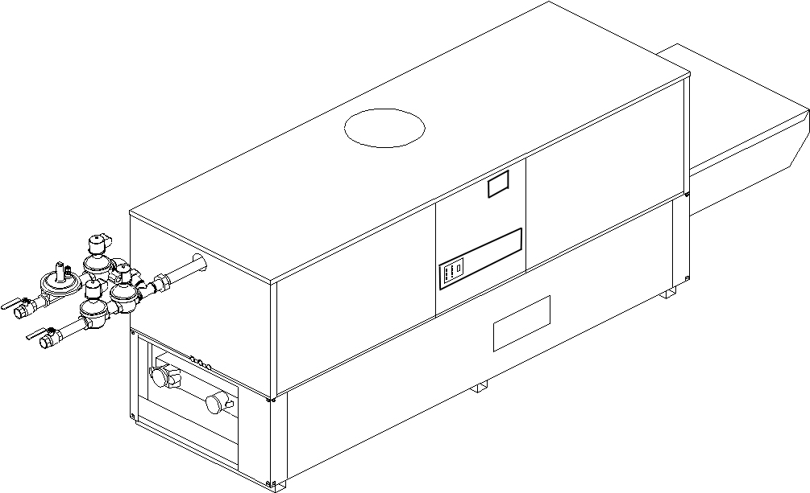
- 100% Factory Fire Tested
- Fast, Economical Natural-to-Propane Gas Switchover
- Thermal Efficiency: 85%
- Versa IC® Controller with LCD Display
- Maximum Setpoint: 220°F
- Maximum Outlet Temperature: 240°F
- Minimum Non-Condensing Inlet Temperature: 105°F
- Thermal Shock Proof Heat Exchanger
- Limited Twenty-Year Thermal Shock Warranty
- Limited Ten-Year Closed Loop Heat Exchanger Warranty
- Full Safety Diagnostics with Fault History
- PolyTuf Powder Coated Cabinet
- No Combustible Floor Shield Required
Patent Nos. 6,904,873 & 7,044,124; other patents pending
- Fan-Assisted

Proudly Assembled in the USA

- Patented Burner Security Blanket
- Ultra-Low NOx – SCAQMD 1146.2 Certified
- Cascade up to 4 Heaters – No External Sequencer Required

Heat Exchanger
- Headers
Glass-Lined Cast Iron – Standard
A-1 Bronze
- ASME Inspected and Stamped
160 PSIG Working Pressure
- National Board Approved
- Fin Tubing
Copper – Standard
A-3 Cupro-Nickel
- ASME Steel Tube Sheet
- Silicone High Temp. O-Rings
- ASME Pressure Relief Valve
45 PSIG – Standard on Models 302CD and 402CD
60 PSIG – Standard on Models 502CD-902CD
PSIG – Optional
- Temperature and Pressure Gauge
- Water Connections
Left – Standard
A-6 Right

Controls
- 120V, 60Hz, 1∅ Power Supply
- 120/24V 60Hz Transformer
- Versa IC® Integrated Control
- 100% Shut-Off/Lockout
- Hot Surface Ignition
- Ignition Module
3-Try – Standard
C-6 Single Try
- Remote Flame Sensor
- Fixed High Limit, Manual Reset 240°F
- On/Off Power Switch
- Flow Switch
- Blocked Vent Pressure Switch
- Combustion Air Proving Switch
- Programmable Pump Time Delays
- Heater
- Recirculation
Enable/Disable

- LCD Display; Status, Fault and Diagnostics
- Cold Water Protection Function
CWR Variable-Speed Pump
(See Cat. 5000.73)
CWS 3-Way Valve
(See Cat. 5000.73)
- Modbus RTU BMS Port (Up to 115K Baud,
B-85 – BMS Gateway – BACnet MS/TP, BACnet IP, N2 Metasys or Modbus TCP
- B-86 – BMS Gateway – LonWorks

Gas Train
- Manual Gas Shut-Off Valve(s)
- Gas Pressure Regulator
- Safety Shut-Off Valve
- Firing Control Valve
- Firing Mode 2-Stage (H3)
- Fuel
Natural Gas
Propane Gas (HD-5)
G – 20 4” WC Nat Supply
- Design Certified - ANSI Z21.13/CSA 4.9

Construction
- Indoor/Outdoor Construction
- Front Controls Enclosed
- PolyTuf Powder Coat Finish
- CSA Low Lead Certified ≤ .25% Lead

Venting
- Vent Location
Top – Standard
D-14 Rear
- Vent Termination Cap
D-11 Outdoor
D-15 Indoor, Horizontal
Indoor, Vertical (by others)
- Combustion Air
D-17 In-Line Filter Kit (TruSeal
only)
D-16 Air Intake Elbow

- Extractor – Optional
By others

Not required

Burner
- Ultra-Low NOx: Less than 20 PPM (NAT)

Options
C-6 Ignition Module, Manual Reset
D-21 TruSeal® Direct Vent
F-10 Low Water Cut-Off, Remote Probe
I-1 High Limit Control, Auto Reset
P- Pump: HP, 120V, 1∅, 60Hz
Cast Iron Bronze
Mounted Loose
Front Rear
P- Cold Water Start (See 2000.48)
P- Cold Water Run (See 2000.48)
S-1 Low Gas Pressure Switch, Manual
S-2 High Gas Pressure Switch, Manual
X-1 SureRack® Kit
X-2 SureRack Add-on
For Metric information, see Catalog

Additional Options or Accessories
For Metric information, see Catalog

Multi-Boiler Temperature Controllers
TempTracker Mod+ Hybrid
B-36, 2-4 Heaters
B-37, 5-10 Heaters
B-38, 11-16 Heaters
B-39 EMS 4-20mA Remote Setpoint Interface Module
B-62 BACnet MS/TP Interface

Hi Delta FlexGas – Type H

Models 302CD-902CD Model

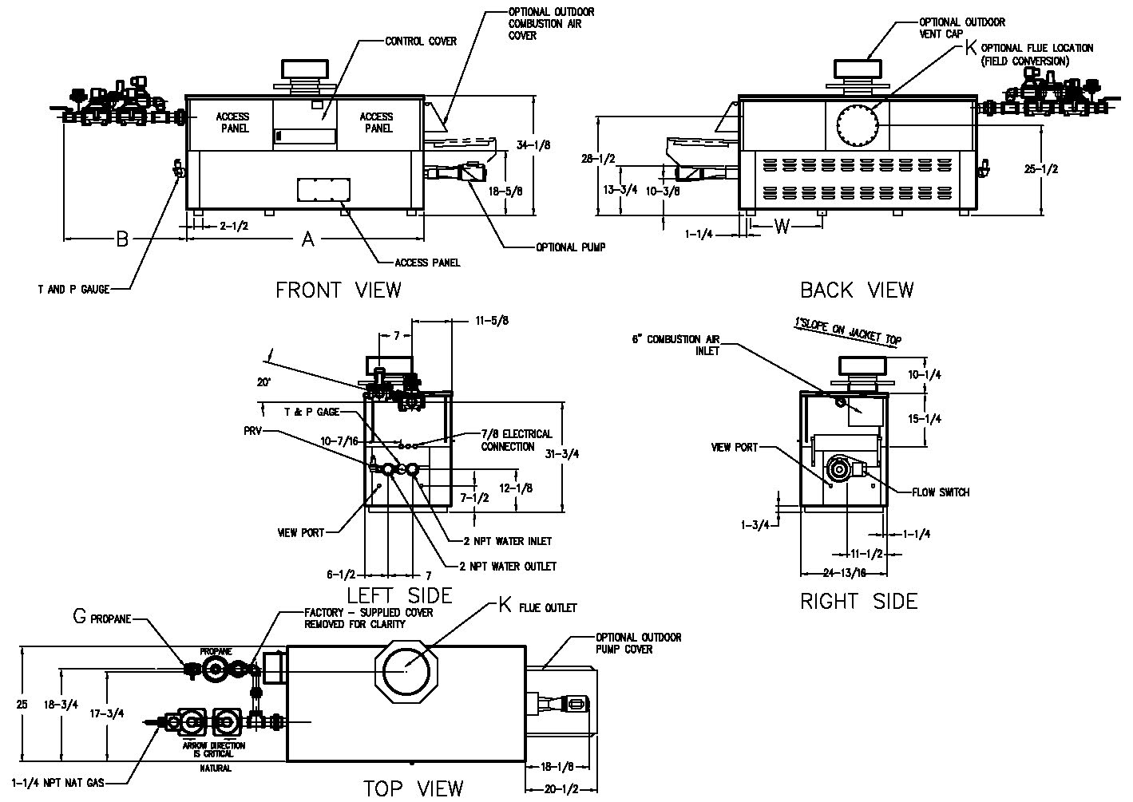
NOTE: Pump location varies based on model and application
Raypak, Inc. 2151 Eastman Avenue, Oxnard, CA 93030 (805) 278-5300 Fax (800) 872-9725 www.raypak.com
SPECIFICATIONS
Approx.
Shipping
Wt. (Lbs.)
Model | MBTUH |  | A  Width | B | G NPT  Pro. | K | W | Amp.  Draw* | Approx.  Shipping  Wt. (Lbs.)
Model | Input | Output
302CD | 300 | 252 | 36 | 41 | 3/4 | 5 | 18 | 6 | 405
402CD | 399 | 335 | 43 | 41 | 3/4 | 6 | 18-1/2 | 6 | 470
502CD | 500 | 420 | 50 | 35-1/2 | 3/4 | 6 | 22 | 6 | 570
652CD | 650 | 546 | 60-1/2 | 30-1/2 | 3/4 | 8 | 27-1/4 | 6 | 615
752CD | 750 | 630 | 67-1/2 | 27-1/2 | 1-1/4 | 8 | 30-3/4 | 6 | 700
902CD | 900 | 756 | 78 | 34-1/2 | 1-1/4 | 8 | 36 | 7 | 765
NOTES:
1. Dimensions are in inches
2. Rates shown are for natural or propane gas, and elevations up to 4,500 feet. For installation above 4,500 feet, please contact manufacturer.
3. Required natural gas supply pressure is 7 - 10.5” WC. Required propane gas supply pressure is 11 - 13” WC.

*Without pump
RATES OF FLOW AND PRESSURE DROPS
Model | 10°F ΔT |  | 20°F ΔT |  | 30°F ΔT |  | Min. Flow |  |  | Max. Flow
Model | GPM | ΔP (ft.) | GPM | ΔP (ft.) | GPM | ΔP (ft.) | GPM | ΔP (ft.) | ΔT | GPM | ΔP (ft.) | ΔT
302CD | 51 | 3.2 | 25 | <1.0 | N/A | N/A | 20 | <1.0 | 25 | 90 | 9.8 | 6
402CD | 68 | 5.4 | 34 | 1.5 | 22 | <1.0 | 20 | <1.0 | 34 | 90 | 10.0 | 7
502CD | 85 | 9.2 | 42 | 2.3 | 28 | 1.1 | 21 | <1.0 | 40 | 90 | 10.5 | 9
652CD | N/A | N/A | 55 | 4.0 | 36 | 1.8 | 28 | 1.1 | 40 | 90 | 10.7 | 12
752CD | N/A | N/A | 64 | 5.5 | 42 | 2.5 | 32 | 1.6 | 40 | 90 | 11.0 | 14
902CD | N/A | N/A | 76 | 8.5 | 51 | 3.8 | 38 | 2.2 | 40 | 90 | 11.8 | 17

Basis is 20 GPM or 40°F ΔT for minimum flow, 90 GPM for maximum flow.

