Job:

Stainless Steel 110-Gallon Non-ASME Storage Tank

Engineer:

Contractor:
Prepared By: Date:
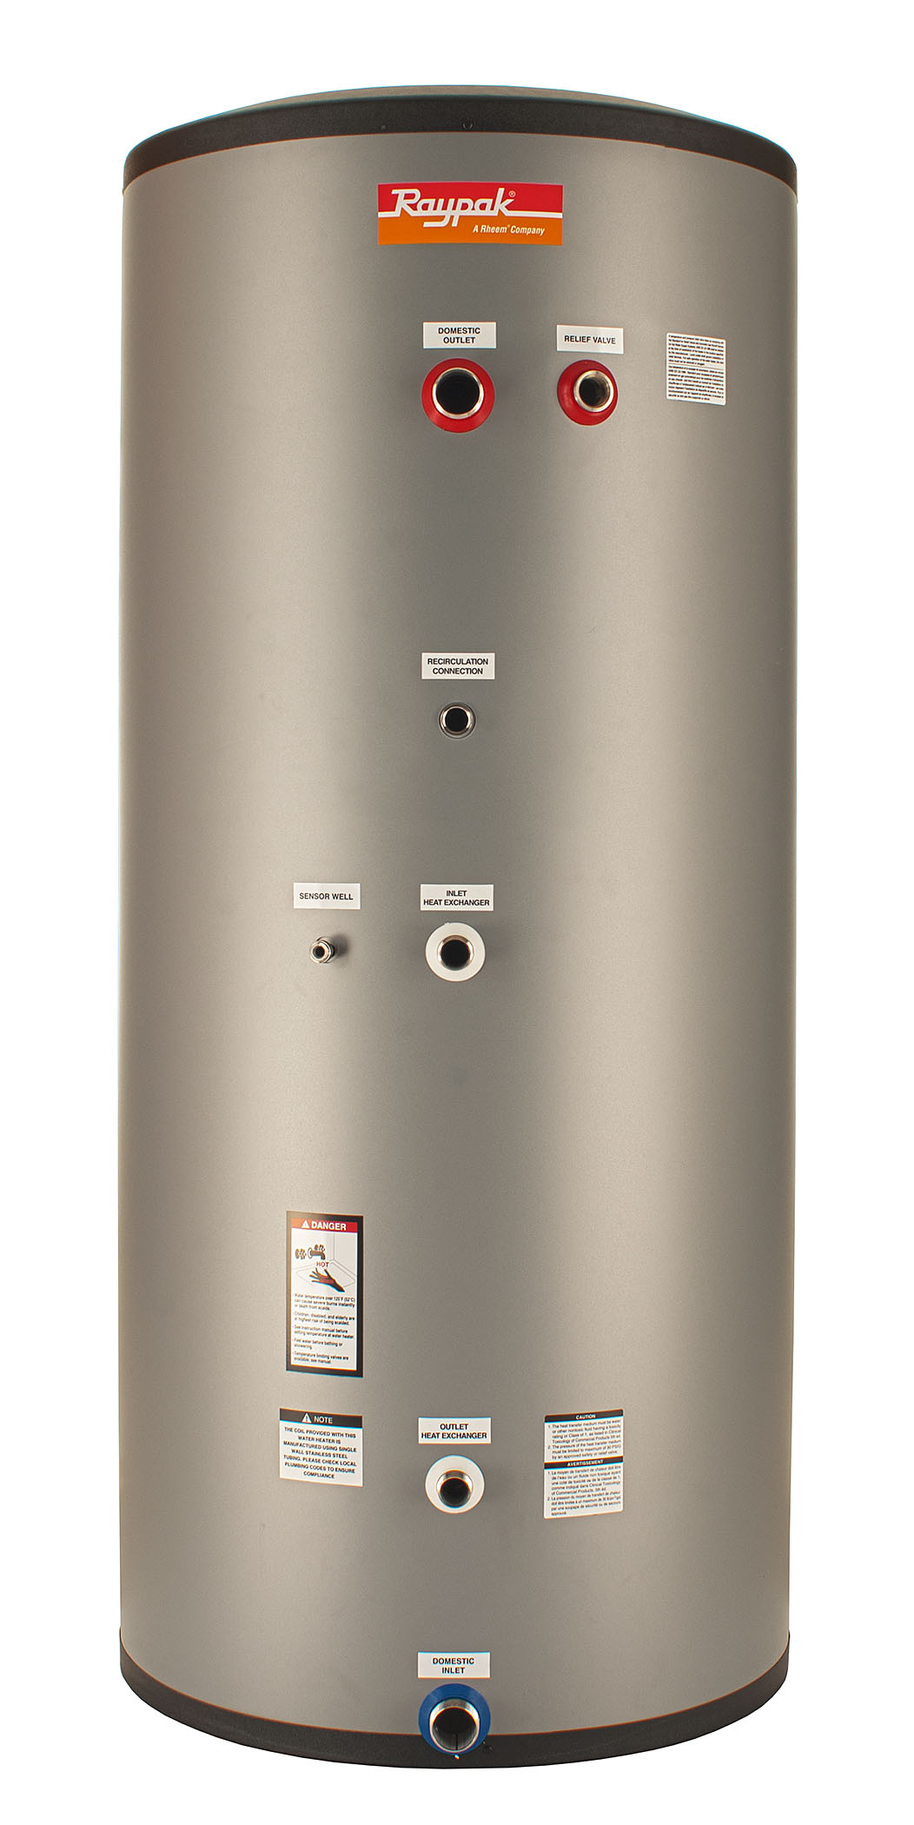
Model:
- 444 Stainless Steel Construction
- Fully Seam-Welded Construction
  - No Lining to Fail
- Fully Pickled and Passivated for Maximum Durability
- 100% Pressure Tested Tank and Coil
- R-18 – 3-1/4 Inch Thick High-Density Neopor® GPS Insulation
  - Graphite Impregnated for Superior Performance
- Indoor – Outdoor Installation
- UV Stable Polypropylene Jacket
- UV Stable EPS Caps Top and Bottom
- 150 PSI Max Pressure Rating
- 180 ͦF Maximum Tank Temperature
- 2 Inch NPT Water Connections
- Hand-Hole Inspection and Cleanout Port
- Sensor / Tankstat Drywell Standard
- No Anodes or Dielectric Fittings Required
- All Tank Connections are on the Side for Easy Installation in Low-Clearance Areas
- Commercial 5-Year Warranty

Stainless Steel Indirect Fired Storage Water Heater

Model Number

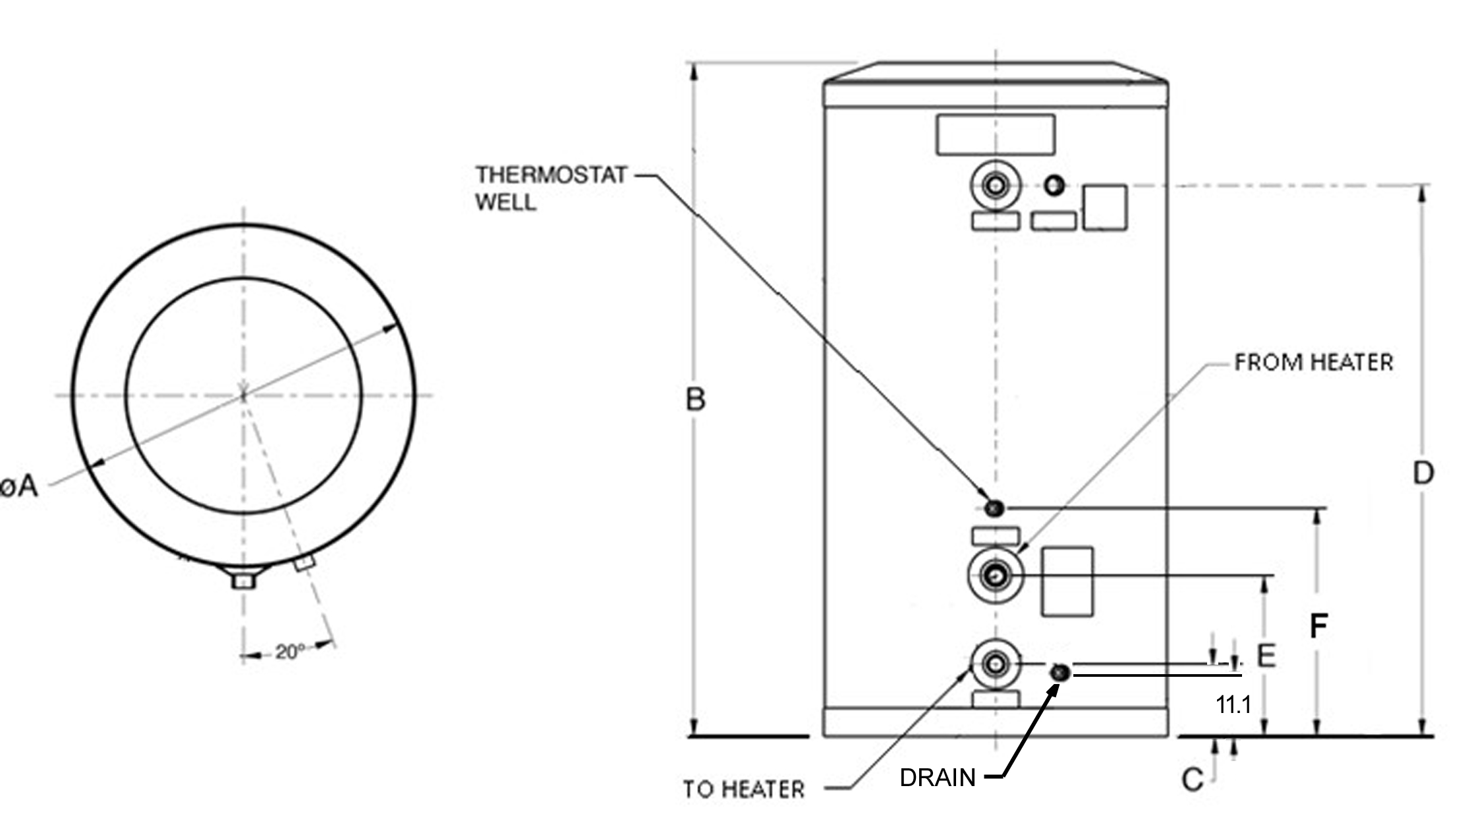

Model | Shipping  Weight  Lb. (kg) | Operating  Weight  Lb. (kg) | Water  Inlet/  Outlet | Diameter  In./(mm)  (A) | Height  In./(mm)  (B) | To Heater  Height  In./(mm)  (C) | Water  Outlet/T&P  Height  In./(mm)  (D) | From Heater  Height  In./(mm)  (E) | Drywell  Height  In./(mm)  (F)
RSST110 | 150  (68) | 1100 (500) | 2 NPT | 31.3 (795) | 67.3 (1710) | 12.2 (310) | 54.8  (1392) | 22  (558) | 27.9 (708)

Raypak, Inc. ▪ 2151 Eastman Ave., Oxnard, CA 93030 ▪ (805) 278-5300 ▪ Fax (800) 872-9725 ▪ www.raypak.com

