Job:

Hi Delta® - Type WH

Water Heaters
Models 302B-902B

Engineer:
Contractor:
Prepared By: Date:
Model: Indoor/Outdoor: MBTUH Input:
100% Factory Fire Tested
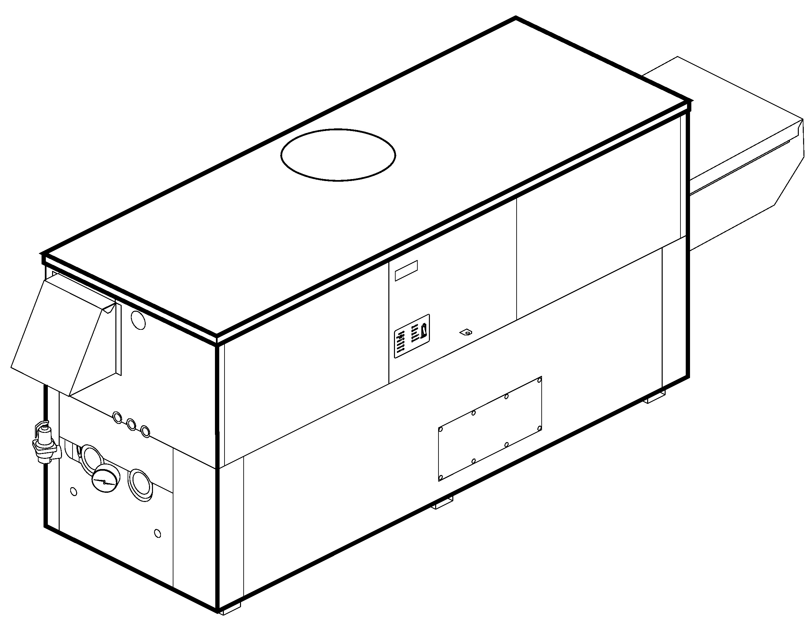
Patent No. 7,044,124
Efficiency: 85%
Maximum Outlet Temperature: 200°F
Minimum Non-Condensing Inlet Temperature: 105°F
Thermal Shock Proof Heat Exchanger
Limited Twenty-Five-Year Thermal Shock Warranty
Limited Five-Year Heat Exchanger Warranty
Full Safety Diagnostics with Fault History
PolyTuf Powder Coated Cabinet
No Combustible Floor Shield Required
Fan-Assisted
 Proudly Assembled in the USA
Patented Burner Security Blanket

Heat Exchanger
- HLW Stamp
- Headers
Brass – Standard
Glass-Lined Cast Iron –
Option A-2
- ASME Inspected and Stamped
160 PSIG Working Pressure
- National Board Approved
- Fin Tubing
Copper – Standard
Cupro Nickel – Option A-3
- ASME Steel Tube Sheet
- Silicone High Temp. O-Rings
- ASME Pressure Relief Valve
125 PSIG – Standard
PSIG – Optional
- Temperature and Pressure Gauge
- Water Connections
Left – Standard
Right – Option A-6

Controls
- 120V, 60Hz, 1∅ Power Supply
- 120/24V 60Hz Transformer
- 100% Shut-Off/Lockout
- Hot Surface Ignition
- Remote Flame Sensor
- High Limit Control, Manual Reset
- On/Off Power Switch
- Manual Shut-Off, Front-Mounted
- Flow Switch
- Blocked Vent Pressure Switch
- Combustion Air Proving Switch
- Economaster Style Pump Time Delay
- Enable/Disable
- Diagnostic Panel with LCD Display 2 Lines, 20 Characters

Gas Train
- Manual Gas Shut-Off Valve(s)
- Combo Valve(s)
- Firing Mode
On/Off: Models 302B-402B
2-Stage: Models 302B-902B
- Fuel
Natural Gas
Propane Gas
4” WC Gas Supply Pressure
G-20
- Design Certified - ANSI Z21.10.3/
CSA 4.3

Construction
- Indoor/Outdoor Construction
- Front Controls Enclosed
- PolyTuf Powder Coat Finish
- CSA Low Lead Certified ≤ .25% Lead

Venting
- Vent Location
Top – Standard
Rear – Option D-14
- Vent Termination Cap
Outdoor D-11
Indoor, Horizontal D-15
Indoor, Vertical (by others)
- Combustion Air
In-Line Filter Kit (TruSeal
only) D-17
Air Intake Elbow D-16
- Extractor – Optional
By others


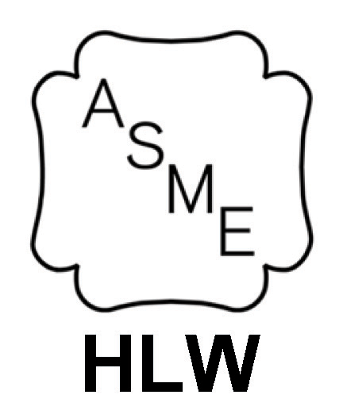

Not required

Burner

Ultra-Low NOx: Less than 20 PPM

Temperature Controls
B-2 Tankstat, Single-Stage
(100-200°F)
B-3 Tankstat, 2-Stage (100-200°F)
B-21 TempTracker Digital Controller,
4-Stage
B-25 Raytemp Digital Controller,
4-Stage
B- TempTracker MOD+ Hybrid (Up to 16 heaters)
B-60 Stage Interface Card

Options
C-6 Ignition Module, Manual Reset
D-21 TruSeal® Direct Vent
F-10 Low Water Cut-Off, Remote Probe
I-1 High Limit Control, Auto Reset
P- Pump: HP, 120V, 1∅, 60Hz Water Hardness: GPG
Bronze
Mounted Loose
Front Rear
P- Cold Water Run (See 1000.19)
S-1 Low Gas Pressure Switch, Manual
S-2 High Gas Pressure Switch, Manual
X-1 SureRack™ Kit
X-2 SureRack Add-on

Regulatory Agency Requirements

Hi Delta – Type WH
Models 302B-902B Model

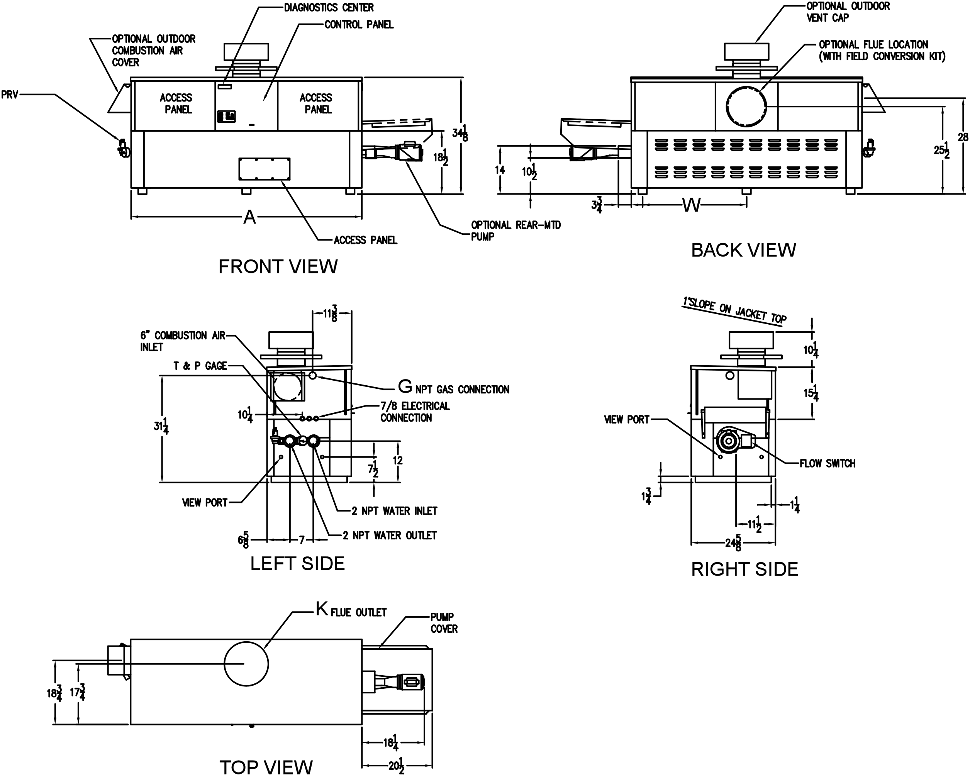
NOTES: 1. Rates shown are for natural or propane gas, and elevations up to 4,500 feet. For installation above 4,500 feet, please contact manufacturer.
2. Required natural gas pressure is 7 – 10.5” WC. Required propane gas pressure is 11 - 13” WC.

RECOVERY RATES (GPH)
 | Temperature Rise in °F
Model | 20° | 30° | 40° | 50° | 60° | 70° | 80° | 90° | 100°
302B | 1545 | 1030 | 773 | 618 | 515 | 442 | 386 | 343 | 309
402B | 2055 | 1370 | 1028 | 822 | 685 | 587 | 514 | 457 | 411
502B | 2576 | 1717 | 1288 | 1030 | 859 | 736 | 644 | 572 | 515
652B | 3348 | 2232 | 1674 | 1339 | 1116 | 957 | 837 | 744 | 670
752B | 3864 | 2576 | 1932 | 1545 | 1288 | 1104 | 966 | 859 | 773
902B | 4636 | 3091 | 2318 | 1855 | 1545 | 1325 | 1159 | 1030 | 927

SPECIFICATIONS
 |  |  |  |  |  |  |  | Approx.
 | MBTUH |  | A | G | K | W | Amp. | Shipping
Model | Input | Output | Width | NPT |  |  | Draw | Wt. (Lbs)
302B | 300 | 255 | 36 | 3/4 | 5 | 18 | 6 | 380
402B | 399 | 339 | 43 | 3/4 | 6 | 18-1/2 | 6 | 445
502B | 500 | 425 | 50 | 1-1/4 | 6 | 22 | 6 | 545
652B | 650 | 553 | 60-1/2 | 1-1/4 | 8 | 27-1/4 | 6 | 590
752B | 750 | 638 | 67-1/2 | 1-1/4 | 8 | 30-3/4 | 6 | 675
902B | 900 | 765 | 78 | 1-1/4 | 8 | 36 | 7 | 740
Dimensions are in inches.
NOTE: Pump location varies based on model and application.
Raypak, Inc. ▪ 2151 Eastman Avenue, Oxnard, CA 93030 ▪ (805) 278-5300 ▪ Fax (800) 872-9725 ▪ www.raypak.com
Model | System Flow and Head Loss
Model | 0-4 Grains Per Gallon |  |  |  |  | 5-15 Grains Per Gallon |  |  |  |  | 16-25** Grains Per Gallon
Model | ∆T (ºF) | GPM | ∆P  (ft wc) | MTS  (in) | SHL  (ft wc) | ∆T  (ºF) | GPM | ∆P  (ft wc) | MTS  (in) | SHL  (ft wc) | ∆T  (ºF) | GPM | ∆P  (ft wc) | MTS  (in) | SHL  (ft wc)
302B | 13 | 40 | 2.0 | 2 | 5.1 | 10 | 52 | 3.3 | 2 | 8.3 | 7 | 74 | 6.6 | 2 | 16.3
402B | 17 | 40 | 2.0 | 2 | 5.1 | 13 | 52 | 3.4 | 2 | 8.4 | 9 | 74 | 6.8 | 2 | 16.4
502B | 21 | 40 | 2.1 | 2 | 5.2 | 16 | 52 | 3.5 | 2 | 8.6 | 12 | 73 | 6.9 | 2 | 16.3
652B | 28 | 40 | 2.2 | 2 | 5.3 | 20 | 55 | 4.1 | 2 | 9.7 | 15 | 72 | 7.0 | 2 | 16.2
752B | 30 | 42 | 2.6 | 2 | 6.0 | 17 | 73 | 7.5 | 2 | 16.9 | 14 | 90 | 11.3 | 2 | 25.1
902B | 30 | 51 | 3.9 | 2 | 8.7 | 21 | 73 | 7.8 | 2 | 17.2 | 17 | 90 | 11.7 | 2 | 25.5

SHL includes 50 ft of tubing each way (100 total)
** Must use optional cupro-nickel tubes. For hardness exceeding 25 GPG, must use water softener

