Job:

Cold Water Start

For Hi Delta®
Models 302B-902B

Engineer:
Contractor:
Prepared By: Date:
Model: Indoor/Outdoor: MBTUH Input:

- 100% Factory Fire Tested System
- PID Control Logic
- Fail Safe Operation
- Spring Return Actuator
- Adjustable Inlet Temperature 100º - 120ºF
- Microprocessor Start-up Sequence
Hi Delta Boiler

- In-line Pump Available for Models 302B–752B;
Integral Pump Available for Models 502B–902B
Proudly Assembled in the USA

*Pump selection based on 75 equivalent feet of piping equal to connection size.

Inline Pump
Models 302B - 752B

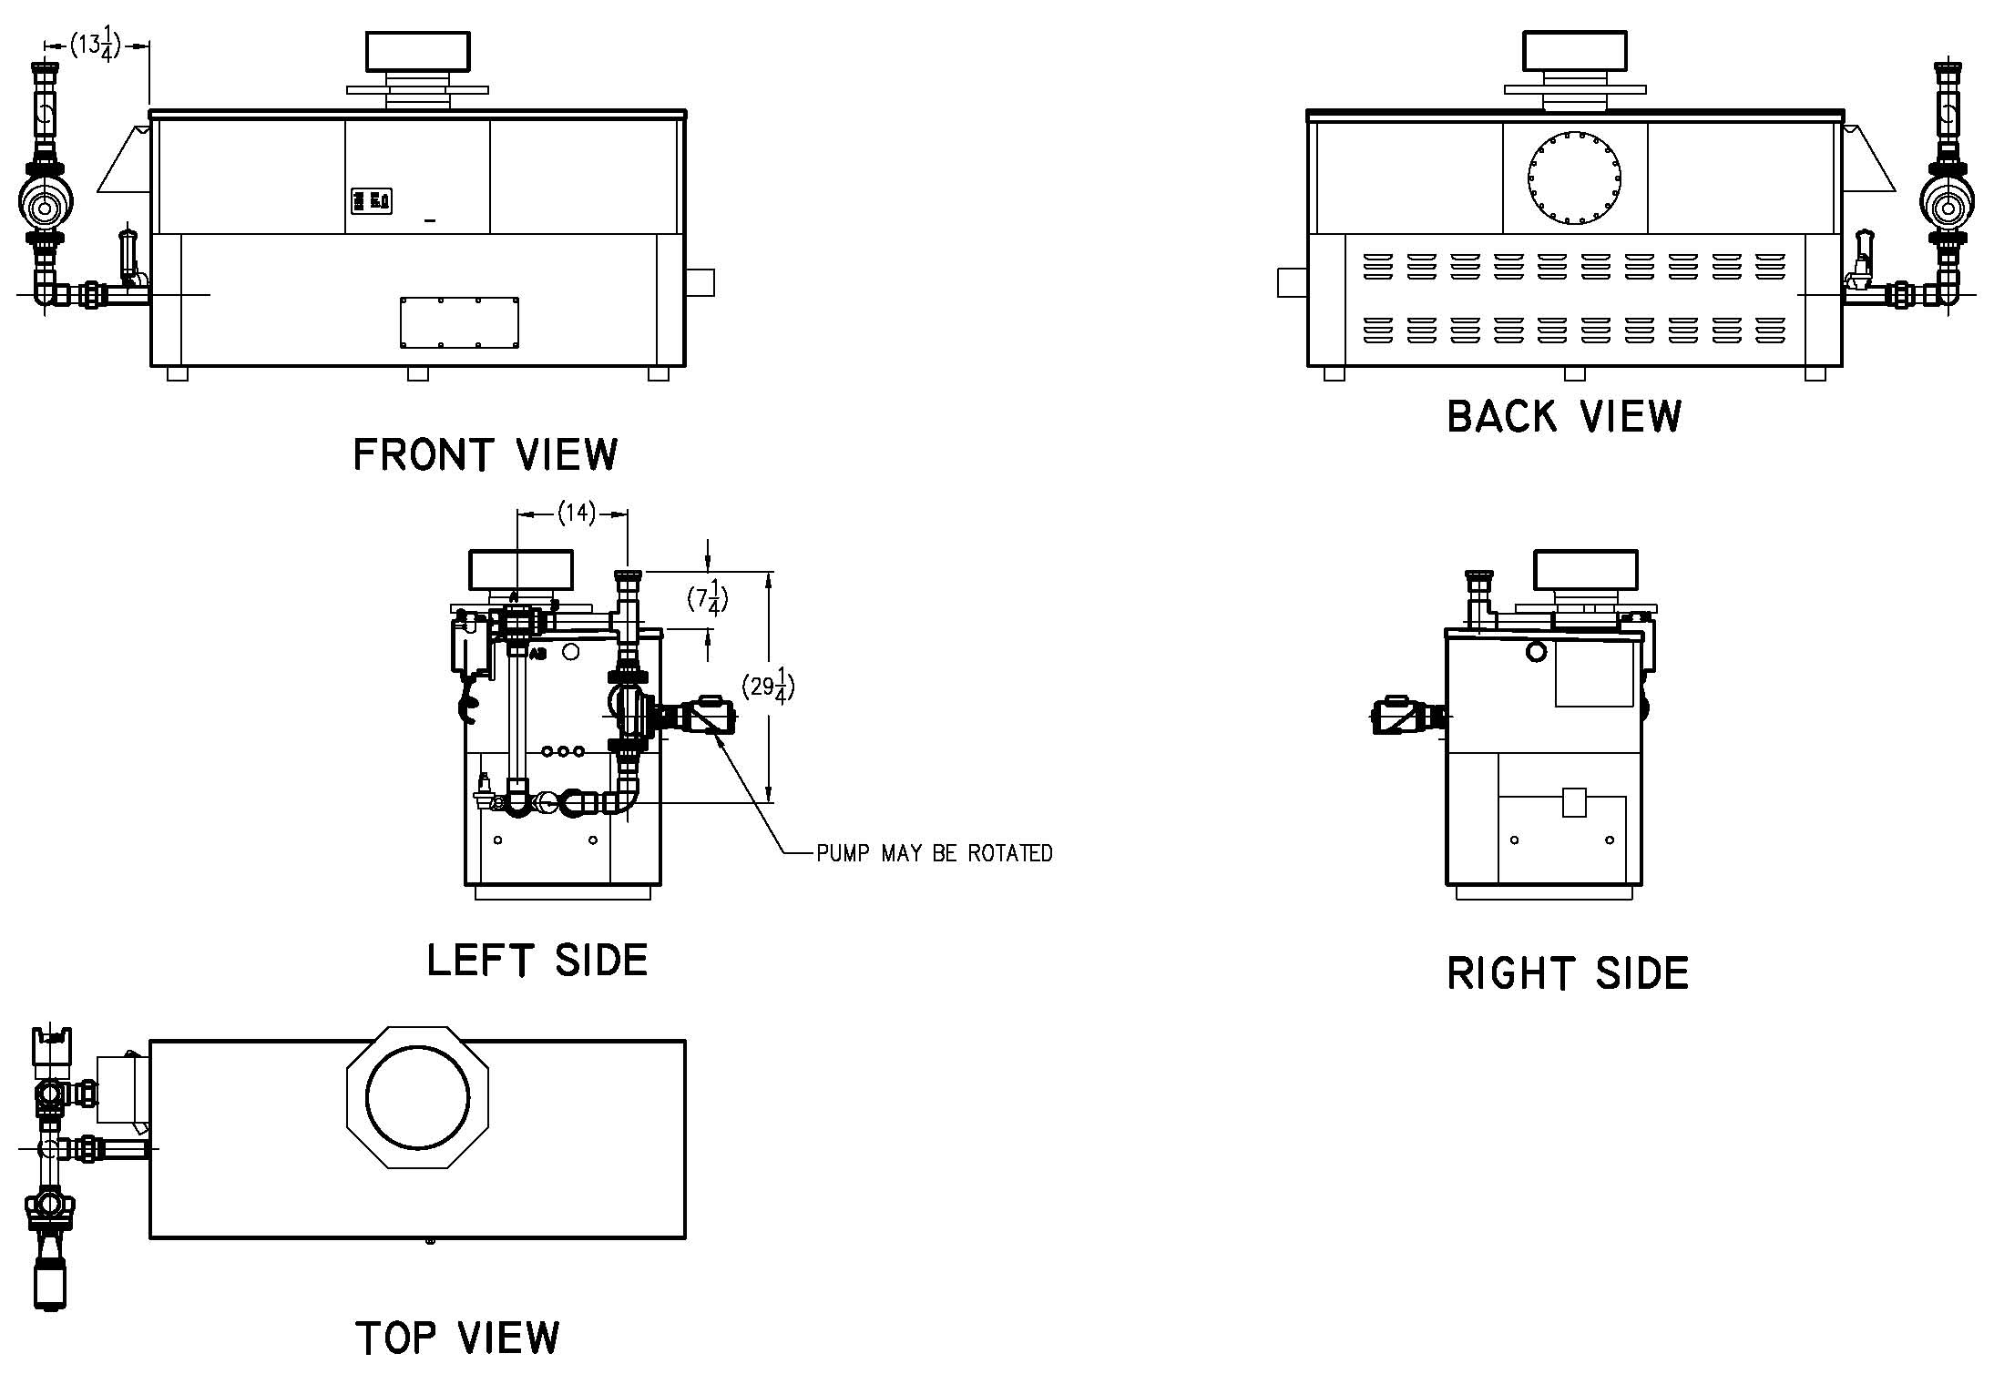

Cold Water Start

For Hi Delta 302B-902B Model

Integral Pump Models 502B - 902B




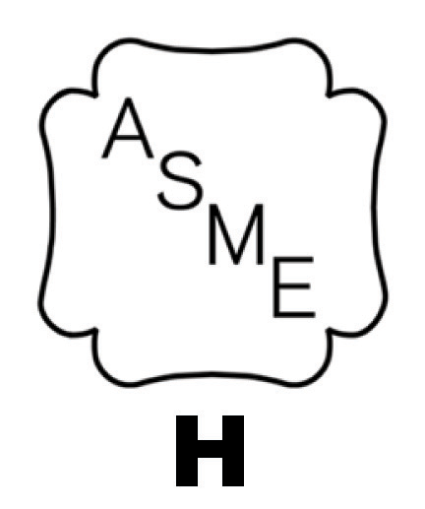
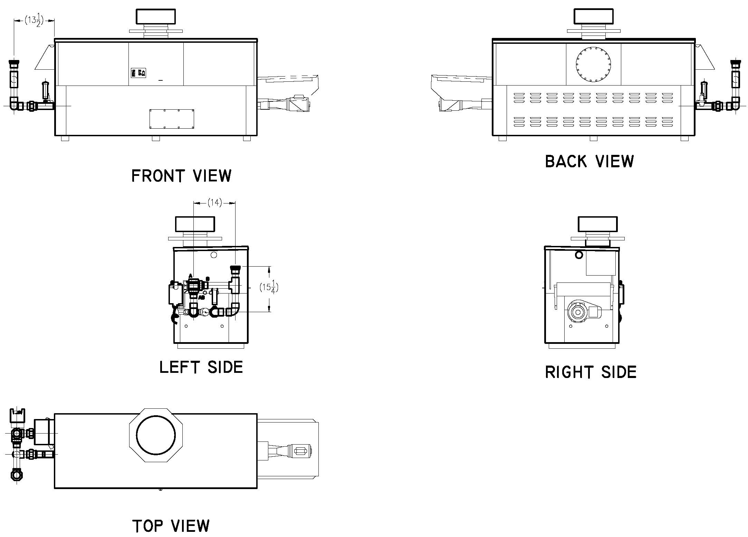
See also Hi Delta submittals:
Models 302B-902B – Catalog No. 2000.302
Raypak, Inc. ▪ 2151 Eastman Avenue, Oxnard, CA 93030 ▪ (805) 278-5300 ▪ Fax (800) 872-9725 ▪ www.raypak.com

