Job:

Hi Delta® - Type WH

Water Heaters
Models 122-322

Engineer:
Contractor:
Prepared By: Date:
Model: Indoor/Outdoor: MBH Input:
TruSeal® Direct Vent
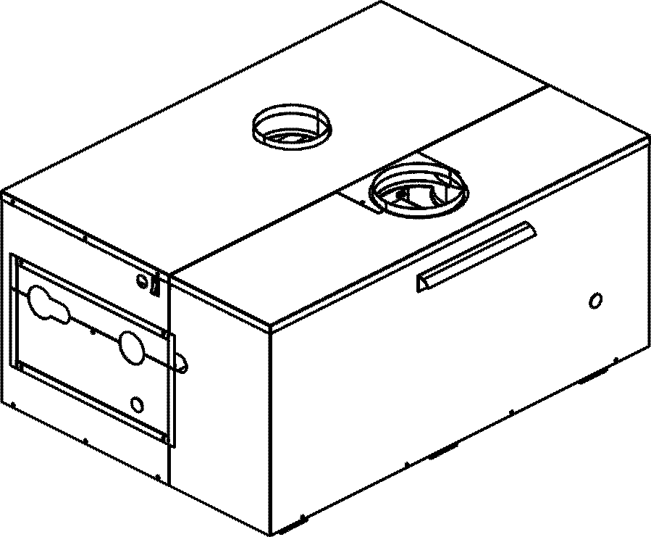
Sealed Combustion Chamber
100% Factory Fire Tested
Efficiency: 85%
Maximum Outlet Temperature: 210°F
Minimum Non-condensing Inlet Temperature: 105°F
Thermal Shock Proof Heat Exchanger
Limited Twenty-year Thermal Shock Warranty
Limited Five-year Heat Exchanger Warranty
Fault Indicator LED
PolyTuf Powder Coated Cabinet
No Combustible Floor Shield Required
Fan-assisted

Heat Exchanger
- HLW Stamp
- Headers
Bronze - Standard
Cast Iron, Glass-lined –
Option A-2
- ASME Inspected and Stamped
160 PSIG Working Pressure
- National Board Approved
- Finned Tubing
Copper - Standard
Cupro Nickel – Option A-3
- ASME Steel Tube Sheet
- Silicone High Temp O-Rings
- ASME Pressure Relief Valve
125 PSIG – Standard
PSIG – Optional
- Temperature and Pressure Gauge
- Left-hand Water Connections

Controls
- 120V, 60Hz, 1∅ Power Supply
- 120/24V 60Hz Transformer
- 100% Pilot Shutoff/Lockout
- Hot Surface Ignition
- Remote Flame Sensor
- Fixed High Limit Control, Auto Reset
- Fixed High Limit Control, Manual Reset
- On/Off Power Switch
- Blocked Vent Pressure Switch
- Combustion Air Proving Switch
- Pump Relay

Gas Train
- Manual Gas Shut-off Valve(s)
- Gas Pressure Regulator
- Safety Shut-off Valve
- Firing Control Valve
- Firing Mode
On/Off (WH1) – Standard
2 Stage (WH3) – Optional
- Fuel
Natural Gas
Propane Gas
- Design Certified -
ANSI Z21.10.3/CSA 4.3

Construction
- Indoor/Outdoor Construction
- Front Controls Enclosed
- PolyTuf Powder Coat Finish
- TruSeal® Direct Vent
- Filter Kit

Venting
- Vent Termination Cap
Outdoor – Option D-11
Indoor, Horizontal – Option D-15
Indoor, Vertical (by others)
- Combustion Air
Air Intake Elbow – Option D16
- Extractor – Optional
By Others
Not Required

Burner
- Ultra-Low NOx (<30 ppm)

Temperature Controls
B-2 1-Stage Controller, 100-200°F
B-3 2-Stage Controller, 100-200°F
B- Remote Controller
By others:

Options
F-1 Flow Switch (shipped loose)
F-10 Low Water Cut-off, Remote Probe
I-1 Adjustable High Limit Control, Auto Reset
I-2 Adjustable High Limit Control, Manual Reset
P- Pump: HP, 120V, 1∅, 60 Hz
Bronze Mounted
Cast Iron Loose
X-1 SureRack™ Kit
Two-high
Three-high
For Metric information, see Catalog




For Metric information, see Catalog

Hi Delta – Type WH
Models 122-322 Model

WATER HEATER RECOVERY RATES (GPH)

 | TEMPERATURE RISE IN ºF
MODEL | 20º | 30º | 40º | 50º | 60º | 70º | 80º | 90º | 100º
WH 122 | 618 | 412 | 309 | 247 | 206 | 177 | 155 | 137 | 124
WH 162 | 824 | 549 | 412 | 330 | 275 | 235 | 206 | 183 | 165
WH 202 | 1030 | 687 | 515 | 412 | 343 | 294 | 258 | 229 | 206
WH 242 | 1236 | 824 | 618 | 495 | 412 | 353 | 309 | 275 | 247
WH 322 | 1648 | 1099 | 824 | 659 | 549 | 471 | 412 | 366 | 330

SPECIFICATIONS

 | MBTUH |  | FIRING | A | B | H | K | T
MODEL | INPUT | OUTPUT | STAGES |  |  | NPT
WH 122 | 120 | 102 | 1* | 24-7/8 | 10-3/4 | 1-1/4 | 4 | 5
WH 162 | 160 | 136 | 1* | 28-1/2 | 12-9/16 | 1-1/4 | 5 | 5
WH 202 | 199 | 169 | 1* | 32-1/8 | 14-3/8 | 1-1/4 | 5 | 5
WH 242 | 240 | 204 | 1* | 35-1/2 | 16-3/16 | 1-1/2 | 5 | 5
WH 322 | 320 | 272 | 1* | 42-5/8 | 19-13/16 | 1-1/2 | 6 | 5
* 2 stage optional
Dimensions are in inches.

Raypak, Inc. ▪ 2151 Eastman Avenue, Oxnard, CA 93030 ▪ (805) 278-5300 ▪ Fax (800) 872-9725 ▪ www.raypak.com

RATES OF FLOW AND PRESSURE DROPS

 | 10ºF T |  | 20ºF T |  | MIN. FLOW |  |  | MAX. FLOW
MODEL | GPM | P (ft) | GPM | P (ft) | GPM | P (ft) | T | GPM | P (ft) | T
WH 122 | 20 | 2.5 | N/A | N/A | 20 | 2.5 | 10 | 30 | 5.4 | 7
WH 162 | 27 | 4.5 | N/A | N/A | 20 | 2.5 | 14 | 30 | 5.5 | 9
WH 202 | 35 | 5.5 | N/A | N/A | 20 | 2.6 | 17 | 35 | 5.5 | 10
WH 242 | 41 | 10.4 | 21 | 2.7 | 20 | 2.7 | 21 | 44 | 11.8 | 9
WH 322 | N/A | N/A | 27 | 4.7 | 20 | 2.7 | 27 | 44 | 12.2 | 12
Basis is 20 GPM for minimum flow, 44 GPM for maximum flow (except for 1.25” header).

NOTES: 1. Rates shown are for natural or propane gas, and elevations up to 5,000 feet. For installations above 5,000 feet, please contact manufacturer.
2. Required natural gas pressure is 7 – 10.5” WC. Required propane gas pressure is 11 - 13” WC.

Dimensions are in inches.
Ratings shown for elevation up to 5,000 feet for natural or propane.
For installation at elevations over 5,000 feet, please contact manufacturer.

Ratings based on natural gas or propane.
Natural gas pressure recommended to be between 7 & 14” w.c.
Propane gas pressure recommended to be between 11 & 14” w.c.

DIMENSIONAL DATA

 |  |  |  |  |  |  |  |  |  | Approx.
 | MBTUH |  |  | A | G | H | K | T | Amp. | Shipping
Model | Input | Output |  | Width | NPT | NPT |  |  | Draw | Wt. (Lbs)
122 | 120 | 102 |  | 24.9 | 3/4 | 1-1/4 | 4 |  | < 5.0
162 | 160 | 136 |  | 28.5 | 3/4 | 1-1/4 | 4 |  | < 5.0
202 | 199 | 169 |  | 32.1 | 3/4 | 1-1/4 | 4 |  | < 5.0
242 | 240 | 204 |  | 35.0 | 3/4 | 1-1/2 | 5 |  | < 5.0
322 | 320 | 272 |  | 42.6 | 3/4 | 1-1/2 | 5 |  | < 5.0

BOILER RATE OF FLOW AND PRESSURE DROP

 | 20°F T |  | Max. Flow |  |  | Min. Flow
Model | GPM | P (ft) | GPM | P (ft) | T | GPM | P (ft) | T
122 | N/A | N/A | 44 | 11.2 | 5 | 20 | 2.50 | 10
162 | N/A | N/A | 44 | 11.4 | 6 | 20 | 2.55 | 14
202 | N/A | N/A | 44 | 11.6 | 8 | 20 | 2.60 | 17
242 | 21 | 2.95 | 44 | 11.8 | 9 | 20 | 2.65 | 21
322 | 27 | 4.7 | 44 | 12.2 | 12 | 20 | 2.75 | 27

