Job:

Hi Delta® - Type WH

Water Heaters
Models 992B-2342B

Engineer:
Contractor:
Prepared By: Date:
Model: Indoor/Outdoor: MBTUH Input:
100% Factory Fire Tested
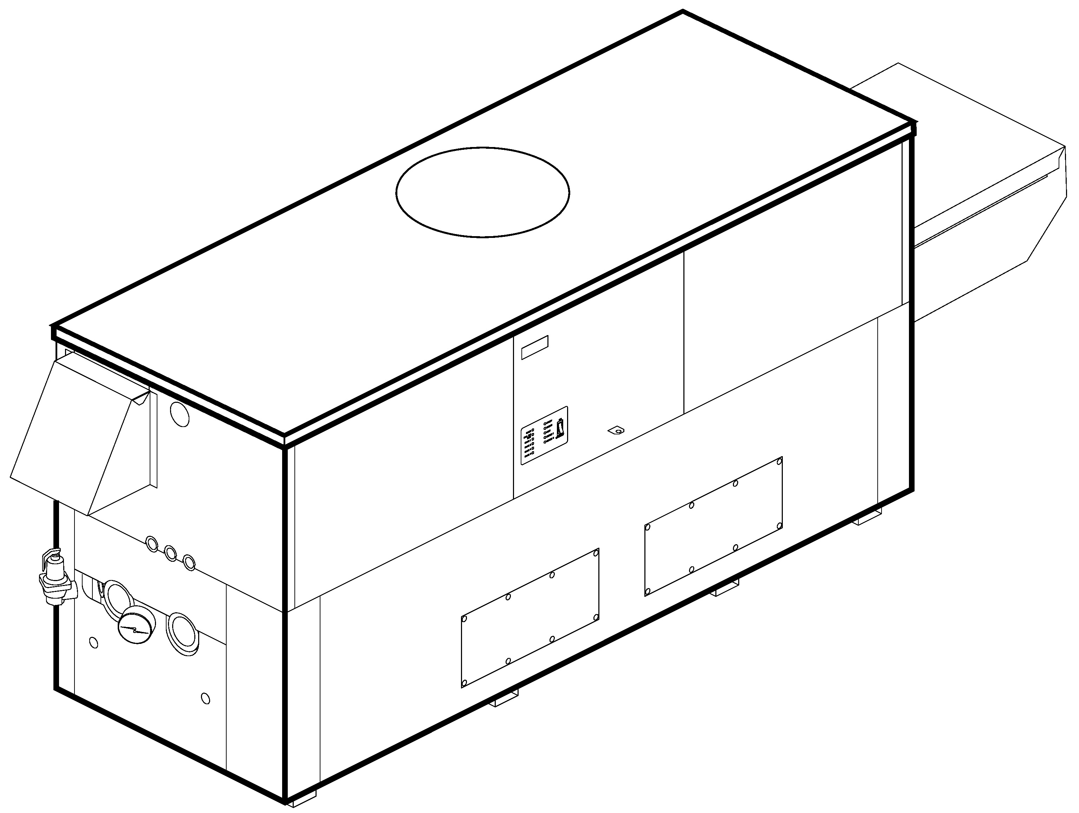
Efficiency: 85%
Maximum Outlet Temperature: 210°F
Minimum Non-Condensing Inlet Temperature: 105°F
Thermal Shock Proof Heat Exchanger
Limited Twenty-Year Thermal Shock Warranty
Limited Five-Year Heat Exchanger Warranty
Full Safety Diagnostics with Fault History
PolyTuf Powder Coated Cabinet
No Combustible Floor Shield Required
Fan-Assisted
Patent No. 7,044,124

Patented Burner Security Blanket
Proudly Assembled in the USA

Heat Exchanger
- HLW Stamp
- Headers
Brass – Standard
Glass-Lined Cast Iron –
Option A-2
- ASME Inspected and Stamped
160 PSIG Working Pressure
- National Board Approved
- Fin Tubing
Copper – Standard
Cupro Nickel – Option A-3
- ASME Steel Tube Sheet
- Silicone High Temp. O-Rings
- ASME Pressure Relief Valve
125 PSIG – Standard
PSIG – Optional
- Temperature and Pressure Gauge
- Water Connections
Left – Standard
Right – Option A-6

Controls
- 120V, 60Hz, 1∅ Power Supply
- 120/24V 60Hz Transformer
- 100% Shut-Off/Lockout
- Hot Surface Ignition
- Remote Flame Sensor
- High Limit Control, Manual Reset
- On/Off Power Switch
- Manual Shut-Off, Front-Mounted
- Flow Switch
- Blocked Vent Pressure Switch
- Combustion Air Proving Switches
- Economaster Pump Time Delay
- Enable/Disable
- Diagnostics Panel with LCD Display
2 Lines, 20 Characters

Gas Train
- Manual Gas Shut-Off Valve(s)
- Combo Valve(s)
- Firing Mode
3-Stage: Model 992B
4-Stage: Models 1262B-2342B
- Fuel
Natural Gas
Propane Gas
4” WC Gas Supply Pressure
G-20
- Design Certified - ANSI Z21.10.3/
CSA 4.3

Construction
- Indoor/Outdoor Construction
- Enclosed Front Controls
- CSA Low Lead Certified ≤ .25% Lead

Venting
- Vent Location
Top – Standard
Rear – Option D-14
- Vent Termination Cap
Outdoor D-11
Indoor, Horizontal D-15
Indoor, Vertical (by others)
- Combustion Air
In-Line Filter Kit (TruSeal
only) D-17
Air Intake Elbow D-16
- Extractor – Optional
By others

Not required

Burner
- Ultra-Low NOx: Less than 20 PPM

Temperature Controls
B-2 Tankstat, Single-Stage (100-200°F)
B-3 Tankstat, 2-Stage (100-200°F)
B-21 TempTracker Digital Controller,
4-Stage
B- TempTracker Mod+ (loose) up to 16
B-60 Stage Interface

Options
C-6 Ignition Module, Manual Reset
D-21 TruSeal® Direct Vent
F-10 Low Water Cut-Off, Remote Probe
I-1 High Limit Control, Auto Reset
P- Pump: HP, 120V, 1∅, 60Hz Water Hardness: GPG
Bronze
Mounted Loose
Front Rear
P- Cold Water Run (See 1000.19)
S-2 High Gas Pressure Switch, Manual
X-1 SureRack™ Kit
X-2 SureRack Add-on
For Metric information, see Catalog

Regulatory Agency Requirements
For Metric information, see Catalog
For Metric information, see Catalog
For Metric information, see Catalog

Hi Delta – Type WH
Models 992B-2342B Model

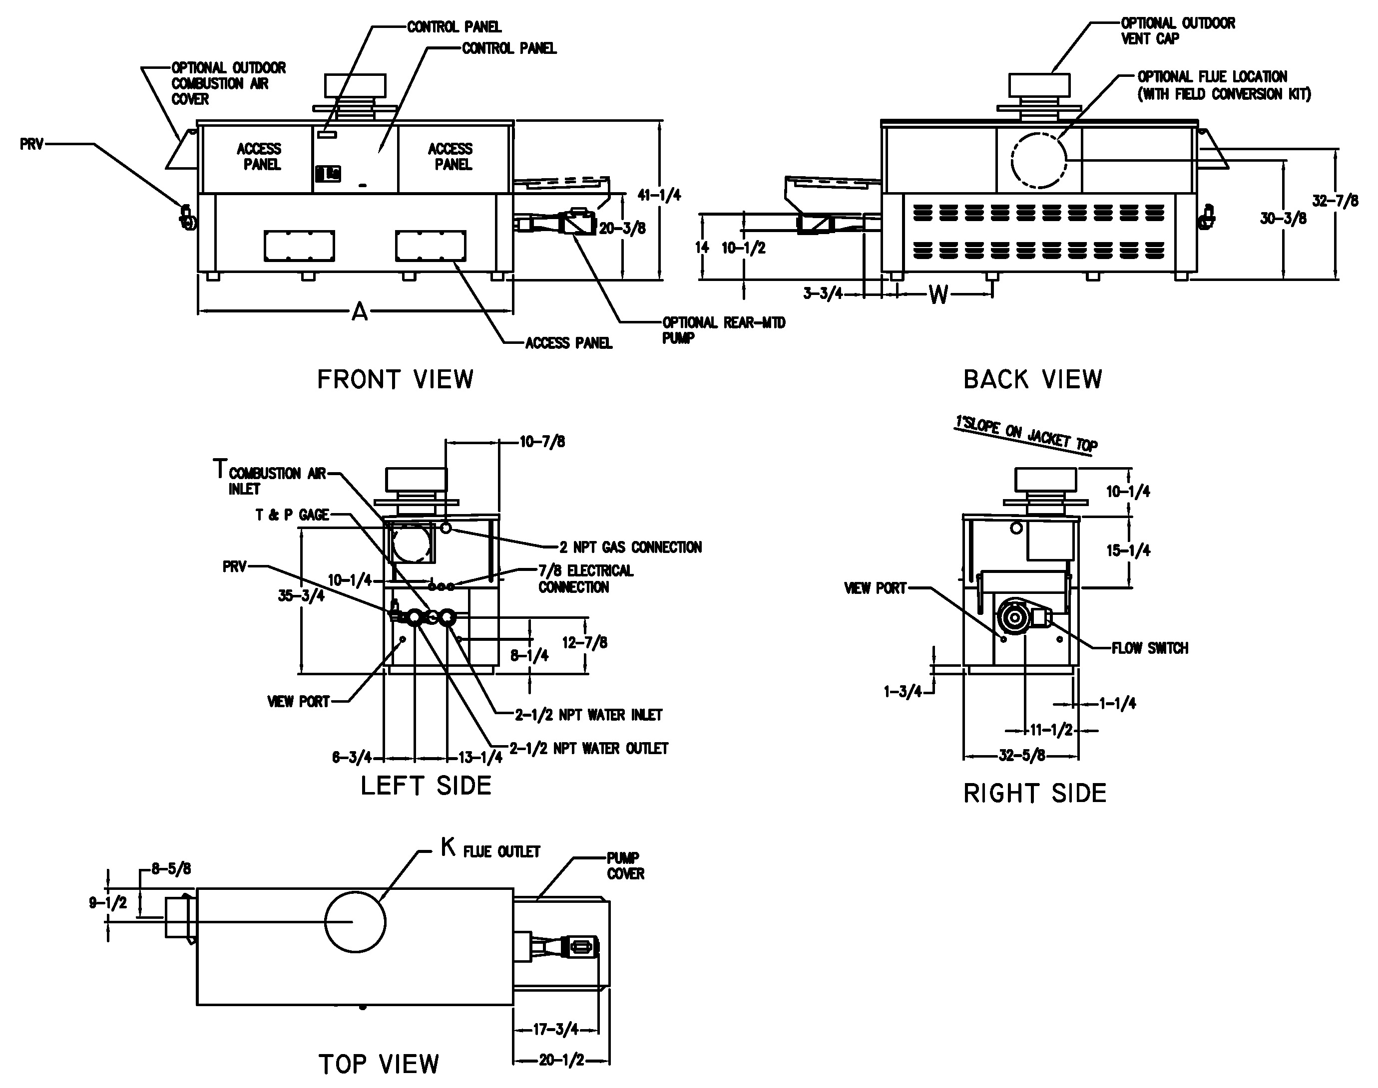
NOTE: Pump location varies based on model and application.
Raypak, Inc. ▪ 2151 Eastman Avenue, Oxnard, CA 93030 ▪ (805) 278-5300 ▪ Fax (800) 872-9725 ▪ www.raypak.com

RECOVERY RATES (GPH)
 | Temperature Rise in °F
Model | 20° | 30° | 40° | 50° | 60° | 70° | 80° | 90° | 100°
992B | 5100 | 3400 | 2550 | 2040 | 1700 | 1457 | 1275 | 1133 | 1020
1262B | 6491 | 4327 | 3245 | 2596 | 2164 | 1855 | 1623 | 1442 | 1298
1532B | 7882 | 5255 | 3941 | 3153 | 2627 | 2252 | 1970 | 1752 | 1576
1802B | 9273 | 6182 | 4636 | 3709 | 3091 | 2649 | 2318 | 2061 | 1855
2002B | 10298 | 6865 | 5149 | 4119 | 3433 | 2942 | 2574 | 2288 | 2060
2072B | 10664 | 7109 | 5332 | 4265 | 3555 | 3047 | 2666 | 2370 | 2133
2342B | 12055 | 8036 | 6027 | 4822 | 4018 | 3444 | 3014 | 2679 | 2411

SPECIFICATIONS
 |  |  |  |  |  |  |  |  |  | Approx.
 | MBTUH |  | Firing | A | H | K | T | W | Amp. | Shipping
Model | Input | Output | Stages | Width | NPT |  |  |  | Draw* | Wt. (Lbs.)
992B | 990 | 842 | 3 | 57-1/8 | 2-1/2 | 10 | 10 | 16-13/16 | <12 | 900
1262B | 1260 | 1071 | 4 | 68-1/2 | 2-1/2 | 12 | 10 | 20-9/16 | <12 | 1010
1532B | 1530 | 1301 | 4 | 79-7/8 | 2-1/2 | 12 | 10 | 24-3/8 | <12 | 1225
1802B | 1800 | 1530 | 4 | 91-1/8 | 2-1/2 | 14 | 10 | 28-1/8 | <12 | 1350
2002B | 1999 | 1699 | 4 | 102-1/2 | 2-1/2 | 14 | 10 | 31-15/16 | <12 | 1450
2072B | 2070 | 1760 | 4 | 102-1/2 | 2-1/2 | 14 | 10 | 31-15/16 | <12 | 1450
2342B | 2340 | 1989 | 4 | 113-7/8 | 2-1/2 | 16 | 10 | 35-11/16 | <12 | 1520
Dimensions are in inches. * Without pump

NOTES: 1. Rates shown are for natural or propane gas, and elevations up to 5,000 feet. For installation above 5,000 feet, please contact manufacturer.
2. Required natural gas pressure is 7 – 10.5” WC. Required propane gas pressure is 11 - 13” WC.

