Job:

Instant-Pak® Commercial Tankless

Water Heaters

Models NH-188 & NH-208
Engineer:
Contractor:
Prepared By: Date:
Model:

High Efficiency
Stepless modulating, 16:1 Near condensing design (.82 Energy Factor) meets or exceeds Energy Star Standards.

Low Emissions
Low NOx design meets latest Green Legislation for 2012 in North America.

Commercial Duty
Instant-Pak can generate 185ºF (85 ºC) temp hot water on
demand without modification.

Electronic Ignition
Direct Spark Ignition
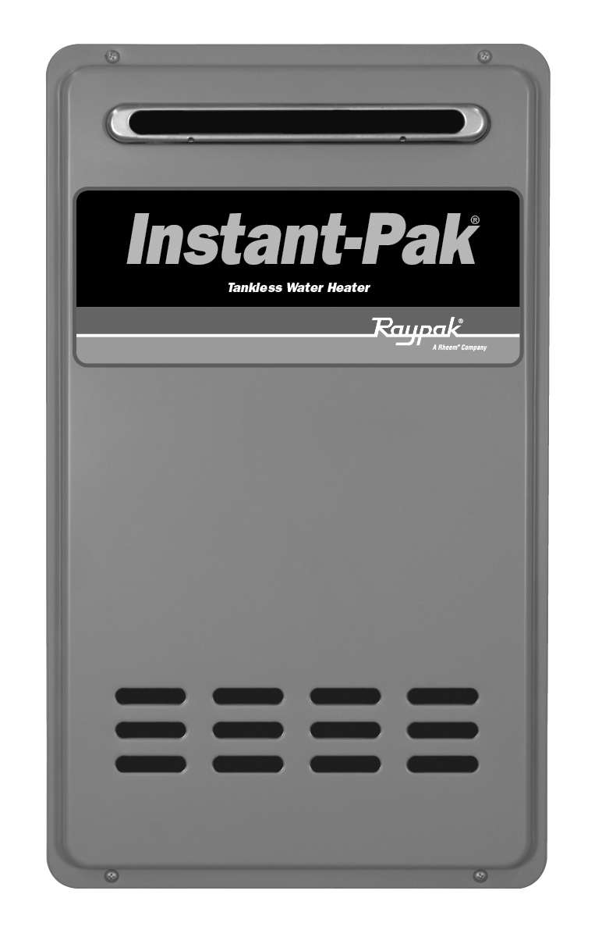
Compact, Lightweight Design
Mounts easily onto walls without heavy bracing.
Easy to Plumb, Easy to Service
Concentric Vent connection on top for indoor unit. Inlet and outlet water piping, gas connections and wiring at bottom. Remote Control (included) mounts easily for convenient access.
Safe Operation
Sealed combustion chamber runs cool and sensors shut down the tankless heater in the event of a fault.
Electronic Thermostat with Diagnostics
Electronic solid state thermostatic control operates the heater in the most energy efficient manner. Faults are displayed on the supplied Remote’s three digit display and specific LEDs.
.

Heat Exchanger

- Finned Copper Tube
- Nine Pass Heat Exchanger
- All Non-Ferrous Waterways
Energy Factor
Model | E F
NH-188 | .82
NH-208 | .82

Controls
- 120V, 60Hz, 1φ Power Supply
- Electronic, Direct Spark Ignition (DSI)
- 100% Flame Monitor Shut-off/Lockout
- High Limit Control
- Operating Limit Control
- Guardian OFWTM Heat Exchanger Overtemp Breach Protection
- Water Pressure Based Activation Switch
- Electronic Flame Monitoring Based Blocked Flue Sensor

Venting Options
- UL 1738 Approved Stainless Steel Vent
- 3” x 5” ( 80 x 125mm) Concentric Vent
- Horizontal or Vertical Vent Termination

Gas Control Train
- Natural Gas or Propane
- 16:1 Modulation
- Manual Gas Shut-Off Valve
- Redundant Valve Feature

Construction
- Indoor and Outdoor Construction
- Remote Control Included
- 120 VAC, Pre-wired Power Cord
- Appliance Grade Finish







Raypak Instant-Pak Commercial

Near Condensing Tankless Water Heater Model
Indoor Models: NH-188DV and NH-208DV Outdoor Models; NH-188X and NH-208X
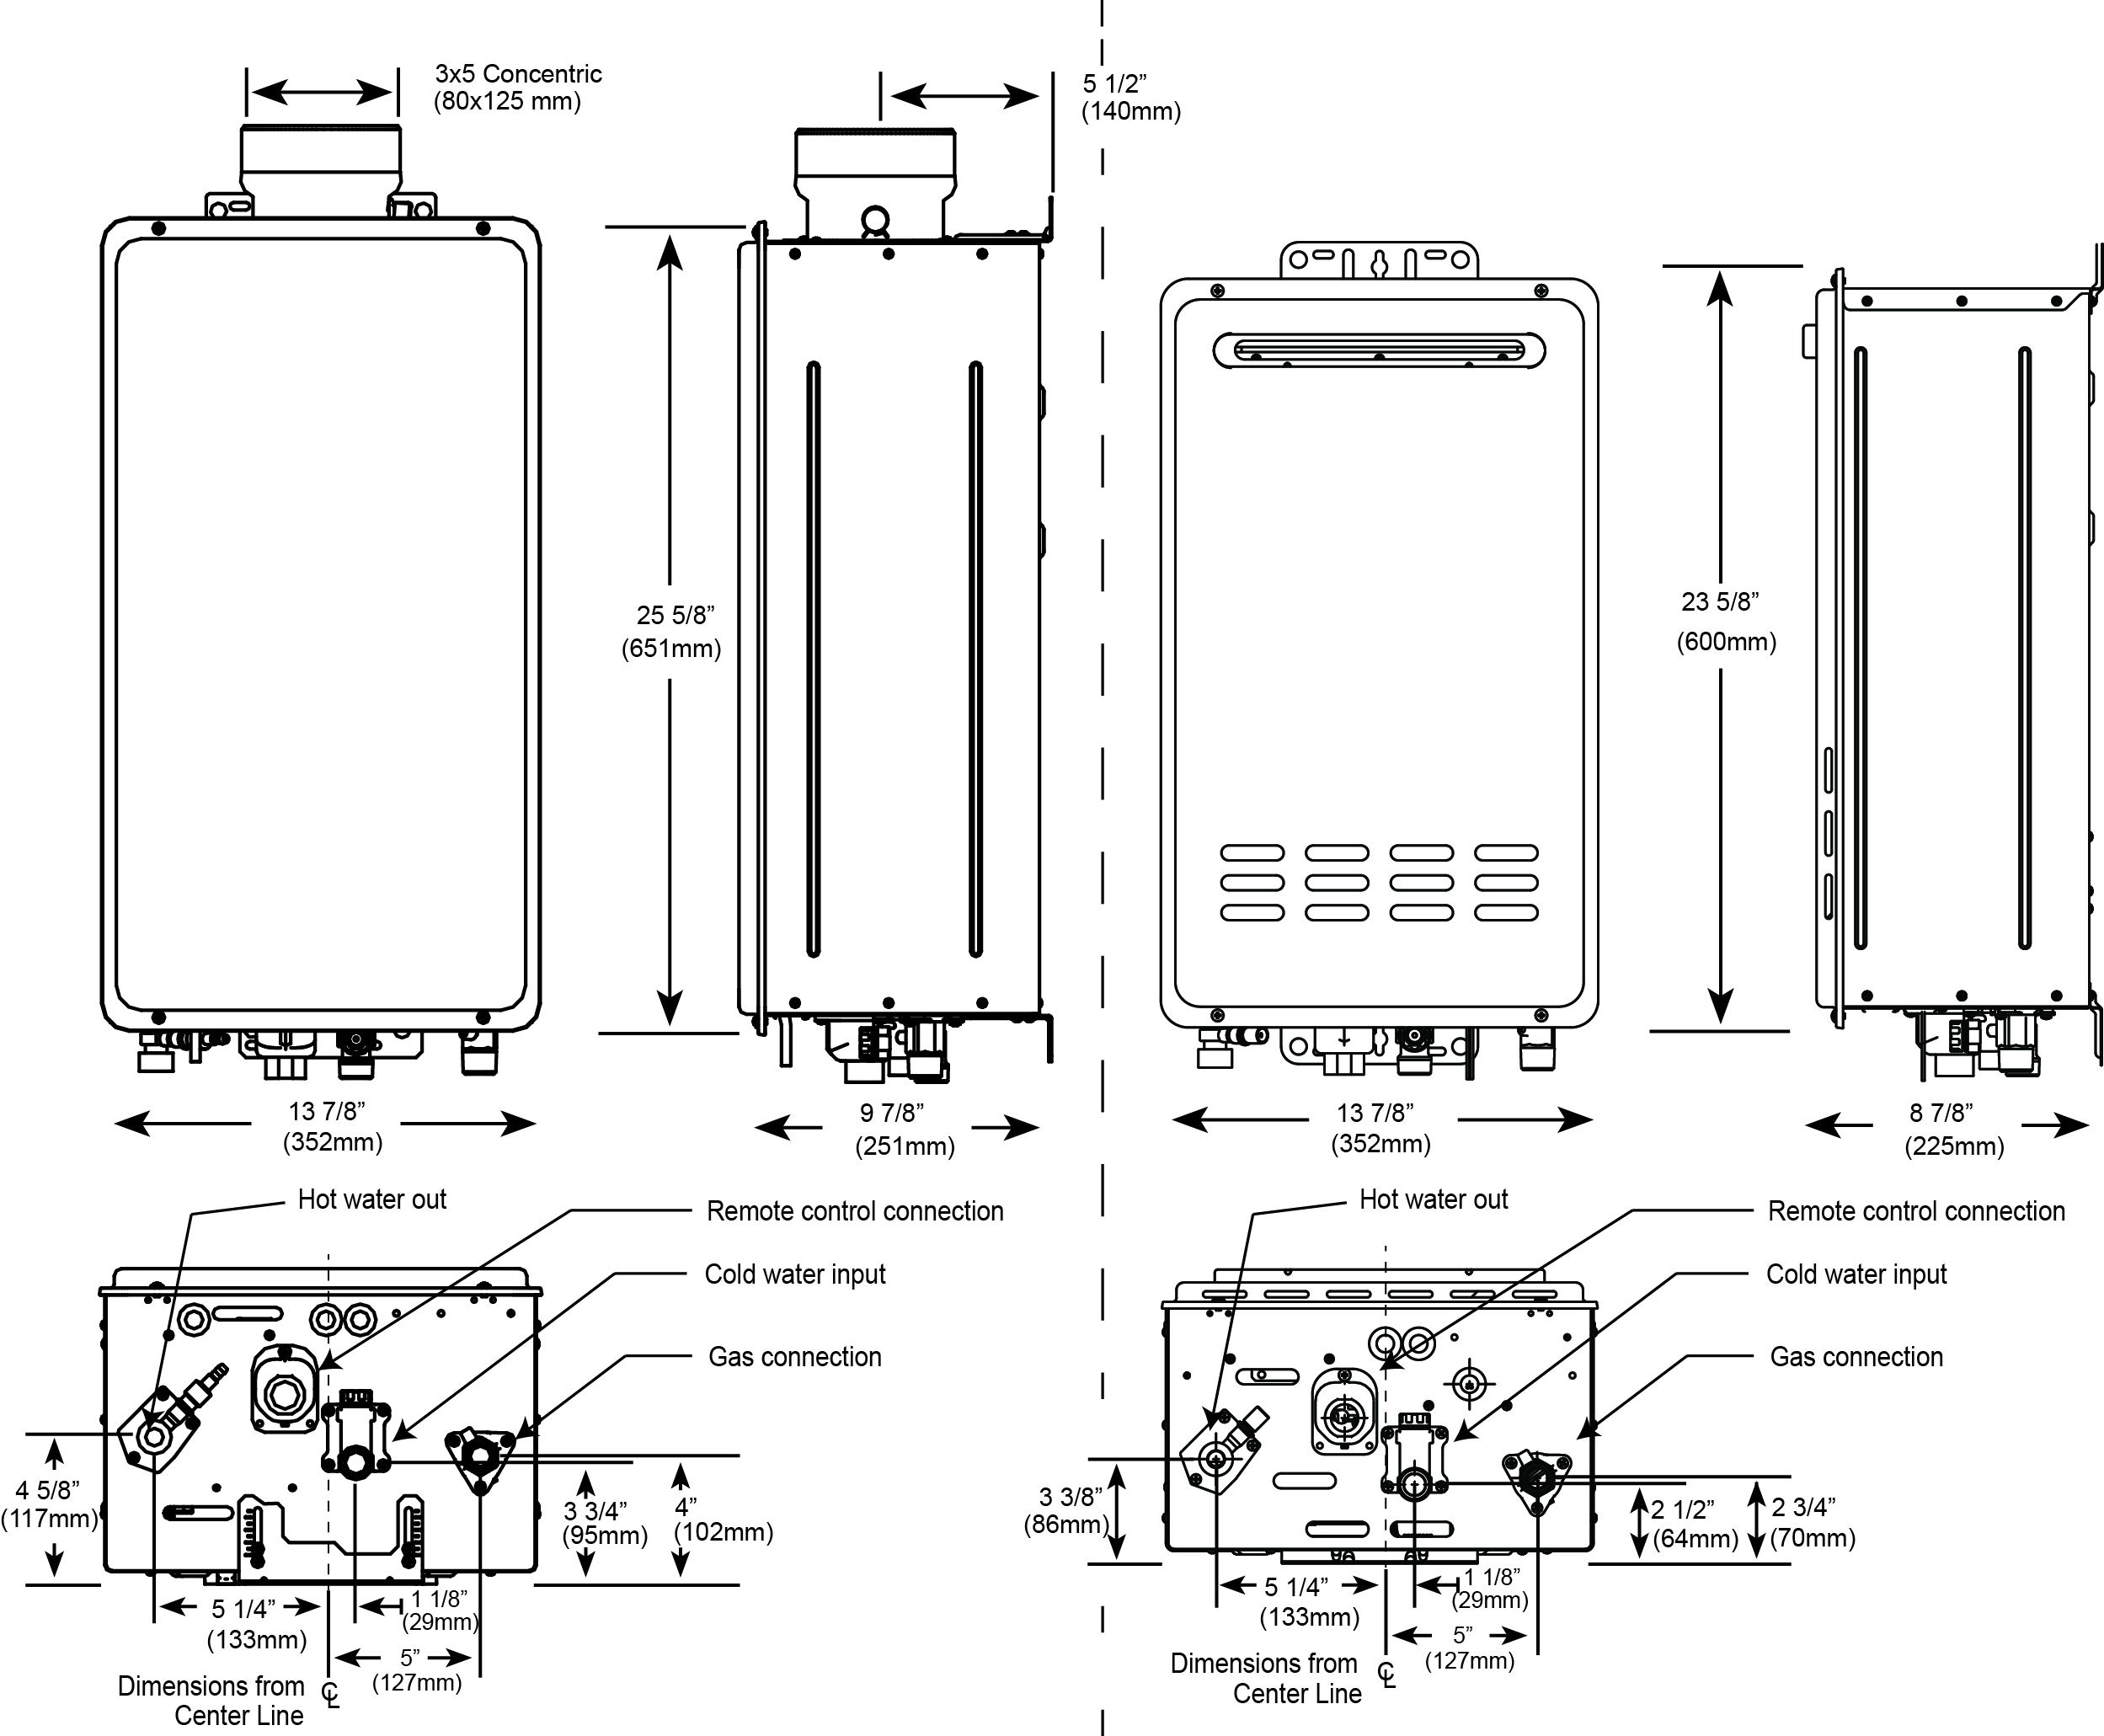

Model | Input  MBTUH  (Kw) | Piping Connections |  | Concentric  Vent Diameter | Approx.  Shipping  Weight  lbs (Kg) | Clearances from Combustibles
Model | Input  MBTUH  (Kw) | Water  NPT  (mm) | Gas  NPT  (mm) | Concentric  Vent Diameter | Approx.  Shipping  Weight  lbs (Kg) | Front  (mm) | Other  Sides  (mm) | Top  (mm) | Flue Vent  (mm)
NH-188  (X & DV) | 180  (52.7) | 3/4"  (N/A) | 3/4"  (N/A) | 3" X 5"  80mm X 125mm  (DV Only) | 54  (24.5) | 12”  (300) | 1"  (25) | 12”  (300) | 0"  (0)
NH-208  (X & DV) | 199  (58.3) | 3/4"  (N/A) | 3/4"  (N/A) | 3" X 5"  80mm X 125mm  (DV Only) | 54  (24.5) | 12”  (300) | 1"  (25) | 12”  (300) | 0"  (0)

Raypak, Inc. 2151 Eastman Avenue, Oxnard, CA 93030 (805) 278-5300 Fax (800) 872-9725 www.raypak.com

