Job:
Engineer:
Contractor:
Prepared By: Date:

Power Vent

For Raytherm®
Models 2100-4001

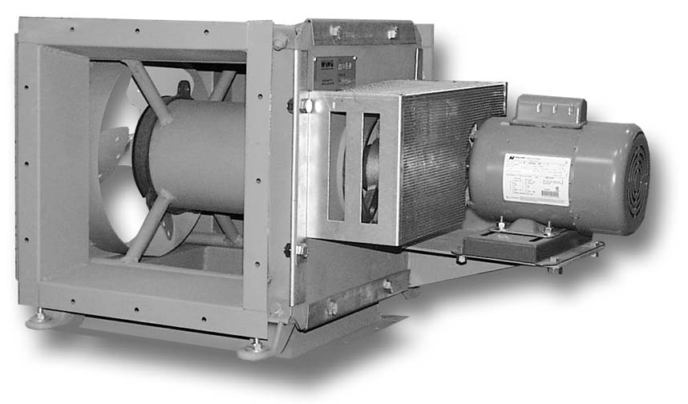
Versatile
Suitable for use with hydronic heating boilers and hot water heaters
Permits sidewall venting
Allows use of smaller diameter vent pipe

Efficient
Maintains thermal efficiency of 82%
on all appliance sizes

Features
- Induced draft
- Plenum sized for appliance capacity
- Pre-wired and shipped loose for field mounting
- Air flow proving switch, mounted and wired
- Fan motor relay, mounted and wired
- Heavy-duty galvanized steel cabinet

- Polytuf powder coat finish
- Indoor construction
- Easy installation
- Limited one-year warranty
- Shipped loose for field mounting

Power Vent

For Raytherm 2100 - 4001 Model

Raytherm Model | MBTU | Max. Runt (ft.) |  | Dimensions |  |  |  |  |  | Electrical Ratings |  |  | Max. CFM @ 70°F
Raytherm Model | MBTU | Vert. | Horiz. | A | B | C | E | F | K | Volts | Amps | HP | Max. CFM @ 70°F
2100 | 2100 | 20 | 60 | 16-7/8 | 22-3/8 | 33-1/2 | 17-1/4 | 7-11/16 | 14 | 115 | 7.2 | 1/2 | 1900
2500 | 2499 | 20 | 60 | 16-7/8 | 22-3/8 | 33-1/2 | 21-3/4 | 12-3/16 | 14 | 115 | 7.2 | 1/2 | 1900
3001 | 3000 | 20 | 60 | 24-1/4 | 27-3/8 | 44-3/4 | 23-5/8 | 10-1/8 | 16 | 115 | 10.7 | 3/4 | 3400
3500 | 3500 | 20 | 60 | 24-1/4 | 27-3/8 | 44-3/4 | 29-1/4 | 15-3/4 | 16 | 115 | 10.7 | 3/4 | 3400
4001 | 4000 | 20 | 60 | 24-1/4 | 27-3/8 | 44-3/4 | 34-7/8 | 21-3/8 | 18 | 115 | 10.7 | 3/4 | 3400

Notes: 1. Vent pipe sizes are based on standard horizontal discharge with maximum sixty feet of horizontal length with no elbows, 300°F nominal flue temperature, and sea-level operation. (Allow 10 ft. equivalent length adjustment for each 90° elbow.) For installation under other conditions, please consult the factory.
2. Left discharge is standard.
3. Vent pipe must meet Category III appliance venting requirements.
4. Follow installation instructions provided by power vent manufacturer.

Raypak, Inc. ▪ 2151 Eastman Avenue, Oxnard, CA 93030 ▪ (805) 278-5300 ▪ Fax (800) 872-9725 ▪ www.raypak.com

