Job:

Raytherm® - Type H

Hydronic Heating Boilers
Commercial

Models 2100-4001 (Indoor)
Engineer:
Contractor:
Prepared By:
Model: Date:
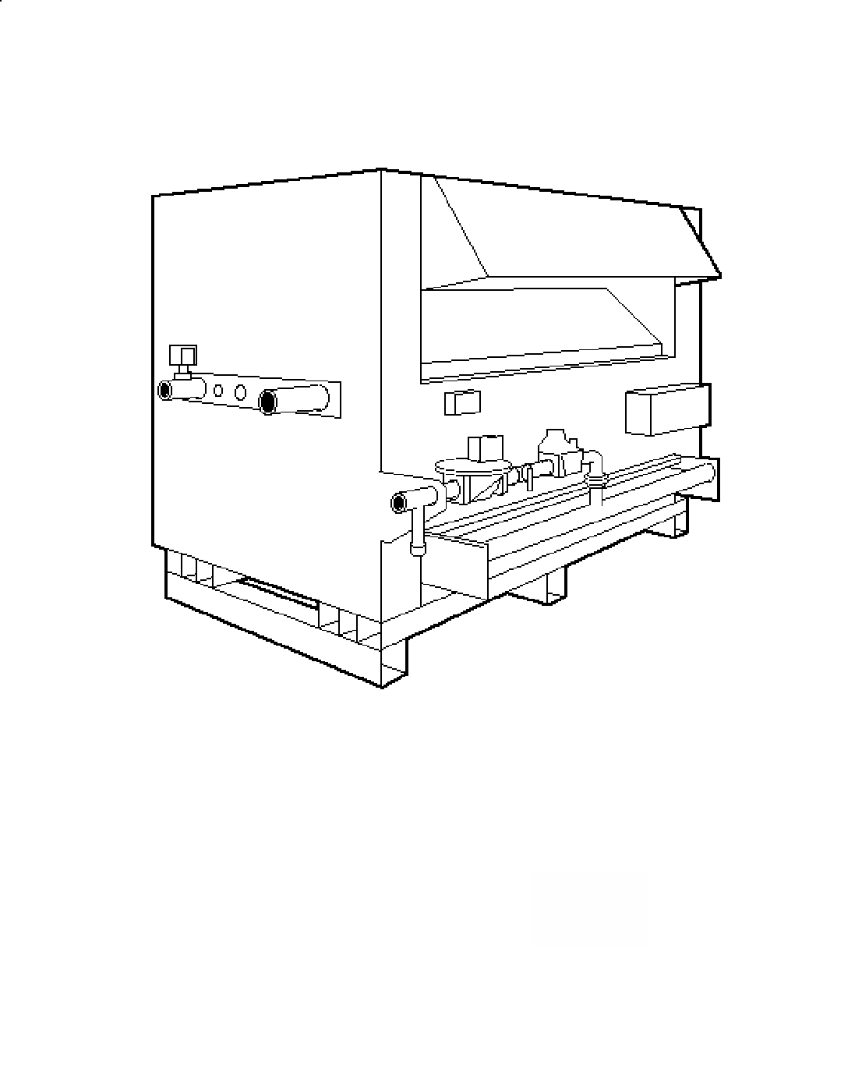
EFFICIENT
- 82% efficiency – highest of any atmospheric boiler available today
THERMAL SHOCK PROOF
- Twenty-year warranty against thermal shock damage
up to 150°F differential
- Maximum operating temperature: 230°F
LIGHTWEIGHT
- A floor load of 70 lbs./sq. ft. or less
HIGH RECOVERY
- Cuts fuel costs substantially because the standby and radiation losses normal to other boilers and tank-type water heaters are eliminated
LOW WATER OPERATING TEMPERATURE

- Operates with inlet water temperature as low as 105°F
without condensing
Proudly Assembled in the USA

Heat Exchanger
- ASME Inspected and Stamped
160 PSIG
- National Board Listed
- Headers
Glass-lined Cast Iron – Standard
Bronze – Option A-1
- Finned Tubing
Copper – Standard
Cupro Nickel – Option A-3
- ASME Steel Tube Sheet
- Silicone O-Rings
- 60 PSIG ASME Pressure Relief Valve
- Temperature and Pressure Gauge (Boiler)
- Water Connections
Left Hand – Standard
Right Hand – Option A-6
- Flow Configuration
Two-pass (Standard)
Single-pass (Cast Iron Only)

Controls
- 120V, 60Hz, 1 Ph Power Supply
- 120/24V Transformer
- 100% Pilot Shut-off/Lockout
- Electronic, Intermittent Ignition (IID) Pilot
- High Limit Control, Manual Reset
- High Limit Control, Auto Reset –
Models 3001-4001
- On/Off Switch
- Flow Switch
- Economaster Pump Time Delay

Gas Control Train
- Manual Main Gas Shut-off Cock
- Main Gas Pressure Regulator
- Redundant Safety Shut-off Valve
- Control Valve
- Firing Mode
On/off (H4)
Two-stage Firing (H3)
Four-stage Firing (H9)
Motorized Modulation (H2)
- Fuel
Natural Gas
Propane Gas
- Design Certified ANSI Z21.13/
CSA 4.9

Construction
- CSA Low Lead Certified ≤ .25% Lead
- Front Controls
- Stainless Steel Burners
- Polytuf Powder Coat Finish
- Built-in Draft Diverter
- Draft Inducer
Motorized Draft Inducer –
Option D-2

Temperature Controllers
B-6 Two-Stage (H3)
B-35 4-20 mA (H2)
B- TempTracker Mod+ Hybrid, 2-16 Boilers (All)
B-40 Motorized Modulation (H2)
B-41 Motorized Modulation, Outdoor reset (H2)
B- Two-stage Digital (H3)
B- Four-stage Digital (H9)
B-60 Stage Interface (H3/H9)

Additional Safety Controls
F-9 Low Water Cut-off Probe
I-1 High Limit Control,
Auto Reset
S-1 Low Gas Pressure Switch
S-2 High Gas Pressure Switch

Regulatory Agency Requirements



Raytherm - Type H

Hydronic Heating Boilers Model

MODELS H 2100 THRU 4001
Model  No. | MBTUH  Natural and Propane Gas |  | Dimensions (inches) |  |  |  |  | Electrical Rating | Approx. Shipping Weight (Lbs.)
Model  No. |  |  | Width | Overall Height | Gas Conn. | Water Conn. | Flue  Dia | Electrical Rating | Approx. Shipping Weight (Lbs.)
Model  No. | Input | Output | A | B | G | H | K | Electrical Rating | Approx. Shipping Weight (Lbs.)
H-2100 | 2100 | 1722 | 61.0 | 68-1/4 | * | 3** | 24 | Less than 8.0 amps without pump  at 120VAC | 1400
H-2500 | 2499 | 2049 | 70.0 | 68-1/4 | * | 3** | 26 | Less than 8.0 amps without pump  at 120VAC | 1580
H-3001 | 3000 | 2460 | 81-1/4 | 68-1/4 | 2 | 3** | 28 | Less than 8.0 amps without pump  at 120VAC | 1750
H-3500 | 3500 | 2870 | 92-1/2 | 68-1/4 | 2 | 3** | 30 | Less than 8.0 amps without pump  at 120VAC | 1920
H-4001 | 4000 | 3280 | 103-3/4 | 68-1/4 | 2 | 3** | 32 | Less than 8.0 amps without pump  at 120VAC | 2100
NOTE: Ratings are for elevations up to 2,000 feet. For  elevations over 2,000 feet, reduce ratings 4% for  every 1,000 feet above sea level |  |  |  |  | * 1-1/2” or 2” contingent on boiler type code requirements  ** 4” on one-pass option

Raypak, Inc. ▪ 2151 Eastman Avenue, Oxnard, CA 93030 ▪ (805) 278-5300 ▪ Fax (800) 872-9725 ▪ www.raypak.com
BOILER RATE OF FLOW AND PRESSURE DROP
 | Model No. | 10º ΔT |  | 20º ΔT |  | 30º ΔT |  | 40º ΔT |  | Minimum Flow |  |  | Maximum Flow
 | Model No. | GPM | ΔP FT | GPM | ΔP FT | GPM | ΔP FT | GPM | ΔP FT | GPM | ΔP FT | ΔT | GPM | ΔP FT | ΔT
TWO-PASS | H-2100 |  |  | 174 | 11.2 | 116 | 5.1 |  |  | 90 | 3.2 | 38 | 200 | 14.8 | 17
TWO-PASS | H-2500 | Exceeds Maximum Flow |  |  |  | 138 | 7.8 | 103 | 4.4 | 103 | 4.4 | 40 | 200 | 15.8 | 21
TWO-PASS | H-3001 |  |  |  |  | 166 | 11.6 | 124 | 6.7 | 124 | 6.7 | 40 | 200 | 16.7 | 25
TWO-PASS | H-3500 |  |  |  |  | 191 | 16.2 | 145 | 9.5 | 145 | 9.5 | 40 | 200 | 17.5 | 29
TWO-PASS | H-4001 |  |  |  |  |  |  | 166 | 13.0 | 166 | 13.0 | 40 | 200 | 18.7 | 33
ONE-PASS | H-2100 | 344 | 14.0 |  |  | Less than Minimum Flow |  |  |  | 180 | 4.0 | 19 | 400 | 18.0 | 9
ONE-PASS | H-2500 | 400 | 18.8 | 205 | 5.3 |  |  |  |  | 180 | 4.1 | 23 | 400 | 18.8 | 10
ONE-PASS | H-3001 |  |  | 246 | 7.8 |  |  |  |  | 180 | 4.3 | 27 | 400 | 19.5 | 12
ONE-PASS | H-3500 |  |  | 287 | 11.0 | 191 | 5.0 |  |  | 180 | 4.5 | 32 | 400 | 20.5 | 14
ONE-PASS | H-4001 |  |  | 328 | 14.8 | 219 | 6.8 |  |  | 180 | 4.7 | 36 | 400 | 21.5 | 16
NOTES:
- Values represent maximum flows and pressure drops for closed heating systems
- Maximum acceptable flow through heat exchanger tubes is 200 GPM (two pass); 400 GPM (one-pass)
- Single-pass heat exchangers are to be used only when flow rates exceed the allowable for two-pass

