Job:

# Hi Delta® - Type P

## Commercial Pool Heaters Models 502C-902C

Engineer:

Contractor:

Prepared By:       Date:

Model:       Indoor/Outdoor:       MBTUH Input:

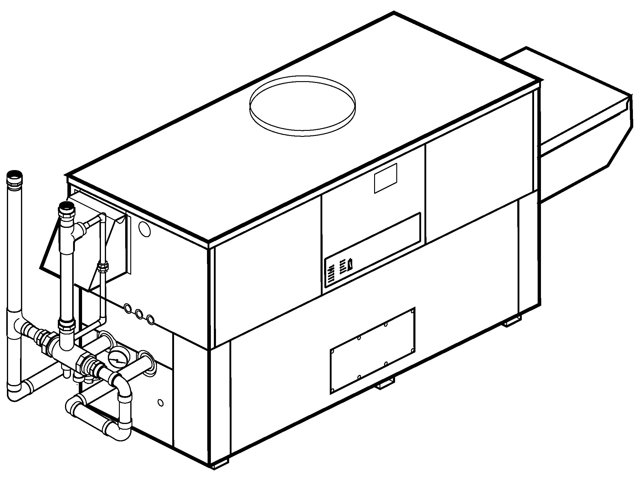

* 100% Factory Fire Tested
* Thermal Efficiency: 83.1%
* Versa IC® Controller with LCD Display
* Maximum Setpoint: 106°F (104°F Default)
* Maximum Outlet Temperature: 160°F
* Minimum Non-Condensing Inlet Temperature: 105°F
* Thermal-Shock Proof Heat Exchanger
* Limited Twenty-Year Thermal Shock Warranty
* Limited Five-Year Heat Exchanger Warranty
* Full Safety Diagnostics with Fault History
* PolyTuf Powder Coated Cabinet
* No Combustible Floor Shield Required
* Fan-Assisted
* Patented Burner Security Blanket
* Ultra-Low NOx – SCAQMD 1146.2 Certified

Proudly Assembled in the USA



* Cascade Up To 4 Heaters – No External Sequencer Needed

**Standard Sparcomatic**

**Bypass Shown**

#### Heat Exchanger

* Brass Headers
* ASME Inspected and HLW Stamped  
  160 PSIG Working Pressure
* National Board Approved
* Cupro-Nickel Finned Tubing
* ASME Steel Tube Sheet
* Silicone High-Temp O-Rings
* 125 PSIG ASME Pressure Relief Valve
* Temperature and Pressure Gauge
* Water Connections

Left – Standard

A-6 – Right

* Bronze Pump, 1/2 HP, 120V, 60Hz
* Non-ferrous Pool Bypass Assembly

with Automatic Control

#### Controls

* 120V, 60Hz, 1∅ Power Supply
* 120/24V 60Hz Transformer
* Versa IC® Integrated Control
* Cascade up to 4 Heaters
* 100% Shut-Off/Lockout
* Hot Surface Ignition
* Ignition Module

3-Try – Standard

C-6 Single Try

* Remote Flame Sensor
* Fixed High Limit, Manual Reset 240°F
* On/Off Power Switch
* Flow Switch
* Blocked Vent Pressure Switch
* Combustion Air Proving Switch
* Programmable Pump Time Delays
* Heater
* System
* Enable/Disable
* LCD Display; Status, Fault and Diagnostics

#### Raypak-Rheem logo, submittalsControls – Cont.

* Cold Water Protection Function

CWR Variable-Speed Pump

Default Sparcomatic Bypass

* Modbus RTU BMS Port (Up to 115K Baud Rate, See Cat. 5000.73)

B-85 – BMS Gateway – BACnet MS/TP, BACnet IP, N2 Metasys or Modbus TCP

B-86 – BMS Gateway - LonWorks

#### Gas Train

* Combination Valves
* On/Off Firing
* Fuel

Natural Gas

Propane Gas (HD-5)

G–20 4” WC Nat. Supply

* Design Certified ANZI Z21.56/  
  CSA 4.7

#### Burner

* Ultra-low NOx:  
  Less than 20 PPM

#### Construction

* Indoor/Outdoor Construction
* Enclosed Front Controls
* PolyTuf Powder Coat Finish
* CSA Low Lead Certified ≤ .25% Lead

#### Venting

* Vent Location

Top – Standard

D – 14 Rear

* Vent Termination Cap

D – 11 Outdoor

D – 15 Horizontal

Indoor, Vertical (by others)

* Combustion Air

D – 17 In-Line Filter Kit (TruSeal only)

D – 16 Air Intake Elbow

#### Venting – Cont.

* Extractor - Optional

By Others

Not Required

#### Options

C-6 Ignition Module, Manual Reset

D-21 TruSeal® Direct Vent

Left Side - Standard   
 Right Side - Optional

F-10 Low Water Cut-Off,   
Remote Probe

S-1 Low Gas Pressure Switch, Manual Reset

S-2 High Gas Pressure Switch, Manual Reset

X-1 SureRack® Kit (Lower Unit Requires Manifold Modification)

X-2 SureRack Add-On (Lower Unit Requires Manifold Modification)

**Additional Options or Accessories**

**Multi-Heater Controllers**

#### B-36 2 – 4 Heaters

#### B-37 5 – 10 Heaters

#### B-38 11 – 16 Heaters

#### B-39 EMS 4-20mA Remote Setpoint Module

#### B-62 BACnet MS/TP Interface



#### Hi Delta – Type P

#### Models 502C – 902C (“Sparcomatic’’ Bypass Option) Model

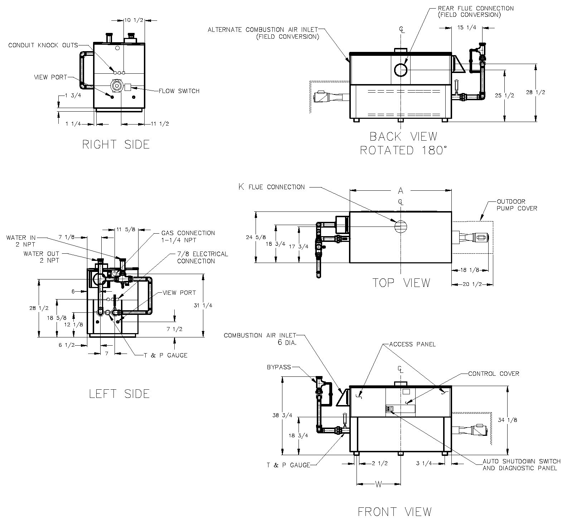

|  |  |  |  |
| --- | --- | --- | --- |
| **Rate of Heat Exchanger Flow and**  **Pressure and Temperature Drop** | | | |
|  | **GPM** | **ΔP (ft.)** | **ΔT (ºF)** |
| 502C | 90 | 10.5 | 10 |
| 652C | 10.7 | 12 |
| 752C | 11.0 | 14 |
| 902C | 11.8 | 17 |

|  |  |  |  |  |  |  |  |
| --- | --- | --- | --- | --- | --- | --- | --- |
| **Model** | **MBTUH** | | **A**  **Width** | **K** | **W** | **Amp Draw (w/ Pump)** | **Shipping Weight (Lbs.)** |
| **Input** | **Output 83.1%** |
| 502C | 500 | 416 | 50 | 6 | 22 | 13 | 545 |
| 652C | 650 | 540 | 60-1/2 | 8 | 27-1/4 | 13 | 590 |
| 752C | 750 | 623 | 67-1/2 | 8 | 30-3/4 | 13 | 675 |
| 902C | 900 | 748 | 78 | 8 | 36 | 14 | 740 |

NOTES: 1. Dimensions are in inches.

2. Rates shown are for natural or propane gas, and elevations up to 4,500 feet.

For installation above 4,500 feet, please contact manufacturer.

#### Hi Delta – Type P

#### Models 502C – 902C (Cold Water Run Option) Model

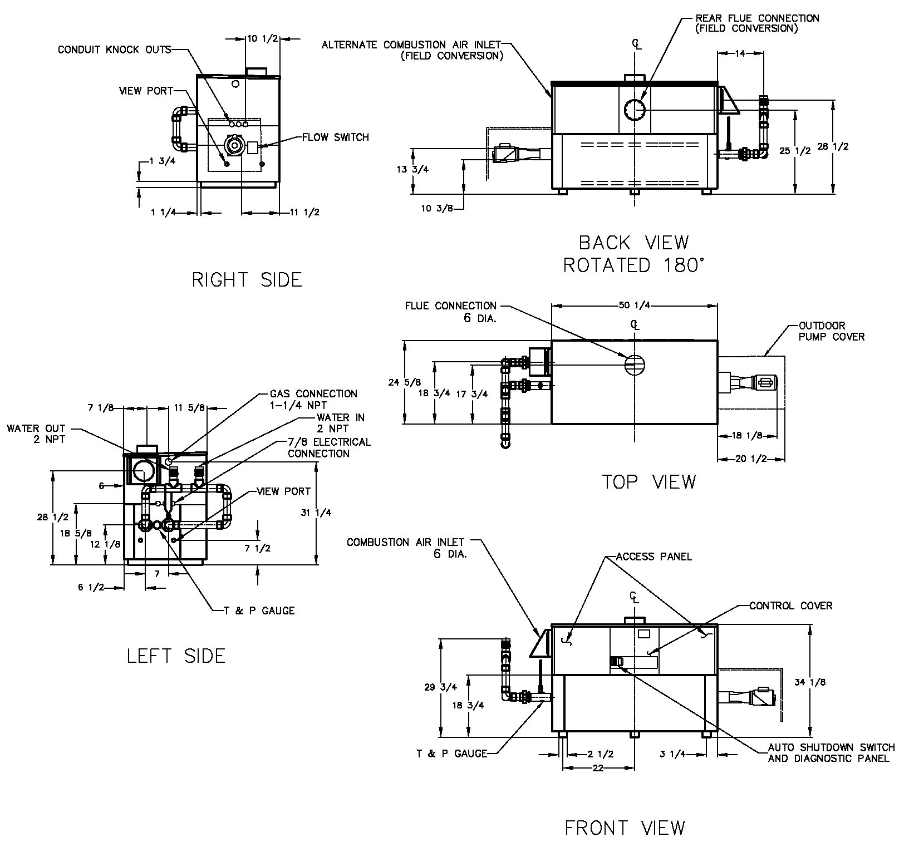

|  |  |  |  |  |
| --- | --- | --- | --- | --- |
| **Rate of Heat Exchanger Flow and**  **Pressure and Temperature Drop** | | | | |
| **Model** | GPM | ΔP (ft.) | ΔT (ºF) | Injector Flow  (GPM) |
| 502C | 90 | 10.5 | 10 | 22 |
| 652C | 10.7 | 12 | 28 |
| 752C | 11.0 | 14 | 32 |
| 902C | 11.8 | 17 | 38 |

|  |  |  |  |  |  |  |  |  |
| --- | --- | --- | --- | --- | --- | --- | --- | --- |
| **Model** | **MBTUH** | | **A**  **Width** | **K** | **W** | **Amp Draw**  **Heater w/ Pump** | **Injector Pump HP** | **Shipping Weight**  **(Lbs.)** |
| **Input** | **Output 83.1%** |
| P 502C | 500 | 416 | 50 | 6 | 22 | 13 | 1/4 | 655 |
| P 652C | 650 | 540 | 60-1/2 | 8 | 27-1/4 | 13 | 755 |
| P 752C | 750 | 623 | 67-1/2 | 8 | 30-3/4 | 13 | 815 |
| P 902C | 900 | 748 | 78 | 8 | 36 | 14 | 905 |

NOTES: 1. Dimensions are in inches.

2. Rates shown are for natural or propane gas, and elevations up to 4,500 feet.

For installation above 4,500 feet, please contact manufacturer.

3. Separate 120 VAC or 240 VAC 1Ø power required for Cold Water Run Option.

4. Injector pump ships loose for field installation at bypass inlet.

Raypak, Inc. ▪ 2151 Eastman Avenue, Oxnard, CA 93030 ▪ (805) 278-5300 ▪ Fax (805) 872-9725 ▪ www.raypak.com