Job:

# Hi Delta® - Type P

## Commercial Pool Heaters Models 992C-2342C

Engineer:

Contractor:

Prepared By:       Date:

Model:       Indoor/Outdoor:       MBTUH Input:

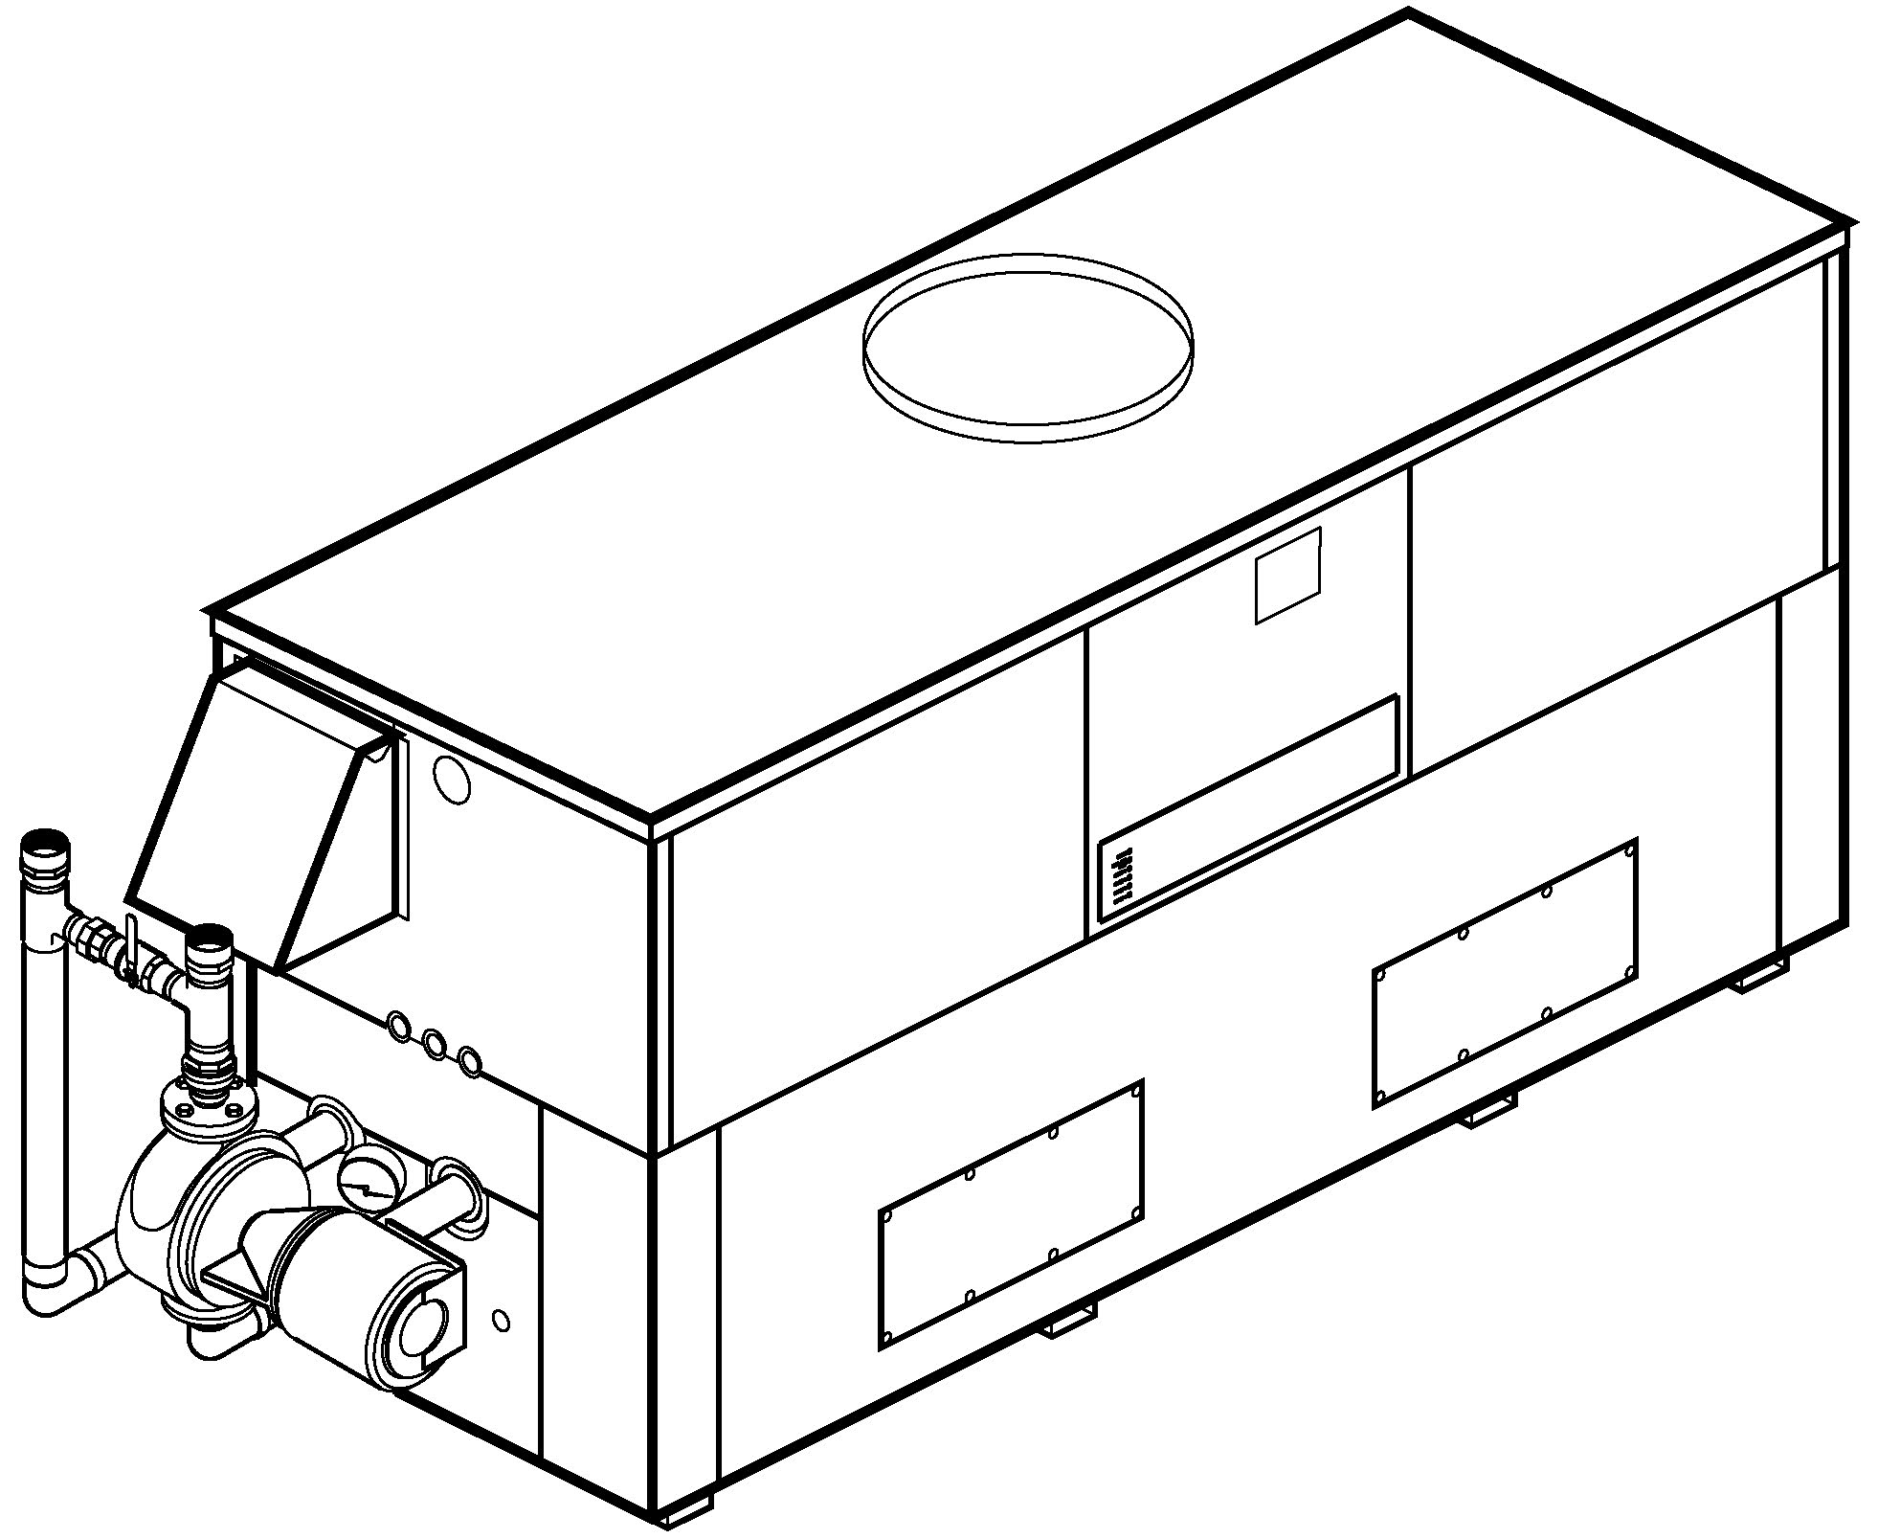

* 100% Factory Fire Tested
* Thermal Efficiency: 83.1%
* Versa IC® Controller with LCD Display
* Maximum Setpoint: 106°F (104°F Default)
* Maximum Outlet Temperature: 160°F
* Minimum Non-Condensing Inlet Temperature: 105°F
* Thermal-Shock Proof Heat Exchanger
* Limited Five-Year Heat Exchanger Warranty
* Full Safety Diagnostics with Fault History
* PolyTuf Powder Coated Cabinet
* No Combustible Floor Shield Required
* Fan-Assisted
* Patented Burner Security Blanket

**Standard “H” Bypass Shown**

* Ultra-Low NOx – SCAQMD 1146.2 Certified (992C – 2002C)
* Cascade Up To 4 Heaters – No External Sequencer Needed



Proudly Assembled in the USA

#### Heat Exchanger

* Brass Headers
* ASME Inspected and HLW Stamped  
  160 PSIG Working Pressure
* National Board Approved
* Cupro-Nickel Finned Tubing
* ASME Steel Tube Sheet
* Silicone High-Temp O-Rings
* 125 PSIG ASME Pressure Relief Valve
* Temperature and Pressure Gauge
* Water Connections

Left – Standard

A-6 – Right

* Bronze Pump, 1/2 HP, 120V, 60Hz
* Non-ferrous Pool Bypass Assembly

#### Controls

* 120V, 60Hz, 1∅ Power Supply
* 120/24V 60Hz Transformer
* Versa IC® Integrated Control
* Cascade up to 4 Heaters
* 100% Shut-Off/Lockout
* Hot Surface Ignition
* Ignition Module

3-Try – Standard

C-6 Single Try

* Remote Flame Sensor
* Fixed High Limit, Manual Reset 180°F
* On/Off Power Switch
* Flow Switch
* Blocked Vent Pressure Switch
* Combustion Air Proving Switch
* Programmable Pump Time Delays
* Heater
* System
* Enable/Disable
* LCD Display; Status, Fault and Diagnostics

#### Raypak-Rheem logo, submittals

#### Controls – Cont.

* Modbus RTU BMS Port (Up to 115K Baud Rate, See Cat. 5000.73)

B-85 – BMS Gateway – BACnet MS/TP, BACnet IP, N2 Metasys or Modbus TCP

B-86 – BMS Gateway – LonWorks

* Cold Water Protection Function

CWR Variable-Speed Pump

Default H-Bypass

#### Gas Train

* Combination Valves
* On/Off Firing
* Fuel

Natural Gas

Propane Gas (HD-5) (Excludes 2002C)

G-20 4” WC Nat. Supply Pressure

* Design Certified ANSI Z21.56/CSA 4.7

#### Burner

* Ultra-low NOx:  
  Less than 20 PPM

#### Construction

* Indoor/Outdoor Construction
* Enclosed Front Controls
* PolyTuf Powder Coat Finish
* CSA Low Lead Certified ≤ .25% Lead

#### Venting

* Vent Location

Top – Standard

D–14 Rear

* Vent Termination Cap

D–11 Outdoor

D–15 Horizontal

Indoor, Vertical (by others)



* Combustion Air

D–17 In-Line Filter Kit (TruSeal only)

D–16 Air Intake Elbow

#### Venting – Cont.

* Extractor - Optional

By Others

#### Not Required

#### Options

C-6 Ignition Module, Manual Reset

D-21 TruSeal® Direct Vent

Left Side - Standard   
 Right Side - Optional

F-10 Low Water Cut-Off,   
Remote Probe

S-1 Low Gas Pressure Switch, Manual Reset

S-2 High Gas Pressure Switch, Manual Reset

X-1 SureRack® Kit (Lower Unit Requires Manifold Modification)

X-2 SureRack Add-On (Lower Unit Requires Manifold Modification)

**Additional Options or Accessories**

**Multi-Heater Controllers**

#### B-36 2 – 4 Heaters

#### B-37 5 – 10 Heaters

#### B-38 11 – 16 Heaters

#### B-39 EMS 4-20mA Remote Setpoint Module

#### B-62 BACnet MS/TP Interface

#### Hi Delta – Type P

#### Models 992C-1262C (H-Bypass Option) Model

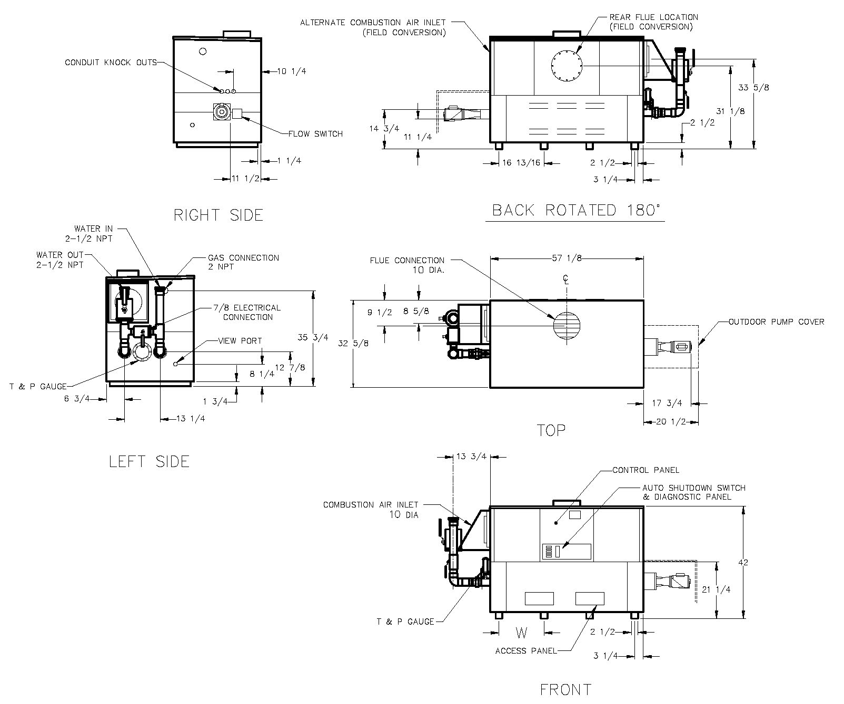

|  |  |  |  |
| --- | --- | --- | --- |
| **Rate of Heat Exchanger Flow and**  **Pressure Drop and Temperature Rise** | | | |
| Model | **GPM** | **ΔP (ft.)** | **ΔT (ºF)** |
| P 992C | 132 | 14.0 | 13 |
| P 1262C | 15.5 | 16 |

|  |  |  |  |  |  |  |  |  |
| --- | --- | --- | --- | --- | --- | --- | --- | --- |
| **Model** | **MBTUH** | | **A**  **Width** | **K** | **W** | **Amp. Draw**  **(w/ Pump)** | **Pump**  **HP** | **Shipping**  **Weight**  **(Lbs.)** |
| **Input** | **Output**  **83.1%** |
| P 992C | 990 | 823 | 57-1/8 | 10 | 16-13/16 | <16 | 1/2 | 1000 |
| P 1262C | 1260 | 1047 | 68-1/2 | 12 | 20-9/16 | 1055 |

NOTES: 1. Dimensions are in inches.

2. Rates shown are for natural or propane gas, and elevations up to 4,500 feet.

For installation above 4,500 feet, please contact manufacturer.

#### Hi Delta – Type P

#### Models 992C-1262C (Cold Water Run Option) Model

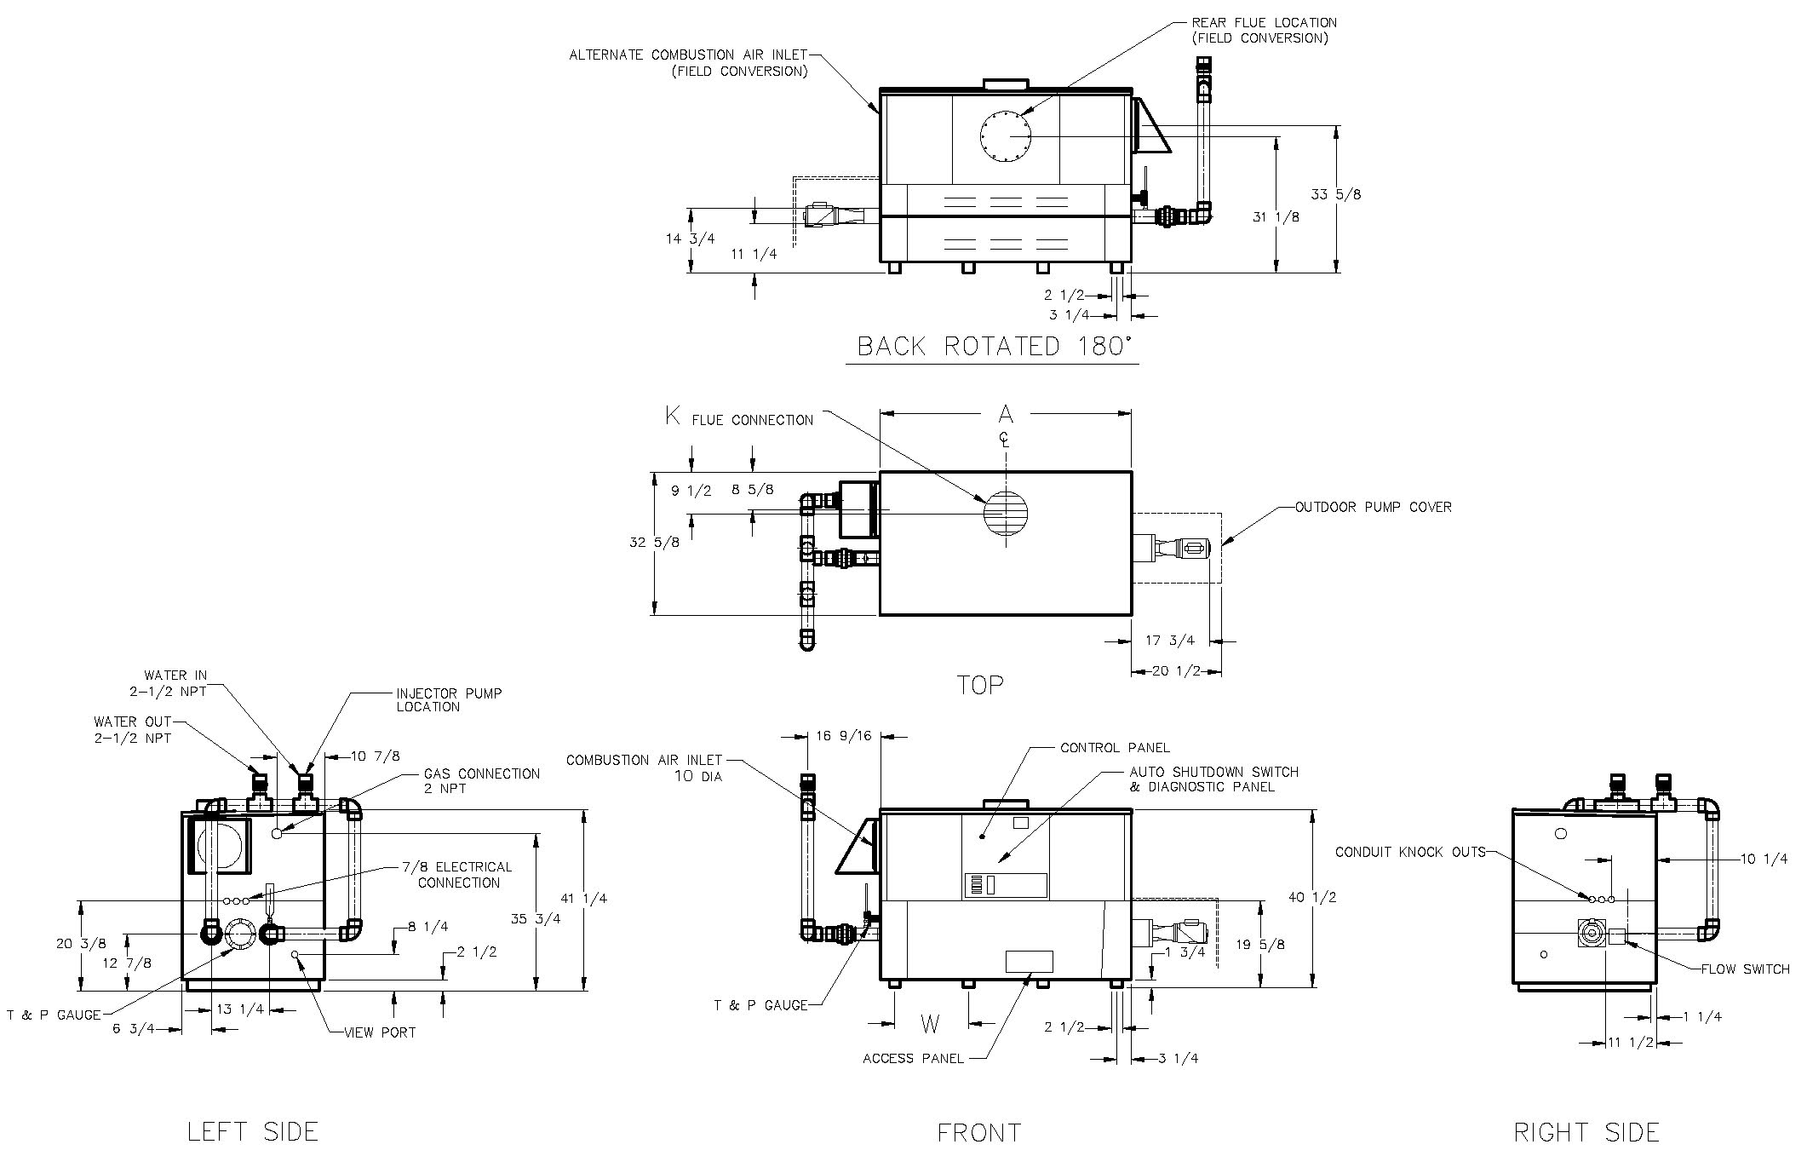

|  |  |  |  |
| --- | --- | --- | --- |
| **Rate of Heat Exchanger Flow and**  **Pressure Drop and Temperature Rise** | | | |
| Model | **GPM** | **ΔP (ft.)** | **ΔT (ºF)** |
| P 992C | 132 | 14.0 | 13 |
| P 1262C | 15.5 | 16 |

|  |  |  |  |  |  |  |  |  |  |
| --- | --- | --- | --- | --- | --- | --- | --- | --- | --- |
| **Model** | **MBTUH** | | **A**  **Width** | **K** | **W** | **Amp. Draw**  **(w/ Pump)** | **Pump**  **HP** | **Injector**  **Pump**  **HP** | **Shipping**  **Weight**  **(Lbs.)** |
| **Input** | **Output**  **83.1%** |
| P 992C | 990 | 823 | 57-1/8 | 10 | 1/3* | <16 | 1/2 | 1/3* | 1000 |
| P 1262C | 1260 | 1047 | 68-1/2 | 12 | 1/3* | 1055 |

NOTES: 1. Dimensions are in inches.

2. Rates shown are for natural or propane gas, and elevations up to 4,500 feet.

For installation above 4,500 feet, please contact manufacturer.

*Separate 120 VAC or 240 VAC 1Ø power required for Cold Water Run Option.

Injector shipped loose for field installation at bypass inlet.

#### Hi Delta – Type P

#### Models 1532C-2342C (H-Bypass Option) Model

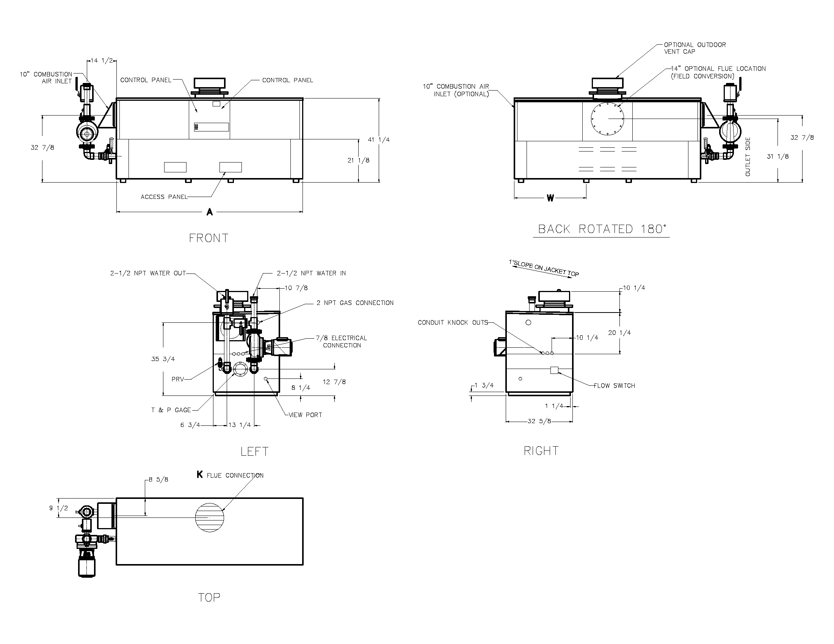

|  |  |  |  |
| --- | --- | --- | --- |
| **Rate of Heat Exchanger Flow and**  **Pressure Drop and Temperature Rise** | | | |
| Model | **GPM** | **ΔP (ft.)** | **ΔT (ºF)** |
| P 1532C | 132 | 16.5 | 20 |
| P 1802C | 18.3 | 23 |
| P 2002C | 19.0 | 26 |
| P 2072C | 19.0 | 27 |
| P 2342C | 21.4 | 30 |

|  |  |  |  |  |  |  |  |  |  |
| --- | --- | --- | --- | --- | --- | --- | --- | --- | --- |
| **Model** | **MBTUH** | | **A**  **Width** | **K** | **W** | **Amp. Draw** | | **Pump**  **HP** | **Shipping**  **Weight**  **(Lbs.)** |
| **Input** | **Output**  **83.1%** | **Heater** | **Pump** |
| P 1532C | 1530 | 1271 | 79-7/8 | 12 | 24-3/8 | <12 | 11 | 3/4 | 1225 |
| P 1802C | 1800 | 1496 | 91-1/8 | 14 | 28-1/8 | 11 | 3/4 | 1350 |
| P 2002C | 1999 | 1661 | 102-1/2 | 14 | 31-15/16 | 14** | 1 | 1450 |
| P 2072C | 2070 | 1720 | 102-1/2 | 14 | 31-15/16 | 14** | 1 | 1450 |
| P 2342C | 2070 | 1945 | 113-7/8 | 16 | 35-11/16 | 21** | 1-1/2 | 1520 |

NOTES: 1. Dimensions are in inches.

2. Rates shown are for natural or propane gas, and elevations up to 4,500 feet.

For installation above 4,500 feet, please contact manufacturer.

** Requires separate circuit breaker

#### Hi Delta – Type P

#### Models 1532C-2342C (Cold Water Run Option) Model

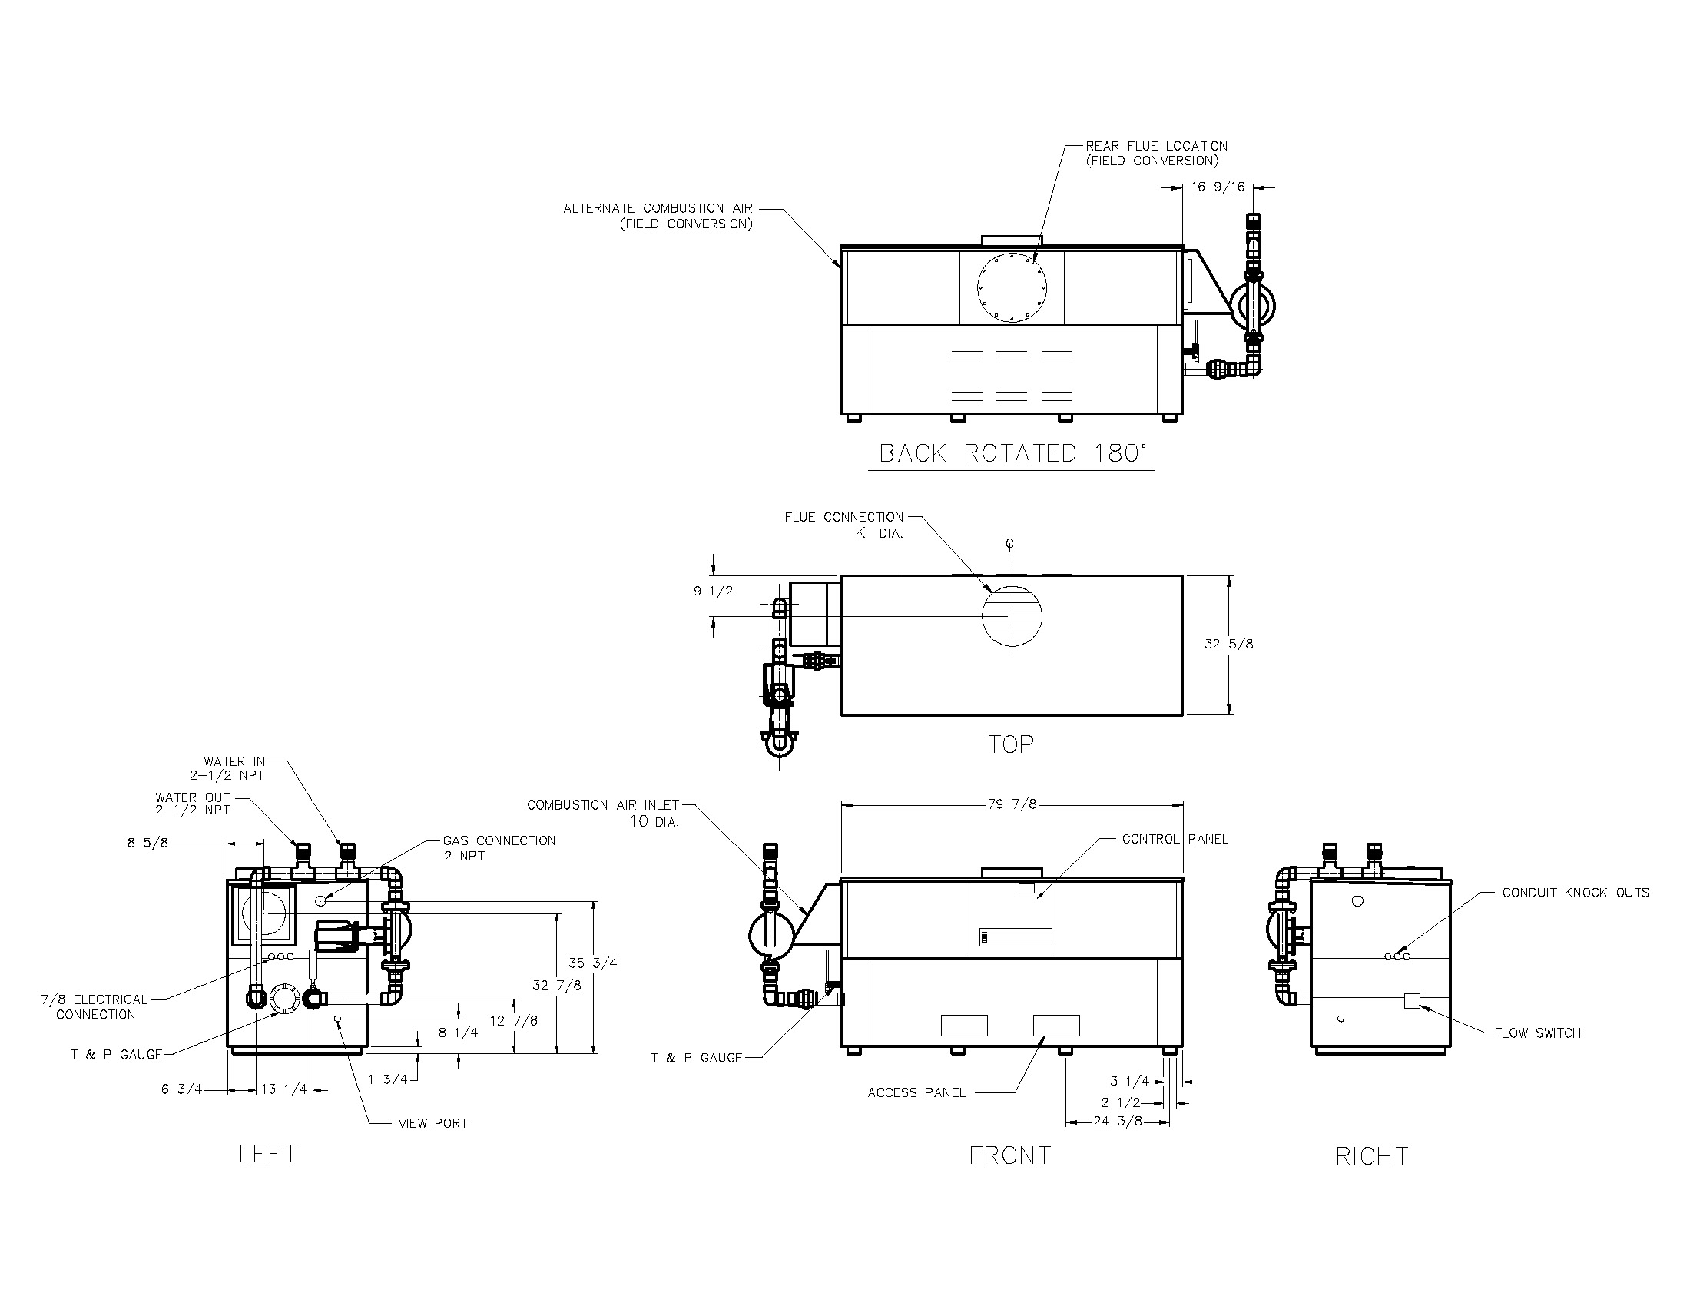

|  |  |  |  |
| --- | --- | --- | --- |
| **Rate of Heat Exchanger Flow and**  **Pressure Drop and Temperature Rise** | | | |
| Model | **GPM** | **ΔP (ft.)** | **ΔT (ºF)** |
| P 1532C | 132 | 16.5 | 20 |
| P 1802C | 18.3 | 23 |
| P 2002C | 19.0 | 26 |
| P 2072C | 19.0 | 27 |
| P 2342C | 21.4 | 30 |

|  |  |  |  |  |  |  |  |  |  |
| --- | --- | --- | --- | --- | --- | --- | --- | --- | --- |
| **Model** | **MBTUH** | | **A**  **Width** | **K** | **W** | **Amp. Draw** | | **Injector**  **Pump**  **HP** | **Shipping**  **Weight**  **(Lbs.)** |
| **Input** | **Output**  **83.1%** | **Heater** | **Pump** |
| P 1532C | 1530 | 1271 | 79-7/8 | 12 | 24-3/8 | <12 | 11 | 1/3 | 1225 |
| P 1802C | 1800 | 1496 | 91-1/8 | 14 | 28-1/8 | 11 | 1/3 | 1350 |
| P 2002C | 1999 | 1661 | 102-1/2 | 14 | 31-15/16 | 14** | 3/4 | 1450 |
| P 2072C | 2070 | 1720 | 102-1/2 | 14 | 31-15/16 | 14** | 3/4 | 1450 |
| P 2342C | 2070 | 1945 | 113-7/8 | 16 | 35-11/16 | 21** | 3/4 | 1520 |

NOTES: 1. Dimensions are in inches.

2. Rates shown are for natural or propane gas, and elevations up to 4,500 feet.

For installation above 4,500 feet, please contact manufacturer.

** Requires separate circuit breaker

Raypak, Inc. ▪ 2151 Eastman Avenue, Oxnard, CA 93030 ▪ (805) 278-5300 ▪ Fax (800) 872-9725 ▪ www.raypak.com