Job:

# XTherm™ - Type WH

## Water Heaters Models 1005-2005

Engineer:

Contractor:

Prepared By:       Date:

X-Therm Iso Rev AModel:       Indoor/Outdoor:

97% Thermal Efficiency at Full Rate; Up to 99% at Part Load

100% Factory Fire Tested

Maximum Outlet Water Temperature: 190°F

Minimum Acceptable Inlet Water Temperature: 50°F

Full Safety Diagnostics with History

Footprint: Less Than 10.8 ft2

Limited Twenty-Five-Year Thermal Shock Warranty

Limited Five-Year Copper/Ten-Year Cupro-Nickel Primary Heat Exch. Warranty

Limited Five-Year Condensing Heat Exchanger Warranty

Full Electronic Modulation, Constant Ratio 4:1 Turndown

Modulating Controller with LCD Display



Proudly Made in the USA

Status Display Lights

#### Heat Exchanger

* Bronze Headers
* ASME HLW Stamped; 160 PSIG MAWP
* National Board Listed
* Fin Tubing

Copper – Standard

Cupro Nickel – Option A-3

* ASME Powder-Coated Tube Sheet
* Silicone High Temp O-Rings
* ASME Pressure Relief Valve

125 PSIG – Standard

150 PSIG – Option A-16

* 150 PSI Air Vent, Auto
* T&P Gauge, Shipped Loose
* Stainless Steel Condensing Heat Exchanger
* Stainless Steel Evaporator Plate
* Boiler Pump: Bronze, 120V, 1∅, 60Hz  
  Water Hardness:       GPG

#### Control

* 120V, 60Hz, 1Ø, Power Supply
* 120/24V 60Hz Transformer
* Ignition Module

3-Try – Standard

Single-Try – Option C-6

* Hot Surface Ignition (HSI)
* Remote Flame Sensor
* Fixed High Limit, Manual Reset, 200ºF
* On/Off Power Switch
* Flow Switch
* Blocked Vent Pressure Switch
* Combustion Air Proving Switch
* Freeze Protection
* Pump Switch
* Pump Time Delay
* Alarm Dry Contact

**Control (cont.)**

* Diagnostics Panel with LCD Display,

2 lines, 20 characters

* Modulating Temperature Control
* Water Temperature Sensors (3)
* Cold Water Protection
* Blocked Condensate Switch

#### Burner

* Ultra-Low NOx: Less than 20 PPM

(Natural Gas Only)

#### Gas Train

* Fuel

Natural Gas

Propane

* Zero Governor Regulator
* Dual-Seat Combination Valve
* Electronic Modulating Firing Mode (WH7)

#### Construction

* Indoor/Outdoor Construction
* Front Controls Enclosed
* PolyTuf Powder Coat Finish
* Rear Connections (Water, Gas, Vent,

Electrical, Comb. Air, Cond. Drain)

* Combustion Air Filter
* Design Certified ANSI Z21.10.3/CSA 4.3
* CSA Low Lead Certified ≤ .25 Lead
* Front Connection Low-Voltage Wiring

#### Venting

* Vent Termination, Cat IV

Outdoor or Indoor, Vertical –

Option D-11   
 Indoor, Horizontal – Option D-15

* Extractor – Optional, Cat II

By others

Not required

**Multi-Heater Digital Temp Controllers**

B-36 TempTracker Mod+ Hybrid,

2-4 Heaters

B-37 TempTracker Mod+ Hybrid,

5-10 Heaters

B-38 TempTracker Mod+ Hybrid,  
11-16 Heaters

B-45 Multi-Mod Platinum,  
2-4 Heaters

B-46 Multi-Mod Platinum EMS,  
2-4 Heaters

B-47 Multi-Mod Platinum BACNet,  
2-4 Heaters

B-48 Multi-Mod Expansion Module,  
1-8 Additional Heaters

#### Options

D-32 PVC Vent Adapter,  
Factory-mtd ONLY

D-33 Polypro Vent Adapter,

Factory-mtd or Field-mtd

I-3 High Limit, Auto Reset,

Adj., 40-180°F

I-5 High Limit, Manual Reset, Adj.,

100-200°F

S-1 Low Gas Pressure Switch,   
Manual Reset

S-2 High Gas Pressure Switch,

Manual Reset

Z-12 Condensate Neutralizer Kit

#### Regulatory Agency Requirements

#### 

Raypak-Rheem logo, submittalsXTherm – Type WH

Models 1005-2005 Model

**NOTE: Primary/Secondary plumbing is mandatory for proper operation.**

**CLEARANCES (in.)**

|  |  |  |  |  |  |  |  |
| --- | --- | --- | --- | --- | --- | --- | --- |
|  | **Front** | **Rear** | **Right** | **Left** | **Top** | **Floor** | **Vent** |
| **Certified Minimum** | 24 | 12 | 1 | 1 | 0 | 0 | 1 |
| **Minimum Service** | 24 | 36 | 24 | 1 | 10 | N/A | N/A |

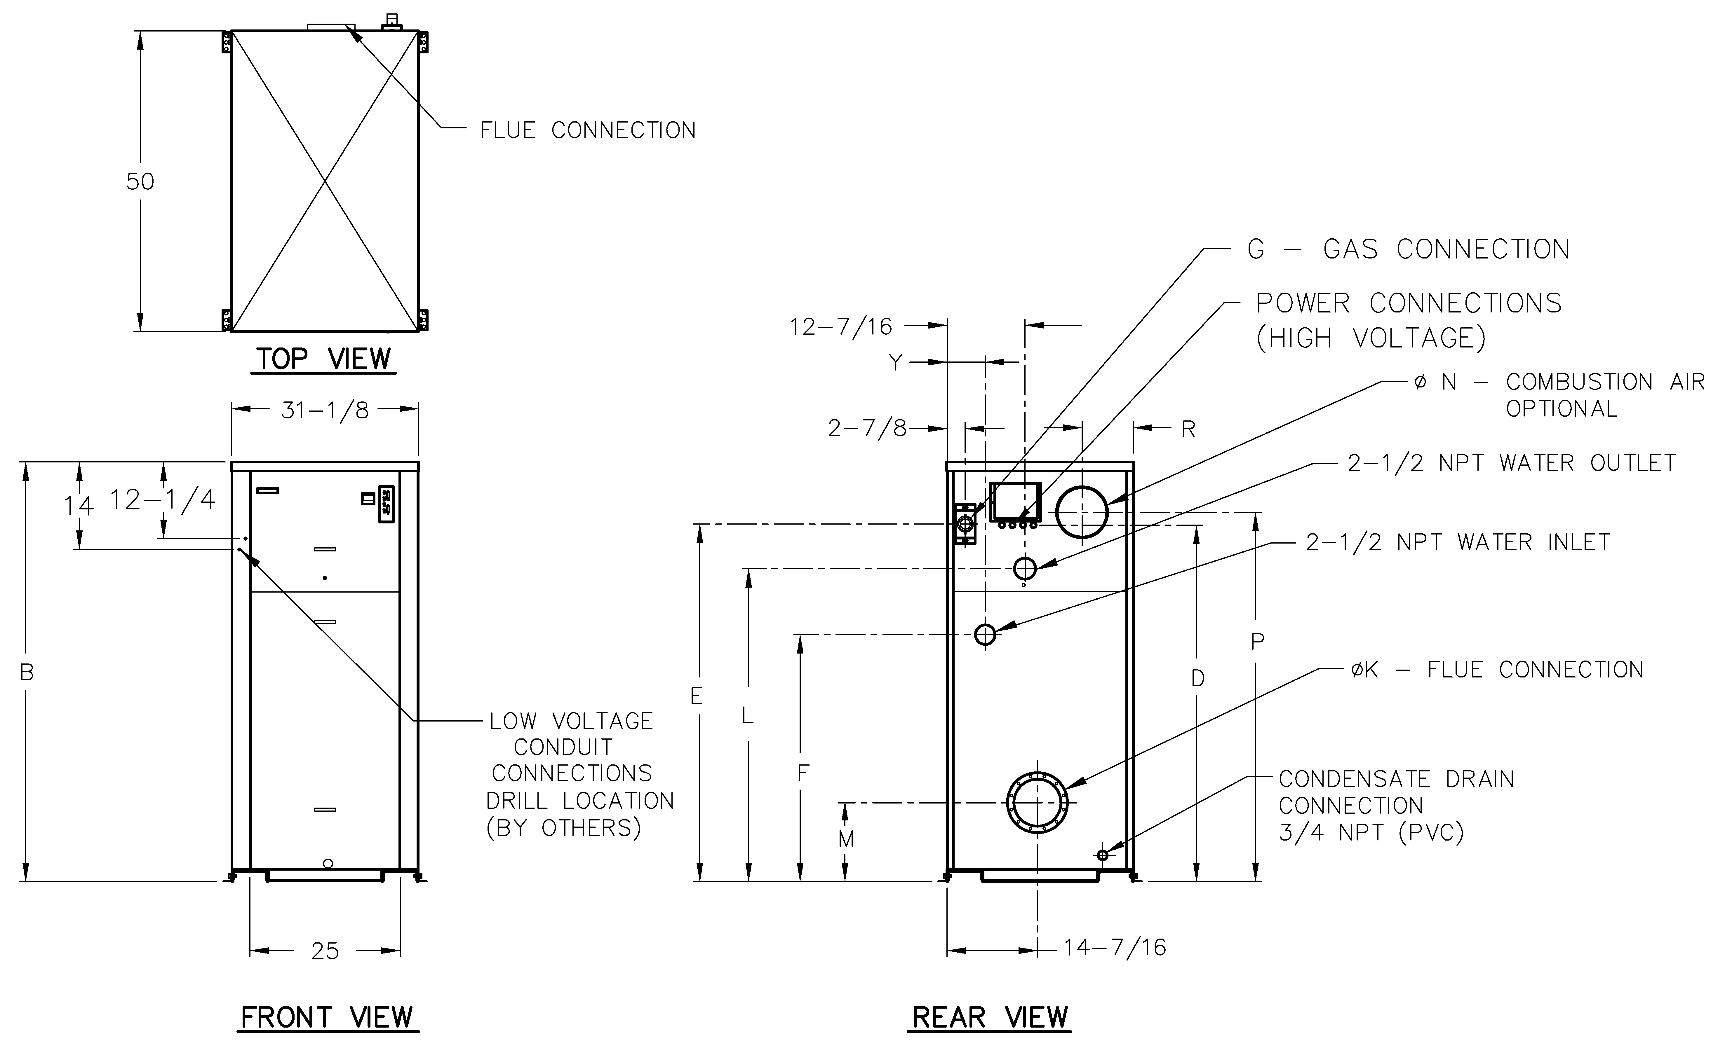

**POWER REQUIREMENTS – AMPS†**

|  |  |  |  |  |
| --- | --- | --- | --- | --- |
| **Model**  **(WH7-)** | **Heater**  **Amp**  **Draw †** | **Pump Amp Draw †** | | |
| **Soft** | **Medium** | **Hard** |
| 1005 | 12** | 10 | 10 | 14 |
| 1505 | 12** | 10 | 14 | 17 |
| 2005 | 18** | 17 | 17 | N/A |

† Separate power connections are factory supplied and separate supply breakers must be field supplied.

** Current draw is for heater only (Supply breaker must have delayed trip).

|  |  |  |  |  |  |  |  |  |  |  |  |  |  |  |  |
| --- | --- | --- | --- | --- | --- | --- | --- | --- | --- | --- | --- | --- | --- | --- | --- |
| **Model (WH7-)** | **MBTUH** | | **Dimensions (in)** | | | | | | | | | | | | **Ship Weight (Lbs.)** |
| **B Height** | **D** | **E** | **F** | **G* NPT** | **K**  **Flue Ø** | **L** | **M** | **N C/A Ø** | **P** | **R** | **Y** |
| **Input** | **Output** |
| 1005 | 999 | 969 | 55-1/8 | 45 | 47-1/8 | 36-1/2 | 1-1/4 | 6 | 40-1/16 | 11-1/2 | 6 | 47-1/8 | 8-1/16 | 6-1/16 | 1065 |
| 1505 | 1500 | 1455 | 67-1/8 | 57 | 59-1/16 | 38-1/2 | 1-1/4 | 8 | 52-1/16 | 12-5/8 | 8 | 59-1/8 | 8-3/16 | 6-1/16 | 1234 |
| 2005 | 1999 | 1939 | 81-1/8 | 71 | 71-3/16 | 38-1/2 | 2 | 8 | 64-1/16 | 12-5/8 | 8 | 73-1/8 | 8-3/16 | 6-1/4 | 1461 |

|  |  |
| --- | --- |
| Note: Ratings shown are for elevations up to 4,500 feet. For installations at elevations  above 4,500 feet, please consult the factory for additional instructions. | * For Propane Gas, all models are 1” NPT |

|  |  |  |  |  |  |  |  |  |  |
| --- | --- | --- | --- | --- | --- | --- | --- | --- | --- |
| **Model (WH7-)** | **RECOVERY RATES** | | | | | | | | |
| **Temperature Rise (°F)** | | | | | | | | |
| **20** | **30** | **40** | **50** | **60** | **70** | **80** | **90** | **100** |
| 1005 | 5817 | 3878 | 2908 | 2327 | 1939 | 1662 | 1454 | 1293 | 1163 |
| 1505 | 8733 | 5822 | 4367 | 3493 | 2911 | 2495 | 2183 | 1941 | 1747 |
| 2005 | 11639 | 7759 | 5813 | 4656 | 3880 | 3325 | 2910 | 2586 | 2328 |