Job:

# Hi Delta® - Type P

## Commercial Pool Heaters Models 502B-902B

Engineer:

Contractor:

Prepared By:       Date:

Model:       Indoor/Outdoor:       MBTUH Input:

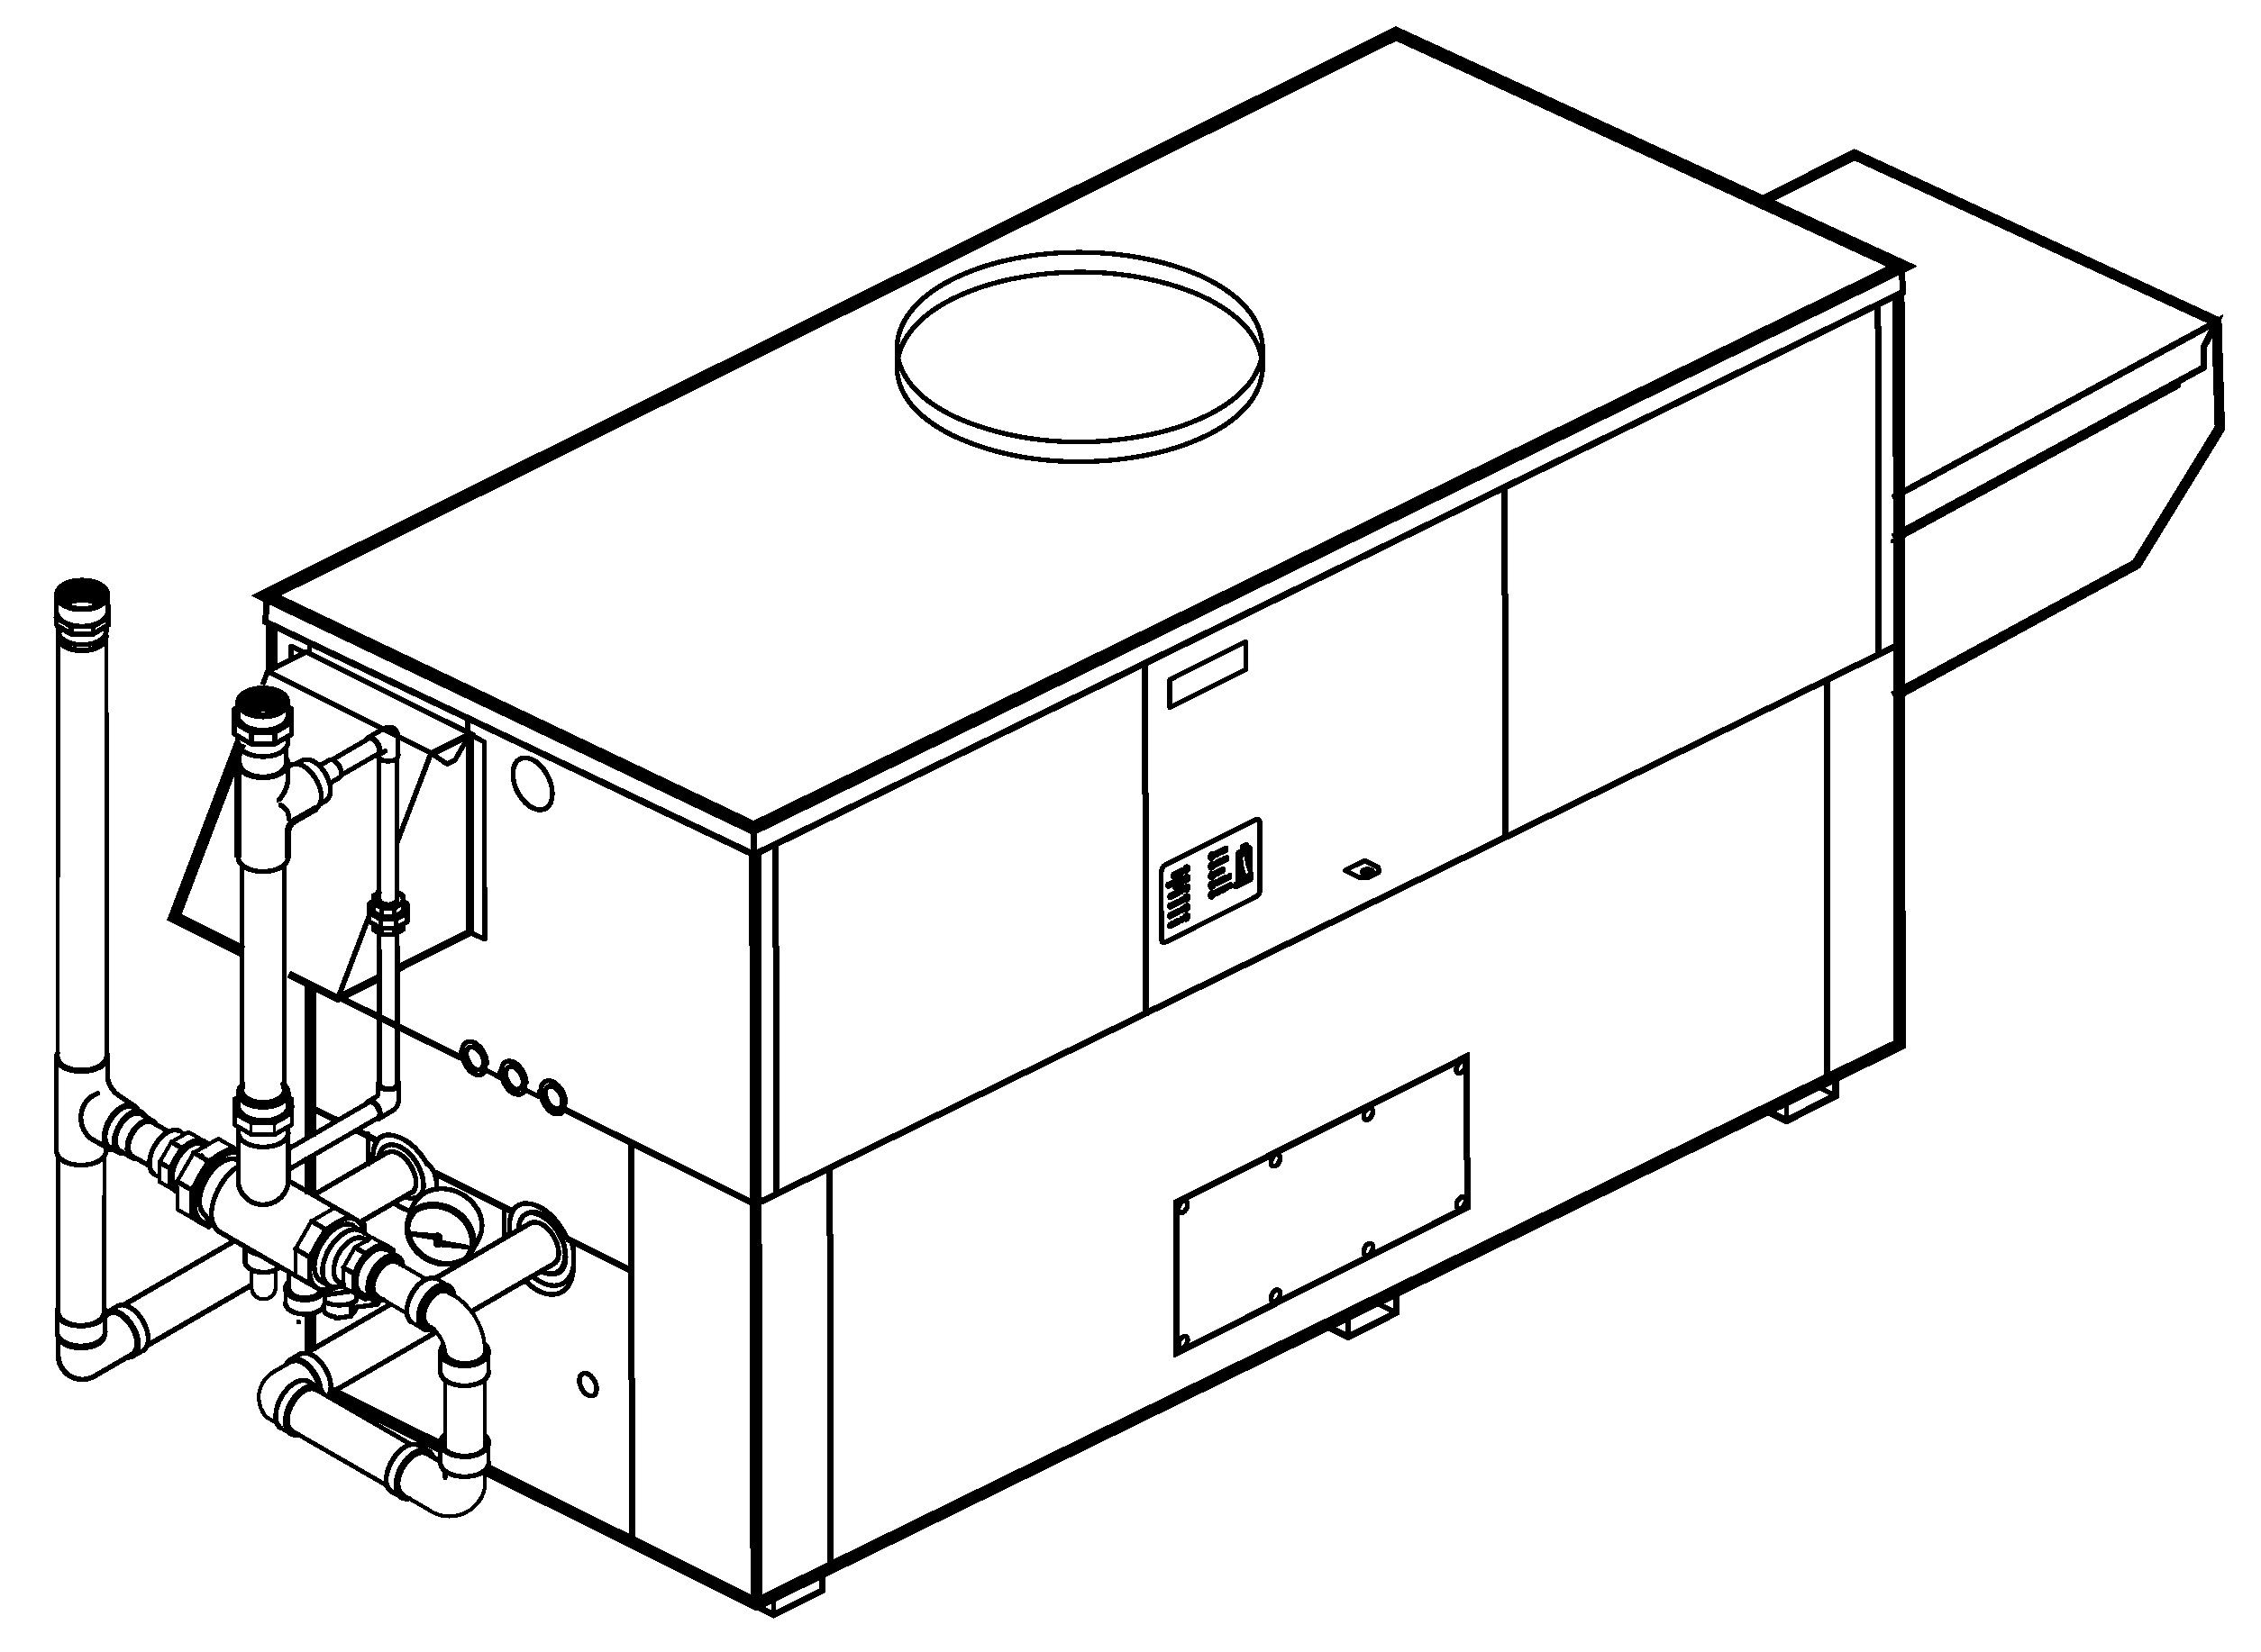

Sealed Combustion Chamber

100% Factory Fire Tested

Efficiency: 85%

Minimum Non-condensing Inlet Temperature: 105°F

Thermal Shock Proof Heat Exchanger

Limited Twenty-year Thermal Shock Warranty

Limited Five-year Heat Exchanger Warranty

Full Safety Diagnostics with Fault History

PolyTuf Powder Coated Cabinet

No Combustible Floor Shield Required

Patent No. 7,044,124

Fan-assisted

Non-ferrous Bypass



Proudly Assembled in the USA

**Standard “Sparcomatic” Bypass Shown**

Patented Burner Security Blanket

#### Heat Exchanger

* Brass Headers
* ASME Inspected and Stamped  
  160 PSIG Working Pressure
* National Board Approved
* Cupro-Nickel Finned Tubing
* ASME Steel Tube Sheet
* Silicone High-Temp O-Rings
* 125 PSIG ASME Pressure Relief Valve
* Temperature and Pressure Gauge
* Water Connections

Left – Standard

Right – Option A-6

* Bronze Pump, 1/2 HP, 120V, 60Hz
* Non-ferrous Pool Bypass Assembly

with Automatic Control

#### Controls

* 120V, 60Hz, 1 Power Supply
* 120/24V 60Hz Transformer
* 100% Pilot Shutoff/Lockout
* Hot Surface Ignition
* Remote Flame Sensor
* High Limit Control, Manual Reset
* On/Off Power Switch
* Thermostat Override Switch
* Manual Shut-off, Front-mounted
* Flow Switch
* Blocked Vent Pressure Switch
* Combustion Air Proving Switch
* Economaster Pump Time Delay
* Poolstat
* Diagnostics Panel with LCD Display,

2 Lines, 20 Characters

#### Raypak-Rheem logo, submittalsGas Train

* Combination Valves
* On/Off Firing
* Fuel

Natural Gas

Propane Gas

* Design Certified ANZI Z21.56/  
  CSA 4.7

#### Burner

* Ultra-low NOx:  
  Less than 20 PPM

#### Construction

* Indoor/Outdoor Construction
* Enclosed Front Controls
* PolyTuf Powder Coat Finish
* CSA Low Lead Certified ≤ .25% Lead

#### Venting

* Vent Location

Top – Standard

Rear – Option D-14

* Vent Termination Cap

Outdoor – Option D-11

Indoor, Horizontal –   
Option D-15

Indoor, Vertical (by others)

* Combustion Air

In-Line Filter Kit (TruSeal only) – Option D-17

Air Intake Elbow –   
Option D-16

#### Multi-Heater Controllers

#### B-26 2-Stage Digital

#### B-21 4-Stage Digital

#### B-__ TempTracker Mod+ (Up to 16 Boilers)

#### Options

C-6 Ignition Module, Manual Reset

D-21 TruSeal® Direct Vent

Left Side - Standard   
 Right Side - Optional

F-10 Low Water Cut-Off,   
Remote Probe

P-__ Cold Water Run System

(See Page 3)

S-1 Low Gas Pressure Switch, Manual Reset

S-2 High Gas Pressure Switch, Manual Reset

X-1 SureRack® Kit (Lower Unit Requires Manifold Modification)

X-2 SureRack Add-On (Lower Unit Requires Manifold Modification)

**Regulatory Agency Requirements**

G-1 CSD-1



#### Hi Delta – Type P

#### Models 502B – 902B (“Sparcomatic’’ Bypass Option) Model

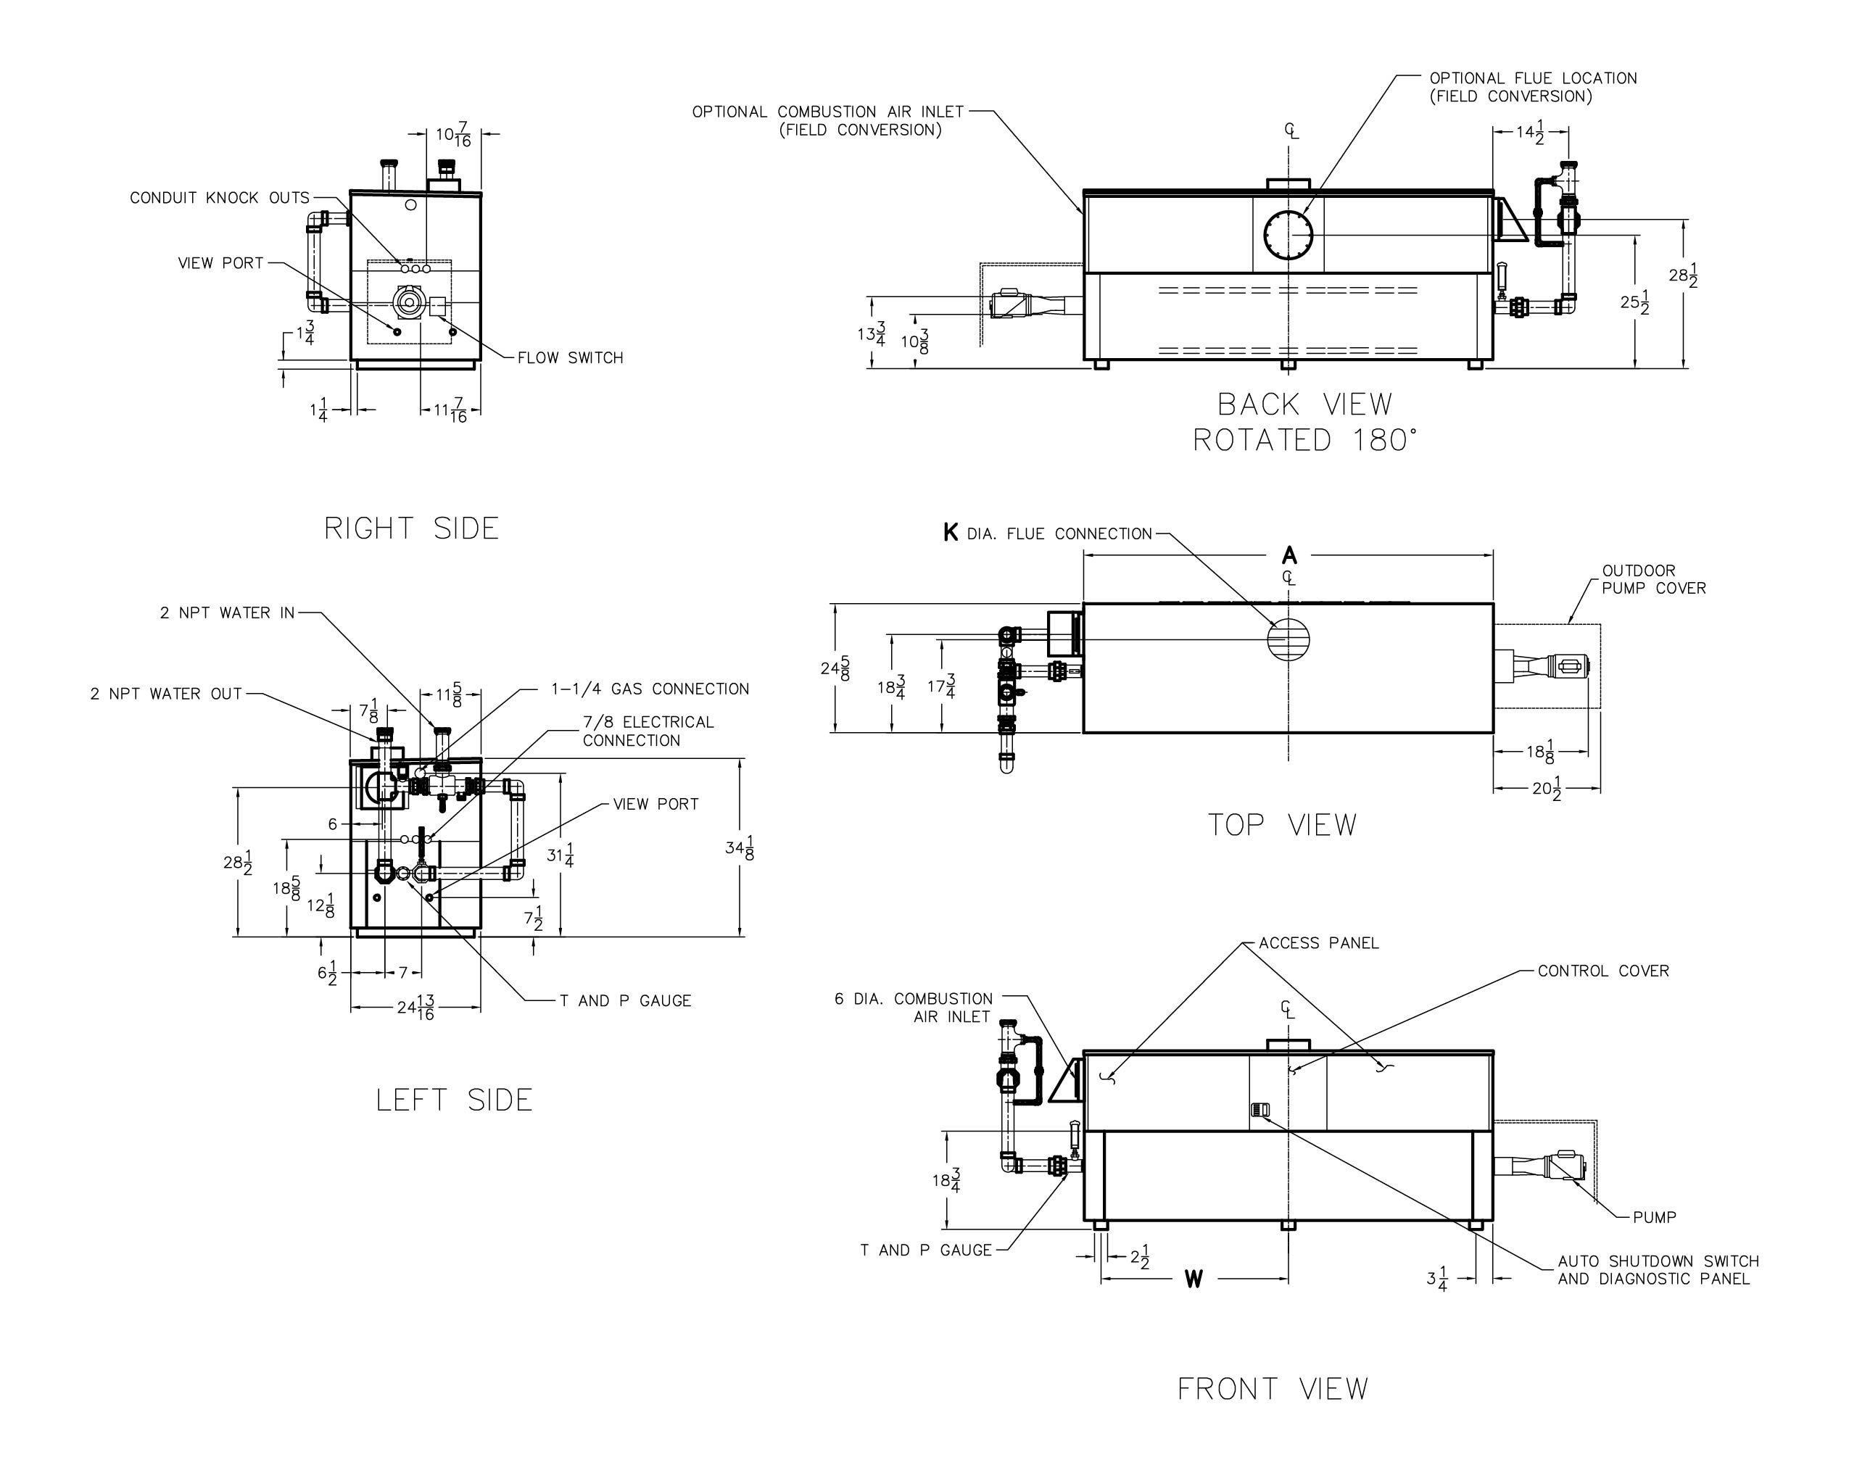

RATE OF FLOW AND PRESSURE DROP

|  |  |  |  |
| --- | --- | --- | --- |
| Model | Max. Flow | | |
| GPM | **∆P (ft)** | ∆T |
| 502B | 90 | 10.5 | 10 |
| 652B | 90 | 10.7 | 12 |
| 752B | 90 | 11.0 | 14 |
| 902B | 90 | 11.8 | 17 |

|  |  |  |  |  |  |  |  |
| --- | --- | --- | --- | --- | --- | --- | --- |
| **Model** | **MBTUH** | | **A**  **Width** | **K** | **W** | **Amp Draw (w/ Pump)** | **Shipping Weight (Lbs.)** |
| **Input** | **Output** |
| 502B | 500 | 425 | 50 | 6 | 22 | 13 | 545 |
| 652B | 650 | 553 | 60-1/2 | 8 | 27-1/4 | 13 | 590 |
| 752B | 750 | 638 | 67-1/2 | 8 | 30-3/4 | 13 | 675 |
| 902B | 900 | 765 | 78 | 8 | 36 | 14 | 740 |

Dimensions are in inches.

Ratings shown are for elevations up to 4,500 feet and for natural or propane gas.

For installation at elevations over 4,500 feet, please contact manufacturer.

#### Hi Delta – Type P

#### Models 502B – 902B (Cold Water Run Option) Model

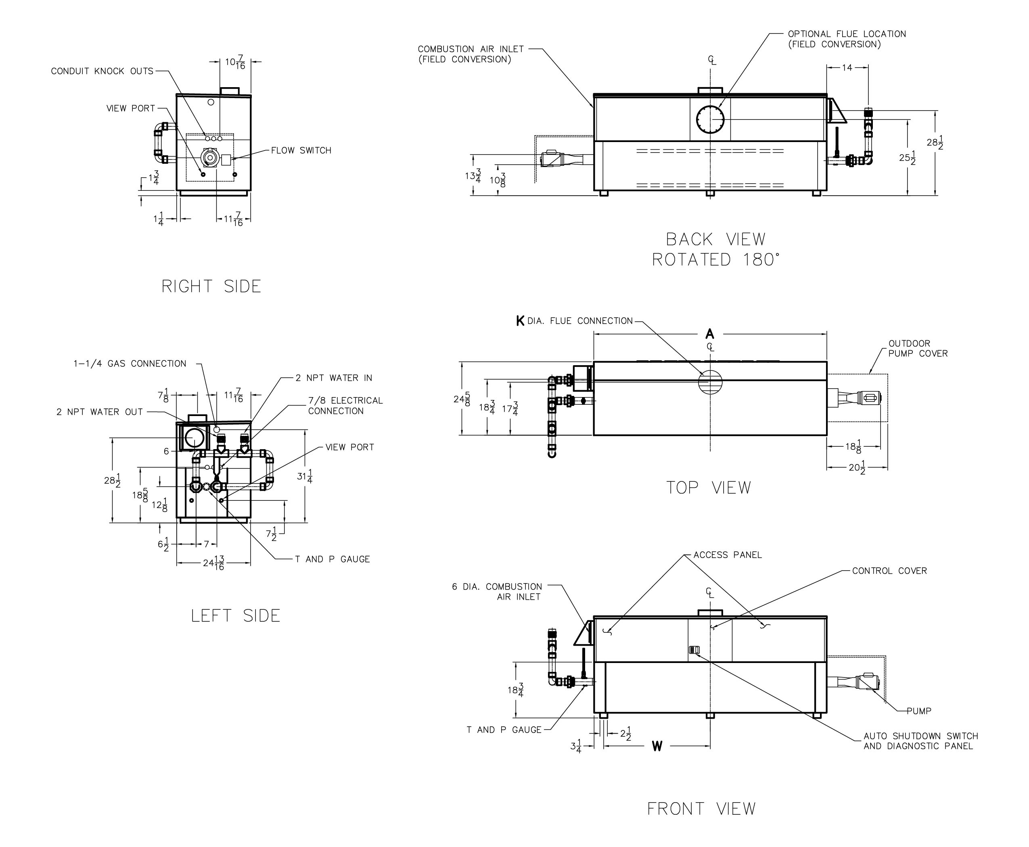

RATE OF FLOW AND PRESSURE DROP

|  |  |  |  |
| --- | --- | --- | --- |
| Model | Max. Flow | | |
| GPM | **∆P (ft)** | ∆T |
| 502B | 90 | 10.5 | 10 |
| 652B | 90 | 10.7 | 12 |
| 752B | 90 | 11.0 | 14 |
| 902B | 90 | 11.8 | 17 |

|  |  |  |  |  |  |  |  |
| --- | --- | --- | --- | --- | --- | --- | --- |
| Model | MBTUH | | A  Width | K | W | Amp Draw | Shipping Weight  (Lbs.) |
| Input | Output | Heater w/ Pump |
| P 502B | 500 | 425 | 50 | 6 | 22 | 13 | 655 |
| P 652B | 650 | 553 | 60-1/2 | 8 | 27-1/4 | 13 | 755 |
| P 752B | 750 | 638 | 67-1/2 | 8 | 30-3/4 | 13 | 815 |
| P 902B | 900 | 765 | 78 | 8 | 36 | 14 | 905 |

Dimensions are in inches.

Ratings shown are for elevations up to 4,500 feet and for natural or propane gas.

For installation at elevations over 4,500 feet, please contact manufacturer.

* Separate 120 VAC or 240 VAC 1Ø power required for Cold Water Run Option.

Injector pump ships loose for field installation at bypass inlet.

Raypak, Inc. ▪ 2151 Eastman Avenue, Oxnard, CA 93030 ▪ (805) 278-5300 ▪ Fax (805) 872-9725 ▪ www.raypak.com