Job:

MVB® - Type P

Pool Heaters
Models 504A-2004A

Engineer:

Contractor:
Prepared By: Date:
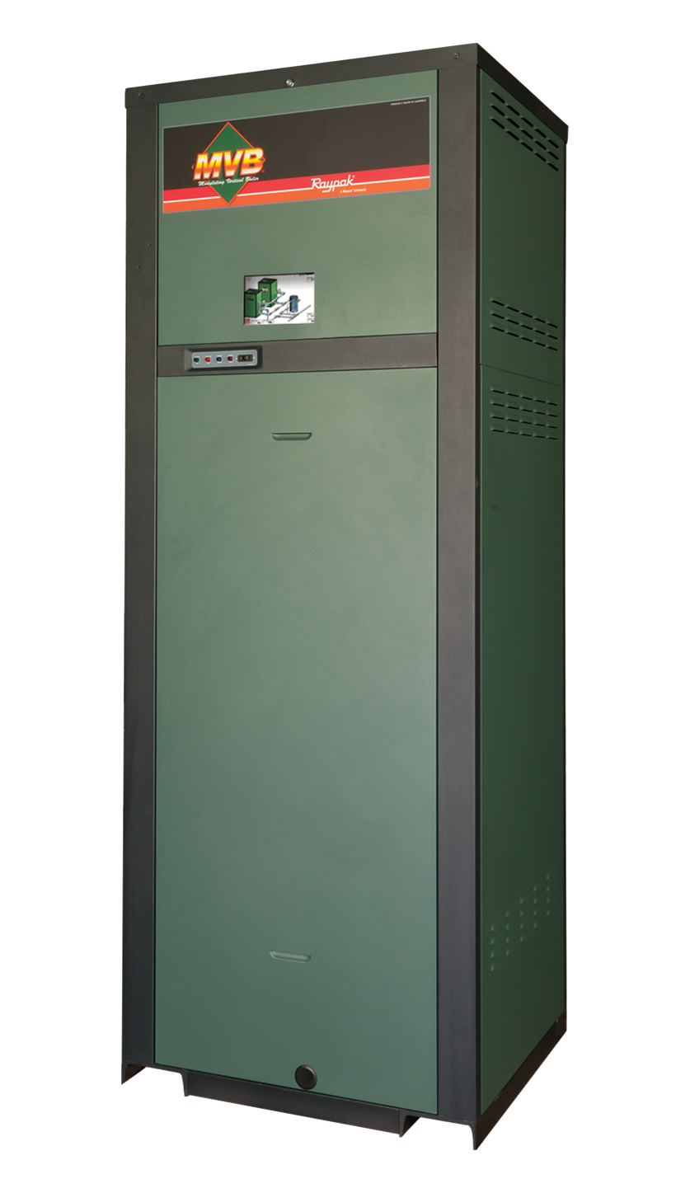
Model: Indoor/Outdoor:
83-83.3% Thermal Efficiency at Full Rate
100% Factory Fire-Tested
VERSA IC® Integrated Controller with 7” Color Touchscreen Display
Raymote™ remote connectivity provided standard
On/Off Operation
Full Safety Diagnostics with History
Status Display Lights
Cascade up to 4 Heaters – No External Sequencer Required
CSA Low Lead Certified ≤ .25% Lead
Maximum Outlet Water Temperature: 180°F
Maximum Pool Setpoint 106°F (104°F Default)
Minimum Inlet Water Temperature: 105°F
Proudly Assembled in the USA

Limited Five-Year Primary Heat Exchanger Warranty
Ultra Low NOx, Less Than 20 PPM

Heat Exchanger
- Bronze Headers
- ASME HLW Stamped; 160 PSIG MAWP
- National Board Listed
- Cupronickel Fin Tubing
- ASME Powder-Coated Tube Sheet
- Silicone High-Temp O-Rings
- ASME Pressure Relief Valve
125 PSIG – Standard
- Manual Air Bleed
- Temperature and Pressure Gauge,
Shipped Loose
- Four pass primary heat exchanger
- Stainless Steel Evaporator Plate
- Heater Pump: Bronze, 120V, 1∅, 60Hz

Control
- 120V, 60Hz, 1Ø, Power Supply
- 120/24V 60Hz Transformer
- VERSA IC® built-in controller
- 7” color HD touchscreen display
- Raymote™ Wi-Fi remote connectivity
- Ignition Module
3-Try – Standard
C-6 Single-Try – Optional
- Remote Flame Sensor
- High Limit Fixed Manual 180ºF
- On/Off Power Switch
- Flow Switch
- Blocked Vent Pressure Switch
- Combustion Air Proving Switch
- Freeze Protection
- Pump Switch
- Alarm Dry Contact
- Pump Time Delay
- Blocked Condensate Switch
- Water Temperature Sensors (4)
- Cold Water Protection
Cold Water Run
H-Bypass
- Modbus RTU BMS Port
B-85 BMS Gateway – BACnet MS/TP, BACnet IP, N2 Metasys or Modbus TCP
B-86 BMS Gateway – LonWorks

Burner
- Hot Surface Ignition (HSI)
- Radially-Fired Knitted Burner

Gas Train
- Fuel
Natural Gas
Propane (minimum grade HD-5)
- Zero Governor Regulator
- Dual-Seat Combination Valve
- Electronic Firing Mode (P)

Construction
- Indoor/Outdoor Construction
- Front Controls Enclosed
- PolyTuf Powder Coat Finish
- Rear Connections (Water, Gas, Vent, Electrical, Comb. Air, Cond. Drain)
- Combustion Air Filter – Shipped Loose
- Design Certified ANSI Z21.56/CSA 4.3
- Front Connection Low Voltage Wiring
- CSA Low Lead Certified ≤ .25% Lead

Venting
- Vent Termination Cap
Outdoor or Indoor, Vertical –
Option D-11
Indoor, Horizontal – Option D-15
- Combustion Air
In-Line Filter Kit – Option D-17
Air Intake Elbow – Option D-16
- Extractor – Optional, Cat II
By others
Not required

Options
F-10 Low Water Cut-Off, Remote Probe
I-3 High Limit, Auto Reset,
Adj., 40-180°F
I-6 High Limit, Manual Reset, Adj., 100-200°F
S-1 Low Gas Pressure Switch,
Manual Reset
S-2 High Gas Pressure Switch, Manual Reset
Z-12 Condensate Treatment Kit

Additional Options or Accessories

MVB® – Type P
Raypak, Inc. 2151 Eastman Avenue, Oxnard, CA 93030 (805) 278-5300 Fax (800) 872-9725 www.raypak.com

Models 504A-2004A Model

With H-Bypass
Model | Pump
 | Model | HP | Amps
P-504A | 1611 | 1/4 | 6
P-754A | 1611 | 1/4 | 6
P-1104A | 1630 | 1/2 | 7
P-1504A | 1634 | 1 | 14
P-2004A | 1636 | 1-1/2 | 22
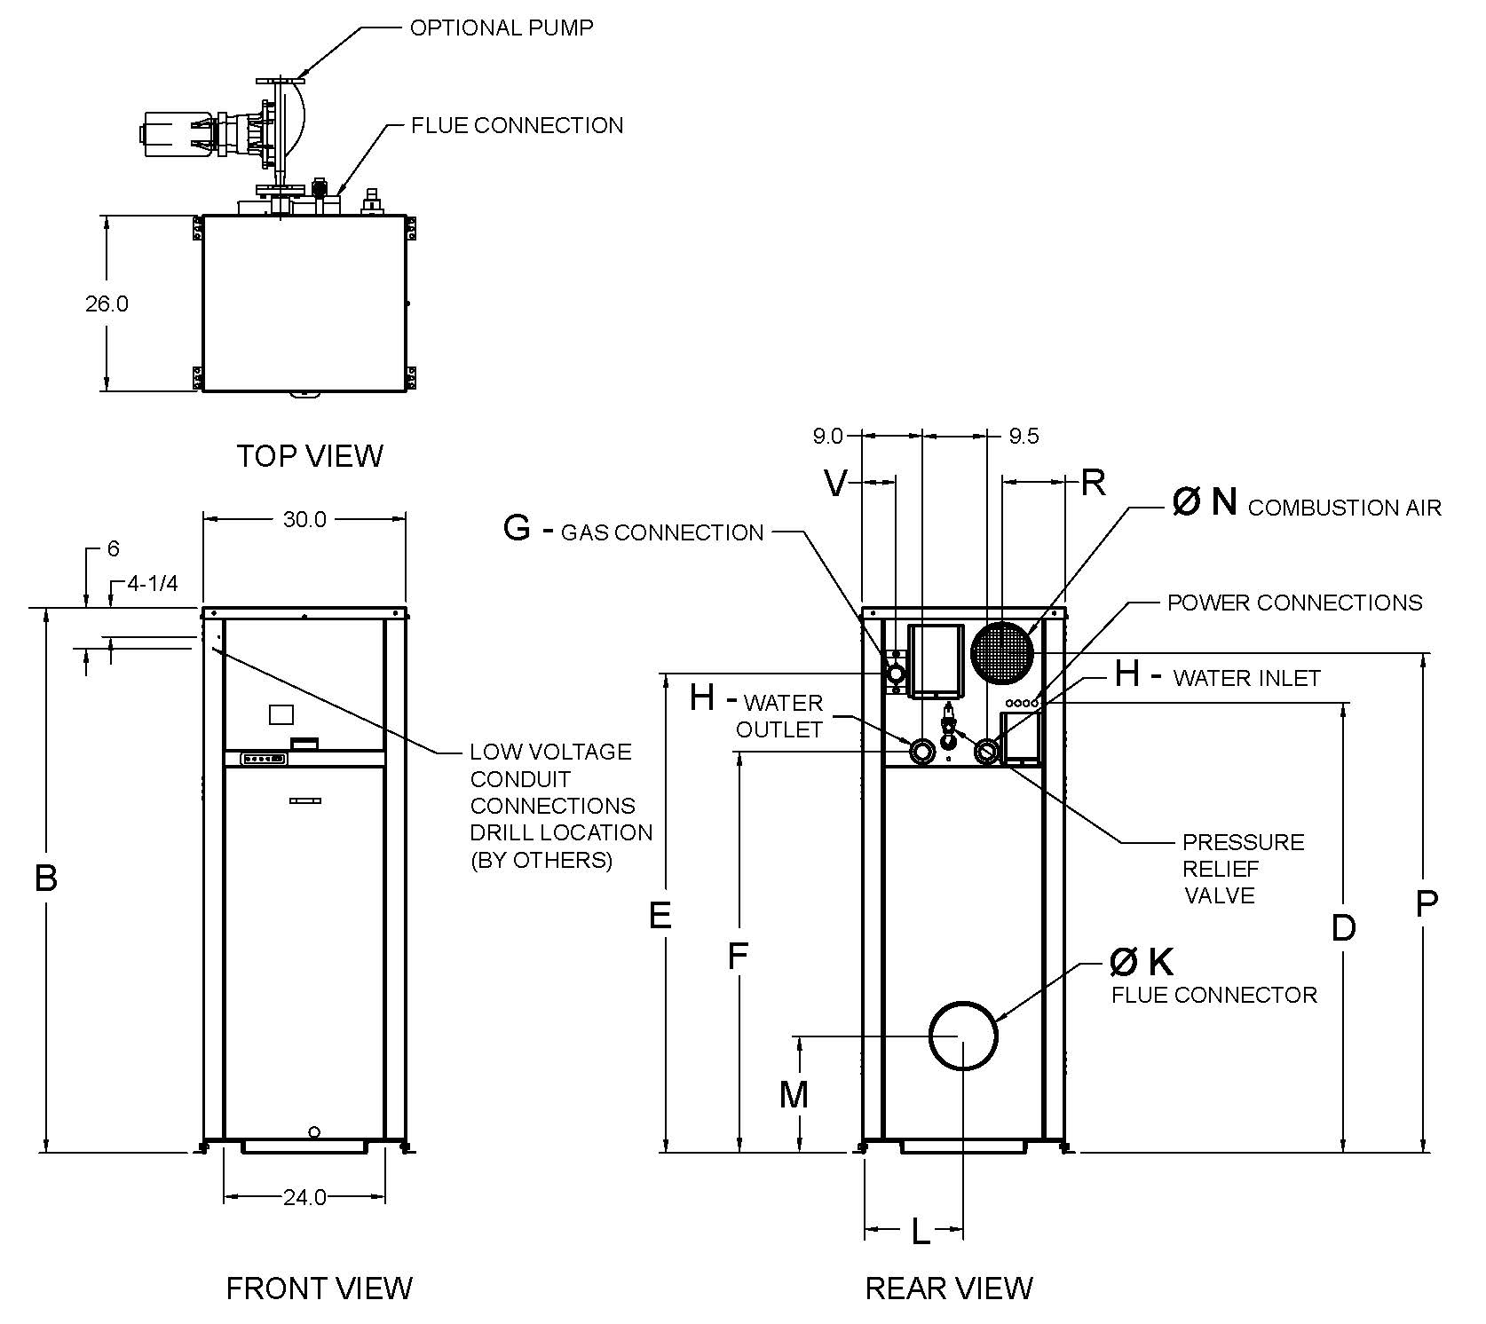
*Current draw is for pump only
(Supply breaker must have delayed trip)

Shown without H-Bypass or Cold Water Run options
CLEARANCES
 | Certified  Minimum | Recomm.  Service
Front | 24” | 24”
Rear | 12” | 24”
Right | 1” | –
Left | 1” | –
Top | 0” | 10”
Floor | 0” | –
Vent | 1” | –

Model | MBTUH |  |  | Dimensions (in.) |  |  |  |  |  |  |  |  |  |  |  |  | Ship  Weight  (Lbs.) |  | Foot-  print  (Ft²) |  | Amps**
 |  |  | B | D | E | F | G* | H | K | L | M | N | P | R | V
 | Input | Output | Height |  |  |  | NPT | NPT | Flue Ø |  |  | C/A Ø
P-504A | 500 | 415 | 43 | 30 | 35 | 23-3/4 | 1 | 2 | 8 | 13-3/4 | 14-1/8 | 6 | 36 | 8 | 2 | 600 |  | 5.4 |  | 12
P-754A | 750 | 623 | 49 | 36 | 41 | 29-3/4 | 1 | 2 | 10 | 13-1/2 | 16 | 6 | 42 | 8 | 2 | 660 |  | 5.4 |  | 12
P-1104A | 1100 | 916 | 55 | 43 | 47 | 35-3/4 | 1-1/4 | 2-1/2 | 10 | 13-1/2 | 16 | 6 | 49 | 8 | 2 | 720 |  | 5.4 |  | 12
P-1504A | 1500 | 1250 | 61 | 50 | 53 | 41-3/4 | 1-1/4 | 2-1/2 | 12 | 13-3/4 | 18-1/8 | 8 | 53 | 8 | 2 | 780 |  | 5.4 |  | 12
P-2004A | 1900 | 1583 | 75 | 61 | 65 | 53-3/4 | 2 | 2-1/2 | 14 | 13-1/2 | 20-1/8 | 8 | 69 | 9 | 5 | 940 |  | 5.4 |  | 18

- Ratings shown are for elevations up to 4,500 feet. For installations at elevations
above 4,500 feet, please consult the factory for additional instructions. No hardware changes requires below 10,000 feet.
* For Natural Gas. For Propane, all sizes are 1” NPT.
**Current draw is for heater only. (Supply breaker must have delayed trip.)
- For direct vent applications, contact the factory about relocating the pump.

Model | RATES OF FLOW
 | 20°F ΔT |  | Minimum Flow |  |  | Maximum Flow
 | GPM | ΔP (ft.) | GPM | ΔP (ft.) | ΔT (°F) | GPM | ΔP (ft.) | ΔT (°F)
P-504A | N/A | N/A | 65 | 5.5 | 13 | 100 | 11.3 | 9
P-754A | 65 | 6.4 | 65 | 6.4 | 20 | 100 | 13.8 | 13
P-1104A | 94 | 13.6 | 85 | 11.5 | 22 | 113 | 18.6 | 17
P-1504A | N/A | N/A | 102 | 18.7 | 25 | 113 | 22.2 | 23
P-2004A | N/A | N/A | 102 | 22.7 | 32 | 113 | 27.2 | 29

