Job:

XTherm® - Type P

Pool Heaters
Models 1005A-2005A

Engineer:

Contractor:
Prepared By: Date:
Model: Indoor/Outdoor:
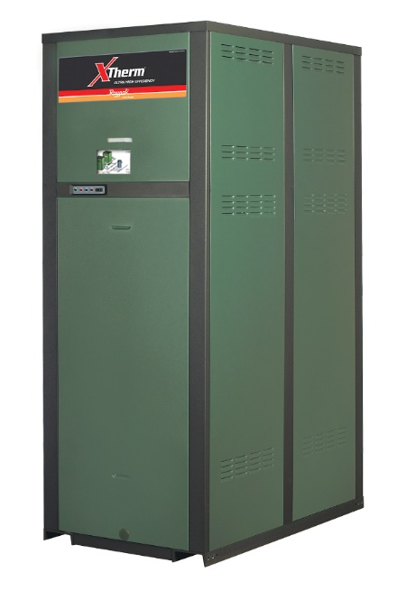
97% Thermal Efficiency at Full Rate
100% Factory Fire Tested
VERSA IC® Controller with 7” color touchscreen display
Raymote™ remote connectivity provided standard
Maximum Outlet Water Temperature Setpoint: 104°F
Minimum Acceptable Inlet Water Temperature: 50°F
CPVC Water Manifold
Full Safety Diagnostics with History
Status Display Lights
Cascade up to 4 heaters – No external sequencer needed
Limited Twenty-Five-Year Thermal Shock Warranty
Limited Five-Year Primary Heat Exchanger Warranty
Proudly Made in the USA

Limited Ten-Year Secondary Heat Exchanger Warranty
On/Off Operation

Heat Exchanger
- Bronze Headers
- ASME HLW Stamped; 75 PSIG MAWP
- National Board Listed
- Cupro Nickel Fin Tubing
- ASME Powder-Coated Tube Sheet
- Silicone High Temp O-Rings
- ASME Pressure Relief Valve
75 PSIG – Standard
- Manual Air Bleed Valve
- T&P Gauge
- Stainless Steel Condensing Heat Exchanger – U stamped
- Stainless Steel Evaporator Plate
- Boiler Pump: Bronze, 120V, 1∅, 60Hz

Control
- 120V, 60Hz, 1Ø, Power Supply
- 120/24V 60Hz Transformer
- VERSA IC®
- 7” color HD touchscreen display
- Raymote™ Wi-Fi remote connectivity
- Ignition Module
3-Try – Standard
Single-Try – Option C-6
- Remote Flame Sensor
- High Limit Fixed Manual 180ºF
- On/Off Power Switch
- Flow Switch
- Blocked Vent Pressure Switch
- Freeze Protection
- Alarm Dry Contact
- Pump Time Delay
- Blocked Condensate Switch
- Water Temperature Sensors (2 mounted, 2 loose with wells)
- Cold Water Protection

Burner
- Hot Surface Ignition (HSI)
- Ultra-Low NOx: Less than 20 PPM
(Natural Gas Only)

Gas Train
- Fuel
Natural Gas
Propane (Grade HD-5)
- Zero Governor Regulator
- Dual-Seat Combination Valve
- Electronic Firing Mode (P)

Construction
- Indoor/Outdoor Construction
- Enclosed Front Controls
- PolyTuf Powder Coat Finish
- Rear Connections (Water, Gas, Vent, Electrical, Comb. Air, Cond. Drain)
- Combustion Air Filter
- Design Certified ANSI Z21.56/CSA 4.3
- Front Connection Low Voltage Wiring
- CSA Low Lead Certified ≤ .25% Lead

Venting
- Vent Termination, Cat IV
Outdoor or Indoor, Vertical –
Option D-11
Indoor, Horizontal – Option D-15
- Extractor – Optional, Cat II
By others
Not required

Options
D-32 PVC Vent Connection (Factory Mounted Only)
D-33 Polypropylene Vent Connection
F-10 Low Water Cut-Off, Remote Probe
I-5 High Limit, Manual Reset, Adj., 100-200°F
S-1 Low Gas Pressure Switch,
Manual Reset
S-2 High Gas Pressure Switch, Manual Reset
Z-12 Condensate Treatment Kit

Additional Options or Accessories

XTherm – Type P

Models 1005A-2005A Model
NOTE: Primary/Secondary plumbing is mandatory for proper operation.
CLEARANCES (in.)
 | Front | Rear | Right | Left | Top | Floor | Vent
Certified Minimum | 24 | 12 | 1 | 1 | 0 | 0 | 1
Minimum Service | 24 | 36 | 24 | 1 | 10 | N/A | N/A

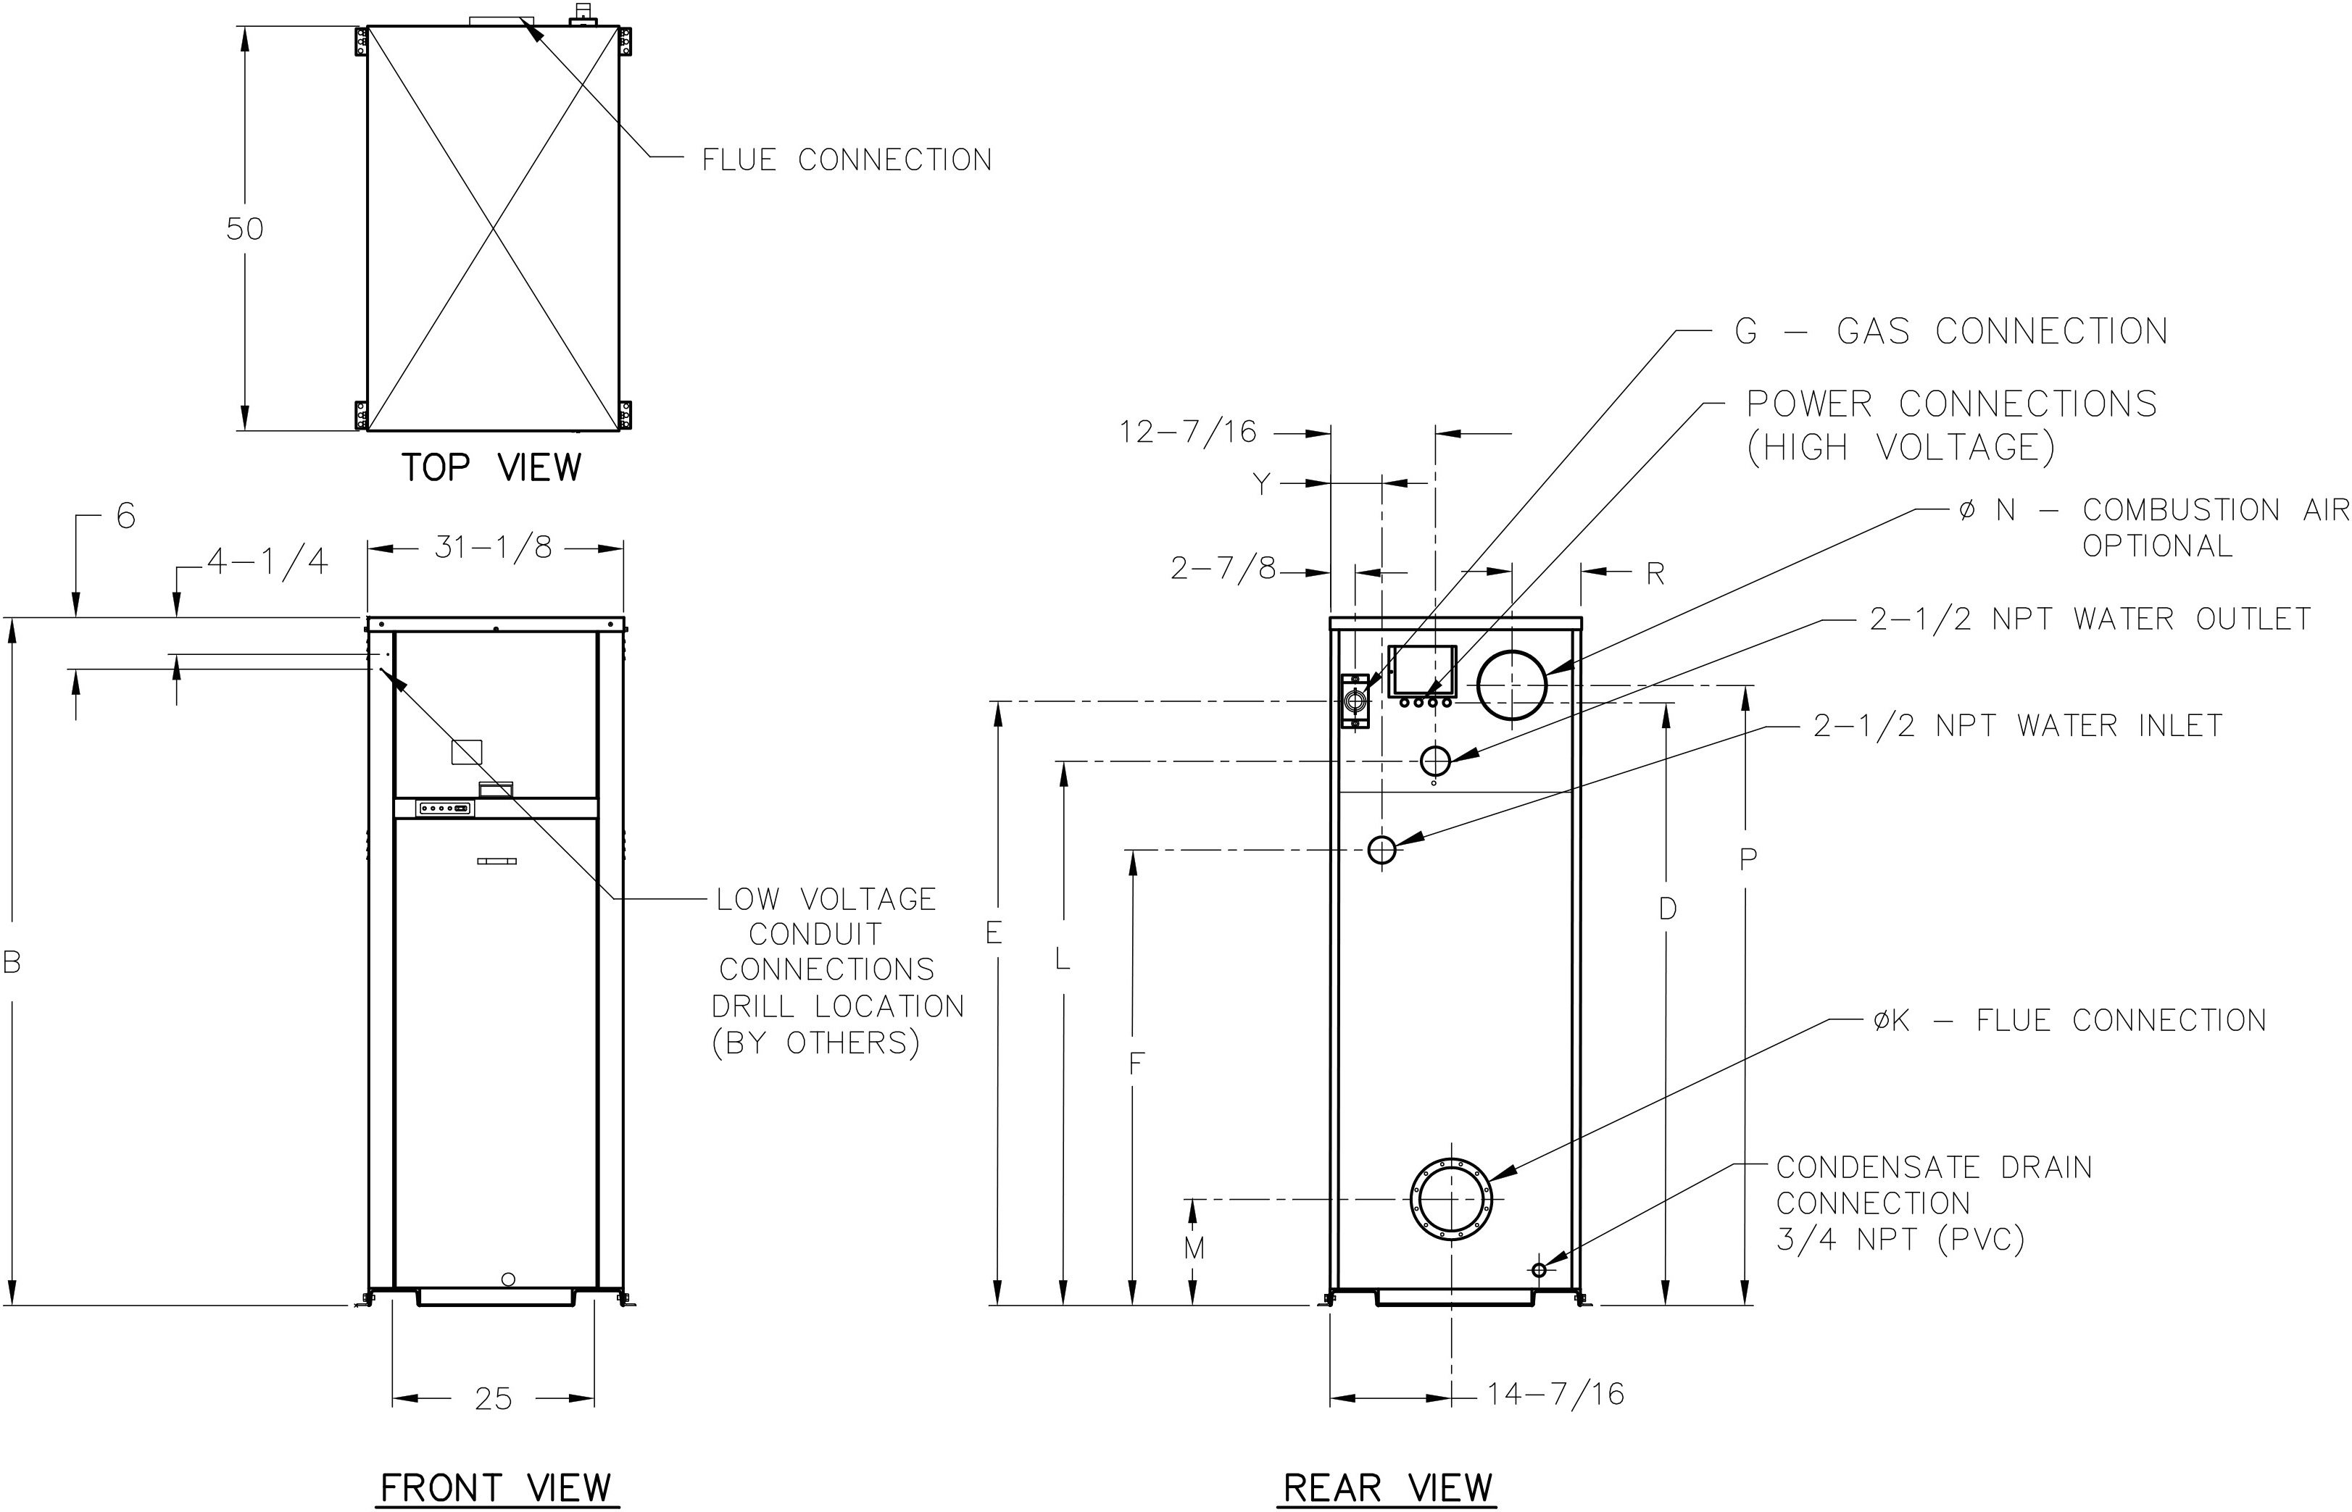
Model | Amp Draw
 | Heater † | Accessories †
☐ 1005A | 12** | 10
☐ 1505A | 12** | 14
☐ 2005A | 18** | 17
† Separate power connections are factory supplied and separate supply breakers must be field supplied.
** Current draw is for heater only (Supply breaker must have delayed trip).

Model (P-) | MBTUH |  | Dimensions (in) |  |  |  |  |  |  |  |  |  |  |  | Ship Weight (Lbs.)
 |  |  | B Height | D | E | F | G* NPT | K  Flue Ø | L | M | N C/A Ø | P | R | Y
 | Input | Output
☐ 1005A | 999 | 969 | 55-1/8 | 45 | 47-1/8 | 36-1/2 | 1-1/4 | 6 | 40-1/16 | 11-1/2 | 6 | 47-1/8 | 8-1/16 | 6-1/16 | 1065
☐ 1505A | 1500 | 1455 | 67-1/8 | 57 | 59-1/16 | 38-1/2 | 1-1/4 | 8 | 52-1/16 | 12-5/8 | 8 | 59-1/8 | 8-3/16 | 6-1/16 | 1234
☐ 2005A | 1999 | 1939 | 81-1/8 | 71 | 71-3/16 | 38-1/2 | 2 | 8 | 64-1/16 | 12-5/8 | 8 | 73-1/8 | 8-3/16 | 6-1/4 | 1461

Note: Ratings shown are for elevations up to 2,000 feet. For installations at elevations  above 2,000 feet, please consult the factory for additional instructions. | * For Propane Gas, all models are 1 NPT

