Job:

Hi Delta® - Type P

Commercial Pool Heaters Models 302B & 402B

Engineer:
Contractor:
Prepared By: Date:
Model: Indoor/Outdoor: MBTUH Input:

Sealed Combustion Chamber
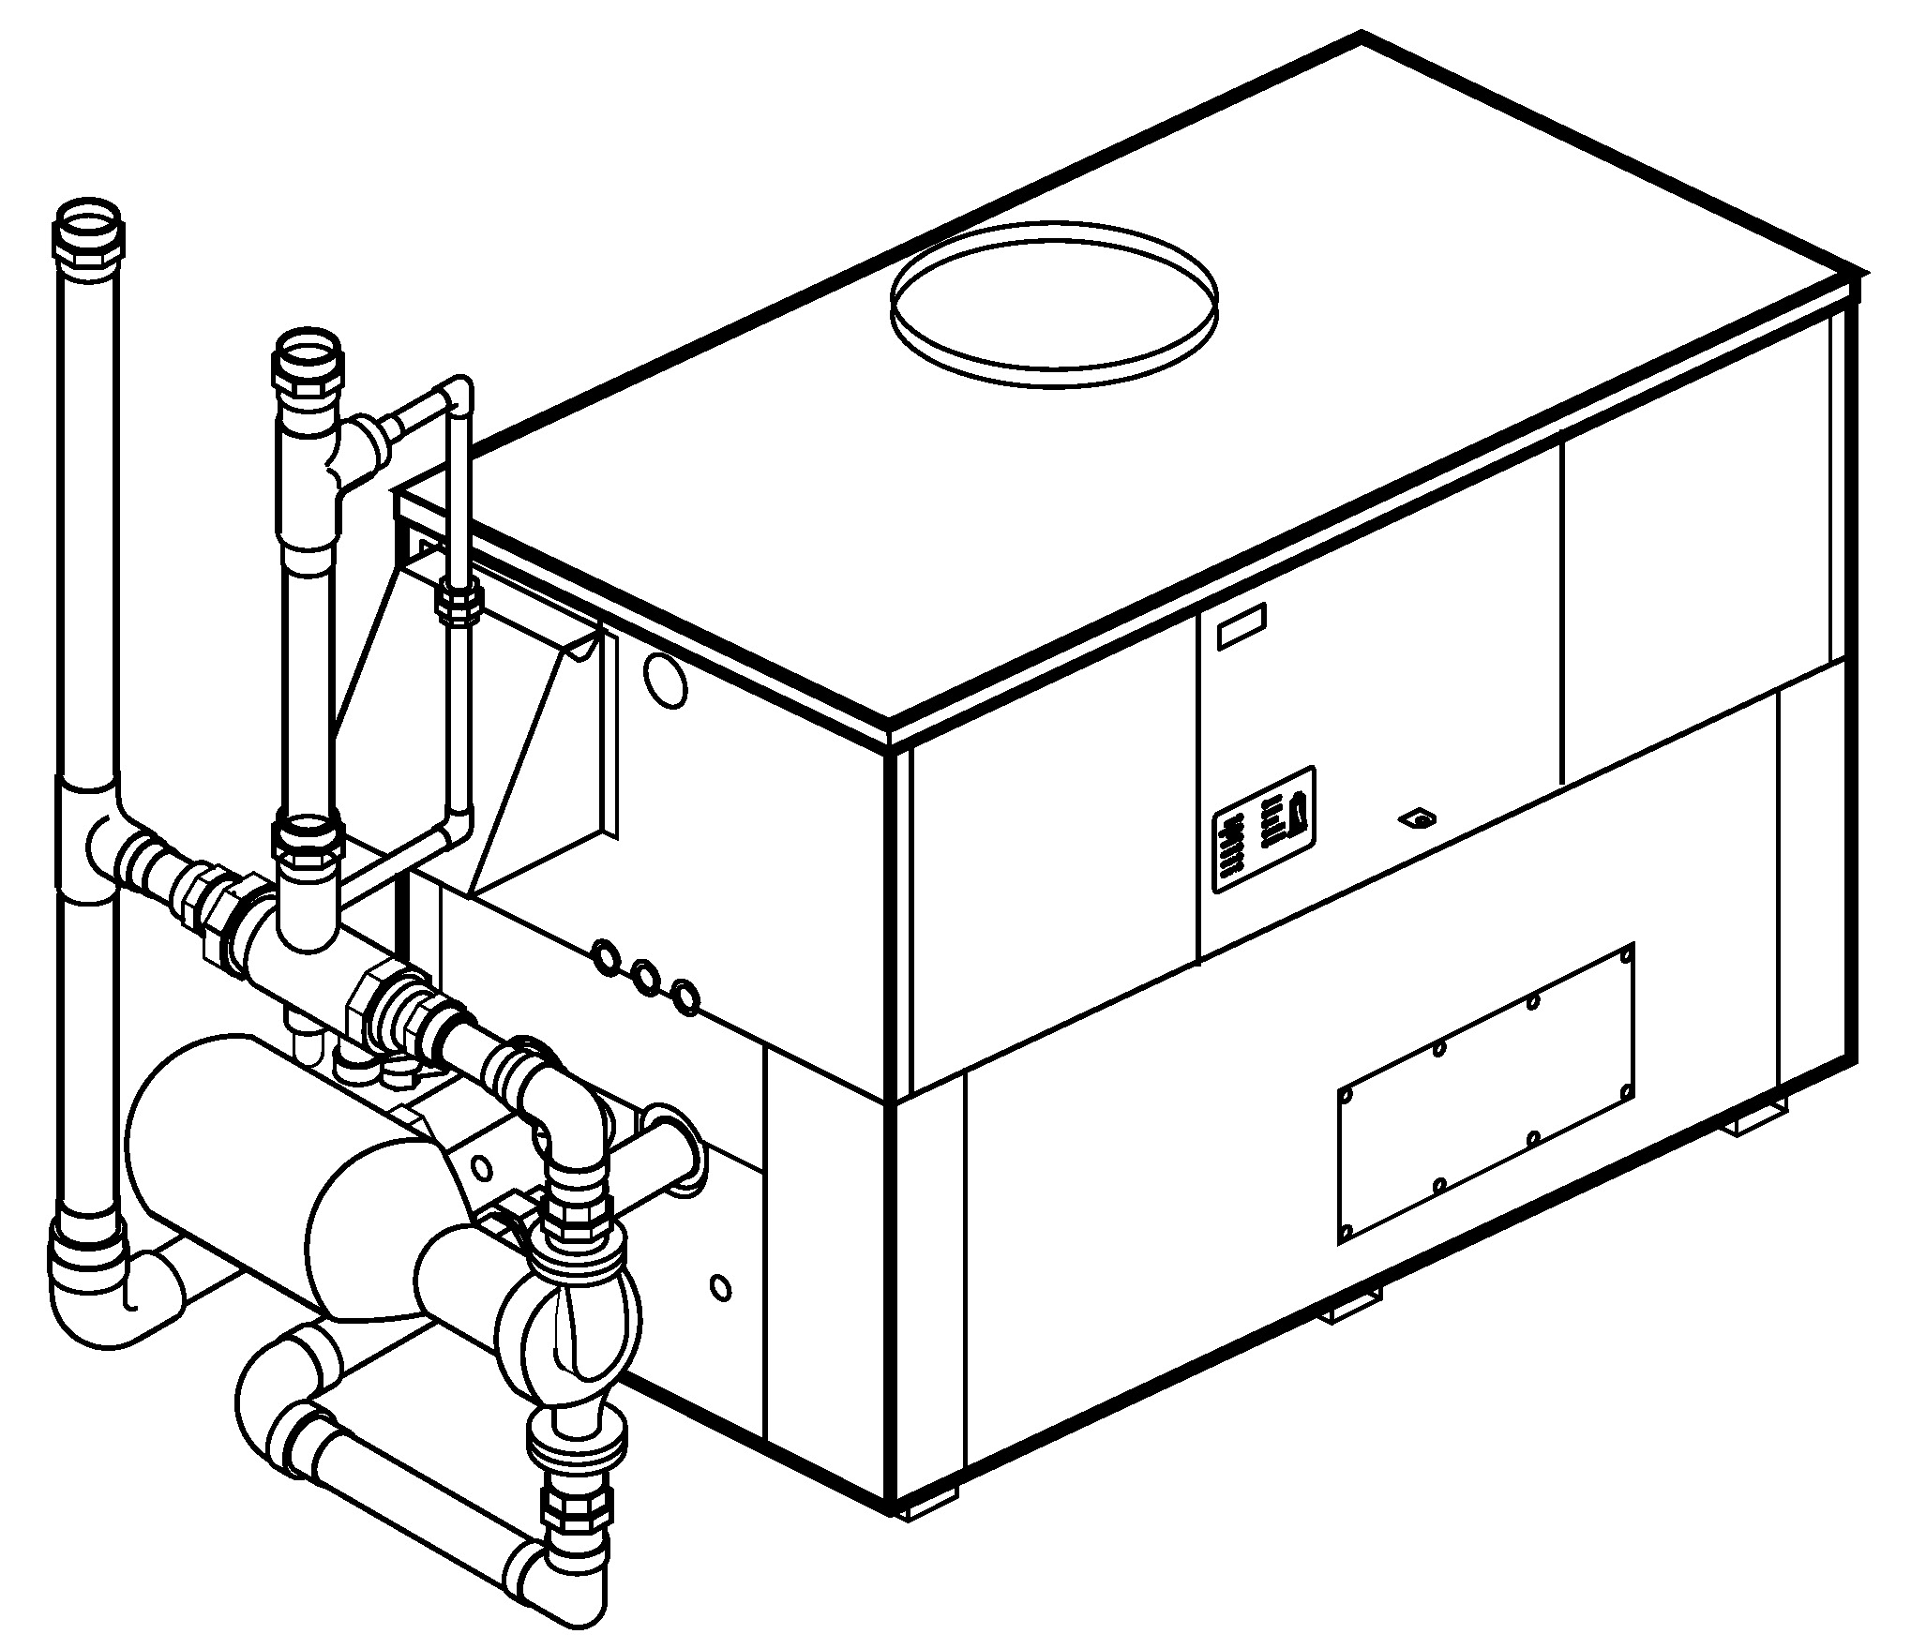

Patent No. 7,044,124
100% Factory Fire Tested
Efficiency: 85%
Minimum Non-condensing Inlet Temperature: 105°F
Thermal Shock Proof Heat Exchanger
Limited Twenty-year Thermal Shock Warranty
Limited Five-year Heat Exchanger Warranty
Diagnostic Center with Fault History
PolyTuf Powder Coated Cabinet
No Combustible Floor Shield Required
Fan-assisted

Non-ferrous Bypass
Proudly Assembled in the USA

Patented Burner Security Blanket
Standard “Sparcomatic” Bypass Shown

Heat Exchanger
- Brass Headers
- ASME Inspected and Stamped
160 PSIG Working Pressure
- National Board Approved
- Cupro-Nickel Finned Tubing
- ASME Steel Tube Sheet
- Silicone High-Temp O-Rings
- 125 PSIG ASME Pressure Relief Valve
- Temperature and Pressure Gauge
- Water Connections
Left – Standard
Right – Option A-6
- Bronze Pump, 1/3 HP, 120V, 60Hz
- Non-Ferrous Pool Bypass Assembly with Automatic Control

Controls
- 120V, 60Hz, 1∅ Power Supply
- 120/24V 60Hz Transformer
- 100% Shut-off/Lockout
- Hot Surface Ignition
- Remote Flame Sensor
- High Limit Control, Auto Reset
- On/Off Power Switch
- Manual Shut-off, Front-mounted
- Flow Switch
- Blocked Vent Pressure Switch
- Combustion Air Proving Switch
- Pump Time Delay
- Poolstat
- Diagnostic Panel with LCD Display
2 Lines, 20 Characters

Gas Train
- Combination Valve
- On/Off Firing
- Fuel
Natural Gas
Propane Gas
- Design Certified ANSI Z21.56/
CSA 4.7

Burner
- Ultra-low NOx:
Less Than 20 PPM

Construction
- Indoor/Outdoor Construction
- Enclosed Front Controls
- CSA Low Lead Certified ≤ .25%
Lead

Venting
- Vent Location
Top – Standard
Rear – Option D-14
- Vent Termination Cap
Outdoor – Option D-11
Indoor, Horizontal –
Option D-15
Indoor, Vertical (by others)
- Combustion Air
In-Line Filter Kit (TruSeal
only) – Option D-17
Air Intake Elbow –
Option D-16

Multi-Heater Controllers
B-26 2-Stage Digital
B-21 4-Stage Digital
B- TempTracker Mod+ (Up to 16 Boilers)

Options
C-6 Ignition Module, Manual Reset
D-21 TruSeal® Direct Vent
F-10 Low Water Cut-Off, Remote Probe
S-1 Low Gas Pressure Switch, Manual
S-2 High Gas Pressure Switch, Manual
X-1 SureRack® Kit (Lower Unit Requires Manifold Modification)
X-2 SureRack Add-on (Lower Unit Requires Manifold Modification)

Regulatory Agency Requirements
G-1 CSD-1
For Metric information, see Catalog






Hi Delta – Type P

Models 302B & 402B (“Sparcomatic” Bypass Option) Model
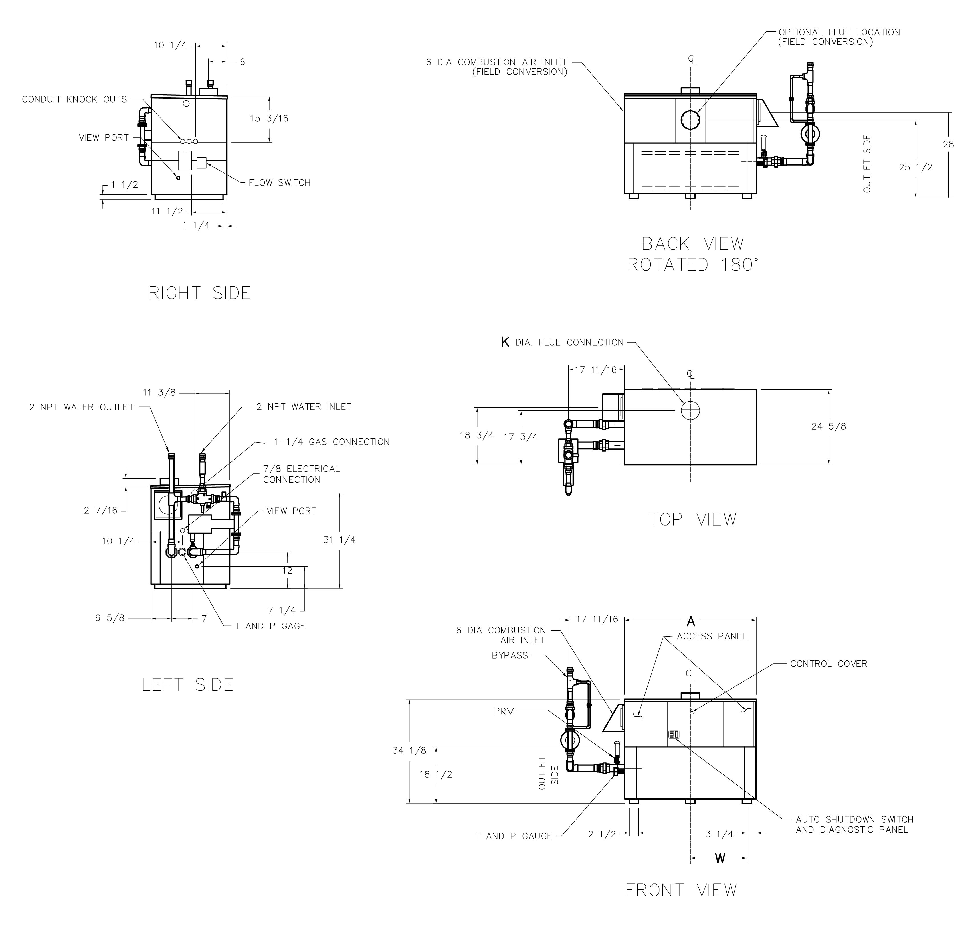

RATES OF FLOW AND PRESSURE DROPS

Model | Max. Flow
Model | GPM | ∆P (ft) | ∆T
302B | 90 | 9.8 | 6
402B | 90 | 10.0 | 8

Model | MBTUH |  | A | K | W | Amp Draw  (w/ Pump) | Operating Weight (Lbs.)
Model | Input | Output | Width |  |  | Amp Draw  (w/ Pump) | Operating Weight (Lbs.)
302B | 300 | 255 | 36 | 5 | 14-3/4 | < 12 | 425
402B | 399 | 339 | 43 | 6 | 18-1/2 | < 12 | 500

NOTES: Dimensions are in inches.
Ratings shown are for elevations up to 4,500 feet and for natural or propane gas.
For installation at elevations over 4,500 feet, please contact manufacturer.

Hi Delta – Type P

Models 302B & 402B (Cold Water Run Option) Model
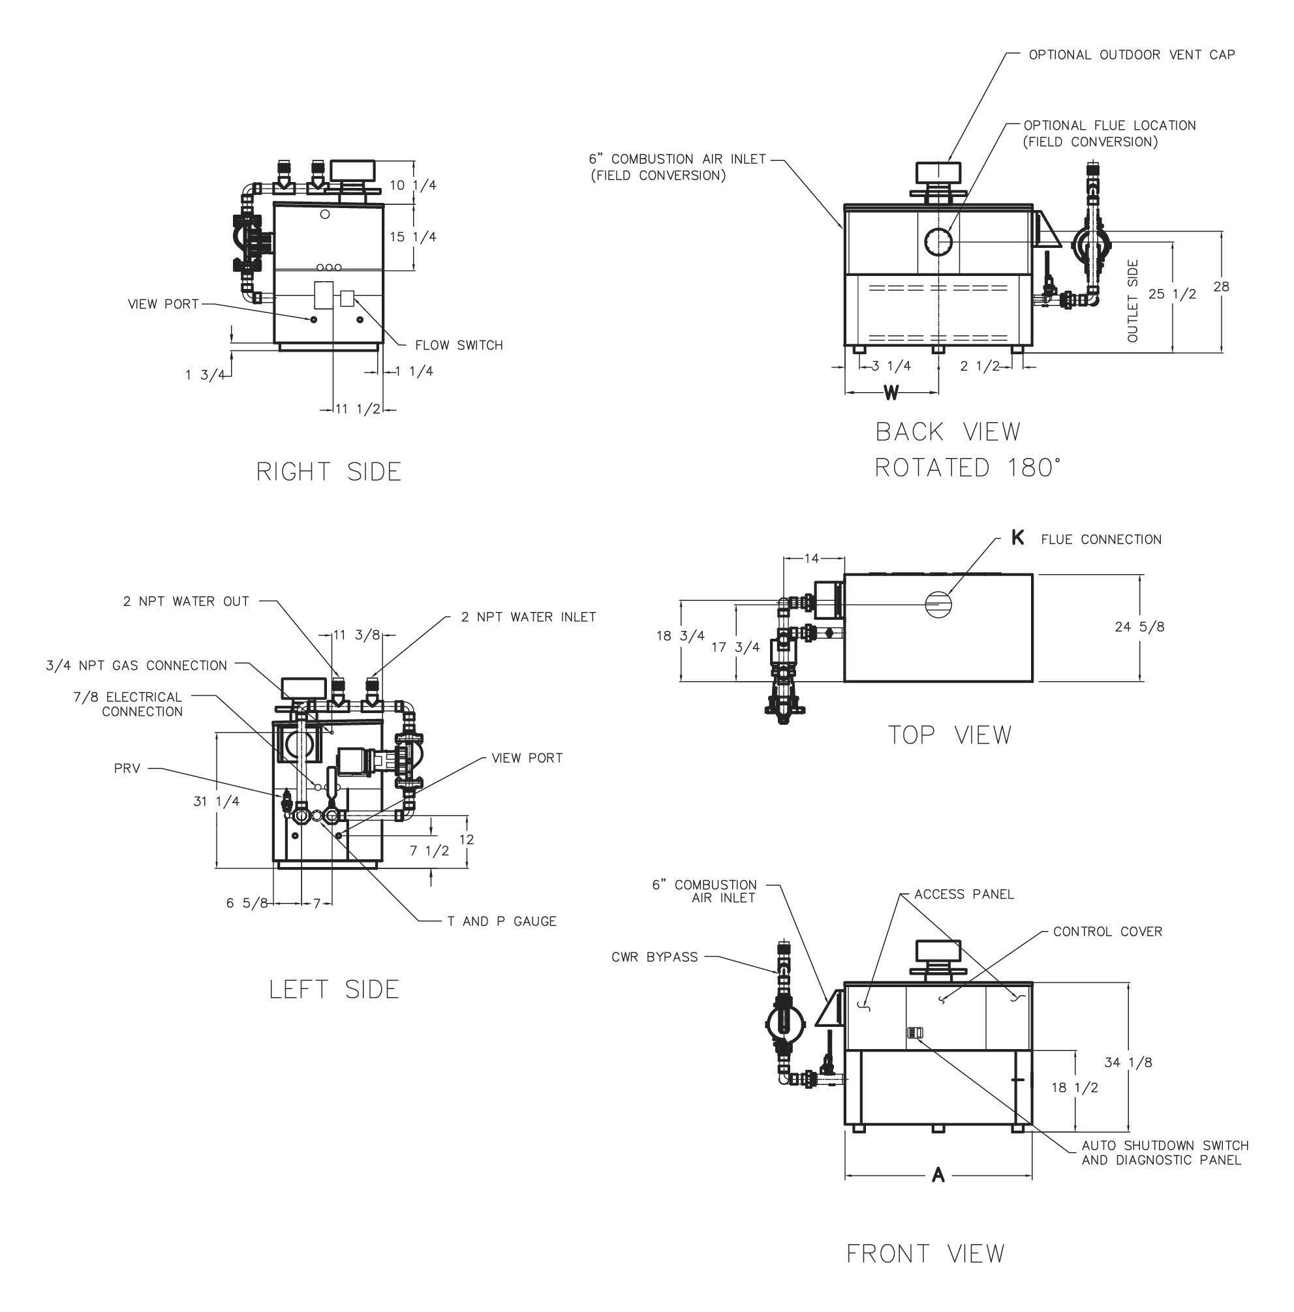

RATES OF FLOW AND PRESSURE DROPS

Model | Max. Flow
Model | GPM | ∆P (ft) | ∆T
302B | 90 | 9.8 | 6
402B | 90 | 10.0 | 8

Model | MBTUH |  | A | K | W | Amp Draw  (w/ Pump) | Shipping Weight (Lbs.) | Pump HP | Injector Pump HP
Model | Input | Output | Width
302B | 300 | 255 | 36 | 5 | 18 | < 12 | 425 | 1/2 | 1/4
402B | 399 | 339 | 43 | 6 | 18-1/2 | < 12 | 500 | 1/2 | 1/4

NOTES: Dimensions are in inches.
Ratings shown are for elevations up to 4,500 feet and for natural or propane gas.
For installation at elevations over 4,500 feet, please contact manufacturer.
* Separate 120 VAC or 240 VAC 1Ø power required.
Injector pump ships loose for field installation at bypass inlet.

Raypak, Inc. ▪ 2151 Eastman Avenue, Oxnard, CA 93030 ▪ (805) 278-5300 ▪ Fax (800) 872-9725 ▪ www.raypak.com

