Job:

Hi Delta® - Type P

Commercial Pool Heaters Models 992B-1262B

Engineer:
Contractor:
Prepared By: Date:
Model: Indoor/Outdoor: MBTUH Input:

Sealed Combustion Chamber

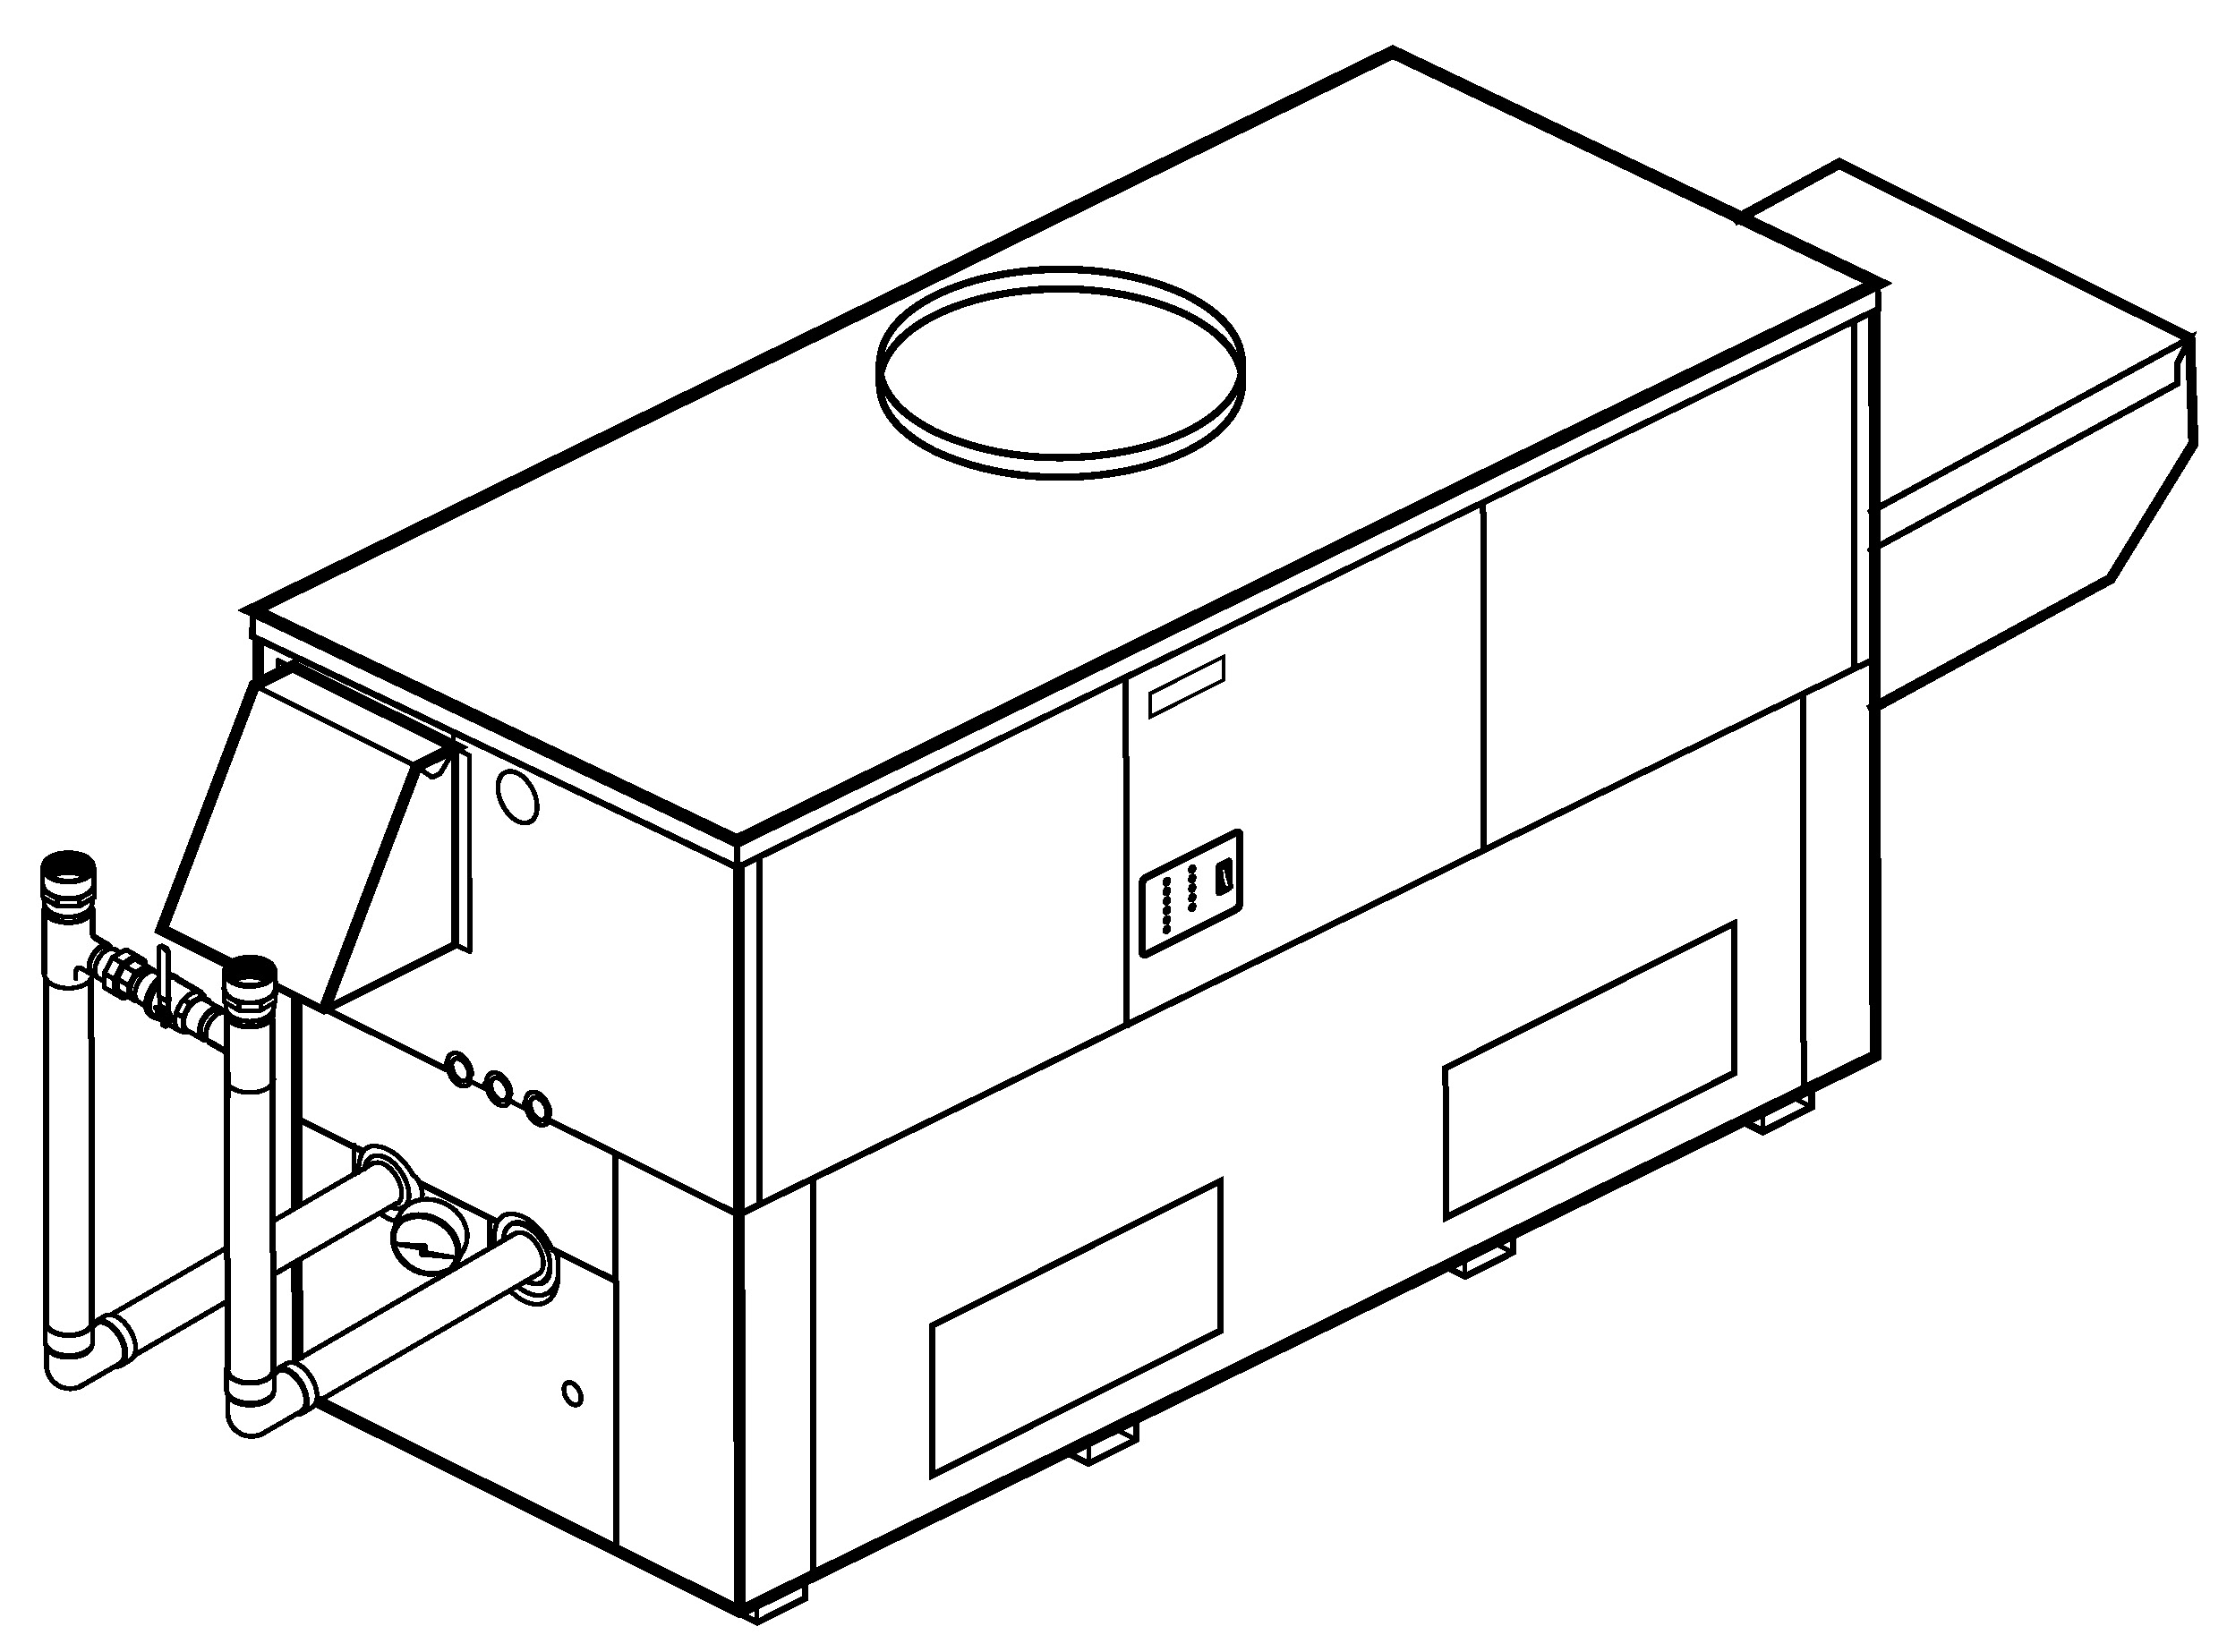
Standard “H” Bypass Shown
Patent No. 7,044,124
100% Factory Fire Tested
Efficiency: 85%
Minimum Non-condensing Inlet Temperature: 105°F
Thermal Shock Proof Heat Exchanger
Limited Twenty-year Thermal Shock Warranty
Limited Five-year Heat Exchanger Warranty
Full Safety Diagnostics with Fault History
PolyTuf Powder Coated Cabinet
No Combustible Floor Shield Required
Fan-assisted

Non-ferrous Bypass
Proudly Assembled in the USA

Patented Burner Security Blanket

Heat Exchanger
- Brass Headers
- ASME Inspected and Stamped
160 PSIG Working Pressure
- National Board Approved
- Cupro-Nickel Finned Tubing
- ASME Steel Tube Sheet
- Silicone High-Temp O-Rings
- 125 PSIG ASME Pressure Relief Valve
- Temperature and Pressure Gauge
- Water Connections
Left – Standard
Right – Option A-6
- Bronze Pump, 1/2 HP, 120V, 60Hz
- Non-ferrous Pool Bypass

Controls
- 120V, 60Hz, 1∅ Power Supply
- 120/24V 60Hz Transformer
- 100% Shut-off/Lockout
- Hot Surface Ignition System
- Remote Flame Sensor
- High Limit Control, Auto Reset
- On/Off Power Switch
- Manual Shut-off, Front-mounted
- Flow Switch
- Blocked Vent Pressure Switch
- Combustion Air Proving Switches
- Economaster Pump Time Delay
- Poolstat
- Diagnostics Panel with LCD Panel
2 Lines, 20 Characters

Gas Train
- Combination Valves
- On/Off Firing
- Low Gas Pressure Switch, Manual
- Fuel
Natural Gas
Propane Gas
- Design Certified ANSI Z21.56/
CSA 4.7

Burner
- Ultra-low NOx:
Less than 20 PPM

Construction
- Indoor/Outdoor Construction
- Enclosed Front Controls
- CSA Low Lead Certified ≤ .25% Lead

Venting
- Vent Location
Top – Standard
Rear – Option D-14
- Vent Termination Cap
Outdoor – Option D-11
Indoor, Horizontal –
Option D-15
Indoor, Vertical (by others)
- Combustion Air
In-Line Filter Kit (TruSeal only) – Option D-17
Air Intake Elbow –
Option D-16

Multi-Heater Controllers
B-26 2-Stage Digital
B-21 4-Stage Digital
B-__ TempTracker Mod+ (Up to 16 Boilers)
B-60 Stage Interface

Options
C-6 Ignition Module, Manual Reset
D-21 TruSeal® Direct Vent
Left Side - Standard
Right Side - Optional
F-10 Low Water Cut-off, Remote Probe
P-__ Cold Water Run System
(See Page 3 Sizes 992B-1262B only)
S-2 High Gas Pressure Switch, Manual (Dual switches on Model 1532B)
X-1 SureRack® Kit (Lower Unit Requires Manifold Modification)
X-2 SureRack® Kit, Above Grade
Add-on (Used with X-1) (Lower Unit Requires Manifold Modification)

Regulatory Agency Requirements
G-1 CSD-1
For Metric information, see Catalog





Hi Delta – Type P
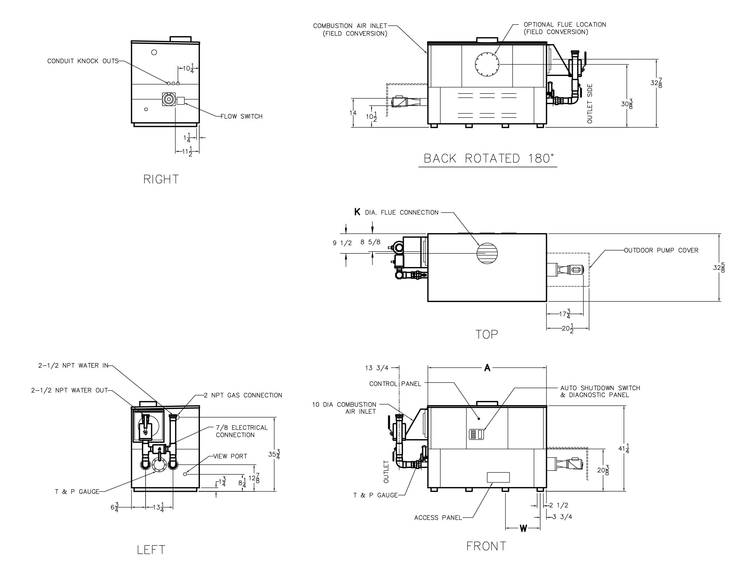
Models 992B-1262B (H-Bypass) Model
Standard “H” Bypass

RATE OF FLOW AND PRESSURE DROP

Model | Max. Flow
Model | GPM | ∆P (ft) | ∆T
992B | 132 | 14.0 | 13
1262B | 132 | 15.5 | 16

Model | MBTUH |  | A | K | W | Amp Draw  (w/ Pump) | Shipping Weight (Lbs.)
Model | Input | Output | Width |  |  | Amp Draw  (w/ Pump) | Shipping Weight (Lbs.)
992B | 990 | 842 | 57-1/8 | 10 | 16-13/16 | < 16 | 900
1262B | 1260 | 1071 | 68-1/2 | 12 | 20-9/16 | < 16 | 1010

Dimensions are in inches.
Ratings shown are for elevations up to 4,500 feet and for natural or propane gas.
For installation at elevations over 4,500 feet, please contact manufacturer.

Hi Delta – Type P
Models 992B-1262B (Cold Water Run Bypass) Model
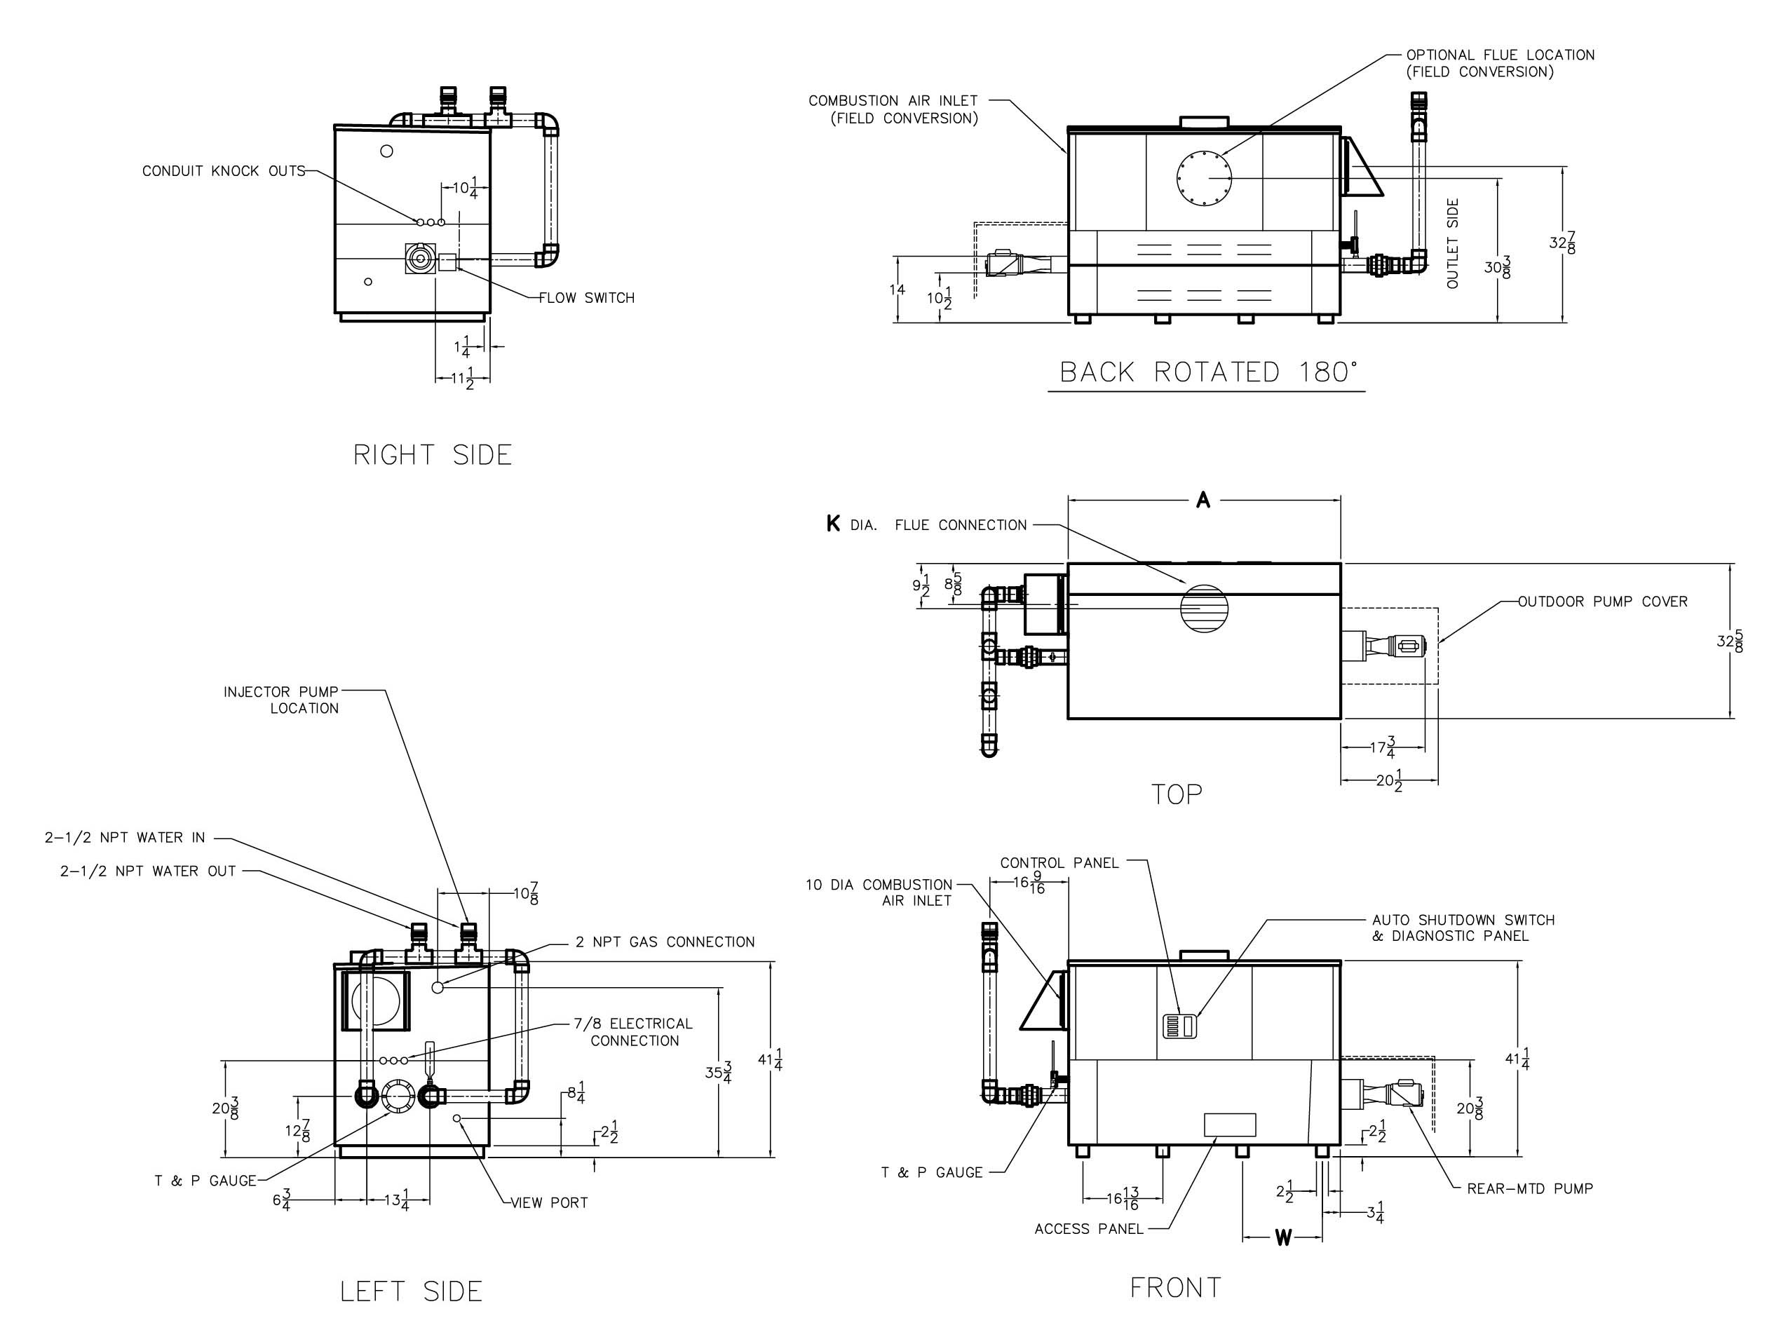

Model | MBTUH |  | A  Width | K | W | Amp Draw  (w/ Pump) | Pump  HP | Injector  Pump  HP | Shipping  Weight  (Lbs.)
Model | Input | Output
P 992B | 990 | 842 | 57-1/8 | 10 | 16-13/16 | < 16 | 1/2 | 1/3 * | 1000
P 1262B | 1260 | 1071 | 68-1/2 | 12 | 20-9/16 | < 16 | 1/2 | 1/3 * | 1055
Dimensions are in inches.
Ratings shown are for elevations up to 4,500 feet and for natural or propane gas.
For installations at elevations over 4,500 feet, please contact manufacturer.
* Separate 120 VAC or 240 VAC 1Ø power required for Cold Water Run option.
Injector pump shipped loose for field installation at bypass inlet.

RATE OF FLOW AND PRESSURE DROP

Model | Max. Flow
Model | GPM | ∆P (ft) | ∆T
992B | 132 | 14.0 | 13
1262B | 132 | 15.5 | 16

Raypak, Inc. ▪ 2151 Eastman Avenue, Oxnard, CA 93030 ▪ (805) 278-5300 ▪ Fax (805) 872-9725 ▪ www.raypak.com

