Job:

RP2100™

ASME Series

Atmospheric Pool Heaters

Models 185B-405B
Engineer:
Contractor:
Prepared By: Date:
Model: Indoor/Outdoor
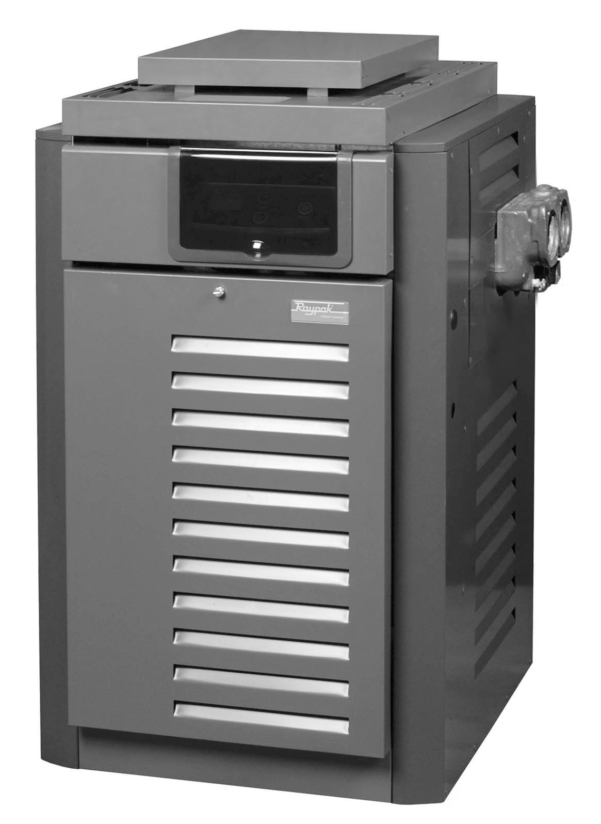

- 82% Efficiency
- ASME Code Glass-Lined Cast Iron Headers
- ASME Code Copper Fin Tube
- 125 lb. Pressure Relief Valve
- Small Footprint
- Unitherm Governor Anti-Condensation Control
- Internal Bypass for High Flow Rates (up to 125 gpm)
- Indoor/Outdoor
Digital model with outdoor top shown

Heat Exchanger
- ASME Inspected and Stamped
160 PSIG
- National Board Approved
- Glass-lined Cast Iron Headers
- Finned Tubing
Copper – Standard
Cupro Nickel – Optional
- ASME Steel Tube Sheet
- Silicone O-Rings
- 125 PSIG Pressure Relief Valve
- Water Connections
Right Hand – Standard
Left Hand – Field Change
- Flow Configuration – Two-pass

Controls – Millivolt Option
- Standing Pilot Ignition
- Thermopile Generator
- Single Mechanical Sensor
- Flame Rollout Switch
- High Limit Control
- On/Off Switch
- Water Pressure Switch

Controls – Digital Option
- 115/230V, 60Hz, 1 Ph Power Supply
- 115/230/24V Transformer
- 100% Pilot Shut-off; Lockout – Propane units only
- Electronic, Intermittent Ignition Pilot (IID)
- High Limit Control
- On/Off Switch
- Flame Rollout Switch
- Water Pressure Switch
- Dual Electronic Temp Sensor
- Digital Display With Diagnostics

Gas Control Train
- Fuel
Natural Gas
Propane
- Combination Control Valve
- On/Off Firing
- ANSI Z21.56 Design Certified

Construction
- Front Controls
- Stainless Steel Burners
- Polytuf Powder Coat Finish
- Indoor/Outdoor
- Vent Selection
Outdoor Stackless Top – Standard
Indoor Draft Diverter– Loose
D-2 Power Vent – Loose
- Base (Optional)
Combustible Floor Shield





RP2100 – ASME Series
Raypak, Inc. ▪ 2151 Eastman Avenue, Oxnard, CA 93030 ▪ (805) 278-5300 ▪ Fax (800) 872-9725 ▪ www.raypak.com
Raypak Canada Ltd. ▪ 2805 Slough St., Mississauga, Ontario, Canada L4T 1G2 ▪ (905) 677-7999 ▪ Fax (905) 677-8036 ▪ www.raypakcanada.com

Atmospheric Pool Heaters Model
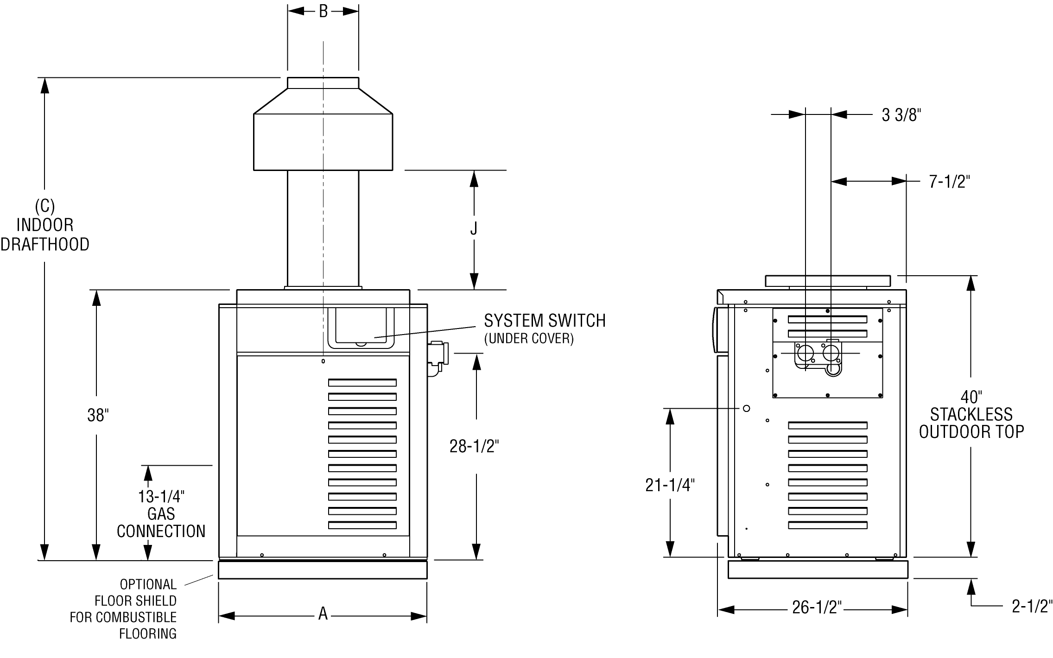

Heater  Model | BTUH  Input  (000) | (A)  Cabinet  Width | (B)  Flue  Dia. | (C)  Indoor  Drafthood | (J) | Gas  Conn. | Water  Conn. | Shipping Weights (lbs)
 |  |  |  |  |  |  |  | Heater with  Stackless Top | Indoor  Drafthood
R185B | 181 | 18-1/4” | 6” | 62-5/8” | 12-1/16” | 3/4" | 2” | 191 | 12
R265B | 264 | 22-3/8” | 7” | 62-7/8” | 11-1/8” | 3/4" | 2” | 214 | 15
R335B | 334 | 25-3/4” | 8” | 63-3/4” | 10-3/4” | 3/4" | 2” | 234 | 17
R405B | 399 | 29-1/4” | 9” | 65-3/8” | 12-1/2” | 3/4" | 2” | 253 | 20

NOTES:
Model number suffix indicates pilot type (E = digital, M = millivolt) and fuel type (P = propane, N = natural gas). Prefix “C” indicates Cast Iron (ASME) headers. Example: Model number CR-405B-EN indicates an ASME unit with digital (IID) ignition using natural gas.
Ratings are for natural gas and elevations up to 2,000 feet above sea level. Reduce input 4% for each 1,000 feet above sea level when installed at over 2,000 feet elevation.
Manufactured under Patent No. 3,623,458.

