Job:

Hi Delta® - Type P

Commercial Pool Heaters Models 1532B-2342B

Engineer:
Contractor:
Prepared By: Date:
Model: Indoor/Outdoor: MBTUH Input:

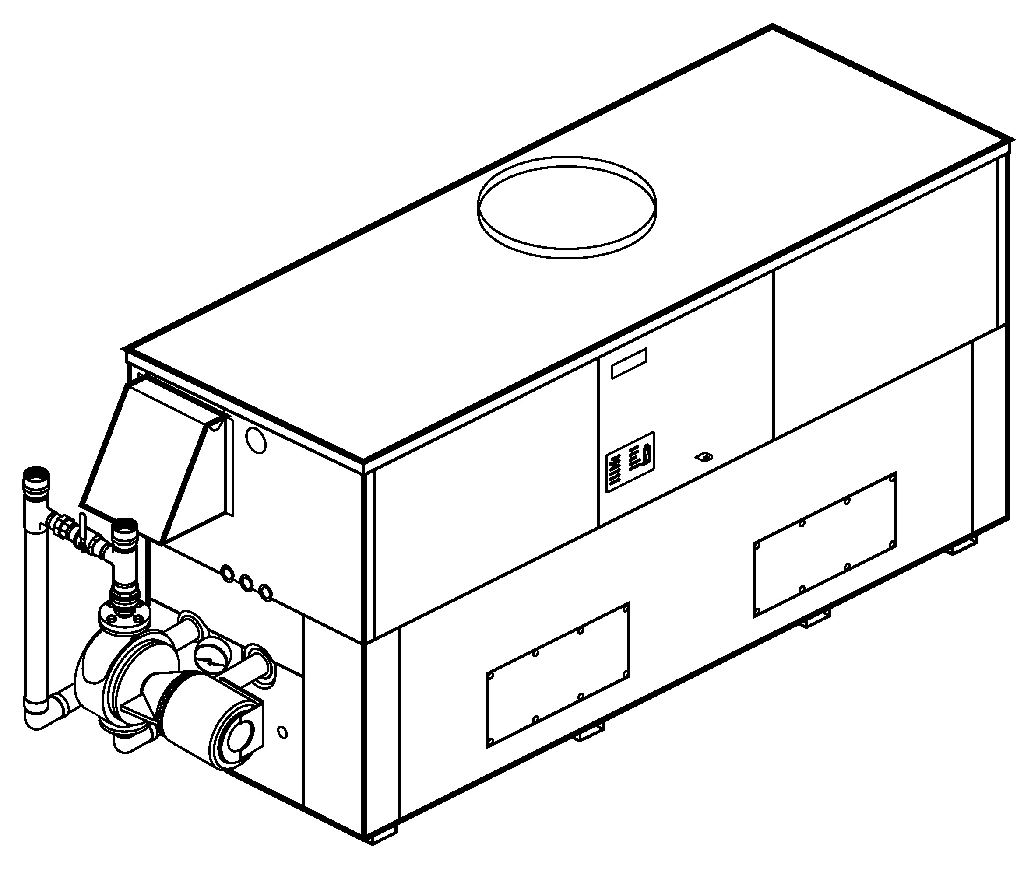
Patent No. 7,044,124
Sealed Combustion Chamber
100% Factory Fire Tested
Efficiency: 85%
Minimum Non-condensing Inlet Temperature: 105°F
Thermal Shock Proof Heat Exchanger
Limited Twenty-year Thermal Shock Warranty
Limited Five-year Heat Exchanger Warranty
Full Safety Diagnostics with Fault History
PolyTuf Powder Coated Cabinet
No Combustible Floor Shield Required
Fan-assisted
Standard “H” Bypass Shown

Non-ferrous Bypass
Proudly Assembled in the USA

Patented Burner Security Blanket

Heat Exchanger
- Brass Headers
- ASME Inspected and Stamped
160 PSIG Working Pressure
- National Board Approved
- Cupro-Nickel Finned Tubing
- ASME Steel Tube Sheet
- Silicone High-Temp O-Rings
- 125 PSIG ASME Pressure Relief Valve
- Temperature and Pressure Gauge
- Water Connections
Left – Standard
Right – Option A-6
- Bronze Pump, 120V, 60Hz
- Non-ferrous Pool Bypass

Controls
- 120V, 60Hz, 1∅ Power Supply
- 120/24V 60Hz Transformer
- 100% Shut-off/Lockout
- Hot Surface Ignition Systems (2)
- Remote Flame Sensors (2)
- High Limit Control, Auto Reset
- On/Off Power Switch
- Manual Shut-off, Front-mounted
- Flow Switch
- Blocked Vent Pressure Switch
- Combustion Air Proving Switches
- Economaster Pump Time Delay
- Poolstat
- Diagnostic Panel with LCD Display
2 Lines, 20 Characters

Gas Train
- Combination Valves
- On/Off Firing
- Low Gas Pressure Switch, Manual
- Fuel
Natural Gas (Only on 2002B)
Propane Gas
- Design Certified ANSI Z21.56/
CSA 4.7

Burner
- Ultra-low NOx:
Less than 20 PPM

Construction
- Indoor/Outdoor Construction
- Enclosed Front Controls
- CSA Low Lead Certified ≤ .25% Lead

Venting
- Vent Location
Top – Standard
Rear – Option D-14
- Vent Termination Cap
Outdoor – Option D-11
Indoor, Horizontal –
Option D-15
Indoor, Vertical (by others)
- Combustion Air




In-Line Filter Kit (TruSeal
only) – Option D-17

Air Intake Elbow –
Option D-16

Options
B-26 2-Stage Digital
B-21 4-Stage Digital
B-__ TempTracker Mod+ (Up to 16 Boilers)

Options
C-6 Ignition Module, Manual Reset
D-21 TruSeal® Direct Vent
Right Side
Left Side (Model 1802B Only)
F-10 Low Water Cut-off, Remote Probe
P-__ Cold Water Run System
(See Page 3)
S-2 Dual High Gas Pressure Switches, Manual Reset
X-1 SureRack® Kit*
X-2 SureRack Kit Above Grade Add-on (used with X-1)*

Regulatory Agency Requirements
G-1 CSD-1

*Lower unit requires manifold modification

Hi Delta – Type P

Models 1532B-2342B (H-Bypass Option) Model

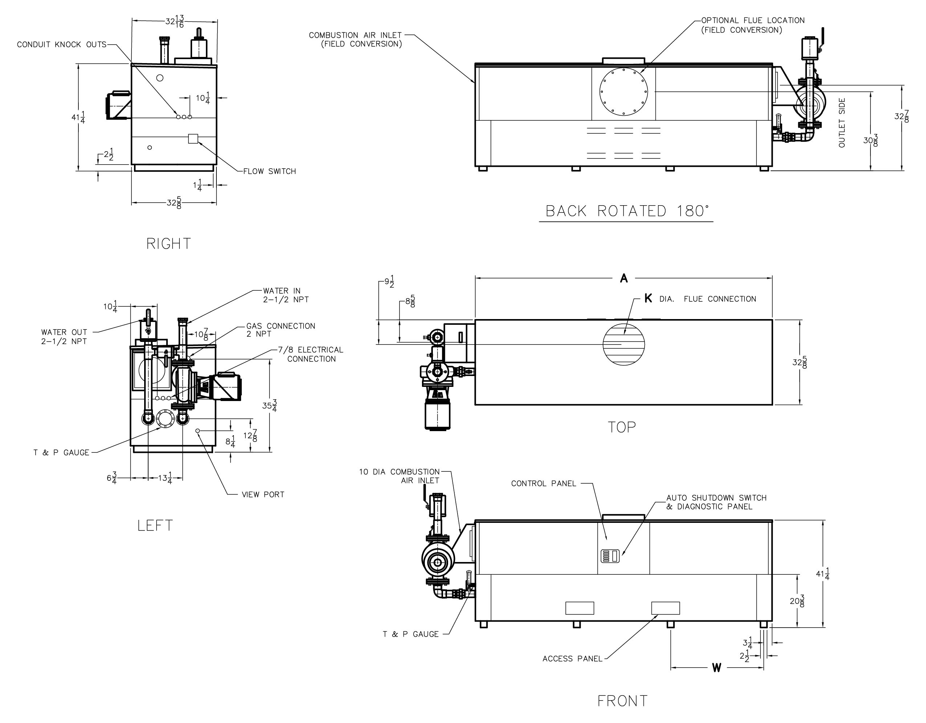
Model | Max. Flow
Model | GPM | ∆P (ft) | ∆T
P 1532B | 132 | 16.5 | 20
P 1802B | 132 | 18.3 | 23
P 2002B | 132 | 19.0 | 26
P 2072B | 132 | 19.0 | 27
P 2342B | 132 | 21.4 | 30

Model |  | MBTUH |  |  |  | A  Width |  | K |  | W |  | Amp Draw |  |  |  | Pump HP |  | Shipping Weight (Lbs.)
 | Input |  | Output |  |  |  |  |  |  |  | Heater |  | Pump
P 1532B |  | 1530 |  | 1301 |  | 79-7/8 |  | 12 |  | 24-3/8 |  | <12 |  | 11 |  | 3/4 |  | 1225
P 1802B |  | 1800 |  | 1530 |  | 91-1/8 |  | 14 |  | 28-1/8 |  | <12 |  | 11 |  | 3/4 |  | 1350
P 2002B |  | 1999 |  | 1699 |  | 102-1/2 |  | 14 |  | 31-15/16 |  | <12 |  | 14** |  | 1 |  | 1450
P 2072B |  | 2070 |  | 1760 |  | 102-1/2 |  | 14 |  | 31-15/16 |  | <12 |  | 14** |  | 1 |  | 1450
P 2342B |  | 2340 |  | 1989 |  | 113-7/8 |  | 16 |  | 35-11/16 |  | <12 |  | 21** |  | 1-1/2 |  | 1520

Dimensions are in inches.
Ratings shown are for elevations up to 4,500 feet and for natural or propane gas.
For installation at elevations over 4,500 feet, please contact manufacturer.

** Requires separate circuit breaker

Hi Delta – Type P

Models 1532B-2342B (Cold Water Run Option) Model

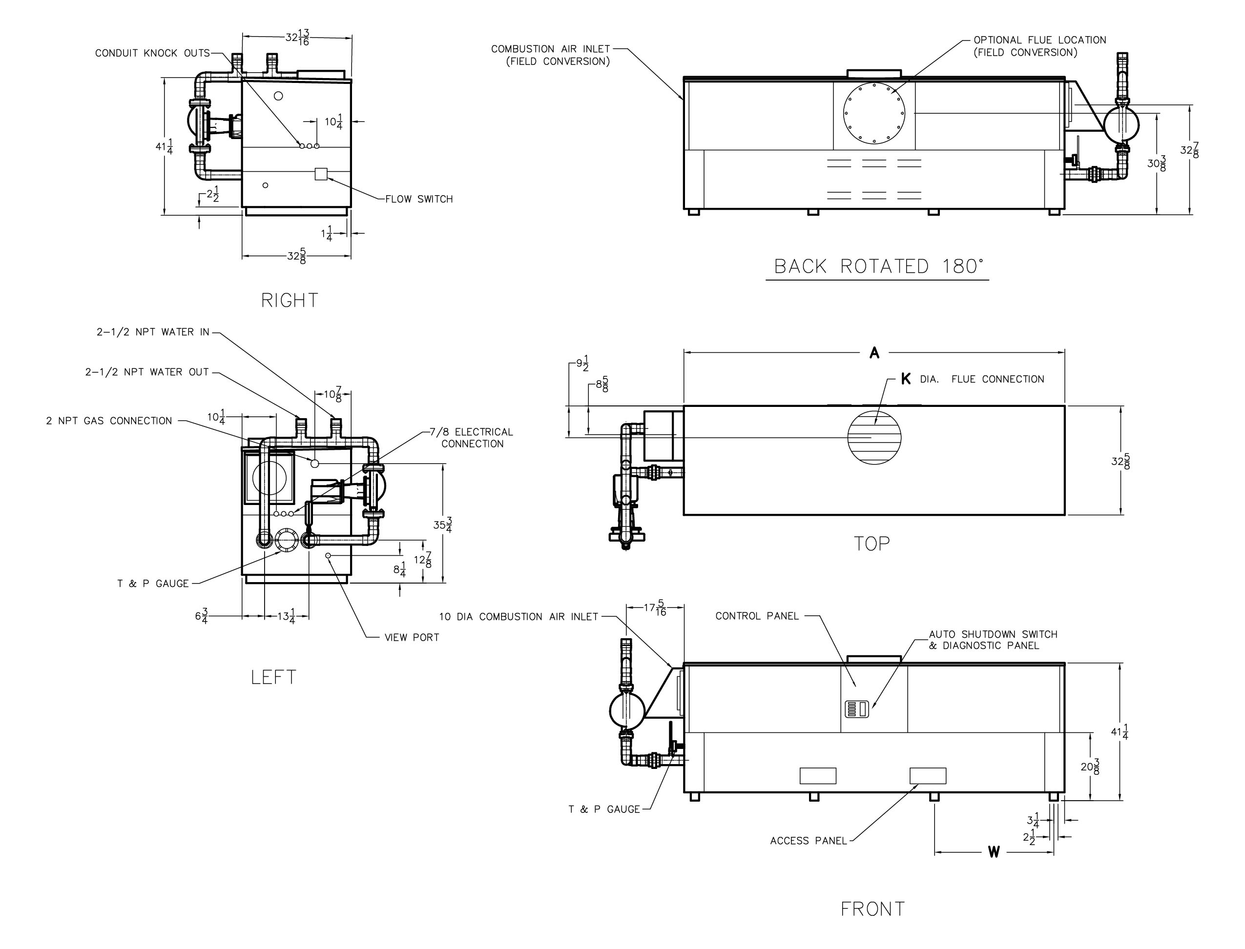
Model | Max. Flow
Model | GPM | ∆P (ft) | ∆T
P 1532B | 132 | 16.5 | 20
P 1802B | 132 | 18.3 | 23
P 2002B | 132 | 19.0 | 26
P 2072B | 132 | 19.0 | 27
P 2342B | 132 | 21.4 | 30

Model |  | MBTUH |  |  |  | A  Width |  | K |  | W |  | Amp Draw |  |  |  | Pump  HP |  | Injector Pump HP |  | Shipping Weight (Lbs.)
 |  | Input |  | Output |  |  |  |  |  |  |  | Heater |  | Pump |  |  |  |  |  | Shipping Weight (Lbs.)
P 1532B | 1530 |  | 1301 |  | 79-7/8 |  | 12 |  | 24-3/8 |  | <12 |  | 12 |  | 3/4 |  | 1/3 |  | 1225
P 1802B | 1800 |  | 1530 |  | 91-1/8 |  | 14 |  | 28-1/8 |  | <12 |  | 12 |  | 3/4 |  | 1/3 * |  | 1460
P 2002B | 1999 |  | 1699 |  | 102-1/2 |  | 14 |  | 31-15/16 |  | <12 |  | 14 |  | 1** |  | 3/4 * |  | 1560
P 2072B | 2070 |  | 1760 |  | 102-1/2 |  | 14 |  | 31-15/16 |  | <12 |  | 14 |  | 1** |  | 3/4 * |  | 1560
P 2342B | 2340 |  | 1989 |  | 113-7/8 |  | 16 |  | 35-11/16 |  | <12 |  | 21 |  | 1** |  | 3/4 * |  | 1620

Dimensions are in inches.
Ratings shown are for elevations up to 4,500 feet and for natural or propane gas.
For installation at elevations over 4,500 feet, please contact manufacturer.
*Separate 120 VAC or 240 VAC 1Ø power required for Cold Water Run option
** Requires separate circuit breaker

Raypak, Inc. ▪ 2151 Eastman Avenue, Oxnard, CA 93030 ▪ (805) 278-5300 ▪ Fax (800) 872-9725 ▪ www.raypak.com

